[An Online Web-Streaming Service for Bitcoin-Exchanges]

Progress Report



Information Technology Capstone Project

COMP5703

Group Members

1. Yangkai Hong (470231528)
2. Karim Santallo (470155497)
3. Jiaqing Li (470166910)
4. Sreejith Warrier (470217050)

Table of Contents

Table of Contents

Table of Contents i

1. Progress Status 3

2. Roles & Responsibilities 4

3. Individual Achievements 5

4. Group Collaboration 7

# Progress Status

|  |  |
| --- | --- |
| **Project Name** | An Online Web-Streaming Service for Bitcoin-Exchanges |
| **Project Start Date** | 8 August 2018 |
| **Project Manager** | Karim Santallo |

|  |  |
| --- | --- |
| Project Description | Implement a web application that retrieves, stores and visualizes data from Bitcoin exchanges. |

|  |  |  |
| --- | --- | --- |
| Project Status Report | #7 | Date: 4 October 2018 |

|  |  |  |
| --- | --- | --- |
| **Status Item** | **Status up to last week** | **Planned for this week** |
| **Major deliverables** | ·CLI feedback messages function  ·Real-tiem data correctness assurance function  ·Mainlayout of the website  ·Candlestick chart time interval selection feature  ·Countdown timer for candlestick chart  ·Price line chart with multiple data series  ·Comparison table | ·Order book table in exchange page  ·Market depth chart in exchange page (optional)  ·Price line chart in dashboard page  ·User profile page |
| **Planned delivery date** | 3 October 2018 | 10 October 2018 |
| **Major issues** | Back-end APIs delayed | Data and APIs |
| **Major risks** | Time constraint | Time constraint |
| **External dependencies** | Bitfinex and HitBTC | react-stockcharts |
| **Estimated effort (hr)** | 20 | 18 |
| **Recorded effort (hr)** | 20 |  |
| **Status (R, Y, G)** | Green | Green |

# Roles & Responsibilities

**Karim Santallo**

**Team Lead, Web Developer, Quality Assurance**

* Keeps the team on track to deliver a quality product on time.
* Responsible for the implementation and management of the agile methodology.
* Maintains the product backlogs and planning of sprints.
* Schedules, organises and facilitates team meetings.
* Implements login, register, dashboard, exchange pages.
* Improves code quality and user interfaces, fixes bugs.

**Jiaqing Li**

**Web developer**

* Implements Google and Github accounts login function.

**Sreejith Warrier**

**Back-End Developer**

* Developing back-end API for providing candle chart data.

**Yangkai Hong** (me)

**Lead Front-End Developer**

* Provides counsel on technical front-end design decisions.
* Implements time interval selection and countdown timer for candlestick chart.
* Implements dashboard pages including price line chart and comparison table.
* Implements order book table and market depth chart
* Implements user profile page user interface.

# Individual Achievements

The tasks in figure 1 were assigned to me on 26 September. And I was asked to finish them before 2 October.

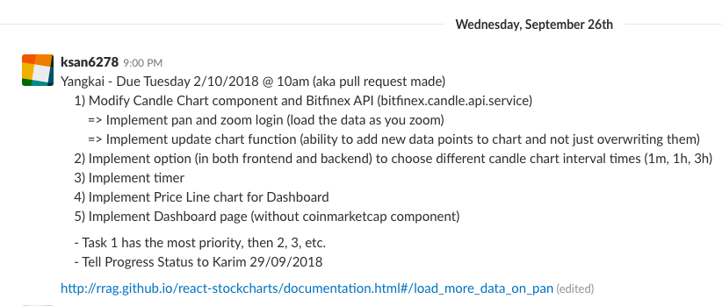

Figure 1. Tasks for Yangkai

The result is that I finished all the tasks and commited my work on 30 September (before the due date) as shown in figure 2.

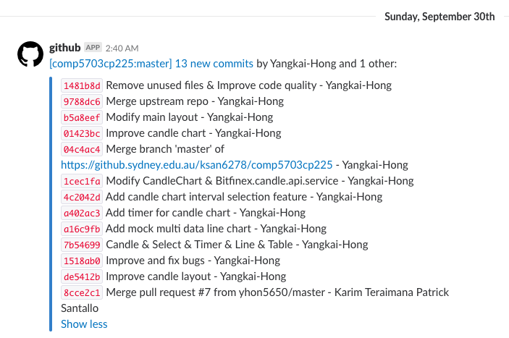

Fgiure 2. Commits by Yangkai

The works I did in those commits basically implement the features that shown in figure 3 and figure 4.

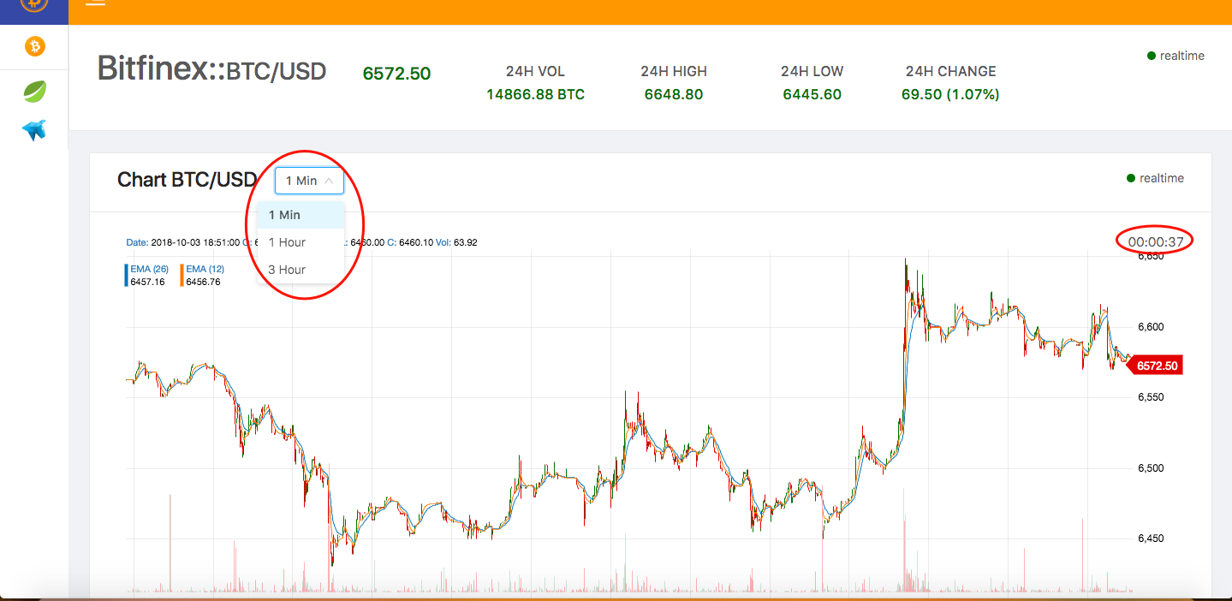

Figure 3. Candlestick Chart with Interval Selection & Timer

After select any time interval, the app will redraw the candlestickchart with that interval. It will meet different needs of users, which helps improving user experience.

The timer on the top right shows the remaining time of next data point, which also improves user experience.

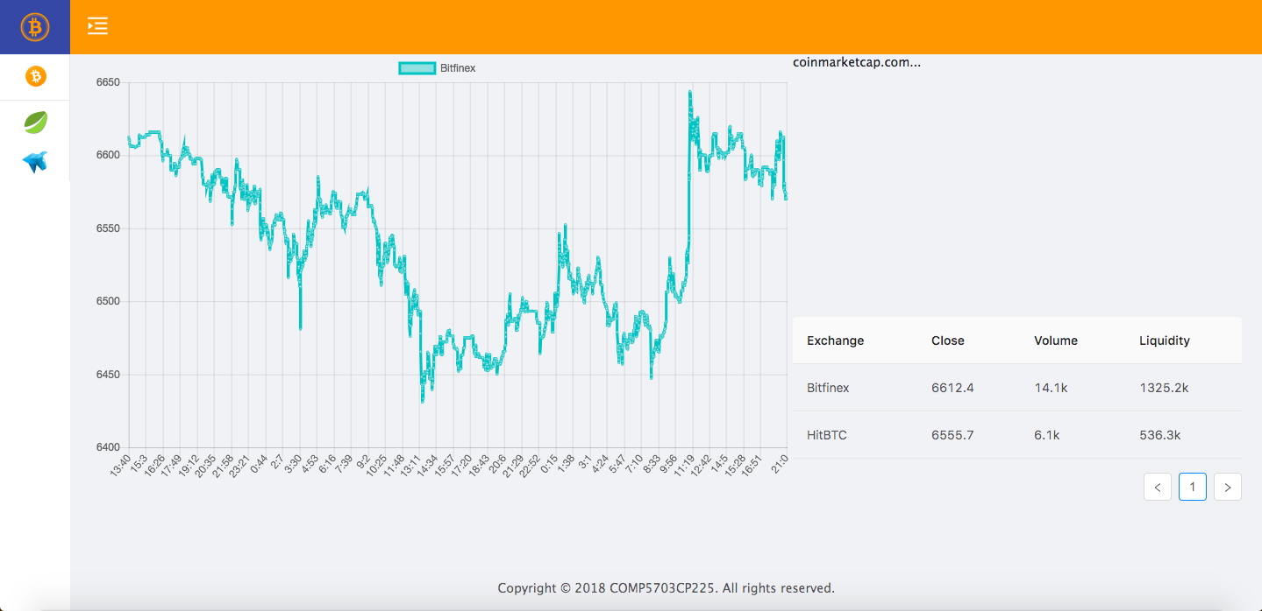

Figure 4. Price Line Chart & Compare Table in Dashboard

Both line chart and table are good approaches to display the comparison of different exchanges to users.

# Group Collaboration

1). Online Meeting

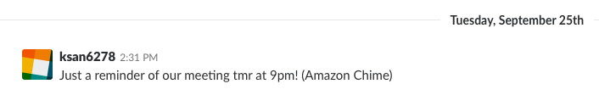

Figure 5. Online Meeting Anouncement

We had an online meeting on 26 September using Amazon Chime software. During the meeting, we allocated tasks in detail to every team member. We planned to deliver (make pull request) the tasks on 2 October.

2) Meeting

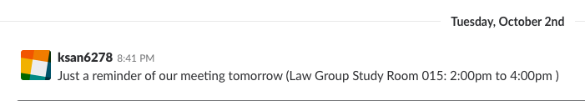

Figure 6. Meeting Anouncement

We had a meeting during 2 to 4pm 3 October, just before the tutorial. In the meeting, we discussed about some issues. For instance, back-end data storage and API services that should be done by Sreejith were delayed. And Jiaqing’s Github login function has not been integrated into our application. After that, we planned the work we were going to do such as order book table, market depth chart and user profile page.

3) Change management

At the beginning, we decided to draw 1 – 2 year’s data in a real-time candlestick chart. However, we found it takes so much time that is not workable. Then I had a conversation with Karim about this problem. At last, both of us agreed to solve this problem by limiting the number of data points. Figure 7 is how we did to meet the application’s requirement.

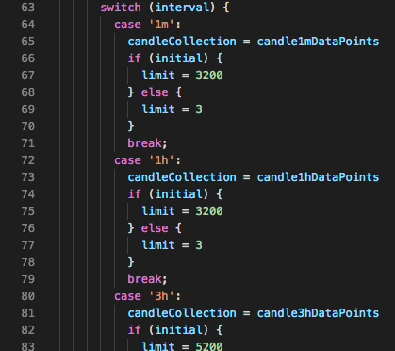

Figure 7. API Service Solution