[An Online Web-Streaming Service for Bitcoin-Exchanges]

Progress Report



Information Technology Capstone Project

COMP5703

Group Members

1. Yangkai Hong (470231528)
2. Karim Santallo (470155497)
3. Jiaqing Li (470166910)
4. Sreejith Warrier (470217050)

Table of Contents

Table of Contents

Table of Contents i

1. Progress Status 3

2. Roles & Responsibilities 4

3. Individual Achievements 5

4. Group Collaboration 7

# Progress Status

|  |  |
| --- | --- |
| **Project Name** | An Online Web-Streaming Service for Bitcoin-Exchanges |
| **Project Start Date** | 8 August 2018 |
| **Project Manager** | Karim Santallo |

|  |  |
| --- | --- |
| Project Description | Implement a web application that retrieves, stores and visualizes data from Bitcoin exchanges. |

|  |  |  |
| --- | --- | --- |
| Project Status Report | #8 | Date: 12 October 2018 |

|  |  |  |
| --- | --- | --- |
| **Status Item** | **Status up to last week** | **Planned for this week** |
| **Major deliverables** | ·Commit price line chart component  ·Commit compare table component  ·Commit order book component  ·Commit market depth chart component | ·Improve price line chart  ·Improve compare table  ·Improve order book  ·Improve market depth chart  ·Commit user profile page  ·Closure coding |
| **Planned delivery date** | 12 October 2018 | 19 October 2018 |
| **Major issues** | ·Candle data missing  ·Order book API service  ·Market depth chart bug | ·Improve the performance of components |
| **Major risks** | Time constraint | Time constraint |
| **External dependencies** | Exchanges’ web APIs | Exchanges’s web APIs |
| **Estimated effort (hr)** | 18 | 18 |
| **Recorded effort (hr)** | 18 |  |
| **Status (R, Y, G)** | Green | Green |

# Roles & Responsibilities

**Karim Santallo**

**Team Lead, Web Developer, Quality Assurance**

* Keeps the team on track to deliver a quality product on time.
* Responsible for the implementation and management of the agile methodology.
* Maintains the product backlogs and planning of sprints.
* Schedules, organises and facilitates team meetings.
* Implements the menu, logout, dashboard features.
* Improves the performance of candle chart component.

**Jiaqing Li**

**Web developer**

* Implements user profile page.

**Sreejith Warrier**

**Back-End Developer**

* Implemented order book API service and HitBTC candle API service.

**Yangkai Hong** (me)

**Lead Front-End Developer**

* Provides counsel on technical front-end design decisions.
* Implemented time interval selection feature.
* Implements countdown timer, price line chart, compare table, order book and market depth chart components.
* Contributes to dashboard and exchanges pages.
* Improves the performance of order book and market depth chart components.
* Fixes bugs / issues in price line chart component

# Individual Achievements

1. I commited my work on Price Line Chart, Order Book and Market Depth Chart to our upstream repository.

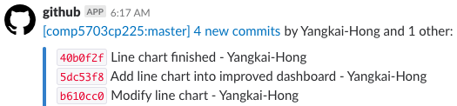

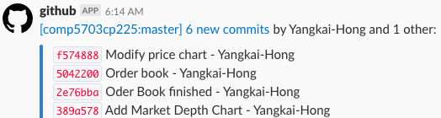

1. Price Line Chart is displayed in dashboard page, providing users with useful and direct comparison between different exchanges.

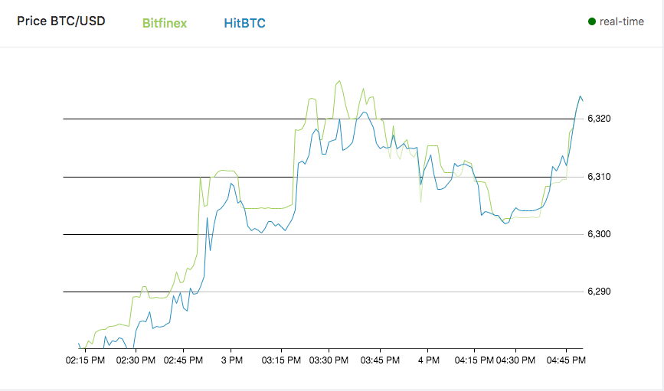

1. Order Book is displayed in exchange page, providing users with Bid and Ask books information of the selected exchange.

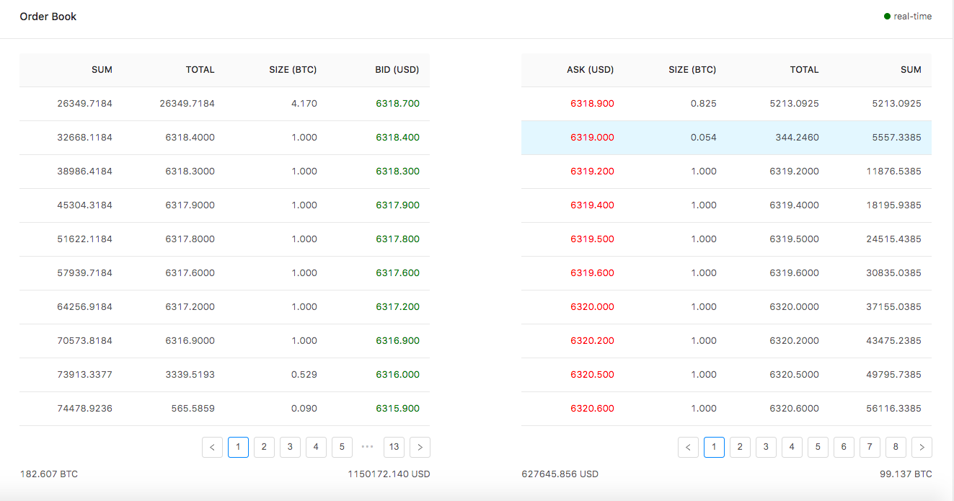

1. Market Depth Chart is displayed in exchange page, providing users with price and volume information from order book data.

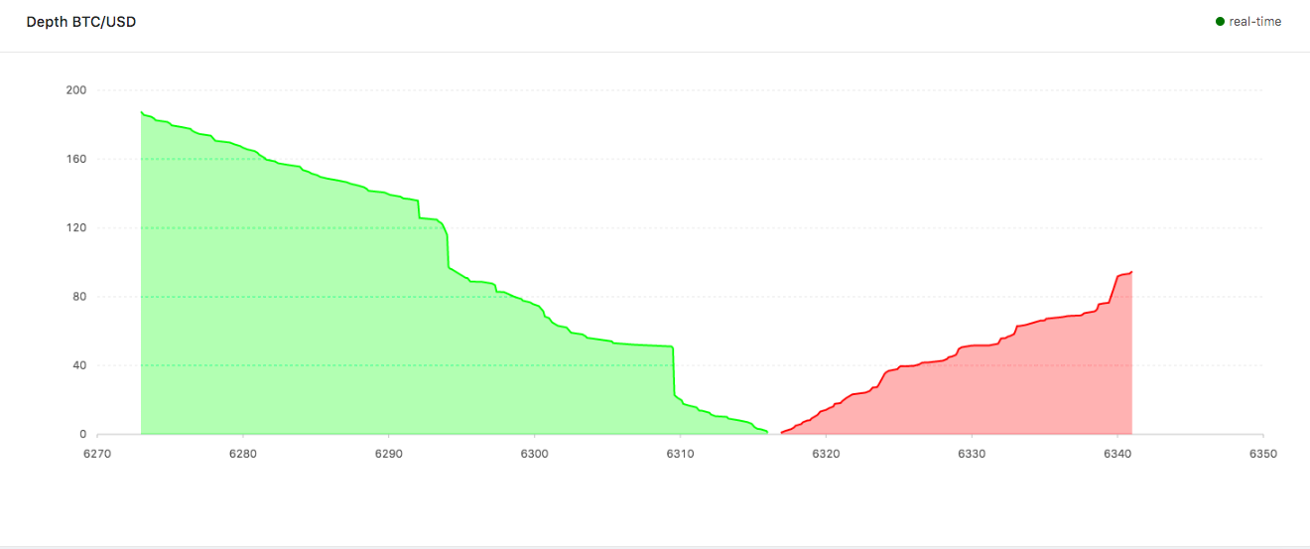

# Group Collaboration

1. Everyone contributes to the upstream repository.

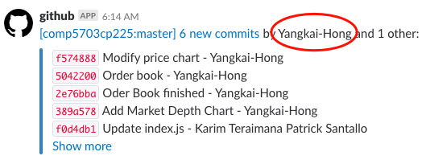

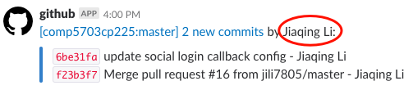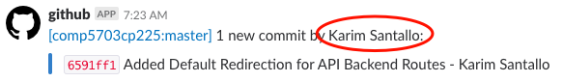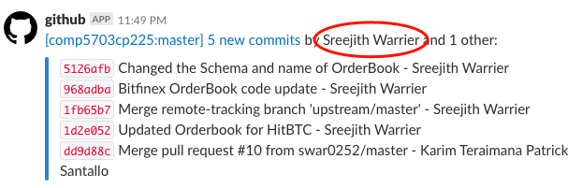

1. Our group stay on schedule. As shown in the figure below, the whole project is almost finished, the remaining tasks are closure of coding, presentation and final report.

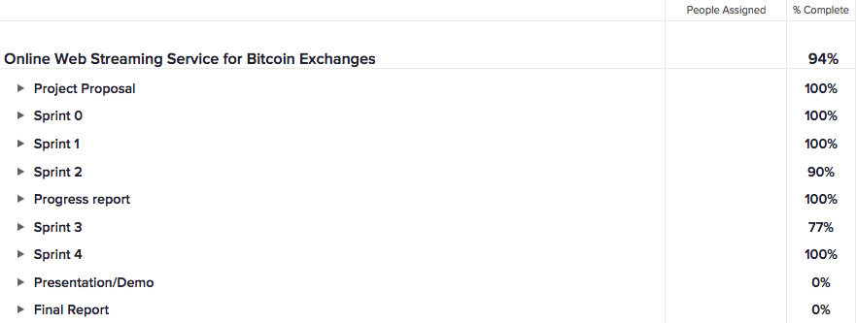

1. We collaborated on Group Progress Report using OneDrive online application.

