[An Online Web-Streaming Service for Bitcoin-Exchanges]

Progress Report



Information Technology Capstone Project

COMP5703

Group Members

1. Yangkai Hong (470231528)
2. Karim Santallo (470155497)
3. Jiaqing Li (470166910)
4. Sreejith Warrier (470217050)

Table of Contents

Table of Contents

Table of Contents i

1. Progress Status 3

2. Roles & Responsibilities 4

3. Individual Achievements 5

4. Group Collaboration 8

# Progress Status

|  |  |
| --- | --- |
| **Project Name** | An Online Web-Streaming Service for Bitcoin-Exchanges |
| **Project Start Date** | 8 August 2018 |
| **Project Manager** | Karim Santallo |

|  |  |
| --- | --- |
| Project Description | Implement a web application that retrieves, stores and visualizes data from Bitcoin exchanges. |

|  |  |  |
| --- | --- | --- |
| Project Status Report | #9 | Date: 19 October 2018 |

|  |  |  |
| --- | --- | --- |
| **Status Item** | **Status up to last week** | **Planned for this week** |
| **Major deliverables** | * Improved order book API, candle data API and ticker data **API services** * Improved price line chart , exchanges table, order books and market depth chart **components** * Improved dashboard and exchanges **pages** * Improved local, GitHub and Google login & profile features | * The closure of coding * Presentation slides * Final report draft * Individual report_10 |
| **Planned delivery date** | 19 October 2018 | 26 October 2018 |
| **Major issues** | HitBTC books data stored are wrong, causing issues in order books and depth chart. | None |
| **Major risks** | None | Unknown rubrics |
| **External dependencies** | * Bitcoin platforms’ APIs * React libraries | * Presentation rubric * Final report rubric |
| **Estimated effort (hr)** | 18 | 18 |
| **Recorded effort (hr)** | 18 |  |
| **Status (R, Y, G)** | Green | Green |

# Roles & Responsibilities

**Karim Santallo**

**Team Lead, Web Developer, Quality Assurance**

* Keeps the team on track to deliver quality products on time.
* Responsible for the implementation and management of the Scrum methodology.
* Maintains the product backlogs and planning of sprints.
* Schedules, organises and facilitates team meetings.
* Implements and improves components in the login, dashboard and exchanges pages.
* Designs the product, testing, identifies problems.

**Jiaqing Li**

**Web Developer**

* Implements Github and Google login functions.
* Implements user profile page.
* Organising for preparation of the presentation.

**Sreejith Warrier**

**Back-End Developer**

* Implements order books data storage services.

**Yangkai Hong** (me)

**Lead Front-End Developer**

* Provides counsel on technical front-end design decisions.
* Implements Timer component in candlestick chart.
* Implements price line chart and exchanges comparing table components in dashboard.
* Implements order books and market depth chart components in exchanges page.
* Adds more features on books, candles and tickers API services to meet front-end needs.
* Identifies issues in front-end components.
* Testing, debugging and improving performance in front-end.

# Individual Achievements

1. Price Line Chart

I have improved the price line chart which is displayed in dashboard page this week. The time interval of data points was one minute before. But usually there will be data missing issue while the interval is one minute. And the dashboard aims to provide an overview information. So I changed the time interval to be one hour and displaying one week’s data. Then the data missing issure was solved.

In addition, there was an lastest data points updating issue, which means the latest 3 data points of Bitfinex and HitBTC are the same (but they should not). Finally, I realized that it results from an issue in our candle API service. So I moved three lines of code there. Then this issue has been solved.

Now, the price line chart is good enough. It shows a high correlation between Bitfinex and HitBTC exchanges, see figure 1.

1. Exchanges Comparing Table

I have created the exchanges comparing table this week. Actually, I have implemented a previous version before it. But this Wednesday Karim told me that the requirement should be changed because we couldn’t get the liquidity column adequately because of the limit on the order book API (eg bitfinex limits it to 200). He is right so I replaced the liquidity column with 24h change column. This is why the table was delayed 2 days for delivering.

The table shows price, 24h volume and 24h change information of Bitfinex and HitBTC exchanges. The green color means increasing while red color means decreasing. All the data come from our ticker API services.

Now, the exchanges comparing table is good enough and provides useful overview of these two exchanges, see figure 1.

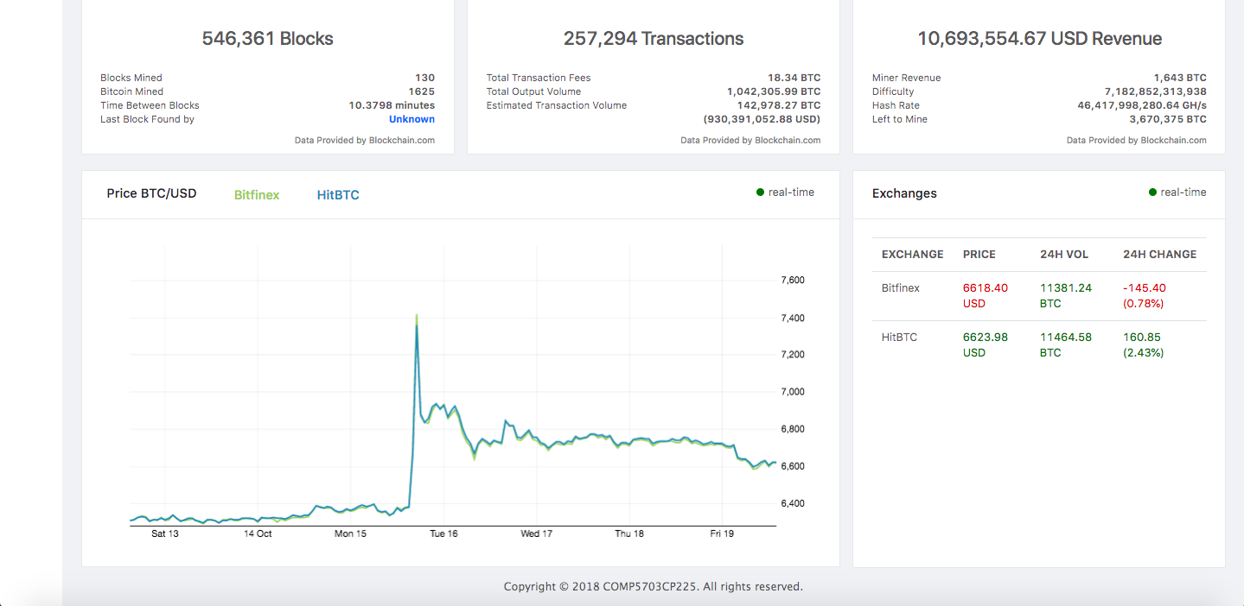

Figure 1. Price line chart & exchanges comparing table

1. Order Books

I have improved the order books implementation this week. In fact, I have implemented a USD-BTC version before it. But this Wednesday, Karim told me that we are doing BTC-USD market. I just realized they are different. Then I spent some time to modify the books component. I deleted the Total column, which is in USD unit (USD price multiplies amount) because we don’t need it any more. And change the Sum column from USD to BTC.

In addition, Karim told me an issue that the order books does not switch while user switches the exchange page. So I added some code in componentDidUpdate lifecycle hook in order book component to solve the issue. It is able to switch between exchanges now.

The books show two sides, Bid and Ask. Each side has three columns which are Price, Amount and Sum. Now it is good enough to be delivered, see figure 2.

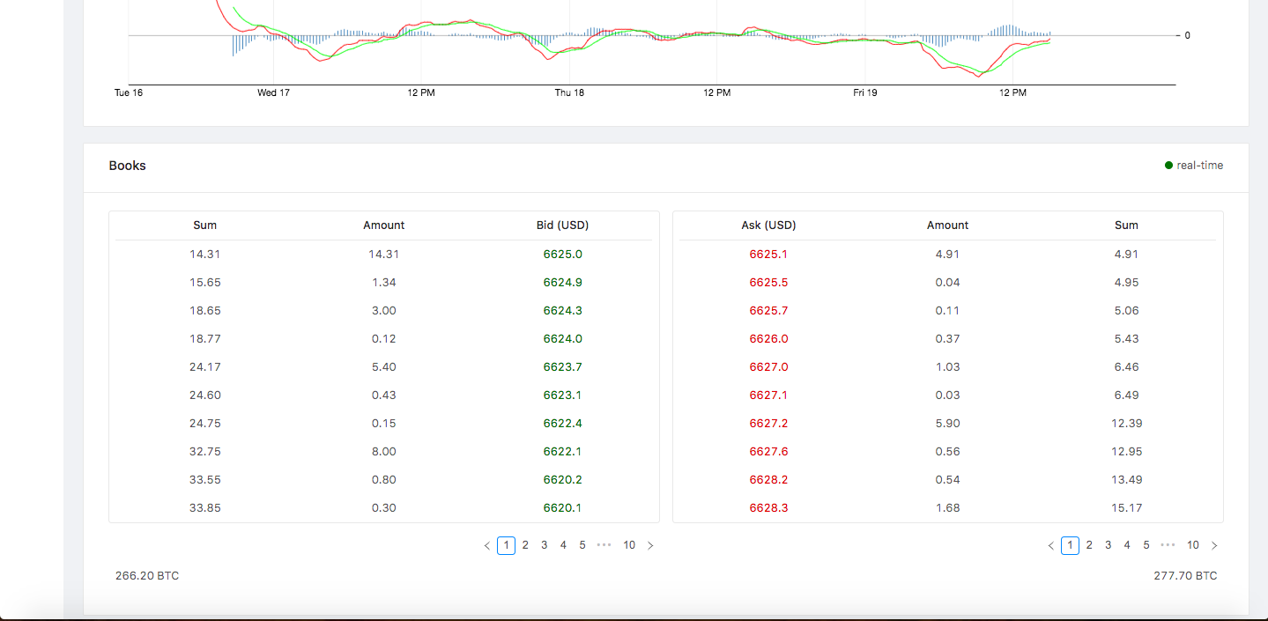

Figure 2. Order Books

1. Market Depth Chart

I have improved the depth chart implementation this week. At the beginning, it has an issue that calculating/looping too much and making the browser crash. It results from that using array.reverse() function to process the data array from server messages. Sometimes, the bids side are rendered in not reversed order. So I modified the book API service to send data according to front-end message (indicate ascending or descending) and solved the issue.

Also, I reduced its height, modified the padding, changed the tickInterval on x and y axises to make the chart looking better, see figure 3. Now it is ready to be delivered.

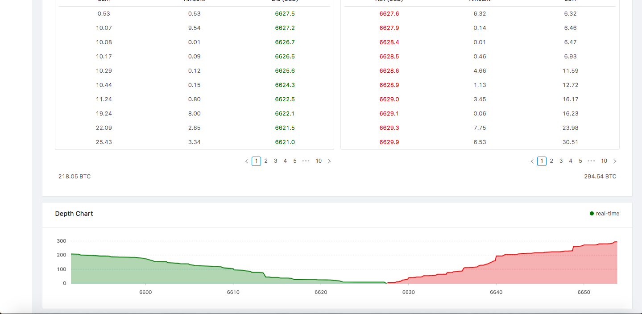

Figure 3. Market depth chart

1. My git commits this week

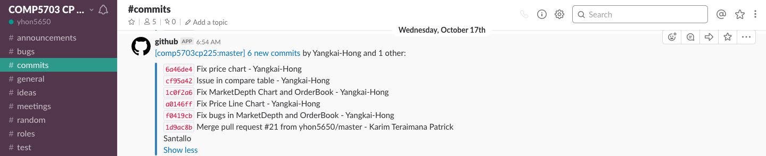

Wednesday, 17 October 2018

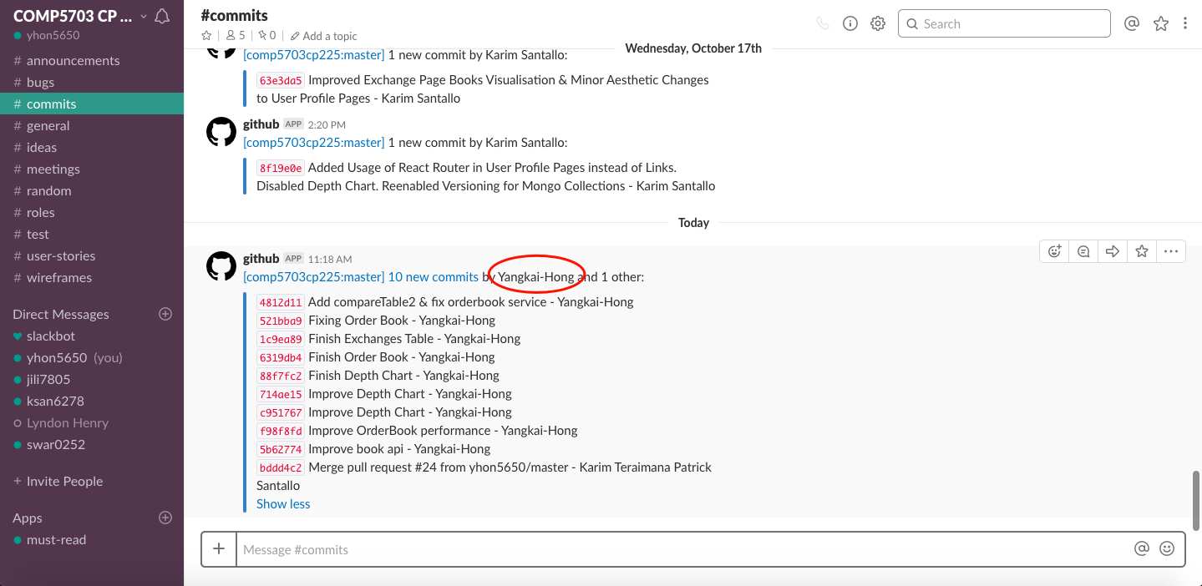

Friday, 19 October 2018

# Group Collaboration

1. This Monday, our group organised our questions about final report and presentation. And posted our concerns on Slack general channel since we want to prepare better for the report and presentation.

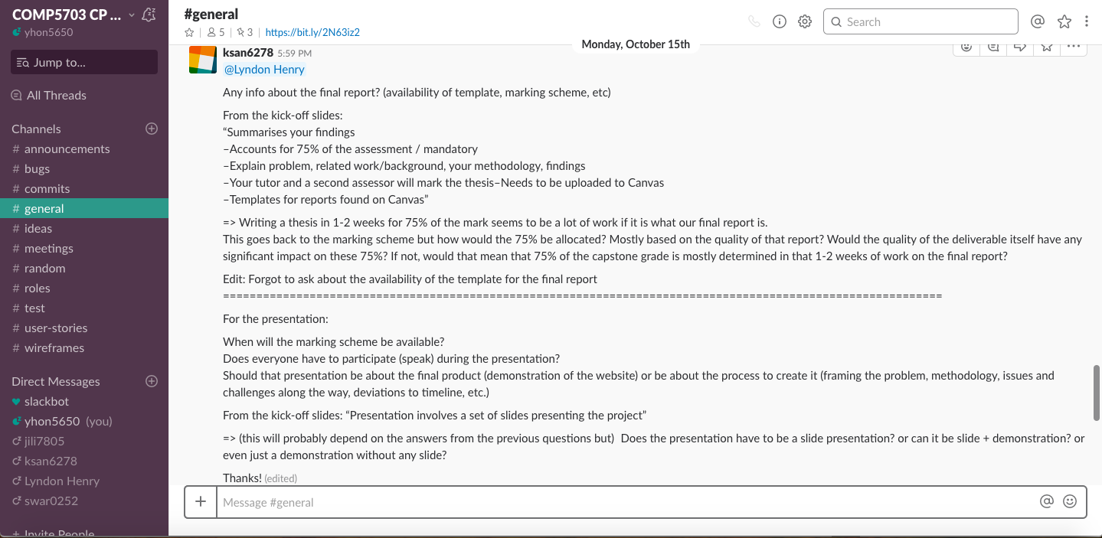

1. When I was implementing the order book component, I found that we have some issues in storing order books data (wrong data). It means we might miss some updating message from exchange APIs. Then I talked the issue with Karim. He told me that he or Sreejith will solve the issue.

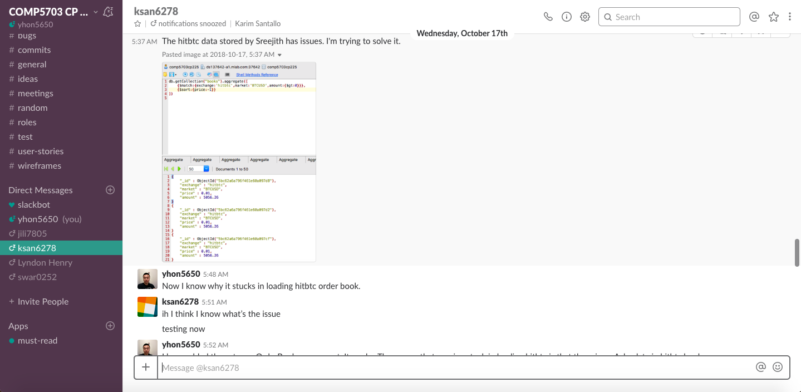

1. Karim told me that there is an issue with switching order book / depth chart component. Then I added some code in componentDidUpdate lifecycle hook in these two components. Then they are able to swtich between Bitfinex and HitBTC exchanges. Karim was satisfied with this solution.

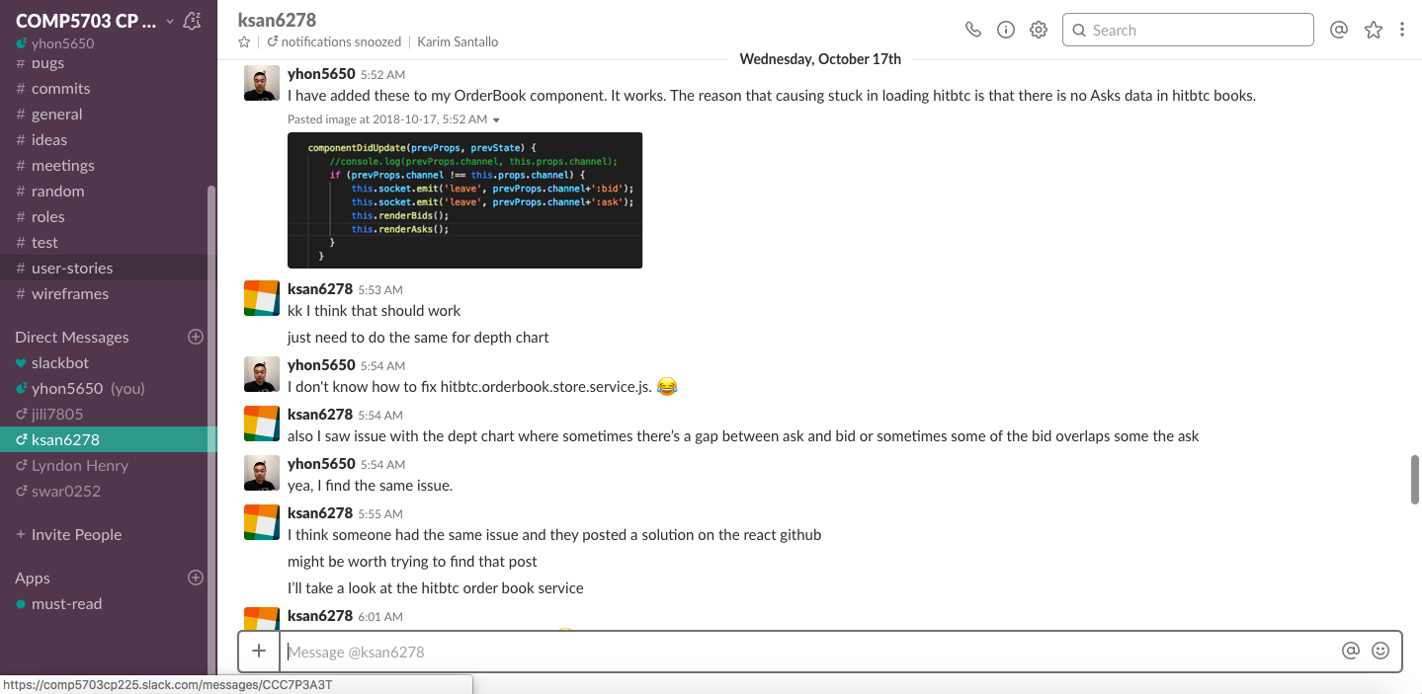

1. Karim and I had an conversation about issues in order book and depth chart components. We agreed that the order book is in BTC-USD market, not USD-BTC market. And we should not use array.reverse() function while processing data array in depth chart component. After that, we solved the issues. The product’s quality has been improved a lot.

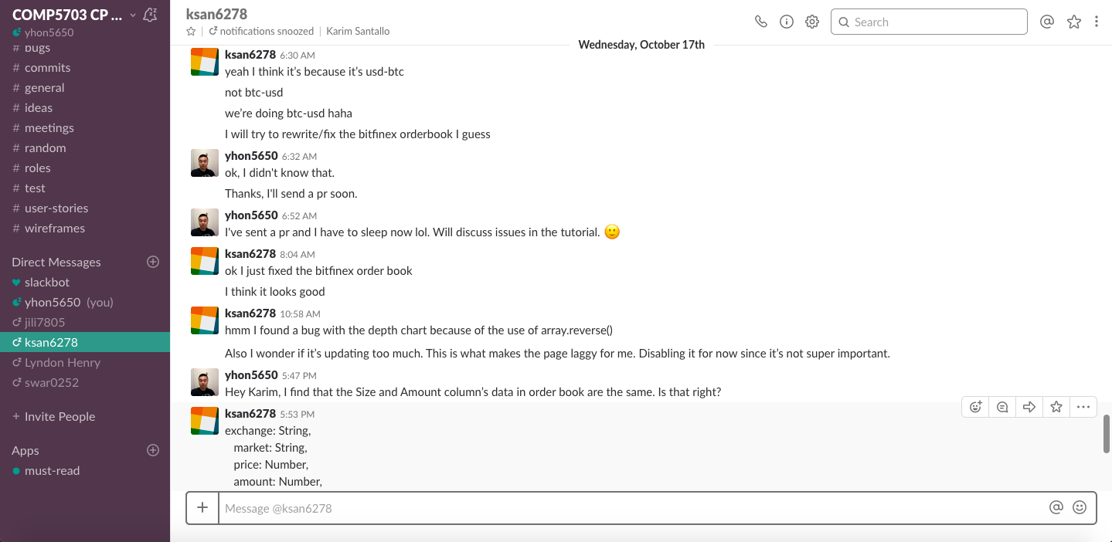

1. This Thursday, we solved the last issue in front-end (order book component). After that, I sent a pull request to our upstream repository. Karim has merged the pr today.

The only one remaining issue is the books data storage service. So now we are very close to the closure of coding. After solving that issue, all of us will focus on presentation and final report, I think.

