[An Online Web-Streaming Service for Bitcoin-Exchanges]

Progress Report



Information Technology Capstone Project

COMP5703

Group Members

1. Yangkai Hong (470231528)
2. Karim Santallo (470155497)
3. Jiaqing Li (470166910)
4. Sreejith Warrier (470217050)

Table of Contents

Table of Contents i

1. Progress Status 1

2. Roles & Responsibilities 2

3. Individual Achievements 2

4. Group Collaboration 2

# Progress Status

|  |  |
| --- | --- |
| **Project Name** | An Online Web-Streaming Service for Bitcoin-Exchanges |
| **Project Start Date** | 8 August 2018 |
| **Project Manager** | Karim Santallo |

|  |  |
| --- | --- |
| Project Description | Implement a web application that retrieves, stores and visualizes data from Bitcoin exchanges. |

|  |  |  |
| --- | --- | --- |
| Project Status Report | #1 | Date:17 August 2018 |

|  |  |  |
| --- | --- | --- |
| **Status Item** | **Status up to last week** | **Planned for this week** |
| **Major deliverables** | Project management plan:  Scope, Time, Quality, Resources, Leadership, Communication, Risk | Business proposal draft |
| **Planned delivery date** | 15 August 2018 | 22 August 2018 |
| **Major issues** | ·Roles & Responsibilities allocation  ·Github upstream repository  ·Idea of business proposal | ·Proposal  ·Frontend framework  ·Backend API  ·Data visualization |
| **Major risks** | Knowledge of cryptocurrencies | Technology stack selection |
| **External dependencies** | Cryptocurrencies, git | React, D3.js, websocket |
| **Estimated effort (hr)** | 18 | 18 |
| **Recorded effort (hr)** | 18 |  |
| **Status (R, Y, G)** | Green | Green |

# Roles & Responsibilities

**Yangkai Hong**: Web Developer

• Research on frontend frameworks. Design our frontend architecture and implement it.

• Research on bitcoin exchanges order book data visualisation theories and design our implementation.

• Research on JavaScript charting libraries and implement the visualisation of order book data.

**Karim Santallo**: Team Lead, Web Developer, Quality Assurance

• Make sure the team stays on track, meet the milestones, delivers a product that meet the requirement we would have gathered and set, etc.

• Organise/schedule meetings and lead meetings discussion as well as provide a written summary of them.

• Provide ideas based on researches and my experience with crypto currency

• Do some coding (but not be the main developer), preferably focusing on css design or some backend stuff (gathering data from api and storing them in the database). Nothing really related to charting front-end

• (adding just too) Formating, editing, collating our report deliverables too

**Jiaqing Li**: Web developer / Data specialist, Quality Assurance

1. providing advices mainly in business studies &scenarios and data related topics like data structure, analytics solutions and so on

2. Coding mainly in backend and help aligning with the web frontend

3. Supporting Karim in PM as an auditor and QA for our project

**Sreejith Warrier**: Web Developer

• Main backend developer - Research, Design, Coding and Testing

• Also flexible and can help with front end, especially with CSS design.

# Individual Achievements

·Forked our group’s upstream github repository. Got familiar with git operations and be prepared to commit it later.

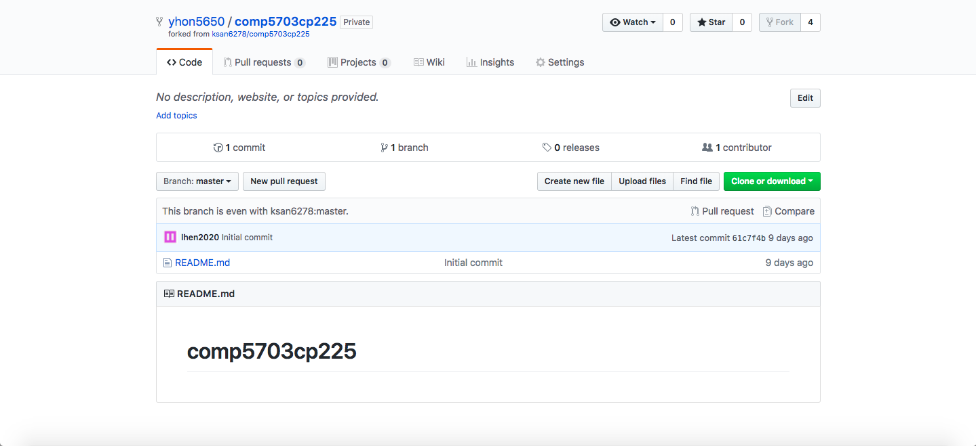

·Splitted the project proposal. Researched related problems and started to draft my section.

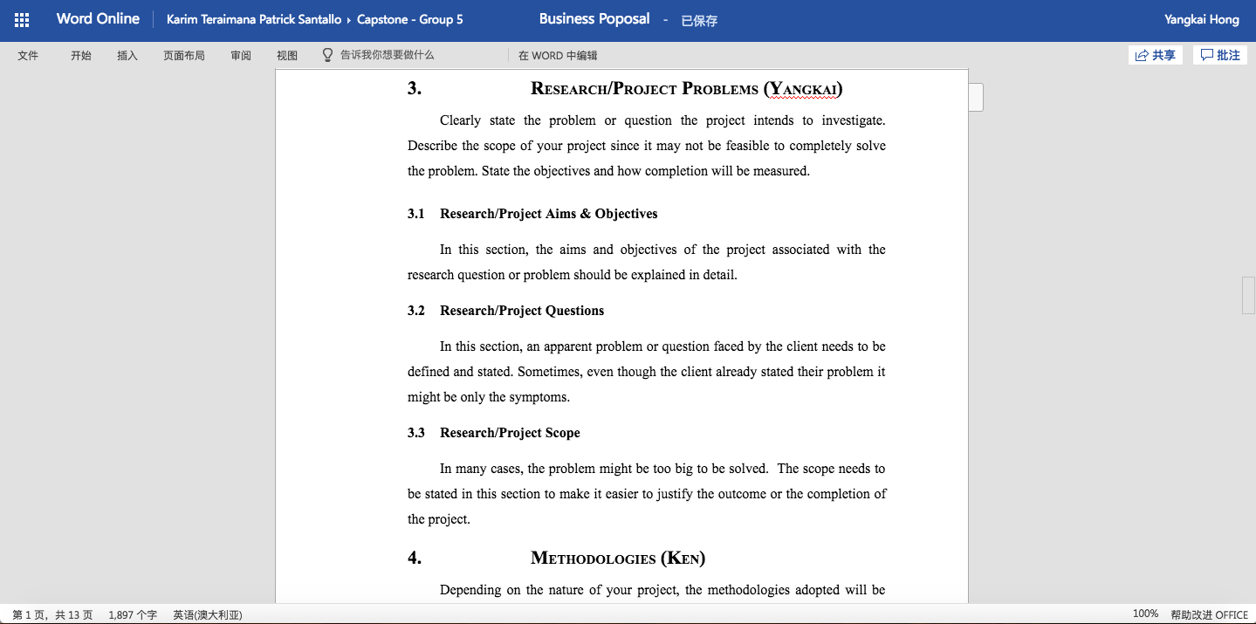

·Practiced JavaScript charting libraries with constant data, be well prepared for later development.

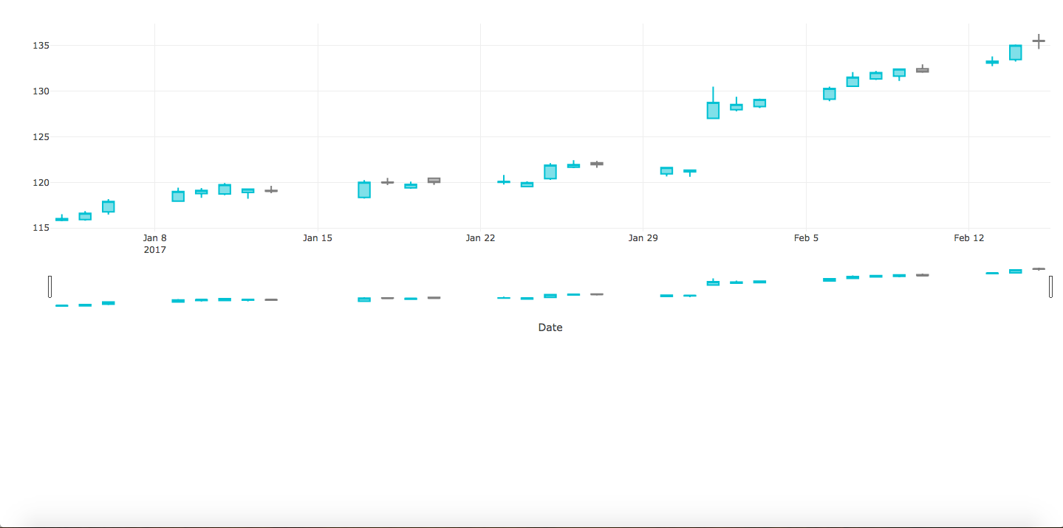

·Learned React tutorials to help designing our application’s attritecture, be well prepared to start development later.

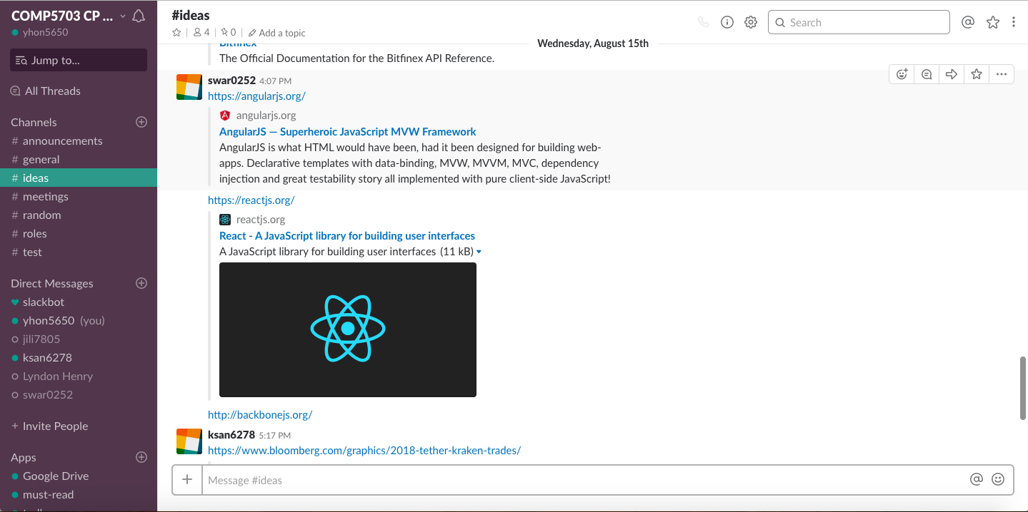

# Group Collaboration

·Actively particapate in discussions on Slack, response to teammates.

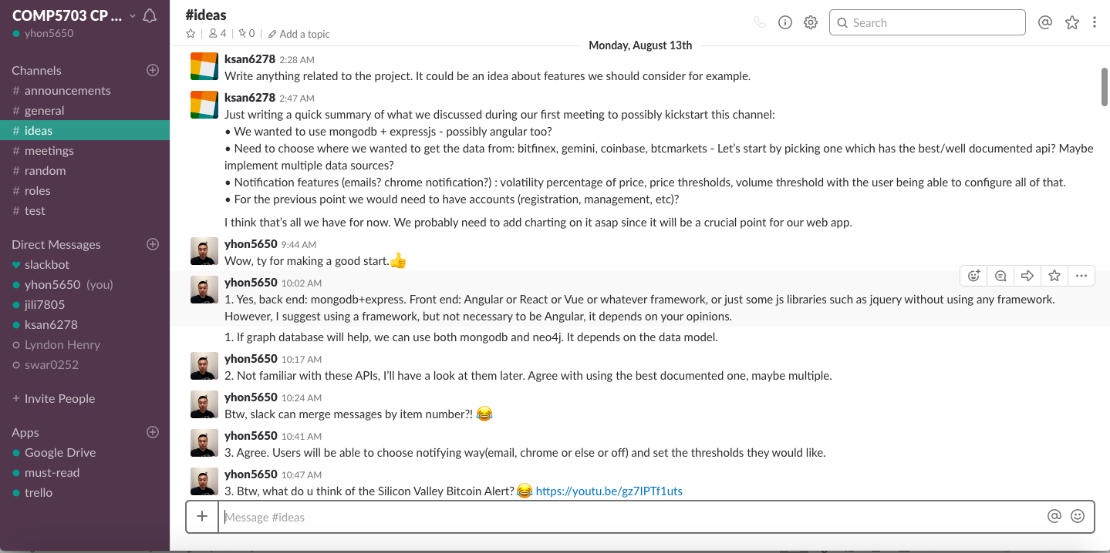

·Share links and articles, try to help solving problems we faced with.

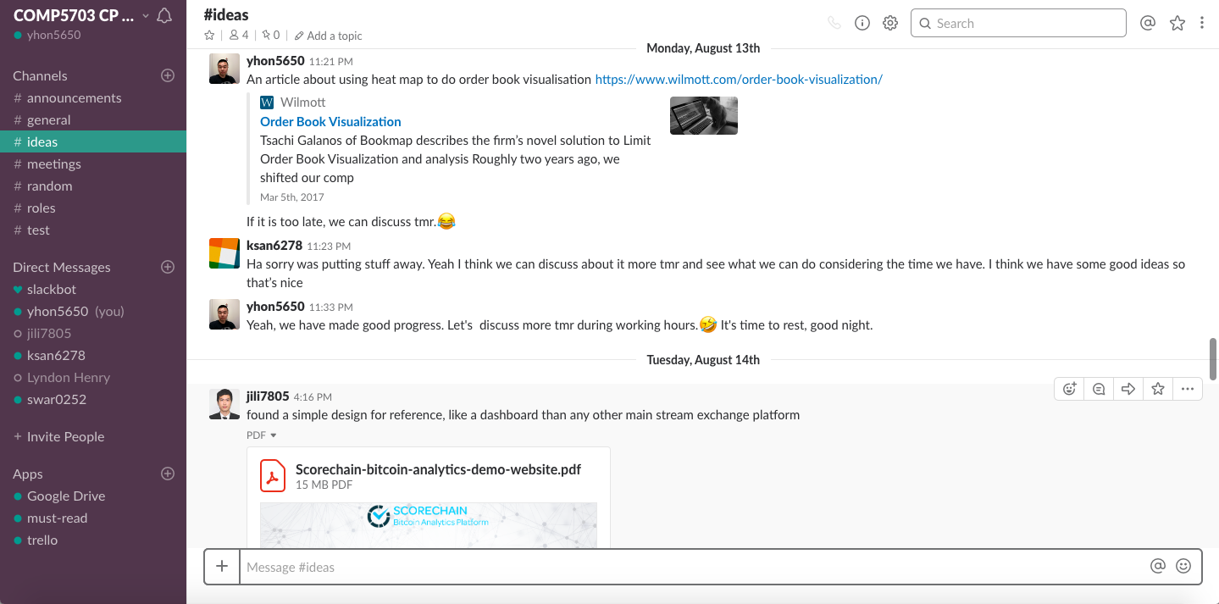

·Attend tutorial and physical meetings, actively participate in discussions and share my views.

