[An Online Web-Streaming Service for Bitcoin-Exchanges]

Progress Report



Information Technology Capstone Project

COMP5703

Group Members

1. Yangkai Hong (470231528)
2. Karim Santallo (470155497)
3. Jiaqing Li (470166910)
4. Sreejith Warrier (470217050)

Table of Contents

Table of Contents i

1. Progress Status 1

2. Roles & Responsibilities 2

3. Individual Achievements 2

4. Group Collaboration 2

# Progress Status

|  |  |
| --- | --- |
| **Project Name** | An Online Web-Streaming Service for Bitcoin-Exchanges |
| **Project Start Date** | 8 August 2018 |
| **Project Manager** | Karim Santallo |

|  |  |
| --- | --- |
| Project Description | Implement a web application that retrieves, stores and visualizes data from Bitcoin exchanges. |

|  |  |  |
| --- | --- | --- |
| Project Status Report | #3 | Date:31 August 2018 |

|  |  |  |
| --- | --- | --- |
| **Status Item** | **Status up to last week** | **Planned for this week** |
| **Major deliverables** | ·Project Proposal  ·Push the initial commit on the usyd github repository  ·Deploy our initial web application to Heroku | ·Basic Website Skeleton  ·Liquidity & Volume Comparison Dashboard  ·Candlestick chart component  ·Volume chart component  ·Order books table component |
| **Planned delivery date** | 29 August 2018 | 5 September 2018 |
| **Major issues** | ·Proofread proposal | ·Have no experience in building a real web application from scracth with React |
| **Major risks** | ·Unfamiliar with github forking work flow | ·Learning curve of React, Redux, babel, D3.js, webpack  ·Developing time is short, but we have a lot of coding tasks |
| **External dependencies** | ·Related project | ·Bitcoin exchanges API |
| **Estimated effort (hr)** | 17 | 20 |
| **Recorded effort (hr)** | 17 |  |
| **Status (R, Y, G)** | Green | Green |

# 2. Roles & Responsibilities

**Karim Santallo**

**Team Lead, Web Developer, Quality Assurance**

* Keeps the team on track to deliver a quality product on time.
* Responsible for the implementation and management of the agile methodology.
* Maintains the product backlogs and planning of sprints.
* Schedules, organises and facilitates team meetings.
* Front-End/Back-End functions design, implementation, and testing.
* Quality assurance of software and report deliverables.

**Jiaqing Li**

**Web developer / Data specialist, Quality Assurance**

* Assist Team Lead with management duties and responsibilities.
* Responsible for design and implementation of database functions.
* Front-End/Back-End functions design, implementation, and testing.
* Quality assurance of software and report deliverables.

**Sreejith Warrier**

**Lead Back-End Developer**

* Responsible for major back-end functions design, implementation, and testing.
* Provides counsel on technical back-end design decisions.
* Assist with front-end development when necessary.

**Yangkai Hong** (me)

**Lead Front-End Developer**

* Responsible for major front-end functions design, implementation, and testing.
* Provides counsel on technical front-end design decisions.
* Assist with back-end development when necessary.

# Individual Achievements

1). Contributed project problems section to our group proposal report.

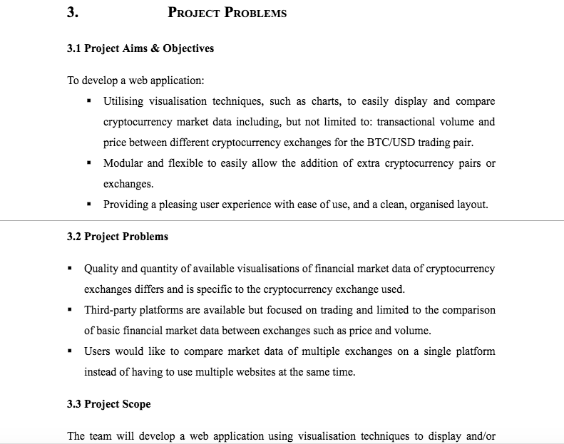

2). Contributed to section 2 of the proposal by searching related projects/websites.

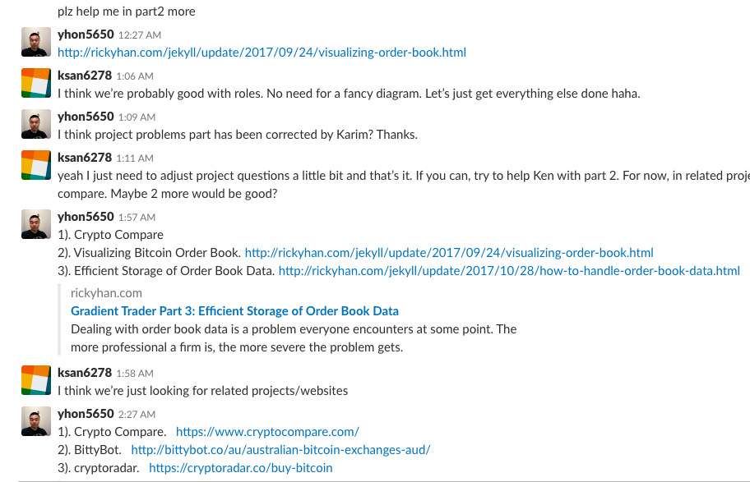

3). Learned a series of tutorials about building real web app with React. Cloned our initial github commit to my computer, then setup react project, eslint and react-router in the project. And I have figured out github standard fork & pull request workflow. So I have planned to implement a login form with client side validation. After that, I will commit it to my forked repository and send pull request to our upstream repository.

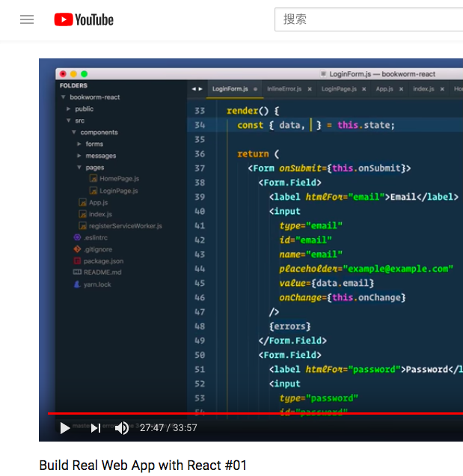

# Group Collaboration

1). We had an online meeting on this Tuesday night, discussed about concerns and progress of project proposal. We solved some problems in that meeting.

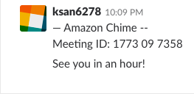

2). We had a physical meeting on 2pm this Wednesday, made a big progress in group project. Also, in that meeting, we summarized some questions to ask the tutor. After these questions were answered, we have a deeper understanding of the project.

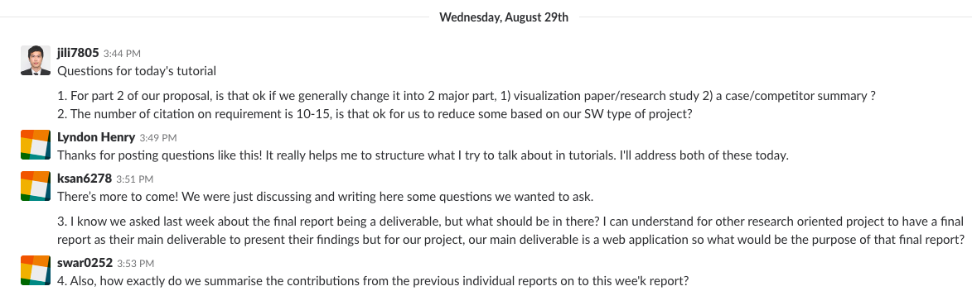

3). We have planned an online meeting this Saturday to really start off development sprint 1.

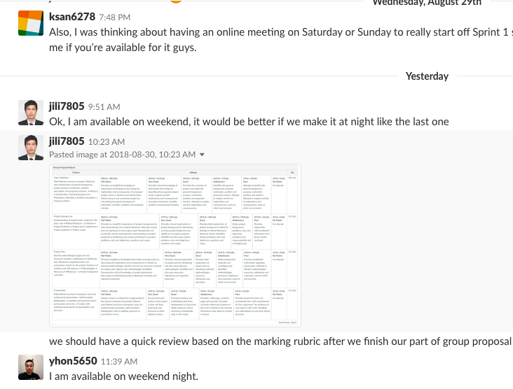

# Summary

Week 3

·Forked our group’s upstream github repository. Learned git workflow and operations.

·Splitted the project proposal. Researched related problems and started to draft project problems section.

·Practiced JavaScript charting libraries with constant data, be well prepared for later development.

·Learned React tutorials to help designing our application’s components.

Week 4

·Continued drafting project problems section of the proposal.

·Continued learning React. Learned a two and half hours long React tutorial on Youtube.

·Learned knowledge of Visual Studio Code editor, which has great plugins for React developing. Learned .jsx script(e.g. use className instead of class) which is used in React. Learned React Developer Tools in chrome, which helps tracking bugs. Learned controlled component concept, React lifecycle hooks, props, stateless functional component, class component. Improved my skills on React. Build a practicing project with React.

Week 5

1). Finished project problems section, contributing to our group proposal report.

2). Contributed to section 2 of the proposal by finding 2 related projects/websites.

3). Learned a series of tutorials about building real web application with React.

4). Cloned our initial github commit to my computer, then setup react project, eslint and react-router in the project. And spent some time to figure out github standard fork & pull request workflow.

5). I have created a local git branch to implement a login form with client side validation. After I finished developing this function, I will merge it with local master branch, which is up-to-date with upstream git repository. Then commit it to my forked repository and send pull request to our upstream repository.

**SID** _4_._7_._0_._2_._3_._1_._5_._2_._8_ Name _________________Yangkai Hong___________________________________

Student identification number First name (Preferred first name) Family name

**The submission of the deliverables up to this week required the application of the following three software development, project management and team work activities from each colleague in your team:**

* Contribution to the design and implementation of the current sprint user stories.
* Contribution to the full range of software development activities (including requirements capture, analysis and design, coding, testing and documentation).
* Contribution to group work and sharing of work.

Based on the overall combination of the contribution above, rate your teammates’ performance in the activities up to and including week 5.

**IMPORTANT: You *must* assess all your teammates. Use only whole numbers addressing the criteria below:**

|  |  |  |  |  |
| --- | --- | --- | --- | --- |
| **1**  **[0 – no contribution]** | **2** | **3** | **4** | **5** |
| Below satisfactory in 3 criteria ***or*** very poor in *any* activity | Satisfactory in 1 criteria ***and*** poor in 2 activities (none very poor) | Good in at least 2 criteria ***and*** activity in 1 | Excellent in at least 1 activity ***and*** good in 2 others | Excellent in all 3 activities |

|  |  |  |  |
| --- | --- | --- | --- |
| **Student ID** | **Name** | **Rating 0 to 5 *no fractions\*** | **Reason for rating** |
| 470155497 | Karim Santallo | 5 | ·Great project manager  ·Designed the project sprints  ·Proofread the proposal  ·Sharing of work |
| 470166910 | Jiaqing Li | 5 | ·Contribute to design and user stories  ·Contribute to requirements capture, analysis and design, proposal  ·Sharing of work |
| 470217050 | Sreejith Warrior | 5 | ·Contribute to implementation  ·Contribute to coding and proposal  ·Contribute to group work |
|  |  |  |  |

**Comments**: