[An Online Web-Streaming Service for Bitcoin-Exchanges]

Progress Report



Information Technology Capstone Project

COMP5703

Group Members

1. Yangkai Hong (470231528)
2. Karim Santallo (470155497)
3. Jiaqing Li (470166910)
4. Sreejith Warrier (470217050)

Table of Contents

Table of Contents i

1. Progress Status 1

2. Roles & Responsibilities 2

3. Individual Achievements 2

4. Group Collaboration 2

# Progress Status

|  |  |
| --- | --- |
| **Project Name** | An Online Web-Streaming Service for Bitcoin-Exchanges |
| **Project Start Date** | 8 August 2018 |
| **Project Manager** | Karim Santallo |

|  |  |
| --- | --- |
| Project Description | Implement a web application that retrieves, stores and visualizes data from Bitcoin exchanges. |

|  |  |  |
| --- | --- | --- |
| Project Status Report | #4 | Date: 7 September 2018 |

|  |  |  |
| --- | --- | --- |
| **Status Item** | **Status up to last week** | **Planned for this week** |
| **Major deliverables** | ·11 commits to upstream repository  ·Web application demo on Heroku platform  ·Basic Components (Navbar, Footer and Signin Form)  ·Candle chart component  ·Price line chart component  ·Price table component | ·Create Volume chart component  ·Create Order books table component  ·Improve candle chart component  ·Implement React routers |
| **Planned delivery date** | 5 September 2018 | 12 September 2018 |
| **Major issues** | ·Git forking workflow | ·Backend API data structure |
| **Major risks** | ·Not using Redux | ·Web application performance with large dataset |
| **External dependencies** | ·react-stockcharts library | ·react-stockchart library |
| **Estimated effort (hr)** | 20 | 18 |
| **Recorded effort (hr)** | 20 |  |
| **Status (R, Y, G)** | Green | Green |

# 2. Roles & Responsibilities

**Karim Santallo**

**Team Lead, Web Developer, Quality Assurance**

* Keeps the team on track to deliver a quality product on time.
* Responsible for the implementation and management of the agile methodology.
* Maintains the product backlogs and planning of sprints.
* Schedules, organises and facilitates team meetings.
* Implementing user authenticatin function
* Quality assurance of software and report deliverables.

**Jiaqing Li**

**Web developer / Data specialist, Quality Assurance**

* Assist Team Lead with management duties and responsibilities.
* Responsible for design and implementation of database functions.
* Quality assurance of software and report deliverables.
* Implementing Google and Facebook account login function.

**Sreejith Warrier**

**Lead Back-End Developer**

* Developing back-end API for providing candle chart data.
* Provides counsel on technical back-end design decisions.
* Assist with front-end development when necessary.

**Yangkai Hong** (me)

**Lead Front-End Developer**

* Implementing front-end components including Navbar, Footer, Signin Form, Candle chart, price line chart, volume chart and order books table.
* Provides counsel on technical front-end design decisions.
* Designing data structure and communicate with back-end developer.

# Individual Achievements

1). Sent pull request to our upstream repository and be merged by the owner.

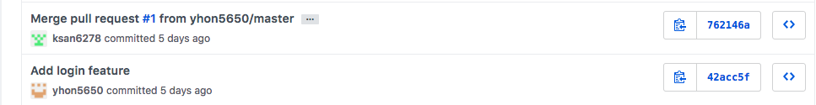

2). Deployed a demonstration to Heroku platform showing what I have done so far, and sharing it to my team.

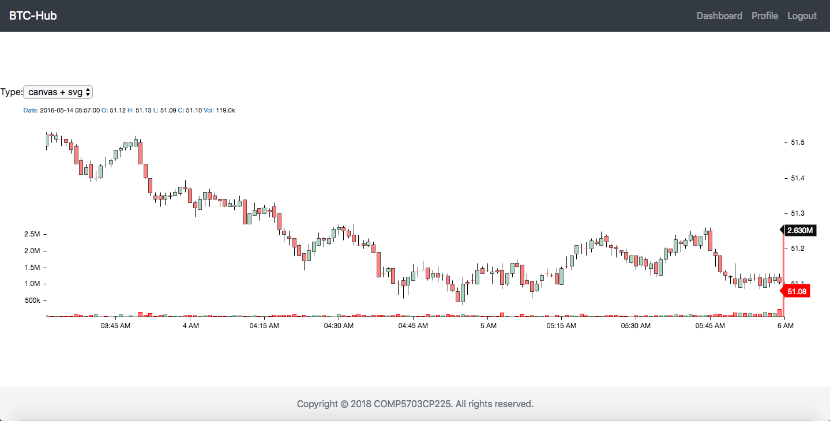

3). Developed several components, including Navbar, Footer, Signin Form, Candle chart, Price line chart and Price table, for our web application’s front-end.

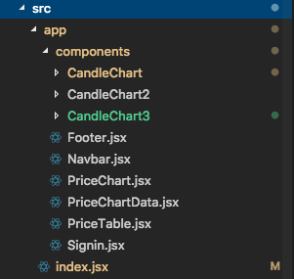

# Group Collaboration

1). We had an online meeting on Saturday night to start off our sprint 1. We discussed about our concerns. Project manager assigned tasks to everyone and we planned to delivery something on Wednesday meeting.

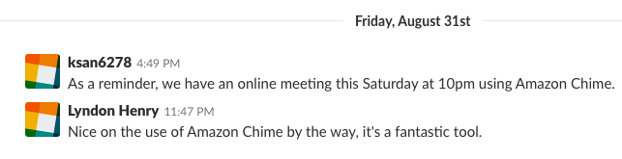

2). We had a consistent physical meeting on 2pm Wednesday. Dicussed everyone’s progress and planned future work. By the way, we launched a vote in that meeting.

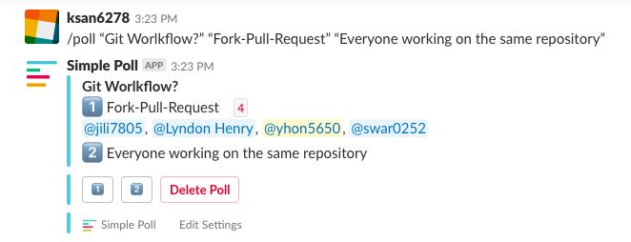

3). After meeing and tutorial on Wednesday, we are more clear with our tasks. I designed the data structure that I need to render a candle chart and communicate with our project manager and major back-end developer to make sure delivering a real-time candle chart.

