Howard University
College of Engineering and Architecture
Department of Electrical Engineering & Computer Science

Large Scale Programming
Fall 2024

Midterm Exam – Part I
October 17, 2024

Part I: 50 pts. (essay questions)

Instructions:
- Submit completed exam to your github repository under package org.howard.edu.lsp.midterm

Verify that the commit(s) completed successfully

- OPEN BOOK, OPEN NOTES. THERE IS NO COLLABORATION ON THIS EXAM
- Site any and ALL references for anything obtained off the internet.

Question 1. (10 pts.)

You are reviewing the following class in a Fitness Tracking System. The class is intended to manage various aspects of a user’s fitness activities.

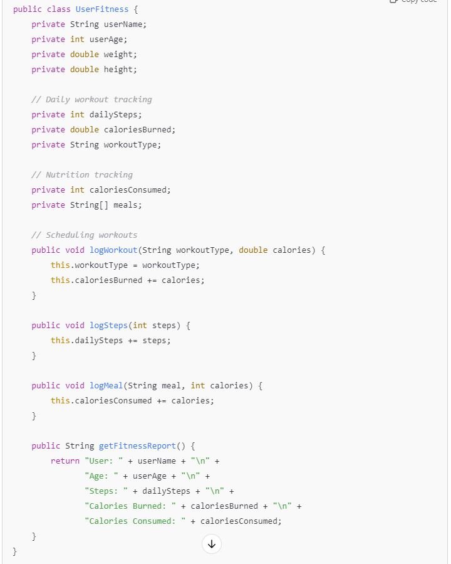

Tasks:
- Analyze the UserFitness class. Explain why this class has low cohesion. (5 pts.)
This class has low cohesion because it’s responsible for too many things that are vaguely connected to one another.

- Describe, in general, how you would split the UserFitness class into more cohesive classes. Your answer should not be a complete design. (5 pts.)
I would split this class into more cohesive classes by making separate classes where one holds the user’s information, one tracks and logs steps/workout type, one tracks and logs nutrition and calorie data, and one generates a fitness report.

Question 2. (5 pts.)
Given the following, answer the below questions.

A university manages its students using a program that has a class Student with subclasses FirstYear, SecondYear, and ThirdYear for year-specific state and behaviors. The program has a List that contains all Students.

Should Student be a class, an abstract class or an interface? Explain your answer
Student should be an abstract class because the subclasses are expected to inherit from it while also adopting some of their own unique behaviors

- At the end of each year, the third-year students graduate and must be removed. This is done by passing the list to the following method:

void removeThirdYears(List<Students> students) {
for (Student student : students) {
try {
ThirdYear = (ThirdYear) student;
students.remove(thirdyear);
}
}
}

Why is the above method flawed? Hint: Another Arthur Riel heuristic (5 pts.)

This method is flawed because items in the list are getting removed while iteration is happening, which would lead to errors.

Question 3. (5 pts.)
Given the following, answer the below questions.

public class BankAccount {
public String accountHolderName;
public String accountNumber;
public double balance;
public double interestRate;

public BankAccount(
String accountHolderName,
String accountNumber,
double initialDeposit,
double interestRate) {
this.accountHolderName = accountHolderName;
this.accountNumber = accountNumber;
this.balance = initialDeposit;
this.interestRate = interestRate;
}

// Exposed implementation for adding interest
public void addInterest() {
double interest = balance * (interestRate / 100);
balance += interest;
}

// Exposed implementation for deposits
public void deposit(double amount) {
balance += amount;
}

// Exposed implementation for withdrawals
public void withdraw(double amount) {
balance -= amount;
}
}

- Is BankAccount well-encapsulated? Why or why not? If so, describe what changes you would make to the class. Otherwise, state nothing. (5 pts.)
BankAccount is not well-encapsulated because all the variables are public, which doesn’t limit access enough for tampering. In order to fix this. I would make all the variable fields private and create functions to receive information like interests rates.

Question 4. (10 pts.)
Given the following, answer the below questions.

Given:
A car manufacturer uses Java software to track current vehicles being built. The UML diagram below shows an excerpt of the current software structure. You should assume the presence of other appropriate fields and methods

Car
getTrimLevel()
Engine
accelerate()
getFuelLevel()
Base
Sports
Luxury
Electric
Petrol

Each car can be built to one of three trim levels: Base, Luxury or Sport. They can also be configured with an electric or petrol engine. At various points in the manufacturing process the customer can choose to change the trim level.

Task:
- Explain in detail why the current structure does not support this. (5 pts.)
This structure does not support this because there is no functionality available to change trim level

- Describe how to refactor the structure to allow trim-level change for a car to dynamically change. Hint: How would you modify Car to use composition to solve the problem? (5 pts.)
In order to allow this, I would create an interface for TrimLevel and have each class implement this. Then I would add code to the Car class to change the trim level.

Question 5. (5 pts.)
Suppose you are about to code a particular class and find that you have written another class with nearly the functionality that you now are developing. This means that the two classes in large parts contain the same code, but in smaller parts have different code. Explain in detail why this may be a problem and how to solve it. Give your answer in terms of Arthur Riel’s design heuristics.
This may be a problem because it may make your code too complex, harder to read, and harder to manage. This would go against Arthur Riel’s design heuristics because according to H2.3, we want to minimize the number of operations in a class. To solve this, you would need to separate these responsibilities between classes and create any needed additional ones

Question 6. (5 pts.)
Suppose we need to store instances of the classes Car and BankAccount in a database. To obtain low coupling it may seem as if the functionality to save an instance should be in precisely those classes, since they have the information that shall be saved. Why is it unwise to place the database calls there?
It's unwise to place database calls here because it gives the classes too much responsibility and ends up leading into a higher coupling and harsher maintenance.

Question 7. (5 pts.)
Given a set of requirements, what conditions must be met to make it appropriate to create a new class hierarchy using inheritance? Neither superclass nor subclass exist before, the question is about designing a new class hierarchy.
In order to create this, we need a situation to apply polymorphism, a is-a relationship, common behavior, and specific responsibilities

Question 8. (2.5 pts.)
Describe the difference between inheritance and composition why would you choose one over the other.
Inheritence describes an is-a relationship with one class extending another, whereas composition is a “has-a” relationship with one class making up objects that contain one another. You want inheritance for loose coupling and more flexibility and inheritance for code reuse and overrriding
Question 9. (2.5 pts.)
Explain the meaning of cohesion and describe whether low or high cohesion is better.

Cohesion tells us how much the parts of a class are related and built for a single goal. With this in mind, having a high cohesion is better than a low cohesion.

