吴 洋 轩 |  |  |  |  |  |  | 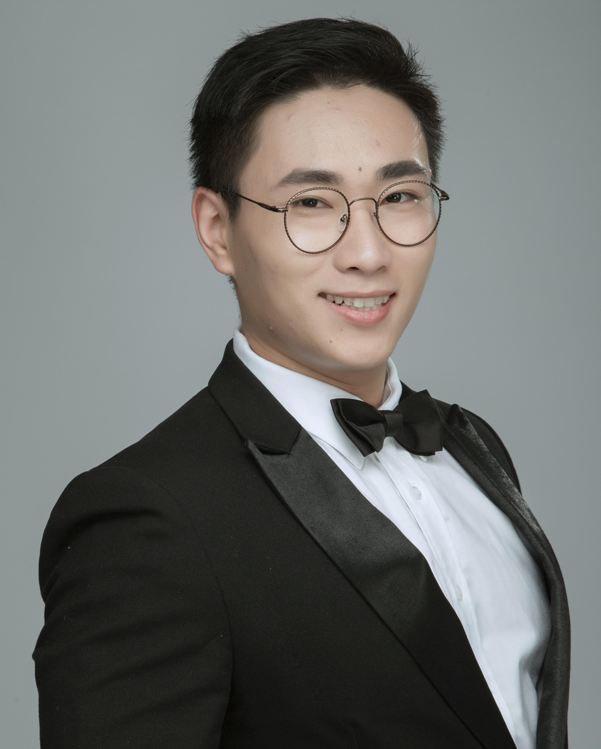
电 话 | +1（309）750-5376 |  | 出生年月 | 1991.09
邮 箱 | wuyangxuan18@gmail.com |  | 籍 贯 | 安徽合肥
地 址 | 安徽省 合肥市 包河区 宝利丰智慧公馆 5#601
教育背景
2019.01-2020.12 | 伊利诺伊州立大学 |  |  |  | 网络安全硕士
发表论文
- Automatic belief network modeling via policy inference for SDN fault localization, Yongning Tang, Guang Cheng, Zhiwei Xu, Feng Chen, Khalid Elmansor and Yangxuan Wu,, Journal of Internet Services and Applications, vol 7, 1(2016)
- Intelligence Enabled SDN Fault Localization via Programmable In-band Network Telemetry,Yongning Tang, Yangxuan Wu, Guang Cheng, Zhiwei Xu, 2019 IEEE 20th International Conference on High Performance Switching and Routing(HPSR) ,May 2019.

技能及证书
- 2014.04高级网络优化工程师资格(TD-CDMA)，华为认证网络工程师。
- 2016.05公共营养师资格证书，国家职业技能鉴定中心颁发。
- 2018.01国家级健身教练资格证书，国家职业技能鉴定中心颁发。
- 完成多项移动通信网组网与后台优化维护工程项目。
- 熟悉C++/Java/R programming/MYSQL/PYTHON语言。
- 参与计算机辅助设计、数学建模、网络管理与控制等项目应用开发。
- 良好的英语听、说、读、写能力。
- 熟练掌握SDN网络架构下的网络运维。
- 熟悉Machine-learning 中关于deep-learning的概念，了解使用keras搭建卷积神经网络的常规方法。

工作经历
2013.09-2017.05 安徽电信工程有限责任公司 网规网优工程师
- 负责无线移动网络设计与维护、数据采集、分析与管理、移动设备参数配置与分析管理、3G/4G网络后台优化与升级、前台4G LET网络设置及测试评估等。
- 完成河北省邯郸市移动网络项目：移动TD-SCDMA网格设计与规划，后台网络运维与维护，满足客户感知度需求的网络优化等。
- 完成安徽省六安市移动网络项目：联通4G基站分组与设计，室分网格优化及布网分析与设计，后台数据分析与管理，网络数据端KPI优化设计等。
2017.08-2018.02
- 名英教育集团 托福雅思教师
2018.02-2018.10
- 九盟教育集团 托福雅思教师
2020.05-2020.12
- 独立设计并完成个人项目（实验）：机器学习中的异常检测探究（本项目需要对连接到网络设备的网络服务器生成的数据集进行分析。根据多变量时间序列异常检测的随机递归神经网络，将异常数据以多变量时间序列的方式表达，通过异常分析对异常原因进行诊断和注释。）
社会活动
- 曾担任学生会安全部部长，参与组织年度校、系晚会和各类学生活动。
- 参加2018年安徽健身教练职业技能大赛。
自我评价
- 学习上：勤奋刻苦、认真好学、脚踏实地，能不断充实自己的专业知识，主动学习新知识。
- 生活上：活泼开朗、乐观向上、兴趣广泛、爱好体育运动；适应力强、坚忍不拔、吃苦耐劳、勇于迎接新挑战；具有良好的人际关系。
- 工作上：具有较强的复杂问题分析与解决能力，具备良好的沟通能力和团队合作精神，执行能力、抗压能力和责任心强。
Yangxuan Wu
Phone |  | +1（309）750-5376 | Birth | 1991.09
Email |  | wuyangxuan18@gmail.com | Place of Birth | Hefei Anhui
Address |  | 709 S.Main.St. Apt306 (61761)Normal，IL，US
Educational Background
2019.01-2020.12 |  | Information System of Illinois State University |  |  |  | Master of Network Security and management
Paper
- Automatic belief network modeling via policy inference for SDN fault localization, Yongning Tang, Guang Cheng, Zhiwei Xu, Feng Chen, Khalid Elmansor and Yangxuan Wu,, Journal of Internet Services and Applications, vol 7, 1(2016)
- Intelligence Enabled SDN Fault Localization via Programmable In-band Network Telemetry,Yongning Tang, Yangxuan Wu, Guang Cheng, Zhiwei Xu, 2019 IEEE 20th International Conference on High Performance Switching and Routing(HPSR) ,May 2019.

Work Experience
2013.09-2017.05 Anhui Telecom Engineering Co. LTD Communication Network engineer
- Responsible for wireless mobile network design and maintenance, data acquisition, analysis and management, mobile device parameter configuration and analysis management, 3G/4G network background optimization and upgrade, front-end 4G LET network setup and test evaluation, etc.
- Completed the mobile network project of Handan city, Hebei Province: mobile TD-SCDMA grid design and planning, operation, maintenance and maintenance of background network, network optimization to meet customer perception requirements, etc.
- Completed the mobile network project of Lu 'an City, Anhui Province: Group and design of Unicom 4G base station, analysis and design of room grid division optimization and network layout, analysis and management of background data, optimization design of KPI of network data terminal, etc.
2017.08-2018.02
- Mingying Education Toefl and IELTS teaching assistance
2018.02-2018.10
- JiuMeng Education Toefl and IELTS teaching assistance

2020.05-2020.12
- Independent design and complete the individual project (experiment) : machine learning in anomaly detection to explore (the project need to connect to the network equipment network server generated data sets were analyzed according to the multivariate time series random recursive neural network anomaly detection, the abnormal data expressed in the form of multivariate time series, through the analysis of the abnormal reason of abnormal diagnosis and comments)
Skills and Certificates
- 2014.06 Senior Network Optimization Engineer qualification (TD-CDMA), Huawei Certified Network engineer.
- 2016.05 Public nutritionist qualification certificate, issued by the National Vocational Skill Appraisal Center.
- 2018.01 National fitness coach qualification certificate, issued by the National Vocational Skill Appraisal Center.
- Completed a number of mobile communication network networking and background optimization maintenance projects.
- Familiar with C++/Java, master R programming/MYSQL/PYTHON.
- Participate in computer aided design, mathematical modeling, network management and control project application development.
- Good English in listening, speaking, reading and writing.
- Good command of network operation and maintenance under SDN network architecture.
- Familiar with the concept of deep-learning in machine-learning, and familiar with the conventional method of building a convolutional neural network with Keras.
public activity
- Served as the minister of security of the Student Union, participated in the organization of the annual school, department party and various student activities.
- Take part in the 2018 Anhui Fitness Instructor Professional Skills Competition.
self-evaluation
- Study: diligent, studious, down-to-earth, can constantly enrich their professional knowledge, take the initiative to learn new knowledge.
- Life: lively and cheerful, optimistic, broad interests, love sports;Adaptable, indomitable, hard-working and brave to meet new challenges;Have good interpersonal relationship.
- Work: strong ability to analyze and solve complex problems, good communication skills and teamwork spirit, strong executive ability, anti-pressure ability and strong sense of responsibility.
