Issue

# Goal

The goal of this test is to simulate the following HVAC model in dSpace SCALEXIO. The model reprents a building energy system with two thermal zones served by two VAV terminal boxes.

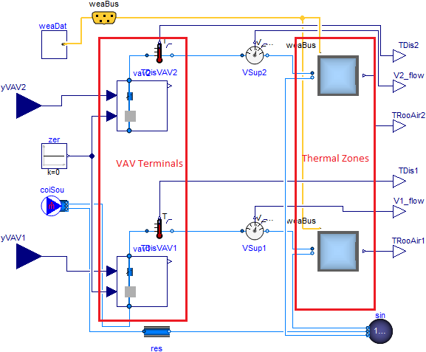

# Issues Debugging

We use the following approach to debug the issues:

1. We have tested each individual component model appeared in the previous figure in SCALEXIO, and all of them can simulate successfully.
2. We tested a simpler representation of the system in the figure. The simple system model only has one VAV terminal and one thermal zone. The simple system can simulate in SCALEXIO.
3. We further tested the two-zone system model, but it didn’t simulate in the SCALEXIO. And we cannot find the error messages in dSpace. This two-zone system is simply a multiplier of the simple model in step 2. And the two zones have no interactions in current design.