**Report for 6rd Regular Meeting**

**Saranya Anbarasu**

9.11.2019

[Saranya.anbarasu@colorado.edu](mailto:Saranya.anbarasu@colorado.edu)

Visiting scholar from CEPT University, India

SBS lab, University of Colorado Boulder

Content

Contents

Content 2

1.1 Conclusion of Last Meeting 3

1.2 Conclusion 3

1.3 Planed Work 3

1.4 Description about the two methods: 4

1.5 Results 5

1.6 Validation experiments. 11

1.7 Scope extension: IDEC – Indirect direct evaporative cooler or two stage evaporative cooler. 12

1.8 Work plan for next week 13

1.9 Long term work plan 13

## Conclusion of Last Meeting

## Conclusion

The enthalpy of the system is zero, but the sensible heat is positive, and the latent heat is negative. The next energy transferred becomes zero. Implementation of pressure drop in the model by varying the constant K in the constant pressure drop model (buildings library). In EnergyPlus version to get more exact results try to fit the efficiency equation with the performance data from experiment.

## Planed Work

1. Keep revising equations with debugging.

2. Test individual blocks with excel calculations.

3. Compare the results with the performance testing data.

4. Validation experiments.

5. Scope extension: IDEC – Indirect direct evaporative cooler or two stage evaporative cooler.

## Description about the two methods:

|  |  |
| --- | --- |
| **EnergyPlus version** | **Numerical version** |
| **Efficiency calculated using** | |
| * Velocity of the air passing the cooling pad (function of mass flow rate) | * Geometric characteristics of the pad:   Characteristic length (Le)= Volume/Total Surface area |
| * Thickness of the pad | * Wetted surface area to volume ratio (m2/m3) [responsible for convective heat transfer) |
|  | * Convective heat transfer coefficient (hc from Nusselt number) |
|  | * Water temperature |
|  | * Water and Air velocity (function of mass flow rate) |
| **Pressure drop** | |
| * User input value | * Calculated using characteristic length |
| (from the technical data sheet) | * Mass flow ate of water and air |

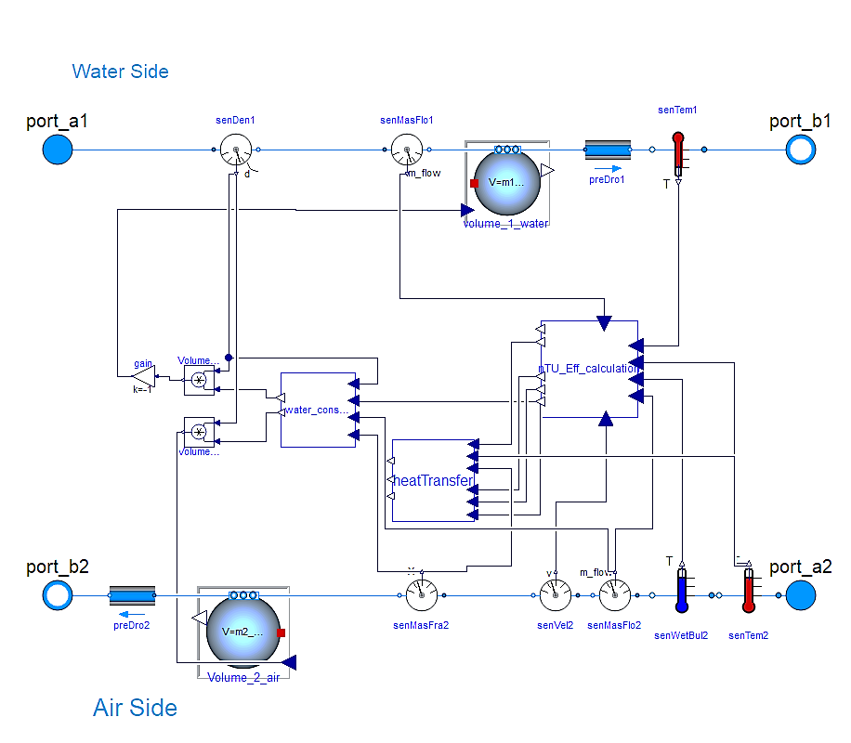

Figure 1 Numerical: Method -2

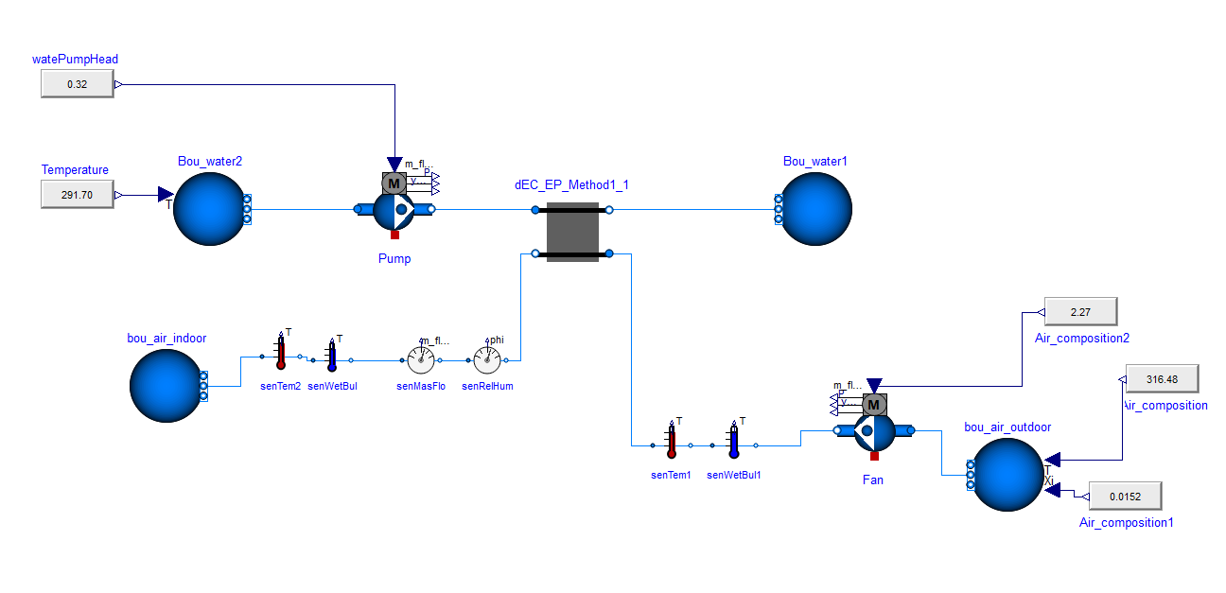

Figure 2 Direct evaporative cooler - complete system

## Results

|  |  |  |
| --- | --- | --- |
| Comparison 1: Efficiency of the cooling pad vs mass flow rate | | |
| Test conditions |  | |
| Inlet DBT (K) | 310 | |
| Inlet WBT(K) | 294 | |
| Mass flow rate(kg/s) | 0-2.27 | |
| Inlet water temperature(K) | 290 | |
| Reference data | Gas, P., Company, E., Services, L., Testing, P., Unit, A., & Notice, L. (2006). *Pacific Gas and Electric Company*. (1). | |
| Error percentage | **EnergyPlus method** | **Numerical Method** |
| **11 %** | **1 %** |

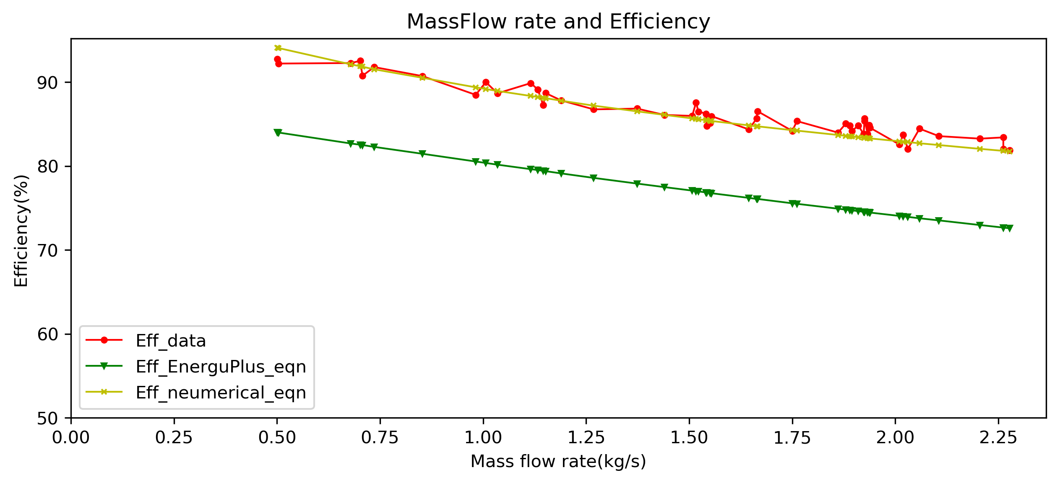

Efficiency equation of EnergyPlus is a curve fit equation for CelDek cooler pad (specific type). The curve fit equation is a three variable, third degree polynomial equation.

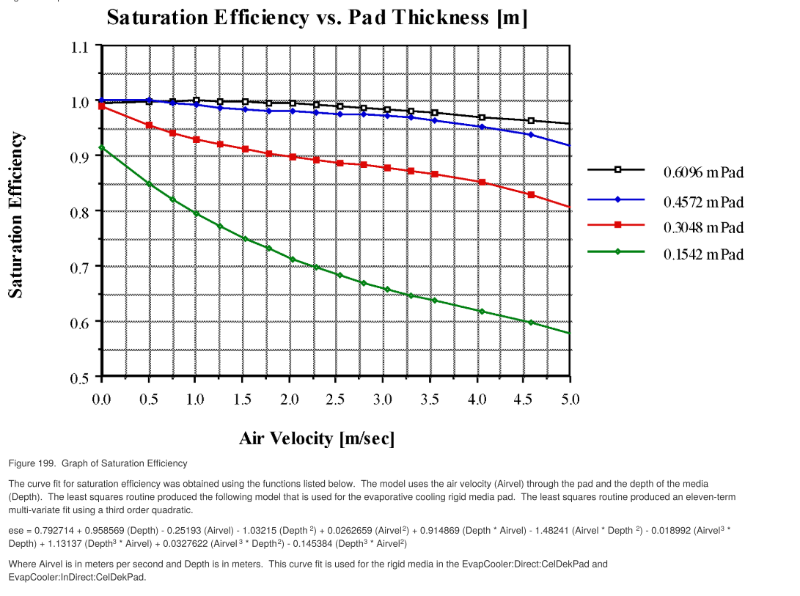

**Query:**

Is it feasible to develop such complicated curve fit equation for 4 curves together for every cooling pad considered?

|  |  |  |
| --- | --- | --- |
| Comparison 2: Water consumption of the cooling pad vs mass flow rate | | |
| Test conditions |  | |
| Inlet DBT (K) | 310 | |
| Inlet WBT(K) | 294 | |
| Mass flow rate(kg/s) | 0-2.3 | |
| Inlet water temperature(K) | 290 | |
| Reference data | Gas, P., Company, E., Services, L., Testing, P., Unit, A., & Notice, L. (2006). *Pacific Gas and Electric Company*. (1). | |
| Error percentage | **EnergyPlus method** | **Numerical Method** |
| **1%** | **-2%** |

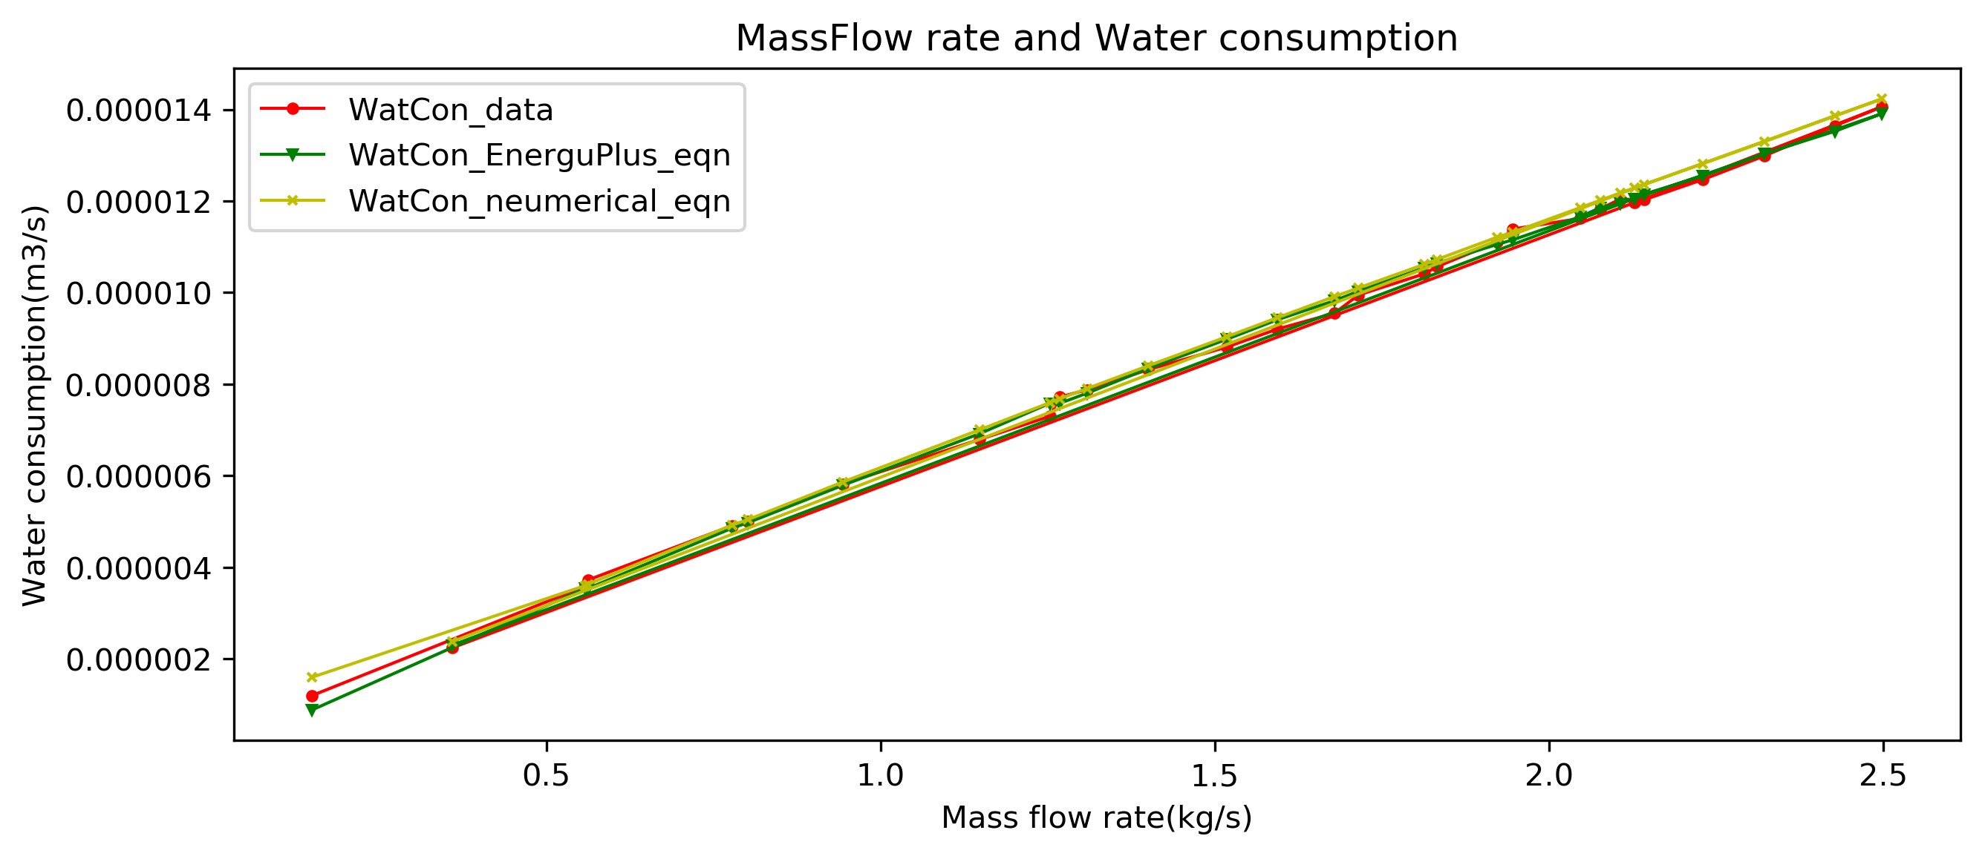

**Enthalpy change = 0, Qs = +ve and Ql= -ve [as discussed]**

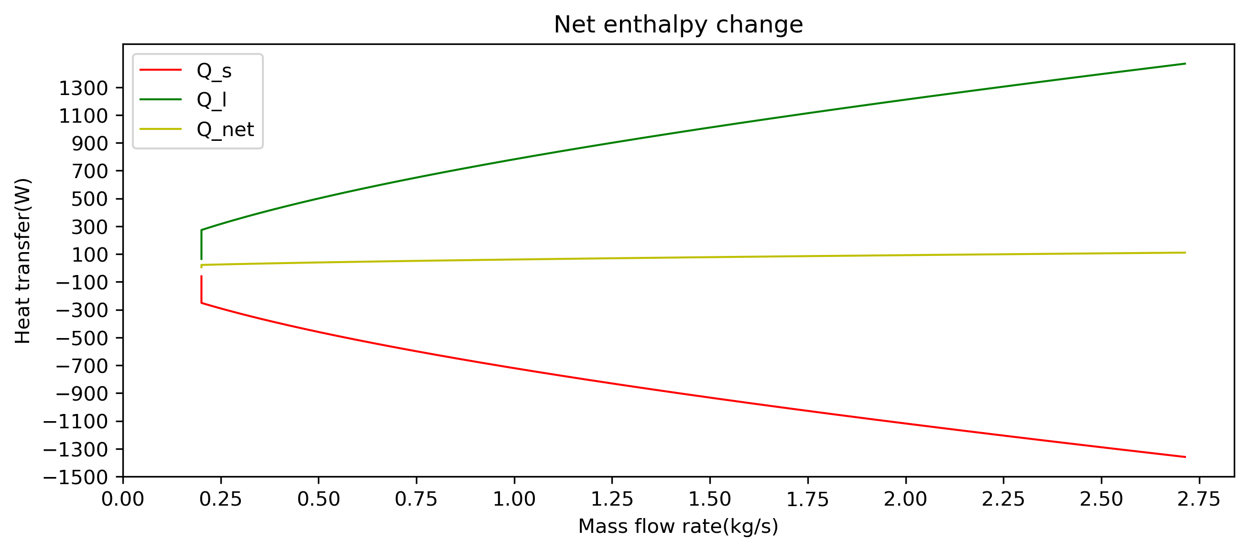

*0>Qnet >100*

For an ideal system Qnet=0, but due to certain mass imbalance the Qnet varies between 0-100 watts for increase in mass flow rate.

|  |  |  |
| --- | --- | --- |
| Comparison 3: Pressure drop of the cooling pad vs velocity | | |
| Test conditions |  | |
| Inlet DBT (K) | 310 | |
| Inlet WBT(K) | 294 | |
| M_flow water | 0.128 kg/s,0.256 kg/s | |
| Mass flow rate(kg/s) | 0.5 – 4kg/s | |
| Inlet water temperature(K) | 290 | |
| Reference data | (A. Franco, D. L. Valera, A. Madueño, & A. Peña, 2010) | |
| Error percentage | **From equation** | **From dp nominal EnergyPlus** |
| **3% & 16%** | **2% and 7%** |

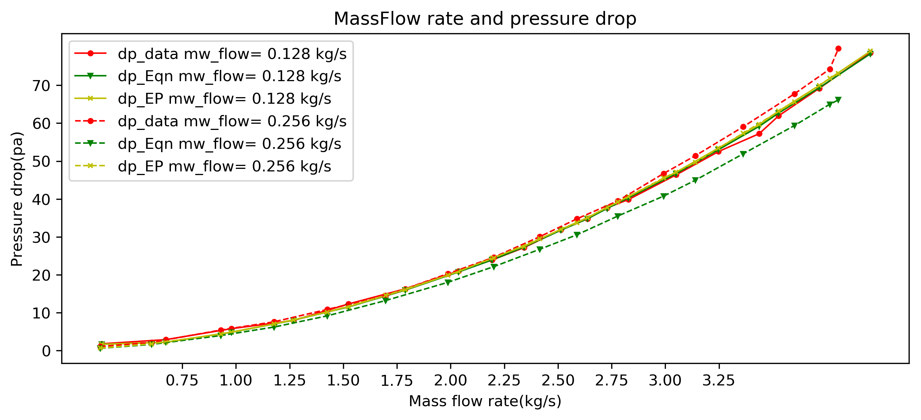

**Equation:**

Where le = characteristic length = V/

Wetted surface area per unit volume

**Comment:**

The equations accuracy varies for different mass flow rates of water. This is to be sorted.

|  |  |  |
| --- | --- | --- |
| Comparison 4: Efficiency of the cooler vs the wet bulb depression | | |
| Test conditions |  | |
| Inlet DBT (K) | 310 | |
| Inlet WBT(K) | 294 | |
| Mass flow rate(kg/s) | 0.7, 1.14, 1.8 | |
| Speed | 1-3, (different RPM) | |
| Inlet water temperature(K) | 290 | |
| Reference data | Gas, P., Company, E., Services, L., Testing, P., Unit, A., & Notice, L. (2006). *Pacific Gas and Electric Company*. (1). | |
| Error percentage | **EnergyPlus method** | **Numerical Method** |
| **11%** | **1%** |

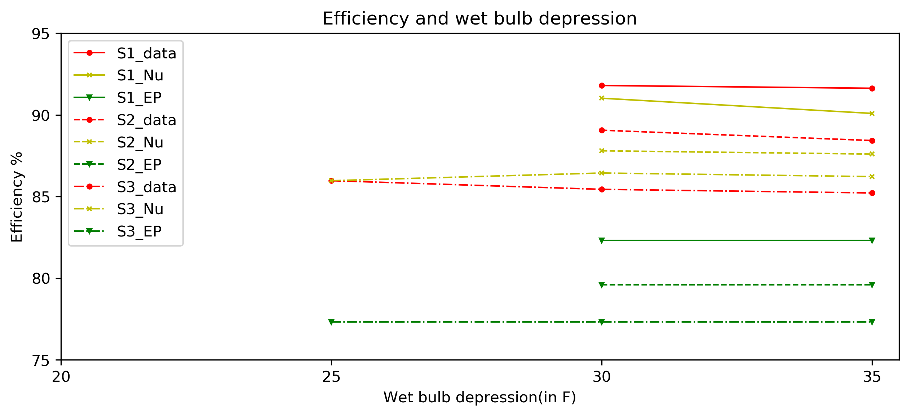

Comments:

The EnergyPlus equations have a 11% variation in efficiency as the pad efficiency purely depends on the velocity and thickness, where as the numerical method is dependent on hc,Water temp,pad dimensions and wetted surface area.

|  |  |  |
| --- | --- | --- |
| Comparison 5: Fan CFM vs Power | | |
| Test conditions |  | |
| Inlet DBT (K) | 310 | |
| Inlet WBT(K) | 294 | |
| Mass flow rate(kg/s) | 0.20 – 2.5 | |
| Inlet water temperature(K) | 290 | |
| Reference data | Standard, I. (1994). *INTERNATIONAL Technical specifications*. *1994*, 3–5. | |
| Error percentage | **EnergyPlus method** | **Numerical Method** |
| **-101%** | **-54%** |

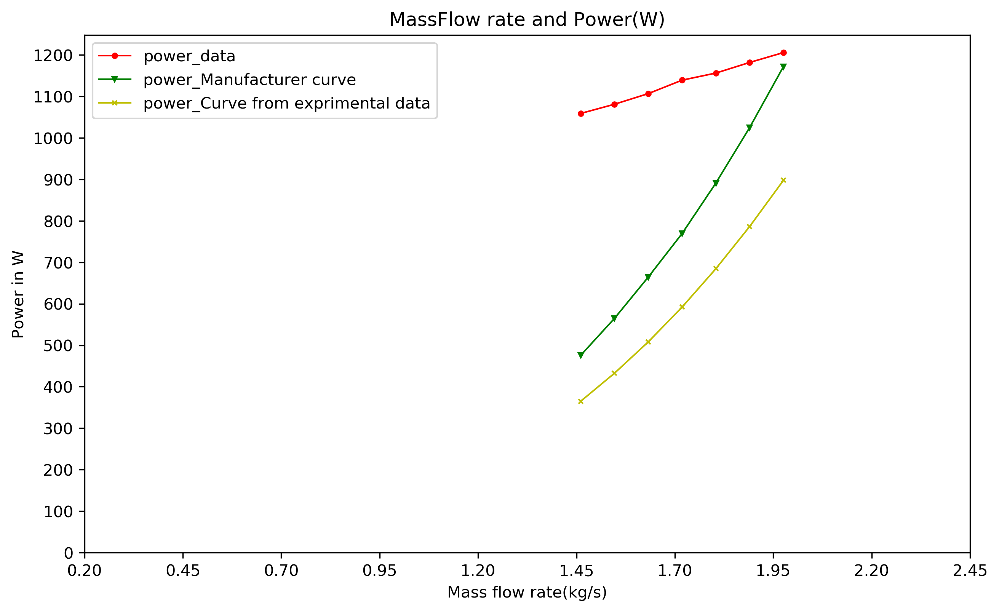

There is a huge difference in the power curves. There is no standard data available from the manufacturer. The power curves vary in every version of technical manual for the same system.

|  |  |  |
| --- | --- | --- |
| Comparison 6: Various pad material and configurations | |  |
| Parameters | Cellulose | Aspen |
| Dimensions | 0.5*0.5 | |
| Le |  |  |
| Wetted surface to volume ratio(m2/m3) | 275 | 325 |
| Thermal conductivity(K) | 0.04 | 0.04 |
| Test conditions |  |  |
| DBT | 41.2 c |  |
| WBT | 26.5 C |  |
| Mass flow kg/s | 0.15-0.9 |  |
| Error percentage | **-2%** | **2%** |
| Reference | Maurya, R., Shrivastava, N., & Shrivastava, V. (2014). Performance evaluation of alternative evaporative cooling media. *International Journal of Scientific & Engineering Research*, *5*(10), 676–684. | |
| Experimental data |  | |

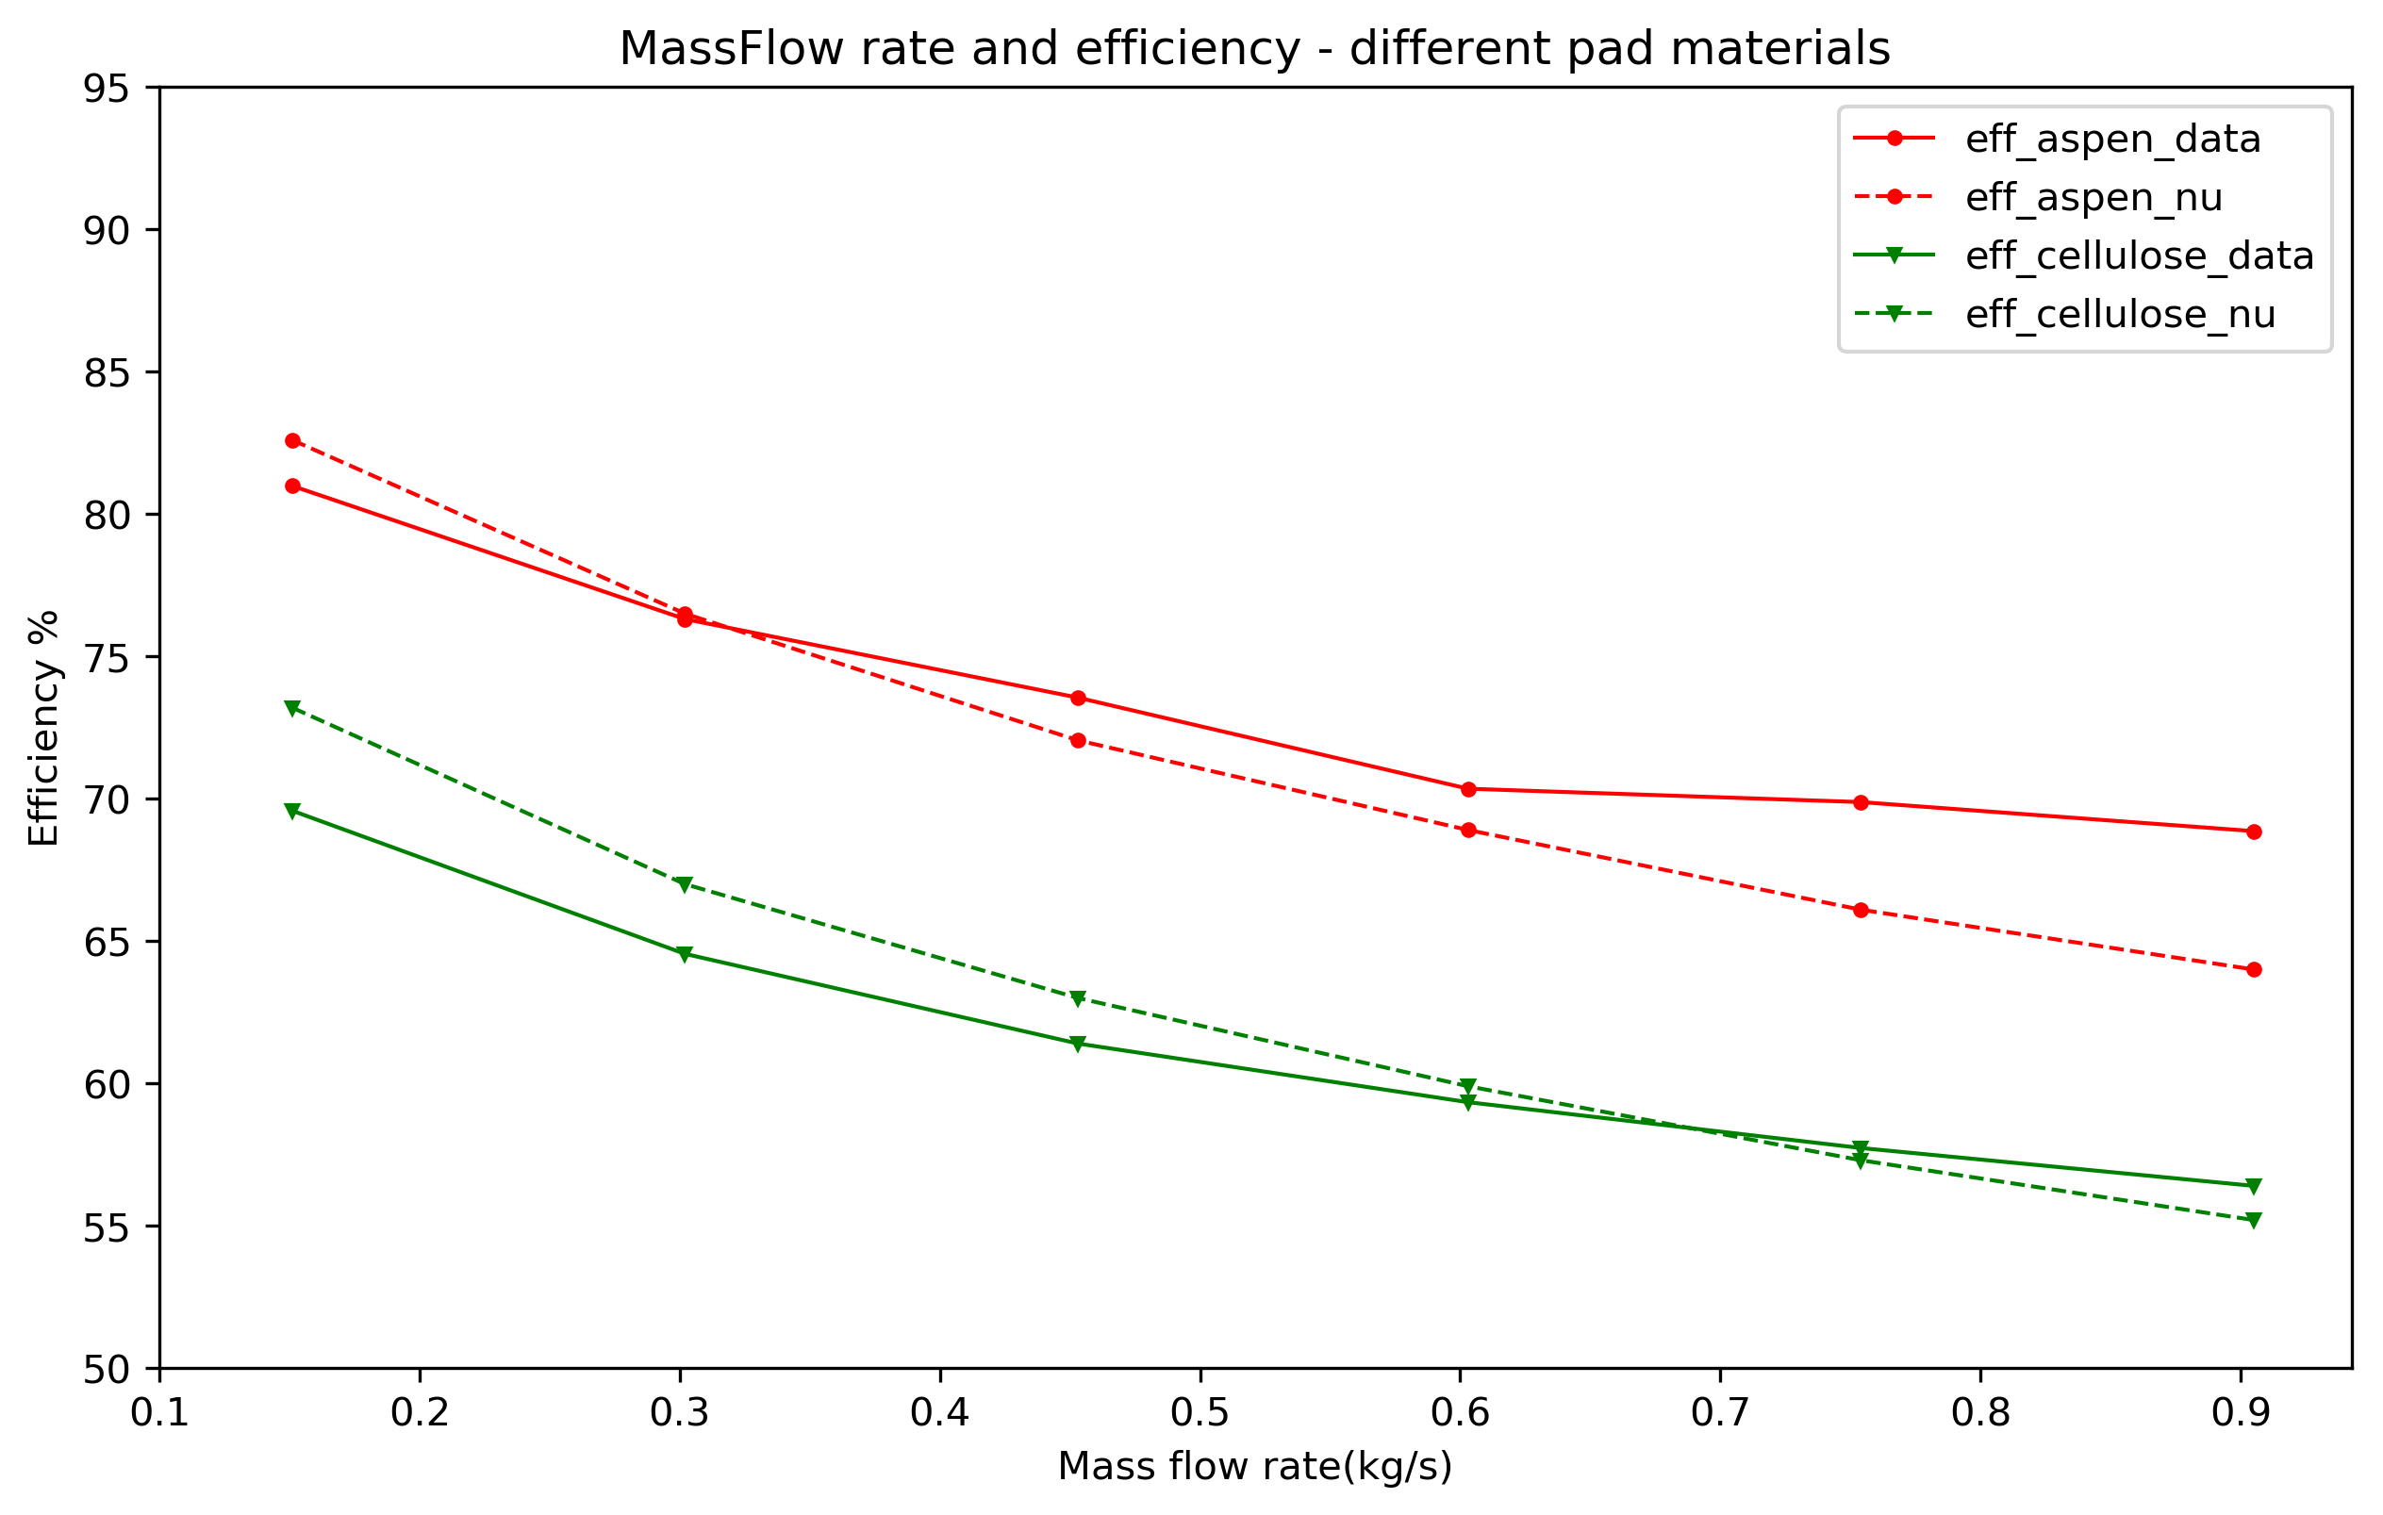

## Validation experiments.

 We should focus on the following points during discussions:

1. Our intent and potential outcome from the validation experiments.  How will the data be used for validation of the model?
   * Intent of the validation experiment is to evaluate the Modelica model w.r.t the experimental performance, to establish the accuracy of the models performance.
   * Potential outcomes: Percentage variation from experimental performance

Potential issues in evaporative cooling in real scenarios that are

difficult to predict.

1. You may also have to highlight how this model is different (and better) than the existing evaporative cooler models.

* Modelica library does not have an evaporative cooler model [there are models for humidifiers, moisture transfer etc.]
* EnergyPlus research special model is used for comparison (which is still a preliminary model).
* The developed model uses the cooling pads geometrical characters, air and water flow rates and inlet conditions to calculate the convective heat transfer coefficient and moisture transfer coefficient.
* Hc and hm has validated relationship with Sc, PR, Re and St numbers. Which are used in the equations.

1. The direct evaporator model(s) to be used for the experiments. We can focus on room air coolers as they are typically used a lot in the Indian market.

* Have contacted a dealer of symphony evaporative coolers (based Ahmedabad) for technical data. We could approach to get a sample.

1. The parameters to be measured during the validation experiments. We may need to just measure the relevant points for the simulation model (as opposed to all 12 earlier points included in the earlier measurements).
   * Inlet and outlet conditions: Tdbt, Twbt, RH, m flow (air and water),Twater.
   * Test chamber test conditions: ASHRAE standard 133-2015 for direct evaporative coolers and ASHRAE standard 143-2015 for indirect evaporative coolers.
   * Pad and cooler technical data: from manufacturer.

## Scope extension: IDEC – Indirect direct evaporative cooler or two stage evaporative cooler.

* + Currently direct evaporative cooler is not largely used, the hybrid models with Indirect evaporative component and DX coils are largely used in industrial and commercial scales.
  + The wet coil heat exchanger is like the indirect evaporative cooler with additional evaporation process. It can be added to the DEC part to form IDEC.

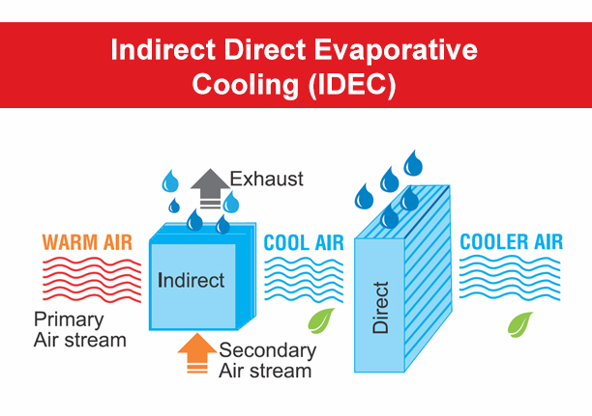

## Work plan for next week

Find the reasons for the deviation from performance data.

Rectify/revise the equations.

Check the model’s performance with any other performance data – for cross verification.

## Long term work plan

Document the work and draft the report – till Sept 30

Revise the DEC model.