

**CONTRASTING RIBBED SWEATSHIRTDETAILS**

**29.90 USD**

**Sweatshirt with a contrasting elastic high collar, long sleeves with contrasting elastic cuffs and a frayed hem.**

Size: S M L XL



**LONG COAT WITH WRAPAROUND COLLARDETAILS**

**149.00 USD**

**Loose-fit wool coat with high collar, long sleeves, piped pockets on the front and crossover fastening with hidden snap button.**

Size: S M L XL



**LYOCELL COTTON SHIRTDETAILS**

**39.90 USD**

**Classic Oxford shirt made of cotton and lyocell with long sleeves. Features a slim fit. Button-down collar and button-up front.**

Size: S M L XL



**DOUBLE FACED JACKETDETAILS**

**149.00 USD**

**Double-sided crackled faux leather jacket with buckles on the collar, zip-up front, side zip pockets and faux shearling lining.**

Size: S M L XL



**T-SHIRT WITH CONTRASTING TRIMSDETAILS**

**22.90 USD**

**Ribbed T-shirt with contrasting trims on the collar, cuffs and hem.**

Size: S M L XL

# Samsung Electronics UN55MU6300 55-Inch 4K Ultra HD Smart LED TV (2017 Model)

|  |  |
| --- | --- |
| Price: | $530.00   * 4X more pixels than Full HD means you’re getting 4X the resolution, so you’ll clearly see the difference. * See vibrant and pure color for a realistic experience. * OneRemote automatically detects and controls all your connected devices and content with no manual programming required*. * Smooth action on fast-moving content with Motion Rate 120 * Please note the differences between the MU6300 and the MU630D. MU6300: Black cabinet, 450 nits HDR sustained brightness, Mega Dynamic Contrast MU630D: Dark Titan cabinet, 430 nits HDR sustained brightness, Ultra Dynamic Contrast |

# Bose SoundTouch 300 Soundbar

|  |  |
| --- | --- |
| Price: | $699.00 |

* HDMI connectivity with 4K pass-through brings your music, movies and TV shows to life
* Premium glass and metal grille make the sound bar look as good as it sounds. Video source compatibility: HDMI and 4K pass-through
* Bluetooth with NFC pairing and Wi-Fi technology let you stream music wirelessly, whichever way you prefer. Listen to music services like Amazon Music, Spotify and Pandora and your personal stored music
* Add optional acoustic mass 300 wireless bass module and virtually invisible 300 wireless surround speakers anytime for deeper bass and full-on surround sound
* Adapted Audio room calibration fine-tunes the system's sound to your room, so your sound always fits your space

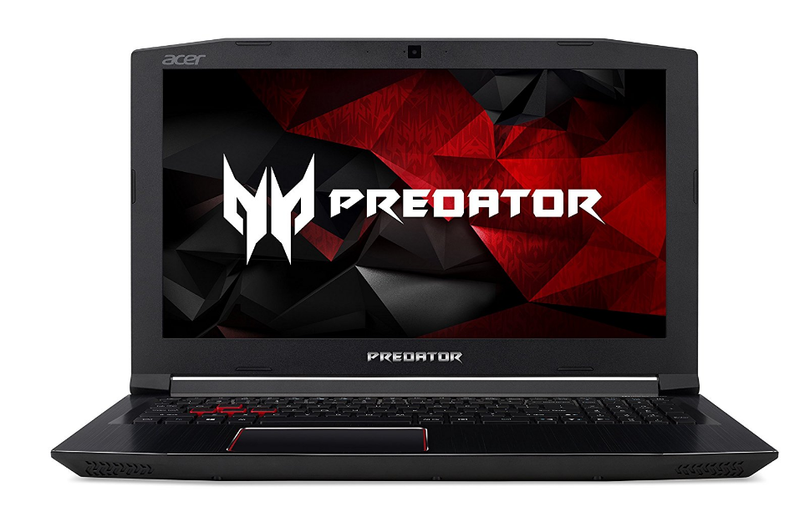

# Acer Predator Helios 300 Gaming Laptop

|  |  |
| --- | --- |
| With Deal: | $1,049.99 |

* For a hard drive expansion cable, please order for free from : csapps.acer.com/kit-request
* Latest 7th Generation Intel Core i7-7700HQ Processor (Up to 3.8GHz)
* Latest NVIDIA GeForce GTX 1060 with 6 GB of dedicated GDDR5 VRAM
* 15.6" Full HD (1920 x 1080) widescreen IPS display
* 16GB DDR4 Memory & 256GB SSD
* Up to 7-hours of battery life
* Red Backlit Keyboard

# 

# Nikon D3300 w/ AF-P DX 18-55mm VR Digital SLR – Black

|  |  |
| --- | --- |
| Price: | $446.95 |

* 24.2 MP CMOS DX-format sensor
* 5 frames per second continuous shooting
* 11 AF points with 3D tracking
* ISO 100-12800 (expandable to 25600)
* 3 inch LCD with 921,000 dots; Lens Compatibility at a Glance***AF-S Lens Required for Autofocus ; Optical Zoom 3x

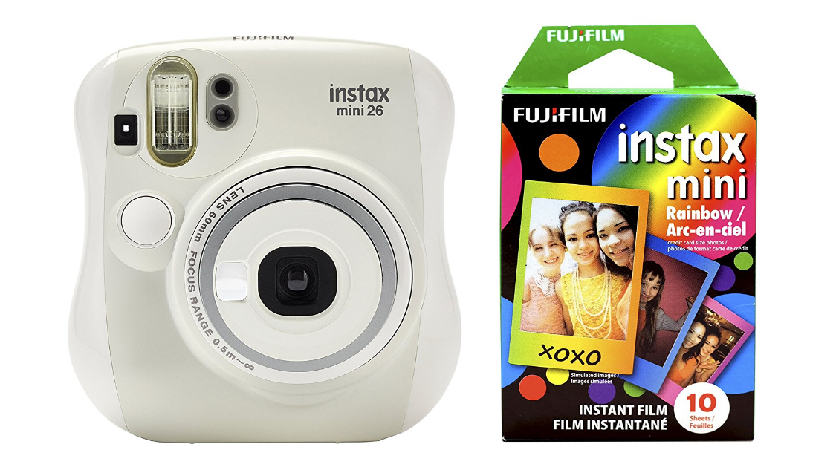

# Fujifilm Instax Mini 26 + Rainbow Film Bundle - White

|  |  |
| --- | --- |
| Price: | $54.99   * Selfie mirror for perfect framing of your selfie photos. * Two shutter buttons allowing comfortable and convenient vertical and horizontal shooting * The Lighten-Darken Control allows you to make the print finish brighter or darker. * Close-up lens for shots up to 35 cm from the subject * For use with Instax Mini style film |