,

<基于azkaban的ETL调度系统>

azkaban设计说明

Author: Yazheng Yang

Creation Date: 2017-01-16

Last Updated: 2017-01-16

Document Ref: azkaban调度系统设计说明

Version: 1.0

1. **Title, Subject, Last Updated Date, Reference Number**, **andVersion** are marked by a Word Bookmark so that they can be easily reproduced in the header and footer of documents. When you change any of these values, be careful not to accidentally delete the bookmark. **You can make bookmarks visible by selecting Tools->Options…View and checking the Bookmarks option in the Show region.**
2. To add additional approval lines, press [Tab] from the last cell in the table above.
3. You can delete any elements of this cover page that you do not need for your document. For example, Copy Number is only required if this is a controlled document and you need to track each copy that you distribute.



## 文档控制

**更改记录**

4

| 日期 | 作者 | 版本 | 更改参考 |
| --- | --- | --- | --- |
|  |  |  |  |
| 2016.11.30 | 杨雅正 | 1.0.0 | ETL项目发布到maven仓库步骤 |
|  |  |  |  |
|  |  |  |  |
|  |  |  |  |

内容目录

文档控制 2

1. 配置中台标准组件maven仓库访问 4

1.1. 仓库服务器发布权限 4

1.2. 项目pom文件配置 4

2. 发布时修改pom 8

2.1. 临时设置provided级别 8

2.2. 注释掉overlays 8

3. 执行发布 10

未结与已结问 11

未结问题 11

已结问题 11

## common部分（核心）

对于不需要发布到中台标准组件maven库的情况，这一部分可以不用配置，直接跳到“发布时剔除HAP jar包”。

### 结果通知

azkaban系统结果通知接口:

|  |
| --- |
| azkaban.alert. Alerter  方法：  void alertOnSuccess(ExecutableFlow exflow) throws Exception;  void alertOnError(ExecutableFlow exflow, String ... extraReasons) throws Exception;  void alertOnFirstError(ExecutableFlow exflow) throws Exception;  void alertOnSla(SlaOption slaOption, String slaMessage) throws Exception; |

说明：

结果通知通过Alerter规范通知的方法，包含：任务流执行成功通知、任务流执行错误通知、任务流首次错误通知、邮件通知。

默认实现（邮件通知方式）：

Emailer，这个是通过邮件进行消息通知的实现(此类继承AbstractMailer)

### 邮件通知方式

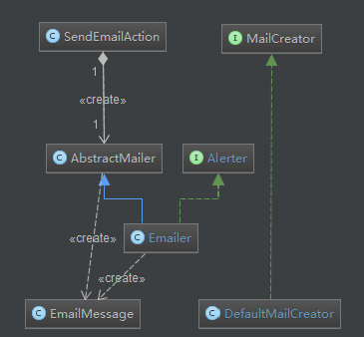

在项目根目录下的pom.xml文件中设置.

替换掉distributionManagement内容:

|  |
| --- |
| <distributionManagement>  <!-- Altered by Allen.Liu on 2016/11/18 for Hmtc Repositories -->  <!--  <repository>  <id>releases</id>  <url>http://nexus.saas.hand-china.com/content/repositories/rdc</url>  </repository>    <snapshotRepository>  <id>snapshots</id>  <name>Internal Snapshots</name>  <url>http://nexus.saas.hand-china.com/content/repositories/rdcsnapshot</url>  </snapshotRepository>  -->  <repository>  <id>hmtc-releases</id>  <name>Hmtc Releases</name>  <url>http://nexus.saas.hand-china.com/content/repositories/hmtc-releases</url>  </repository>    <snapshotRepository>  <id>hmtc-snapshots</id>  <name>Hmtc Snapshots</name>  <url>http://nexus.saas.hand-china.com/content/repositories/hmtc-snapshots</url>  </snapshotRepository>  <!-- The End -->  </distributionManagement> |

repositories标签下添加依赖：

|  |
| --- |
| <!-- Added by Allen.Liu on 2016/11/18 for Hmtc Repositories -->  <repository>  <id>hmtc-releases</id>  <name>Hmtc Releases</name>  <url>http://nexus.saas.hand-china.com/content/repositories/hmtc-releases</url>  </repository>  <repository>  <id>hmtc-snapshots</id>  <name>Hmtc Snapshots</name>  <url>http://nexus.saas.hand-china.com/content/repositories/hmtc-snapshots</url>  </repository>  <!-- The End --> |

pluginRepositories标签下添加如下依赖：

|  |
| --- |
| <!-- Added by Allen.Liu on 2016/11/18 for Hmtc Repositories -->  <pluginRepository>  <id>hmtc-releases</id>  <name>Hmtc Releases</name>  <url>http://nexus.saas.hand-china.com/content/repositories/hmtc-releases</url>  </pluginRepository>  <pluginRepository>  <id>hmtc-snapshots</id>  <name>Hmtc Snapshots</name>  <url>http://nexus.saas.hand-china.com/content/repositories/hmtc-snapshots</url>  </pluginRepository>  <!-- The End --> |

## 概述

Azkaban中涉及到的大部分功能模块之间都通过接口进行有效解耦，支持后续的扩展。

### 临时设置provided级别

项目core目录下的pom.xml文件中，将引用HAP的war包和core-db的war包级别设置为provided（发布之后需要删除或者注释掉）.

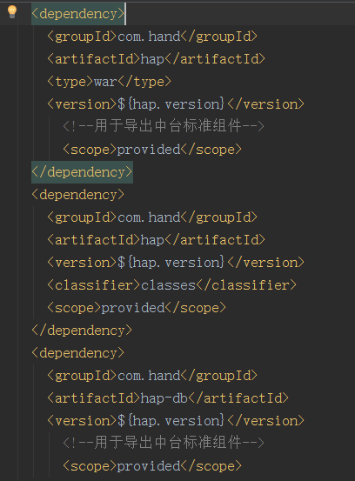

### 注释掉overlays

同时将本文件（core目录下的pom.xml）中的overlays整个注释掉

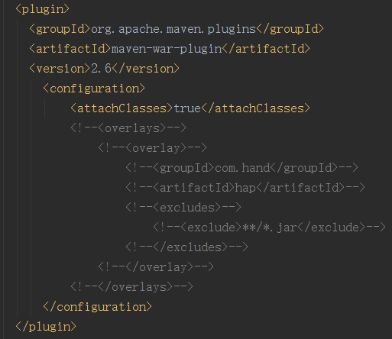

## 执行发布

在项目根目录下执行以下命令：

|  |
| --- |
| mvn clean deploy |

## 发布中常见问题

* web.xml缺失报错：

解决：将HAP的web.xml拷贝到自己项目的WEB-INF下面

## 未结与已结问

### 未结问题

| 序号 | 问题 | 解决方案 | 负责人 | 目标日期 | 实际日期 |
| --- | --- | --- | --- | --- | --- |
|  |  |  |  |  |  |
|  |  |  |  |  |  |
|  |  |  |  |  |  |
|  |  |  |  |  |  |
|  |  |  |  |  |  |

### 已结问题

| 序号 | 问题 | 解决方案 | 负责人 | 目标日期 | 实际日期 |
| --- | --- | --- | --- | --- | --- |
|  |  |  |  |  |  |
|  |  |  |  |  |  |
|  |  |  |  |  |  |
|  |  |  |  |  |  |
|  |  |  |  |  |  |