创建目录与宠物盒问题：

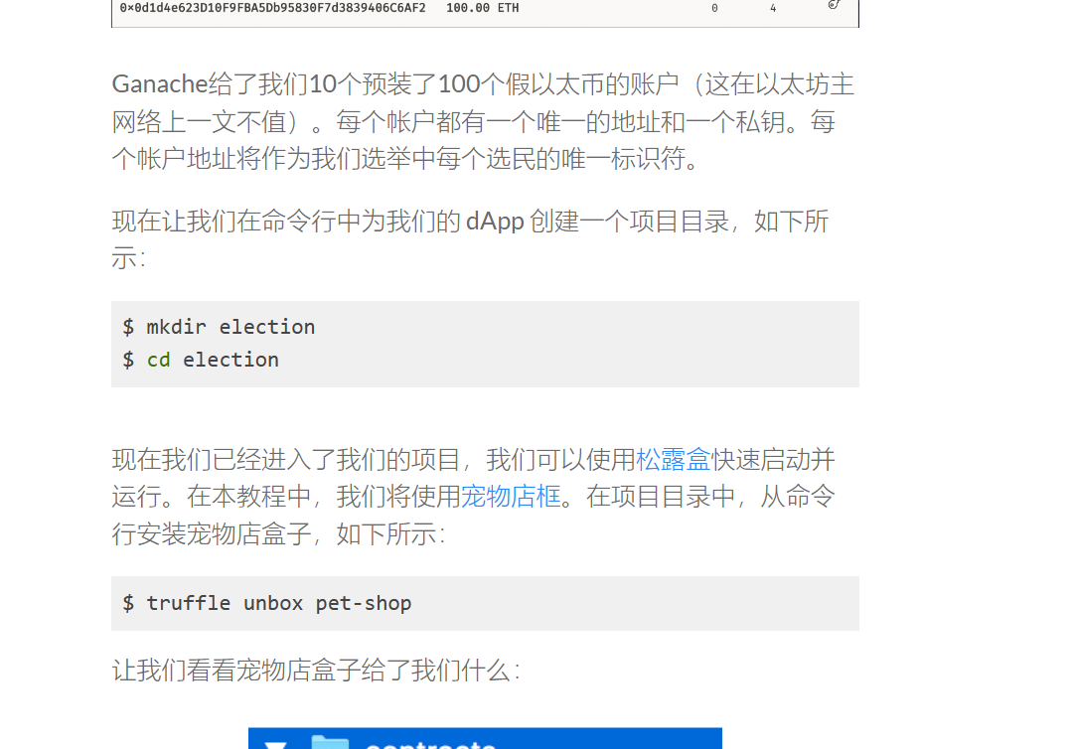

1-我们先打开cmd，键入md election，回车
cd election 回车
安装好目录
- 打开你的VPN和电脑处于同一地点时间后，（clash VPN挺好用的）
我们在cmd 键入truffle unbox pet-shop
Microsoft Windows [版本 10.0.19044.2728]
(c) Microsoft Corporation。保留所有权利。

C:\Users\Administrator>cd election

C:\Users\Administrator\election>truffle unbox pet-shop

Starting unbox...
=================

√ Preparing to download box
× Downloading
Unbox failed!
Error: Error connecting to https://raw.githubusercontent.com/truffle-box/pet-shop-box/master/truffle-box.json. Please check your internet connection and try again.

getaddrinfo ENOENT raw.githubusercontent.com
at Function.AxiosError.from (C:\Users\Administrator\AppData\Roaming\npm\node_modules\truffle\build\webpack:\node_modules\axios\dist\node\axios.cjs:789:1)
at RedirectableRequest.handleRequestError (C:\Users\Administrator\AppData\Roaming\npm\node_modules\truffle\build\webpack:\node_modules\axios\dist\node\axios.cjs:2744:1)
at RedirectableRequest.emit (node:events:514:28)
at ClientRequest.eventHandlers.<computed> (C:\Users\Administrator\AppData\Roaming\npm\node_modules\truffle\build\webpack:\node_modules\follow-redirects\index.js:14:1)
at ClientRequest.emit (node:events:514:28)
at TLSSocket.socketErrorListener (node:_http_client:501:9)
at TLSSocket.emit (node:events:514:28)
at emitErrorNT (node:internal/streams/destroy:151:8)
at emitErrorCloseNT (node:internal/streams/destroy:116:3)
at processTicksAndRejections (node:internal/process/task_queues:82:21)
Truffle v5.11.2 (core: 5.11.2)
Node v18.17.1

C:\Users\Administrator\election>truffle unbox pet-shop

Starting unbox...
=================

√ Preparing to download box
× Downloading
Unbox failed!
Error: Error connecting to https://raw.githubusercontent.com/truffle-box/pet-shop-box/master/truffle-box.json. Please check your internet connection and try again.

getaddrinfo ENOENT raw.githubusercontent.com
at Function.AxiosError.from (C:\Users\Administrator\AppData\Roaming\npm\node_modules\truffle\build\webpack:\node_modules\axios\dist\node\axios.cjs:789:1)
at RedirectableRequest.handleRequestError (C:\Users\Administrator\AppData\Roaming\npm\node_modules\truffle\build\webpack:\node_modules\axios\dist\node\axios.cjs:2744:1)
at RedirectableRequest.emit (node:events:514:28)
at ClientRequest.eventHandlers.<computed> (C:\Users\Administrator\AppData\Roaming\npm\node_modules\truffle\build\webpack:\node_modules\follow-redirects\index.js:14:1)
at ClientRequest.emit (node:events:514:28)
at TLSSocket.socketErrorListener (node:_http_client:501:9)
at TLSSocket.emit (node:events:514:28)
at emitErrorNT (node:internal/streams/destroy:151:8)
at emitErrorCloseNT (node:internal/streams/destroy:116:3)
at processTicksAndRejections (node:internal/process/task_queues:82:21)
Truffle v5.11.2 (core: 5.11.2)
Node v18.17.1

C:\Users\Administrator\election>truffle unbox pet-shop

Starting unbox...
=================

√ Preparing to download box
√ Downloading
npm WARN old lockfile
npm WARN old lockfile The package-lock.json file was created with an old version of npm,
npm WARN old lockfile so supplemental metadata must be fetched from the registry.
npm WARN old lockfile
npm WARN old lockfile This is a one-time fix-up, please be patient...
npm WARN old lockfile
npm WARN deprecated urix@0.1.0: Please see https://github.com/lydell/urix#deprecated
npm WARN deprecated source-map-url@0.4.0: See https://github.com/lydell/source-map-url#deprecated
npm WARN deprecated resolve-url@0.2.1: https://github.com/lydell/resolve-url#deprecated
npm WARN deprecated set-value@2.0.0: Critical bug fixed in v3.0.1, please upgrade to the latest version.
npm WARN deprecated source-map-resolve@0.5.2: See https://github.com/lydell/source-map-resolve#deprecated
npm WARN deprecated mixin-deep@1.3.1: Critical bug fixed in v2.0.1, please upgrade to the latest version.
npm WARN deprecated chokidar@2.0.4: Chokidar 2 does not receive security updates since 2019. Upgrade to chokidar 3 with 15x fewer dependencies
npm WARN deprecated set-value@0.4.3: Critical bug fixed in v3.0.1, please upgrade to the latest version.
npm WARN deprecated axios@0.17.1: Critical security vulnerability fixed in v0.21.1. For more information, see https://github.com/axios/axios/pull/3410
√ Cleaning up temporary files
√ Setting up box

Unbox successful, sweet!

Commands:

Compile: truffle compile
Migrate: truffle migrate
Test contracts: truffle test
Run dev server: npm run dev

C:\Users\Administrator\election>

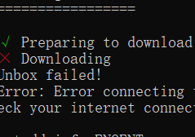
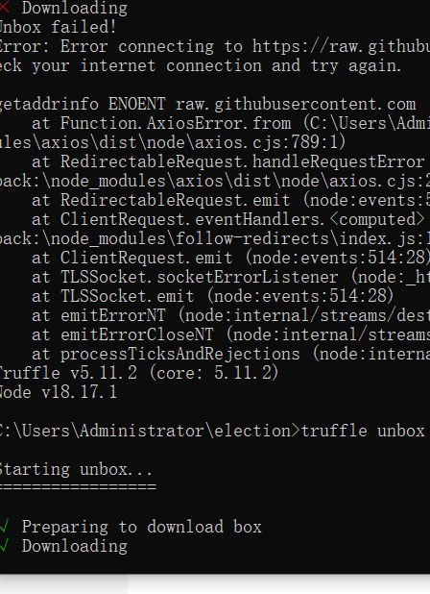
俩种下载对比

又出问题的还是重启cmd，md+cd election和download宠物盒（命令一样的）
Microsoft Windows [版本 10.0.19044.2728]
(c) Microsoft Corporation。保留所有权利。

C:\Users\Administrator>md election
子目录或文件 election 已经存在。

C:\Users\Administrator>cd election

C:\Users\Administrator\election>truffle unbox pet-shop
This directory is non-empty...
? Proceed anyway? (Y/n)
Starting unbox...
=================
我们重新宠物盒下载会遇见Y/N这个，也就是我们之前创的election要新的空的，但是我们之前没打开或者被关了，新人是不太明白，所以吧，我们重新覆盖打开
对了对了对了
忘了告诉你们记得在系统环境变量里的path中添加sublimetext目录（放在下面一页

? Proceed anyway? Yes
√ Preparing to download box
√ Downloading
.gitattributes already exists in this directory...
? Overwrite .gitattributes? Yes
.github already exists in this directory...
? Overwrite .github? Yes
box-img-lg.png already exists in this directory...
? Overwrite box-img-lg.png? Yes
box-img-sm.png already exists in this directory...
? Overwrite box-img-sm.png? Yes
bs-config.json already exists in this directory...
? Overwrite bs-config.json? Yes
contracts already exists in this directory...
? Overwrite contracts? Yes
LICENSE already exists in this directory...
? Overwrite LICENSE? Yes
migrations already exists in this directory...
? Overwrite migrations? Yes
package-lock.json already exists in this directory...
? Overwrite package-lock.json? Yes
package.json already exists in this directory...
? Overwrite package.json? Yes
src already exists in this directory...
? Overwrite src? Yes
test already exists in this directory...
? Overwrite test? Yes
truffle-config.js already exists in this directory...
? Overwrite truffle-config.js? Yes
y
npm WARN old lockfile
npm WARN old lockfile The package-lock.json file was created with an old version of npm,
npm WARN old lockfile so supplemental metadata must be fetched from the registry.
npm WARN old lockfile
npm WARN old lockfile This is a one-time fix-up, please be patient...
npm WARN old lockfile
√ Cleaning up temporary files
√ Setting up box

Unbox successful, sweet!

Commands:

Compile: truffle compile
Migrate: truffle migrate
Test contracts: truffle test
Run dev server: npm run dev

C:\Users\Administrator\election>
C:\Users\Administrator\election>
C:\Users\Administrator\election>subl file.rb

C:\Users\Administrator\election>subl file.rb（就可以打开了）

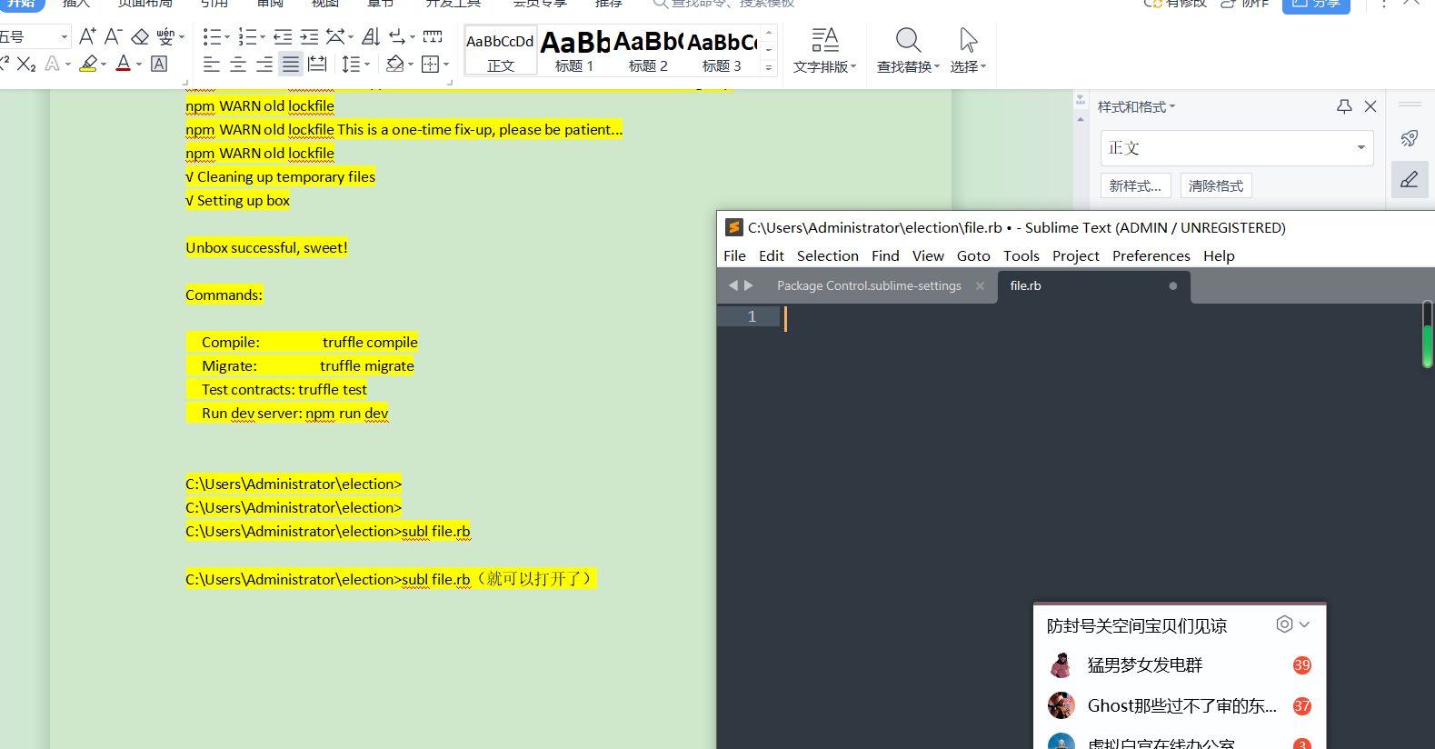
高级系统设置-环境变量-path 像这样设置
您好，这是必应。我很高兴您对使用 subl 命令来在 Windows 的 cmd 中打开 Sublime Text 感兴趣。
根据我从网络上搜索到的信息，您可以使用以下方法来在 Windows 的 cmd 中使用 subl 命令：
- 方法一：将 Sublime Text 的安装目录添加到您的 PATH 环境变量中，这样您就可以在任何位置输入 subl file.rb 来打开文件或 subl . 来打开当前目录。您可以参考这篇文章来了解如何设置 PATH 环境变量。
- 方法二：将 Sublime Text 的命令行工具 subl.exe 复制到一个已经在 PATH 环境变量中的目录，例如 C:\Windows\System32。这样您也可以在任何位置使用 subl 命令。您可以参考这篇文章来了解这个方法的详细步骤。
- 方法三：使用 doskey 命令来为 Sublime Text 创建一个别名，例如 subl。这样您就可以在当前的 cmd 会话中使用 subl 命令。您可以参考这篇文章来了解如何使用 doskey 命令。
我看到您在尝试使用 subl 命令来打开 file.rb 文件，但是遇到了一个错误提示，说 subl 不是一个内部或外部命令，也不是一个可运行的程序或批处理文件。这可能是因为您没有正确地配置 subl 命令，或者您没有将 Sublime Text 的安装目录添加到 PATH 环境变量中。
我建议您尝试以下步骤来解决这个问题：
- 确认您已经安装了 Sublime Text，并且知道它的安装目录。一般情况下，它的安装目录是 C:\Program Files\Sublime Text 或 C:\Program Files (x86)\Sublime Text。
- 确认您已经将 Sublime Text 的安装目录添加到 PATH 环境变量中，或者将 subl.exe 复制到一个已经在 PATH 环境变量中的目录，例如 C:\Windows\System32。
- 重新启动 cmd，并且尝试再次使用 subl 命令来打开文件或目录。如果还是出现错误提示，您可以尝试使用完整的路径来指定 subl.exe 的位置，例如 C:\Program Files\Sublime Text\subl.exe file.rb。

