- 题目选项：d
- 词法分析结果：
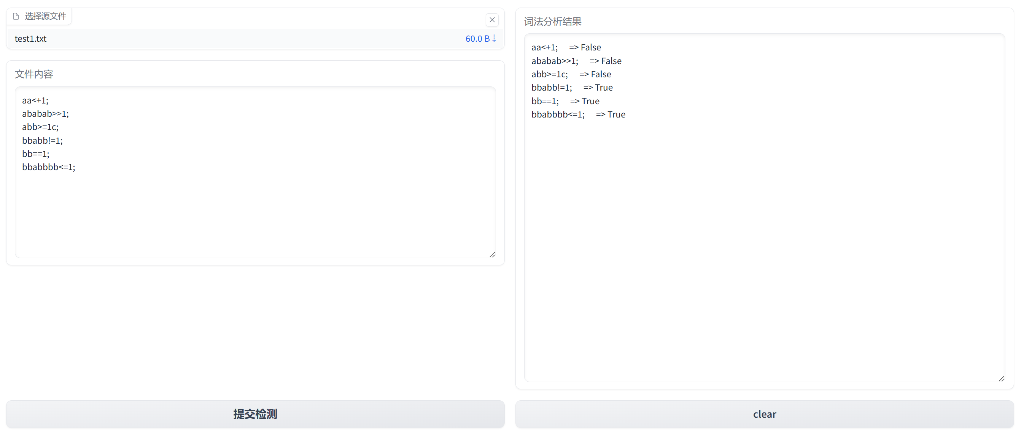
- 编程依据：逐字符读取，按状态转移，判定有效模式。
（4） 编程依据的图、表展示：
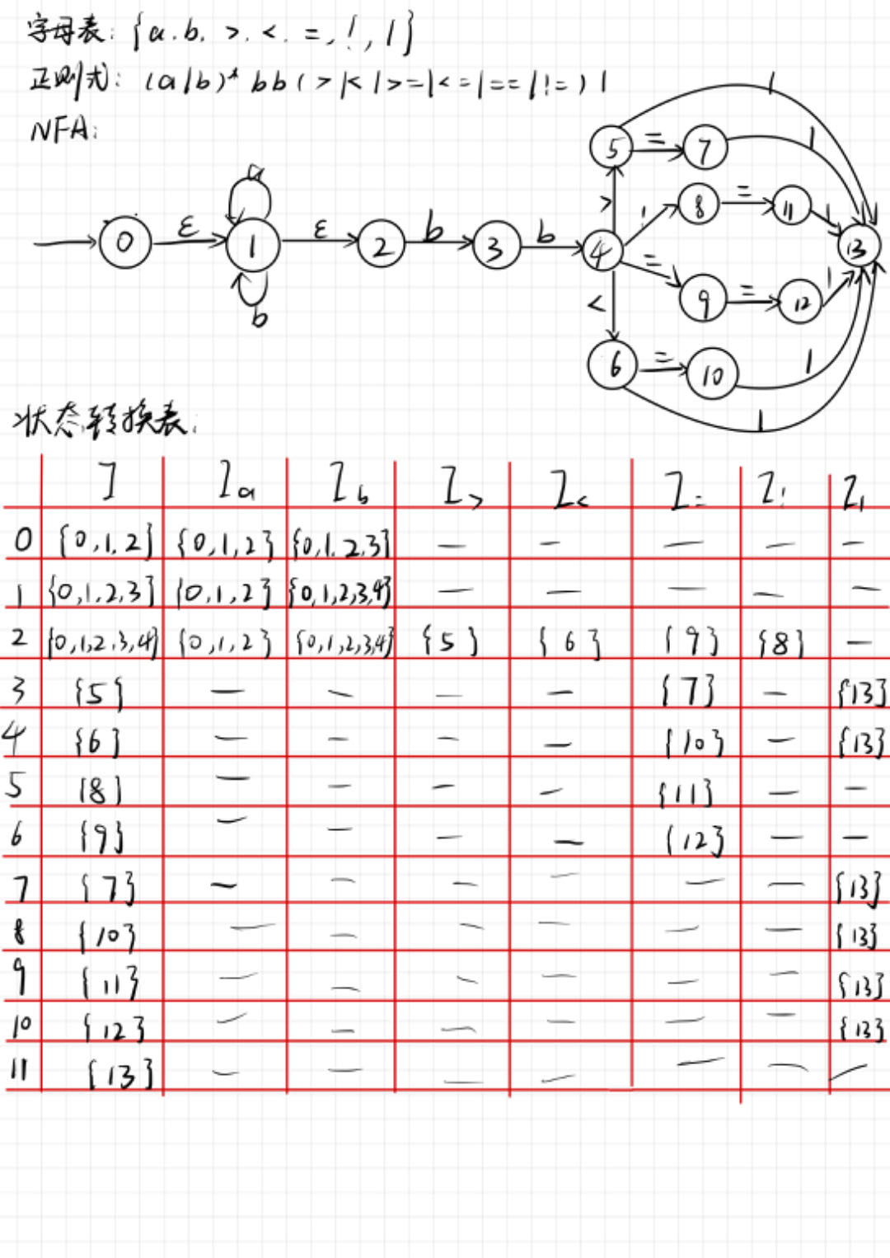
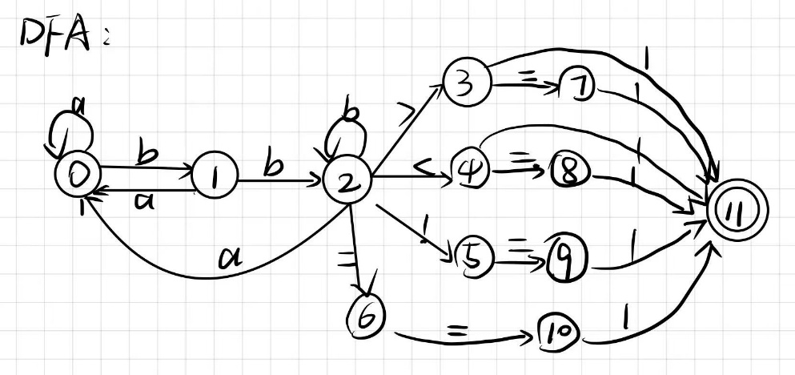
关键代码：
def lexer(text):
state = 0
i = 0
while i < len(text):
c = text[i]
if c in irrelevant_chars:
i += 1
continue # 跳过无关符号
if state == 0:
if c == 'a': state = 0
elif c == 'b': state = 1
else: return False

elif state == 1:
if c == 'a': state = 0
elif c == 'b': state = 2
else: return False

elif state == 2:
if c == 'a': state = 0
elif c == 'b': state = 2
elif c == '>': state = 3
elif c == '<': state = 4
elif c == '!': state = 5
elif c == '=': state = 6
else: return False

elif state == 3:
if c == '=': state = 7
elif c == '1': state = 11
else: return False

elif state == 4:
if c == '=': state = 8
elif c == '1': state = 11
else: return False

elif state == 5:
if c == '=': state = 9
else: return False

elif state == 6:
if c == '=': state = 10
else: return False

elif state in [7,8,9,10]:
if c == '1': state = 11
else: return False

elif state == 11:
return i == len(text)-1

i += 1
return state == 11

