Chenguang Liu cl37533

Yanhan Zhang yz7962

**Expense Splitter**

**Marketing Document**

**Product Vision**

*Roommates share the same apartment, may need an online platform to optimize their daily life.*

*User Story 1: Pay water & electricity bill*

*One roommate pay the water & electricity bill first, then split the bill, and ask other roommates to send money to him. Our system simplify this process: we let the first guy pay the bill, upload the bill to our system, and split the bill automatically and send a notice via email to the rest of roommates, and ask them to transfer money to the first guy.*

*User Story 2: Share information, and make a weekend plan*

*Roommates are busy at weekdays, and have different habits and lifestyle, and thus it would be difficult for all of them to sit together to make a weekend plan. Our system can provide a platform to let them share ideas, write some stories, start a poll for certain topics and even upload pictures. Therefore, they can make a weekend plan in our system, even though they cannot sit together to have a face-to-face discussion.*

*User Story 3: Create a task, and share the bill once someone finished it*

*We need to keep our apartment warm and beautiful, so sometimes we may need some budget for that: a big enough table so everyone can have dinner together, a TV we can watch super bowl together, a birthday cake for someone’s birthday. For all of these cases, we need to create a new Task and let some one to finish it, and then let the rest of people to share the bill.*

**Market Analysis**

*According to a recent survey, most U.S. college students share their room with others. In this way, they can not only save money, but also make some good friends from their roommates. However, there may be huge difference among these college students: they may have different habit, different schedule, and different lifestyle. Some of them find it difficult to manage their apartment.*

*Therefore, our app has a bright future. It can make students’ life easier and have a better college life. In U.S., most roommates need to split their water & electricity bill, make a weekend or holiday plan, and sometimes, create a task and assign the task to someone to finish it. Our app can meet all of these requirements. In the end of each month, we can see very clear which roommate make most contributions to the apartment (finish most tasks).*

**Product Definition**

*Overview:*

*Roommates Helper is an app which can help users to manage their water & electricity bill, share information, make a plan, and create a take.*

*The target users include, but not limited to, college students. We hope to create a app for them to make their life easier, and enjoy their life with roommates.*

*UI Mockups:*

*Homepage for Web:*

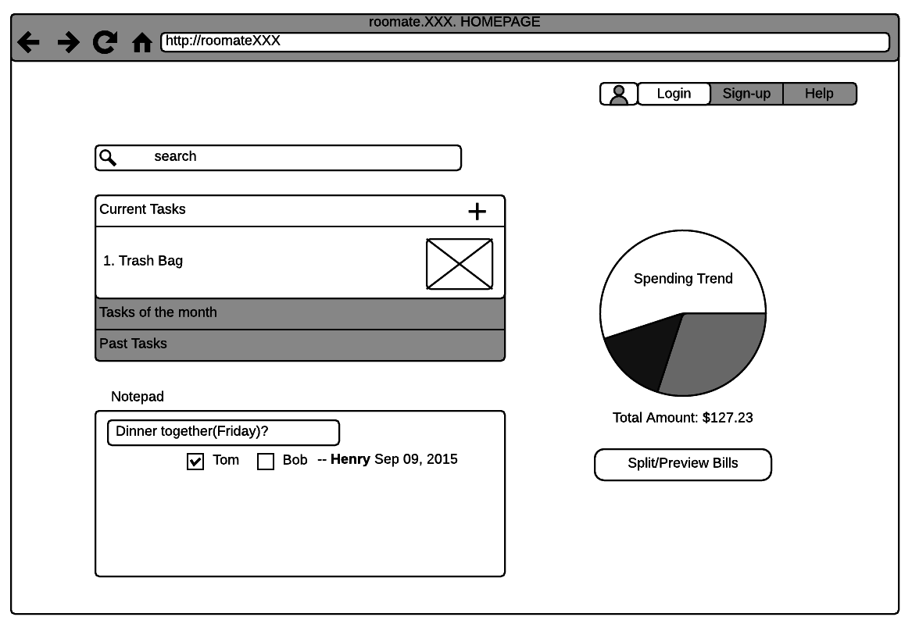

*Mobile Login page:*

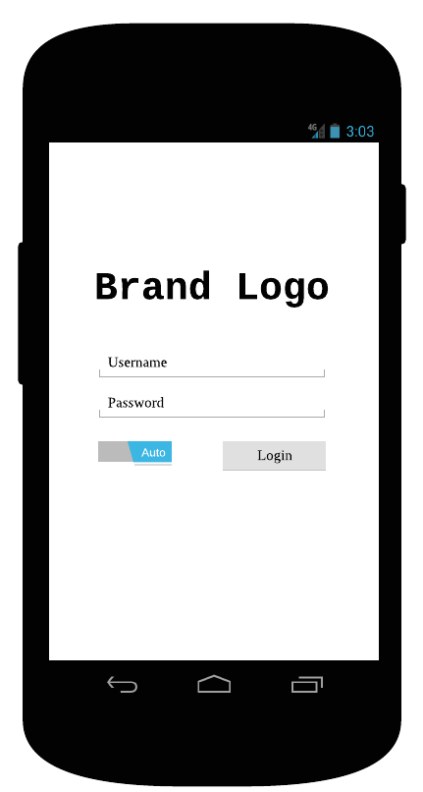

*Mobile home screen:*

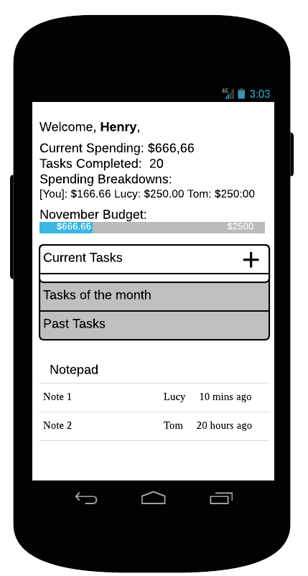

**Design Document**

**Architecture**

The system will be designed with a client-server architecture:

￼￼￼￼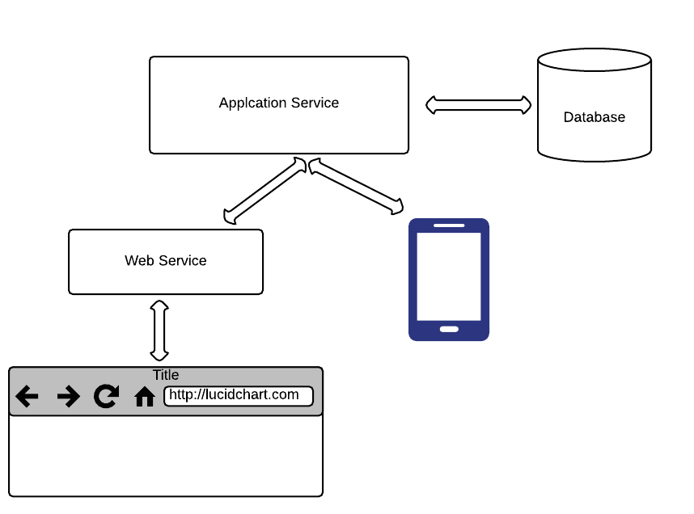

Data Model:

User:

Email

Phone

Address

Name

Birthday

Task:

Start date

Finish date

Cost

Creator

People in charge

Task ID

Task Name

**Possible future problems:**

1 When the app become popular someday, one server may not be enough. We may need multiple servers and a reliable load balancer.

2 We may need some backup for our data just in case the database is in trouble, our data is still there. RAID(redundant array of inexpensive disks) should be a good choice.

3 Different cell phone has different screen size, we may need to deal with this issue.

**Timeline:**

|  |  |
| --- | --- |
| **Date** | **Milestone** |
| Nov 6 | Discussion, data collection. |
| Nov 18 | Build Prototype application layer |
| Nov 23 | Build web service layer, and web UI |
| Nov 27 | Build Android app |
| Nov 30 | Debug and testing |
| Dec 2 | Final Presentation |

**Testing strategy**

We will implement several unit tests for this application, which will simulate HTTP requests to server.

Also, we will ask several users to test our app.

**API:**

<https://docs.google.com/document/d/1H9Acvqa6nXUtnw4qH0Z8CGZsoX_SomO8NcZBXHswQ2g/edit>