Team Project Report

Medical Insurance Cost Prediction and Risk Control Model

Team | FMG
Team members with contribution | 59841620, Bai Yanhua  59371690, Hong Kenan  59485146, Huang Yunxiu  60103011, Cao Yifang  59524140, Guo Jiayi  59031068, Luo Ya
Course | IS6400 S02
Supervisor | Dr. LIU Junming
Date | 2025/12/8

Content
Executive Summary 4
1 Introduction 5
1.1 Business understanding 5
1.2 Problem statement 5
2 Data description and preparation 6
2.1 Overview of the Dataset 6
2.2 Data description 7
3 Methodology 10
3.1 Data processing 10
3.2 Logistic Regression 12
3.3 Linear regression 13
3.4 Random Forest 15
3.5 XGBoost 16
4 Experiment and Discussion 20
4.1 Linear regression 20
4.2 Random forest 21
4.3 XGBoost 22
4.4 Discussion 22
5 Conclusion 23
5.1 Development 23
5.2 Future direction 24
Appendix 25

Executive Summary
For insurers, balancing service quality and operational profitability remains a major challenge amid inherent risks. To address this, this report utilizes a Kaggle dataset identifies a critical risk faced by a specific medical insurance company: the firm incurred a total loss of $79,555,878.7 from 10,000 historical transactions. This finding lays the groundwork for subsequent solutions. First, descriptive statistics and data visualization analyzed the dataset overview, revealing key feature distributions across three categories: Lifestyle Factors, Health Condition Prevalence, and Demographics. Then, data preprocessing was conducted to lay a solid foundation for model training. For predictive modeling, Logistic Regression and XGBoost classification sub-models were used to predict whether customers would file claims. Additionally, Linear Regression, Random Forest, and XGBoost regression sub-models were introduced to predict claim amounts. In model evaluation, Linear Regression provides a transparent baseline but has limited predictive power; Random Forest fits the training set better but lacks generalization. XGBoost delivers the most balanced performance with modest accuracy and stability gains. Key predictors such as chronic condition count, past three years’ hospitalization days, and last year’s visits from Linear Regression highlight their relevance for medical cost estimation. From a business perspective, this model creates a total commercial value of $16,240,358.06 by mitigating claim risks. Operationally, it enables data-driven optimization through precise resource allocation.

1 Introduction

1.1 Business understanding
Medical insurance is a key part of people's social security system, offering financial support when they face medical costs. For medical insurance companies, balancing service provision and operational profitability is a major challenge due to various inherent risks. This report aims to identify and address a critical risk issue that a specific medical insurance company is currently confronting, laying a foundation for subsequent solution development.
To address this urgent business problem, we plan to adopt the BDA method. The core solution is to build a prediction model using customer information. This model will be able to predict the future claim amount of each customer based on their relevant information. With this model, the company can classify transactions into two types: high-risk transactions and low-risk transactions. High-risk transactions are those that the model predicts will cause losses to the company, while low-risk transactions are those that are expected to bring profits. By rejecting high-risk transactions and retaining low-risk ones, the company can achieve the goal of risk control, thereby reduce losses and improve profitability.

1.2 Problem statement
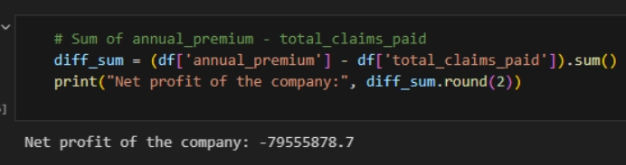
Figure 1 Business problem
The company has accumulated 10,000 transaction records from its daily operations. A thorough analysis of this dataset revealed a severe financial issue: the company incurred a total loss of 79,555,878.7 dollars from these transactions. This substantial loss has disrupted the company's short-term cash flow stability and posed a direct threat to its long-term operational sustainability. The urgent problem to solve now is how to accurately identify and control the risks causing these losses, so as to reverse the loss situation.
To tackle this problem, the BDA method is proposed as a core approach. The initial plan is to develop a prediction model using customer-related information, which can forecast future claim numbers of customers. This model will serve as a tool to distinguish high-risk and low-risk transactions, providing direction for risk control. Specifically, our model aims to predict customers' medical claim amounts in the coming year, and we will reject transactions where the predicted future claim amount exceeds the annual insurance premium, so as to stop losses and achieve profits. Detailed model construction and implementation will be discussed in subsequent sections.

2 Data description and preparation

2.1 Overview of the Dataset
The dataset used in this research is from Kaggle (Appendix A). It contains basic information and medical insurance consumption records of over 100,000 individuals, with a total of 54 variables covering multiple dimensions of personal and healthcare-related information. These variables are logically categorized into six core sections as detailed below:
1. Demographics & Socioeconomic: person_id, age, sex, region, urban_rural, income, education, marital_status, employment_status, household_size, dependents
2. Lifestyle & Habits: bmi, smoker, alcohol_freq, exercise_frequency, sleep_hours, stress_level
3. Health & Clinical: hypertension, diabetes, copd, cardiovascular, cancer_history, kidney_disease, liver_disease, arthritis, mental_health, chronic_count, systolic_bp, diastolic_bp, ldl, hba1c, risk_score, is_high_risk
4. Healthcare Utilization & Procedures: visits_last_year, hospitalizations_last_3yrs, days_hospitalized_last_3yrs, medication_count, proc_imaging, proc_surgery, proc_psycho, proc_consult_count, proc_lab, had_major
5. Insurance & Policy: plan_type, network_tier, deductible, copay, policy_term_years, policy_changes_last_2yrs, provider_quality
6. Medical Costs & Claims: annual_medical_cost, annual_premium, monthly_premium, claims_count, avg_claim_amount, total_claims_paid

2.2 Data description
Through data visualization, the distribution of several key variables in the dataset is presented.
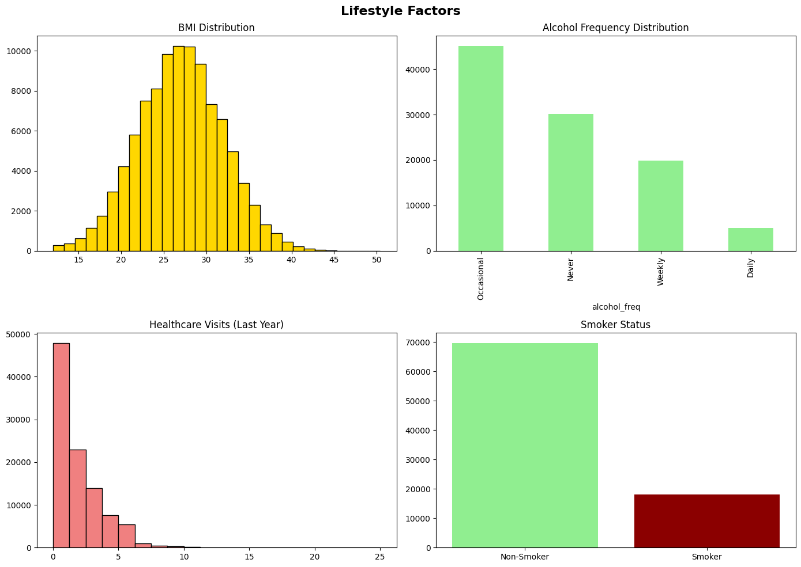
Figure 2 Lifestyle factors
Figure 2 presents the living habits of the research objects, indicating that most subjects have low-frequency smoking and alcohol consumption behaviors, and nearly half of the research objects did not participate in any healthcare visits last year.
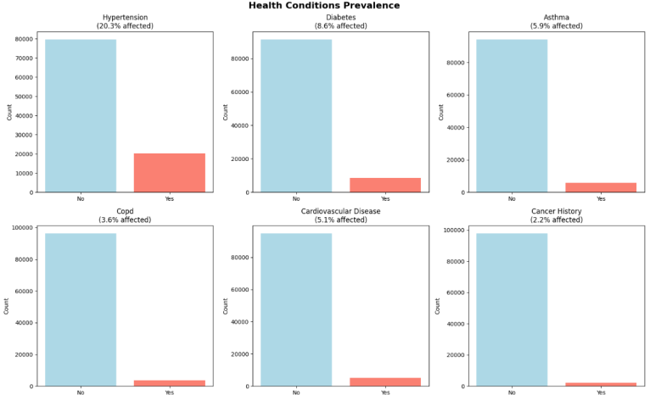
Figure 3 Health conditions prevalence
Figure 3 presents the prevalence of several common diseases among the research objects, showing the proportion of research objects with major chronic conditions such as hypertension and diabetes.
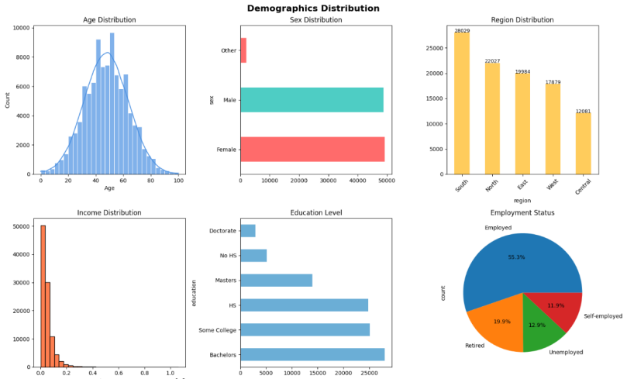
Figure 4 Demographics Distribution
Figure 4 presents the distribution of basic information, illustrating the demographic structure of the sample, including age, gender, and urban-rural distribution. The chart shows that the gender ratio in the sample is balanced, the educational level is relatively high, and more than half of the research objects are employed. In addition, the regional distribution of the sample is relatively balanced, showing a trend of fewer objects in the central region and more in the surrounding areas.

3 Methodology

3.1 Data processing
This section focuses on conducting predictions for customer claims. Through data cleaning, feature derivation and encoding, high-quality data input is provided for model training.
First, missing value handling is carried out. For the reasonable missing values in the "alcohol_freq" column due to the business scenario, the missing values or records marked as "None" resulting from customers not drinking alcohol are uniformly standardized as "Never" to achieve semantic filling.
Next, the redundant and useless feature deletion stage is carried out. First, a list of features that are meaningless for model training or may cause data leakage is sorted out, including "monthly_premium", "annual_medical_cost", "avg_claim_amount", "claims_count" and "person_id". Then, it is verified whether these features exist in the dataset to avoid errors due to mismatched feature names, and then the deletion operation is performed to ensure that the dataset only retains the core features that are effective for modeling.
Then comes the stage of constructing the target variable and derived features. The core is to build a binary label column "claimed" based on "total_claims_paid". Before feature derivation, the missing values in the "total_claims_paid" column are filled with 0, and the negative records are corrected to 0 to ensure the rationality of the derivation logic. Then, according to the rule that if "total_claims_paid" is greater than 0, it is judged as a claim occurrence, otherwise as no claim occurrence, the "claimed" column is generated and converted to integer type to meet the requirements of subsequent modeling.
Categorical variable encoding is a crucial step in data preprocessing. The features to be encoded include sex, region, urban_rural, education, marital_status, employment_status, plan_type, network_tier, deductible, copay, smoker, and alcohol_freq. These categorical features are encoded using the dummy variable transformation method, and the first dummy column of each categorical variable is removed to avoid multicollinearity affecting the model. Eventually, all categorical features are successfully converted into 0-1 encoded numerical features.
Next, the features and the target variable are clearly separated. The total_claims_paid, claimed, and annual_premium columns, which may cause label leakage, are removed from the encoded df_dummies dataset to form the feature matrix X, while the claimed column is extracted as the target variable y, defining the input and output boundaries for model training.
Finally, data splitting and feature standardization are completed. The feature matrix and target variable are split into training and test sets in an 8:2 ratio. During the splitting process, the distribution of the target variable in the training and test sets is kept consistent to avoid model bias due to data imbalance. The random_state is set to 42 to ensure the reproducibility of the experimental results. Considering the sensitivity of the logistic regression model to feature scales, StandardScaler is used to fit and transform the training set features, and only the transformation operation is performed on the test set to avoid data leakage, ensuring all features are on the same scale and effectively improving the convergence speed and prediction accuracy of the model.

3.2 Logistic Regression
3.2.1 Model Selection Criteria
To predict whether customers will file claims, we initially choose Logistic Regression to preliminarily determine whether customers will make claims. Logistic Regression serves as the baseline model, with a relatively simple structure and efficient training, which can serve as a reference for optimizing subsequent more complex models.
3.2.2 Variable Selection and Implementation Process
Logistic Regression takes the results of data preprocessing as the basis, selects the derived binary classification label "claimed" as the target variable, where 1 represents a claim occurrence and 0 represents no claim occurrence.
In the experimental process, based on the preprocessing results, the training set and test set are split in a 8:2 ratio, maintaining sample distribution consistency through stratify=y, and setting random_state=42 to ensure reproducibility of the results; subsequently, considering the feature scale sensitivity of logistic regression, StandardScaler is used to complete the fitting transformation of features in the training set and the separate transformation of features in the test set, avoiding data leakage; then, the logistic regression model is initialized, with max_iter=200 configured, and later optimized to 500 to ensure convergence, L2 regularization is enabled, and the strength is controlled through the C parameter; class_weight='balanced' is set to handle the data imbalance problem, and maximum likelihood estimation method is used to complete the model training; finally, indicators such as accuracy, AUC, classification report, and confusion matrix are used to comprehensively evaluate the effectiveness and practicality of the model in the claim prediction task.
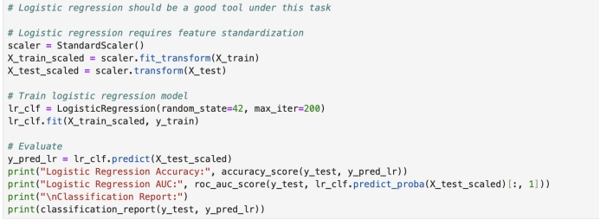
Figure 5 The code of Logistic Regression

3.3 Linear regression
3.3.1 Model Selection Criteria
The core problem addressed by Linear Regression is to predict the claim amount for the customers who have already made claims. The strong interpretability feature of Linear Regression enables it to directly quantify the linear influence degree of each variable on the claim amount. Thus, it can serve as a baseline model and be compared with the results of subsequent other models to verify the explanatory power of the linear relationship in the data.
3.3.2 Variable Selection and Implementation Process
In this section, we initially selected log_total_claims as the target variable. To eliminate the influence of zeros in the data, we logarithmized log_total_claims and used the processed new variable as the final target variable for selection.
Regarding the processing of other variables, we first identified 17 core characteristics related to health and medical based on Pearson correlation analysis and business logic to avoid reducing the reliability of the model due to multicollinearity. In addition, we also deleted several unnecessary columns to ensure the data was well-organized.
During the implementation process, we inherited the results of data preprocessing, split the core features as independent variables, and used log_total_claims as the target variable. Then, we randomly split the dataset in a 8:2 ratio and fitted a linear relationship to obtain the model intercept and feature coefficients. Finally, we calculated the core performance indicators of the training set and test set, and analyzed the linear influence relationship between the independent variables and the dependent variable through feature coefficients.
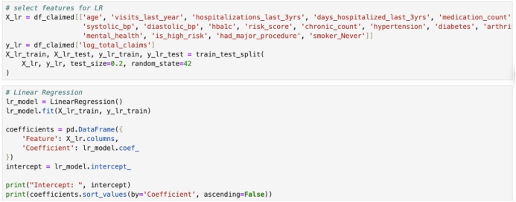
Figure 6 The Code of Linear Regression

3.4 Random Forest
3.4.1 Model Selection Criteria
The random forest regression model, as a non-linear intermediate validation model, has the same objective as linear regression and XGBoost regression, and is all used for predicting the log_total_claims of claimants who have already filed claims. Random Forest can capture the non-linear relationship between independent variables and dependent variables as well as the interaction effects of features and is not sensitive to multicollinearity. It does not require complex feature preprocessing and can reduce the risk of overfitting through ensemble learning. Therefore, we selected Random Forest along with Linear regression and XGBoost to form a gradient comparison of accuracy.
3.4.2 Variable Selection and Implementation Process
In this section, we continue with the previous data normalization and cleaning results, and to ensure consistency, we also chose log_total_claims as our target variable, with all other features serving as independent variables. Since Random Forest inherently has the function of automatically assessing feature importance, no additional data preprocessing operations are required.
During the implementation process, to clearly define the data boundaries, we first split the independent variables and the target variable, randomly sampling the dataset in a 8:2 ratio to maintain the consistency of the random seed. After multiple attempts to vary the number of trees, we determined that 200 trees had the best fitting effect and configured the corresponding hyperparameters. Then, we integrated the prediction results of 200 decision trees through ensemble learning. After training, we calculated the core performance indicators and compared their accuracy with other models, and extracted the feature importance of the independent variables.
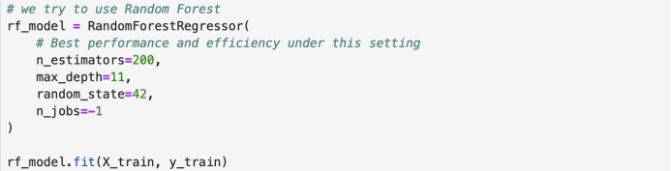
Figure 7 The Code of Random Forest (1)
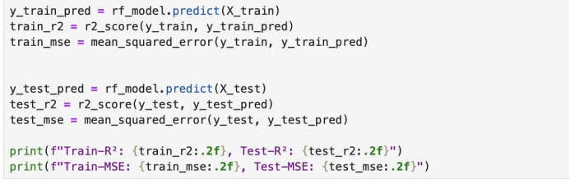
Figure 8 The Code of Random Forest (2)

3.5 XGBoost
3.5.1 Model Selection Criteria
To predict the customer claim situations and claim amounts, we use the XGBoost two-stage model for prediction.
The XGBoost classification sub-model (xgb_clf) has strong generalization ability and excellent anti-overfitting capability, and can effectively capture the interaction relationships between features. Therefore, after the previous Logistic Regression model, we adopt this model to further analyze whether customers will make claim behaviors and screen the target customers for the subsequent amount prediction.
The XGBoost regression sub-model (xgb_opt) supports nonlinear fitting ability and has high training efficiency. It can improve accuracy by adjusting hyperparameters and is used for quantifying the amounts of customers who have already made claims. The combination of this model with the previous xgb_clf classification model includes customer screening and subsequent prediction, which can balance the entire business process and further ensure the reliability of the model.
3.5.2 Variable Selection
Both sub-models are based on the encoded full customer data set and inherit the results of data preprocessing, ensuring the consistency and standardization of the input data.
The independent variables of the xgb_clf model exclude all features after removing total_claims_paid and the label column claimed, thereby fundamentally avoiding the problem of data leakage. The dependent variable directly adopts the binary classification identifier claimed for whether the customer made a claim.
The target variable of the xgb_opt model selects log_total_claims after logarithmic transformation, in order to alleviate the influence of the right-skewed distribution of the original claim amount total_claims_paid on the model's prediction effect. The independent variables are all features after removing log_total_claims. The model can automatically handle redundant information through the built-in regularization and feature sampling mechanism, without the need for additional manual screening.
3.5.3 Implementation Process
During the implementation process, xgb_clf first stratified and sampled the dataset in a 8:2 ratio to split it into training and testing sets, ensuring that the class distribution of the training set and the testing set is balanced. Then, it configured the optimized hyperparameters to balance model performance and training efficiency. Based on the training data, it fitted the model and learned the patterns of claim behavior. Finally, it predicted whether new data should be claimed and screened the target customers, and the evaluation stage measured the model's prediction effect using classification accuracy as the core indicator.
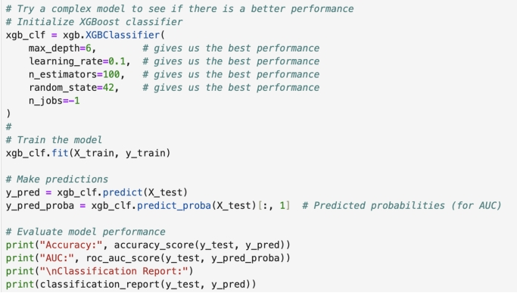
Figure 9 The code of xgb_clf
Xgb_opt reused the dataset of already claimed customers. It also randomly sampled and split the dataset in a 8:2 ratio and maintained the same random seed as other models. After multiple validations, we configured multi-dimensional optimized hyperparameters. Through iterative training with the gradient boosting algorithm to optimize prediction errors, after training was completed, we used the coefficient of determination R² and mean squared error MSE as the core evaluation indicators to compare the accuracy with linear regression and random forest regression models and conducted feature importance analysis.
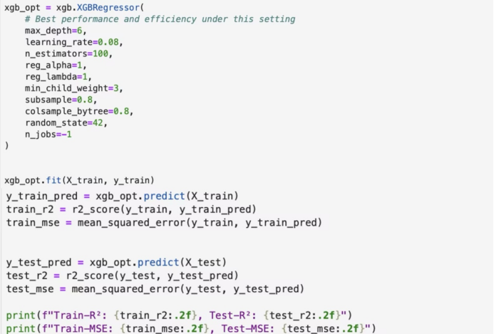
Figure 10 The Code of xgb_opt
This flowchart below illustrates the process of the two-stage model of XGBoost, which first determines whether a customer will file a claim, and then makes targeted predictions on the claim amount. The specific logic of the model operation is as follows:
In the input stage, the preprocessed customer data is input, and then the xgb_clf is used to determine "whether the customer will initiate a claim". If the judgment result is "No", the claim amount will be directly returned as 0; if the judgment result is "Yes", it will enter xgb_opt to predict the specific claim amount, that is, predicted_total_claims_paid.
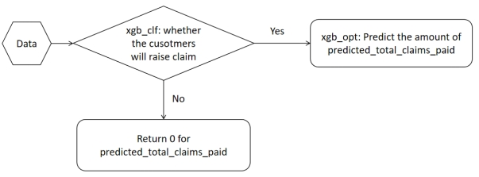
Figure 11 The flowchart of XGBoost model

4 Experiment and Discussion

4.1 Linear regression
The linear regression model achieves a training R² of 0.24 and a test R² of 0.26, indicating limited explanatory power. The corresponding meaning squared error (MSE) is 0.66 on the training set and 0.65 on the test set, suggesting that is consistent but relatively high prediction error.
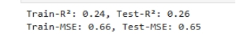
Figure 12 Performance of linear regression
Feature coefficient reveals that risk score had the strongest positive influence (coefficient = 1.146), followed by chronic condition count (0.127), hospitalization days in the past three years(0.103), and visits last year(0.085). Other positively weighted features include arthritis, hypertension and major procedures, though their coefficients were relatively small.
In contrast, features such as age, diabetes and smoking status (Never) showed negative coefficients, with smoking status having the largest negative impact (−0.170). This suggests that individuals who never smoked tend to incur lower predicted costs.
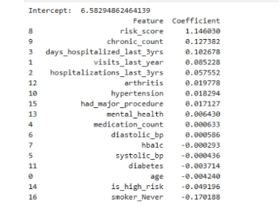
Figure 13 Coefficient of features
Although linear regression offers interpretability through direct coefficient analysis, its predictive capacity proves insufficient for modeling the complex structure of healthcare expenditures.

4.2 Random forest
Random Forest model is trained with 200 estimators and a maximum depth of 11. The model achieves a training R² of 0.38 and a test R² of 0.25. Though the training fit improved, the test performance is not better than that of linear regression, with a test MSE remaining at 0.65. This suggests a limited generalization.
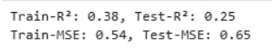
Figure 14 Performance of random forest
These results indicate that the model is well-suited for capturing non-linear patterns in numerical health indicators, but its overall predictive accuracy remained constrained.

4.3 XGBoost
The XGBoost model is configured with 100 estimators, a learning rate of 0.08 and a maximum depth of 6. It achieves a training R² of 0.31 and a test R² of 0.26, with corresponding MSE values of 0.60 and 0.65. Compared to the other models, XGBoost demonstrates slightly better generalization and lower training errors, suggesting that it improved robustness.
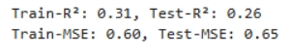
Figure 15 Performance of XGBoost
The model’s ability to capture complex interactions contributed to its relatively stable performance across datasets.

4.4 Discussion
In summary, though linear regression provides a transparent baseline, its predictive power is limited. Random Forest shows stronger fitting on the training set but fails to generalize effectively. XGBoost offers the most balanced performance, with modest improvements in accuracy and stability. Across linear regression model, key features such as chronic condition count, hospitalization days in the past three years and visits last year consistently emerged as significant predictors, underscoring their relevance in estimating medical costs.

5 Conclusion

5.1 Development
This study develops a multi-model integrated framework to predict insurance customers’ claim behavior and amounts, addressing medical insurers’ core challenge of balancing service quality and profitability and laying a foundation for sustainable business development.
The most important value of this model is enhancing commercial profitability. Tests on 20,000 transactions show the model’s remarkable commercial value. Without risk control, these transactions incurred a $15,582,597.8 loss; after using the model to predict claim amounts and reject loss-prone transactions, the remaining business yielded a $657,760.26 profit. This translates to a total commercial value of $16,240,358.06, demonstrating the model’s power in loss mitigation and profit generation.
This model also achieves data-driven operational optimization. For claims processing, customers are tired by predicted claim likelihood and amounts. Dedicated teams handle high-risk cases to streamline processes and boost satisfaction, while low-risk cases use automated processing to cut labor costs. In customer service, high-risk groups receive personalized support, while low-risk customers use self-service channels, maximizing resource utilization and reducing waste.

5.2 Future direction
Ideally, if the model could predict total_claims_paid with 100% accuracy, we could earn 4,126,096.64 dollars from the 20,000 transactions. Currently, our profit of 657,760.26 dollars accounts for 15.94% of this ideal value. There are two main reasons why this model has not achieved perfect performance. One is the lack of some key data. For example, if we had the claim history of each customer over the past few years, the model could have higher accuracy. Therefore, as more comprehensive data becomes available in the future, the model's performance will improve. The second reason is that illness and injury are highly random events. It is difficult for the model to predict whether a customer will file a claim in the future, such as car accidents or serious illnesses, which are very random. In summary, our model has performed very well and created a high commercial value of 16,240,358.06 dollars. It can effectively help the company stop losses and achieve profits.

Appendix
Appendix A: Dataset link
https://www.kaggle.com/datasets/mohankrishnathalla/medical-insurance-cost-prediction.
Appendix B: Code link
https://github.com/YanhuaB/Medical_Insurance_Risk_Control_Project/blob/main/6400final_3.ipynb

