**CHAPTER II**

**REVIEW OF RELATED LITERATURE**

**Related Literature**

***Directory of Open Access Publications (DOAJ)***

According to Heather Morrison (2007), the Directory of Open Access Publications (DOAJ) is a free website that compiles a list of more than 2,800 completely open access, peer-reviewed scientific journals that has been approved by librarians. DOAJ is rapidly expanding, with more than one new title added every day. The DOAJ home page includes a description of the service, as well as an up-to-date count of journals listed in DOAJ, as well as information on how many journals can be searched at the article level through DOAJ and how many articles may be obtained. DOAJ is largely used by libraries and serials support services (such as Serials Solutions, SFX, and reSearcher) to find scholarly Open Access publications and to connect users with Open Access material via link resolving services. The Directory of Open Access Publications (DOAJ) is a collection of completely open access, peer-reviewed scientific journals that has been vetted by librarians. According to the DOAJ Selection Criteria, a journal must "conduct peer-review or editorial quality control to be included." This is a very specific definition; there are many different types of academic quality control, and defining peer review is far more complicated than it appears. The DOAJ definition is far clearer than Ulrich's (considered an authoritative conventional list of subscription-based journals), which offers no explanation for what it refers to as "refereed" publications.

***OAPEN (Open Access Publishing in European)***

[Gajanan,](https://www.researchgate.net/profile/Gajanan-Khiste) Et. Al (2019) claimed that theOAPEN (Open Access Publishing in European Networks) is a collaborative effort in the Humanities and Social Sciences to establish and implement a long-term open access strategy for scientific publishing. The OAPEN Foundation is a not-for-profit organization located in the Netherlands, with its registered office at The Hague's National Library. Open access, peer-reviewed books are the focus of OAPEN. The OAPEN Library (www.oapen.org), a central repository for holding and spreading OA literature, and the Directory of Open Access Books (DOAB, www.doabooks.org), a discovery tool for OA books, are both operated by OAPEN. OAPEN collaborate with publishers to create a high-quality library of open-access books, and OAPEN offer dissemination, quality assurance, and digital preservation services to publishers, libraries, and research funders. The mission of OAPEN is to create a branded collection of open access peer-reviewed titles, raise the exposure and retrievability of high-quality publications, and promote open access book production. A number of institutions came together to form the OAPEN Foundation. These organizations are participants in the foundation and provided financial support to help it get started. A Council of Participants is formed, and it meets once a year. The members of the OAPEN Board are chosen by the Council from its circle. University of Amsterdam (UvA), University of Leiden (UL), University Library of Utrecht University (UU), Netherlands Academy of Sciences (KNAW), and National Library of the Netherlands are the current members of the OAPEN Foundation (KB).

***Differences of Directory of Open Access Publications (DOAJ) and OAPEN (Open Access Publishing in European on Open Access Research Output Archive***

The Open Access Research Output Archive and Directory System is similar to the DOAJ. The DOAJ's goal is to "improve the exposure, accessibility, reputation, usage, and impact of high-quality, open-access scholarly research journals," (Heather Morrison, 2007) while the Open Access Research Output Archive and Directory System's goal is to "assist the Research office in storing, retrieving, and protecting research outputs.".

The goal of the Open Access Research Output Archive and Directory System is to allow students and teachers to use the internet research output as a source of information. This goal is similar to OAPEN's goal of encouraging and supporting the transition to open access for academic literature, as well as creating a long-term publishing model for academic books in the humanities and social sciences, as well as increasing the visibility and use of high-quality academic research in Europe.

**CONCEPTUAL FRAMEWORK**

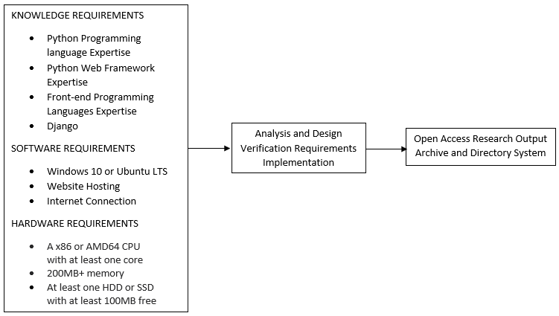

**Figure 1. Conceptual Framework of The Study**

Figure 2.1 shows the conceptual framework of the study which shows the input, process, and output.

When constructing this system, knowledge of Python programming language, Python web framework, front-end programming languages, and Django is required. The developers handle the development process using the Windows 10 or Ubuntu LTS operating systems. The system's developers will publish the website on the Internet by using website hosting and an Internet connection. Additionally, the hardware requirements are the minimum PC or laptop specifications needed to install the software and begin the development process. Finally, in order to attain the Open Access Research Output Archive and Directory System, the second stage of the development process includes analysis and design, verification requirements, and implementation.

**TECHNICAL BACKGROUND**

**Python** is a high-level, general-purpose programming language that is interpreted. The use of considerable indentation in its design philosophy emphasizes code readability. Its language elements and object-oriented approach are aimed at assisting programmers in writing clear, logical code for both small and large-scale projects.

**Django** is a free and open-source web framework built on Python and following the model–template–views architectural paradigm. It is maintained by the Django Software Foundation, a non-profit organization based in the United States.

A **web framework**, often known as a web application framework, is a software framework for developing web applications such as web services, web resources, and web APIs. Online frameworks are a set of guidelines for creating and deploying web applications on the Internet.

**Front-end** web development is the process of creating a website's graphical user interface using HTML, CSS, and JavaScript so that people can view and interact with it.

**Back-end** Development refers to the server-side development. Databases, scripting, and website architecture are all covered. It describes the operations that take place behind the scenes when a user performs a specific activity on a website. It could be logging into an account or purchasing anything from an internet retailer. Back-end developers write code that allows browsers to interface with database information.

A **programming language** is a formal language made up of a set of strings that generate various types of machine code. Programming languages are a type of computer language that is used to implement algorithms in computer programming. The majority of programming languages are made up of computer instructions.

A **web hosting** service is a sort of Internet hosting service that hosts websites for customers, i.e., it provides the tools needed to construct and manage a website and makes it available on the Internet. Web hosts refer to companies that provide web hosting services.

**References:**

Heather Morrison (August 17, 2007), Directory of Open Access Journals (DOAJ), Morrison Project Coordinator, BC Electronic. Network Simon Fraser University Library. WAC Bennett Library. 8888 University Drive. Burnaby, BC. V5A 1S6.

[Gajanan Khiste](https://www.researchgate.net/profile/Gajanan-Khiste) & D.B Maske, (January 2019). Open Access Publishing in European Networks (OAPEN) at a Glance. Shri Panditguru Pardikar Mahavidyalaya, Sirsala, Tq. Parli (V.) Dist. Beed, Maharashtra India.