Step 6 - TODO GUI

1. 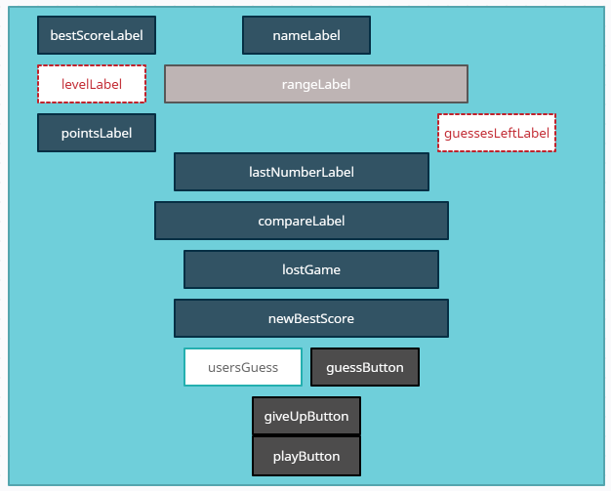
2. levelLabel and guessesLeftLabel gradually change colour depending on the level and the remaining guesses