1. Prerequisites
- Python 3.x must be installed on your machine.
- The raw capture file must be named DumpFile.txt.
- The scripts and the input file (DumpFile.txt) must be placed in the same folder.
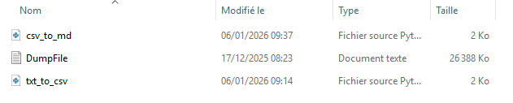
- Note: Output files (Network_Analysis.csv and Network_Report.md) will be automatically created in this folder after execution.

2. Tool 1: CSV Converter (txt_to_csv.py)
This script parses the raw textual data to extract IP traffic information.
How to use:
- Open your terminal or command prompt.
- Navigate to the project folder: cd "path/to/your/folder".
- Run the script: python txt_to_csv.py.
Output:
- A file named Network_Analysis.csv will be generated.
- This file can be opened in Excel (using ; as a delimiter) for manual filtering and statistics.

3. Tool 2: Markdown Reporter (csv_to_md.py)
This script analyzes the previously generated CSV to create a high-level diagnostic report.
How to use:
- Ensure Network_Analysis.csv is present in the folder.
- Run the script: python csv_to_md.py.
Output:
- A file named Network_Report.md will be generated.
- This report includes a summary of suspicious activities, such as SSH Brute Force attempts and Network Latency/Packet Loss.

4. Troubleshooting
- FileNotFoundError: Ensure you are running the script from the correct directory. Use cd to navigate to the script's folder before execution.
- Encoding Issues: The scripts use utf-8. If your text file uses a different encoding, you might need to adjust the open() function in the Python code.

5. Technical Context for Administrators
These tools were specifically developed to identify security threats. During our analysis, we successfully detected:
- SSH Brute Force: Identified by multiple source ports from the same IP connecting to port 22 in a short timeframe.
- TCP Retransmissions: Identified by duplicate sequence numbers, indicating potential hardware failure or network congestion.

