Dot Matrix Assembly Manual

For hardware revision 0.6
Power Supply
Populate C1, C3, U1 and Q2. Verify that 5V test point is not shorted to GND neither to 3V3 test points. If not, you can apply 5V voltage on the GND and VCC pins of the J9 connector (see the other side of the PCB) and verify voltage on 5V and 3V3 test points.

Reset and Boot Selection
At least C11, R13 and R16 needs to be soldered to reliable boot the MCU. Bootloader can be then started by shorting the J14, applying power and disconnecting the short. If SW3, C10 and Q1 is populated, then SW3 can be used either to reset MCU (short press) or entering bootloader (long press). For now do not solder the SW3 yet as it will be in the way while soldering other parts.

Debug LED
Populate R5 and D5, while there solder R3 too. Keep in mind LED polarity (the green dots on the LED should align with the marked pin). Take care to not touch the LED resin blob with the soldering iron or not overheat the diode.
If the MCU (U2) is not soldered you can test LED by connecting TP6 to GND with power applied. If the MCU is already soldered, and the power is applied it should flash the LED several times.

MCU and USB connector
You should be now skilled enough to solder the USB connector. Use 5V, GND, D+ and D- testpoints to check for shorts Then connect USB cable and check conductivity. If not presoldered now you can solder the MCU (U2) and the 0603 size capacitors C6, C7, C8, C9. If the preprogrammed MCU was used the LED should blink if you connect the power via the USB.

External Clock
There are two types of external clock the High Speed one, used e.g. for USB and the Low Speed Clock that is used for RTC. For HSE (High Speed Clock) Y1 is needed. LSE (Low Speed Clock), Y2, C14, C15 are needed. LSE is not needed for this workshop, but it's easier to solder now, than on the complete kit.

Led Matrix Driving
Solder U3,U4,U5 (R3 should be already in place). Use the LED matrix as the holder for soldering the "socket headers". Don't forget that the LED matrix should be on the other side of the PCB than the rest of the components. Once assembled correctly and powered the preloaded MCU should show some demo on the matrix.
Buttons
This is optional. It makes the board more versatile and the demo can't be controlled without them. It's easier to do before the side headers are soldered but it still can be done later if you are getting short on time now. Solder SW1 and SW2 and R2, R14, C2, C4. (It's good time for SW3 now too.) The resistors and capacitors form the hardware button debounce. If you for some reason need a quick response on cost of doing the button debounce in software they can be omitted (the buttons can't be used in the demo in that case).

Interface headers
The headers J1, J2, J4, J5, J6, J7, J8, J9 needs to be soldered now. The headers need to be as perpendicular to the PCB. If possible use a jig, or pile of another PCBs to hold the headers in place.

Mechanical part
Now you should have the electrical part complete and you only need to complete the mechanical part. Insert the M3 nuts in the holes of the display support. You might eventually need do clean the 3D part a bit. The larger central part of the support should face upwards to the Display. If mounted remove the Display, and use the four nylon spacers to secure the display support on the PCB. Pay attention to properly aligned nuts in order to not damage the threading on the spacers. Reinstall the LED Display. The small 3D printed squares and small solder-less breadboards are for interconnecting the boards. The holes in the breadboard are connected in lines as the protrusion on top shows. If connected in wrong direction it will short circuit the header. The nuts with washers are for mounting the board to some support.

Part | Pcs |  |  | Part | Pcs
Printed Circuit Board | 1 | 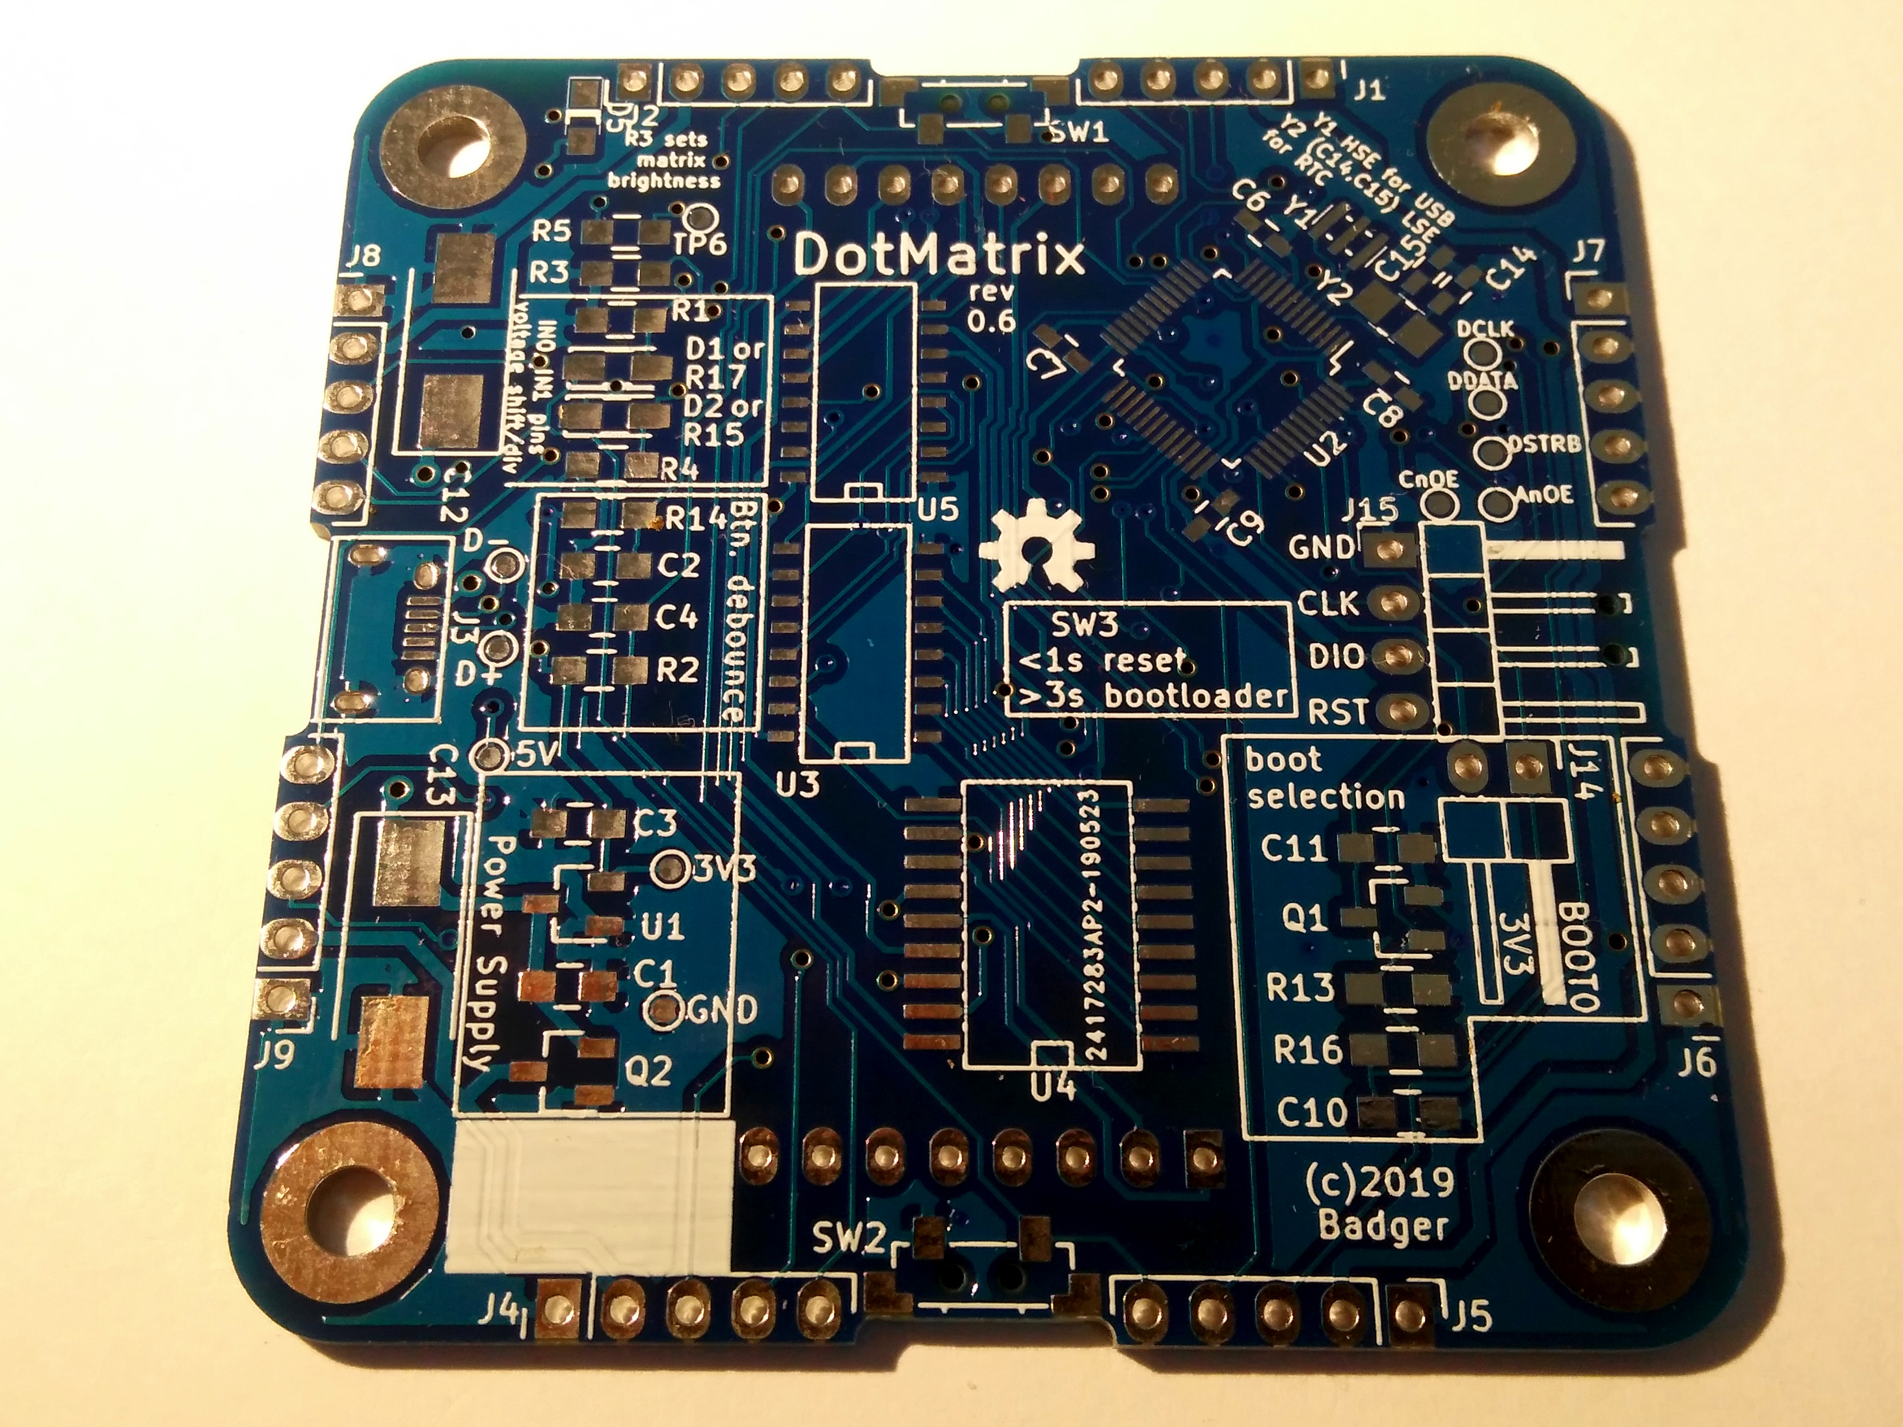 |  | M3x15+6 spacer | 4 | 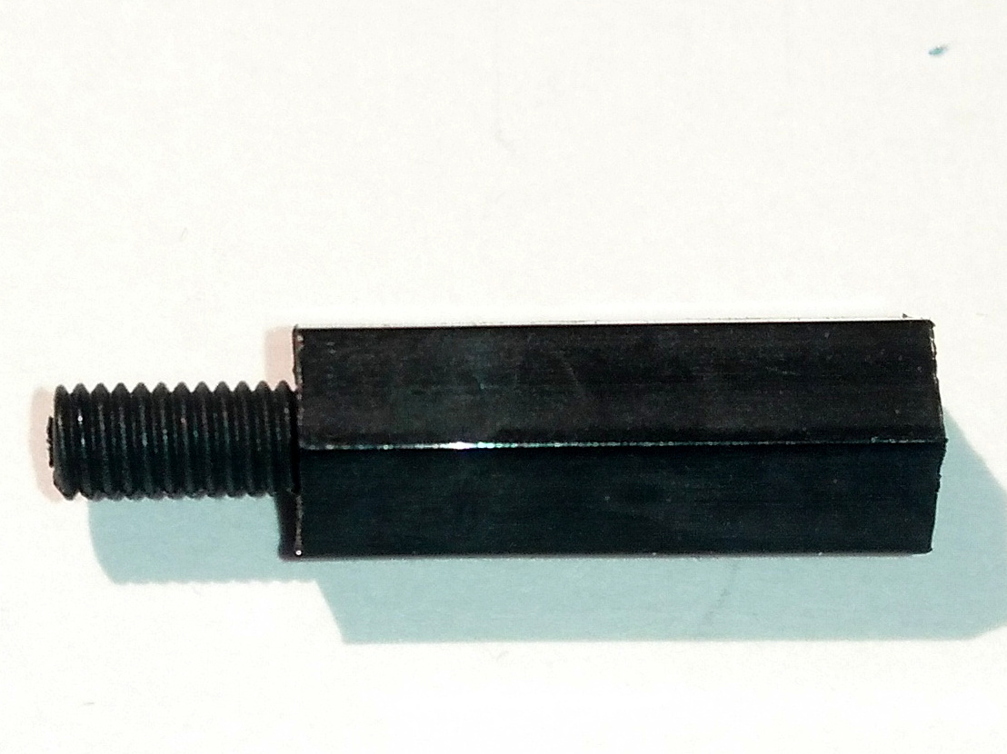
Display Support | 1 | 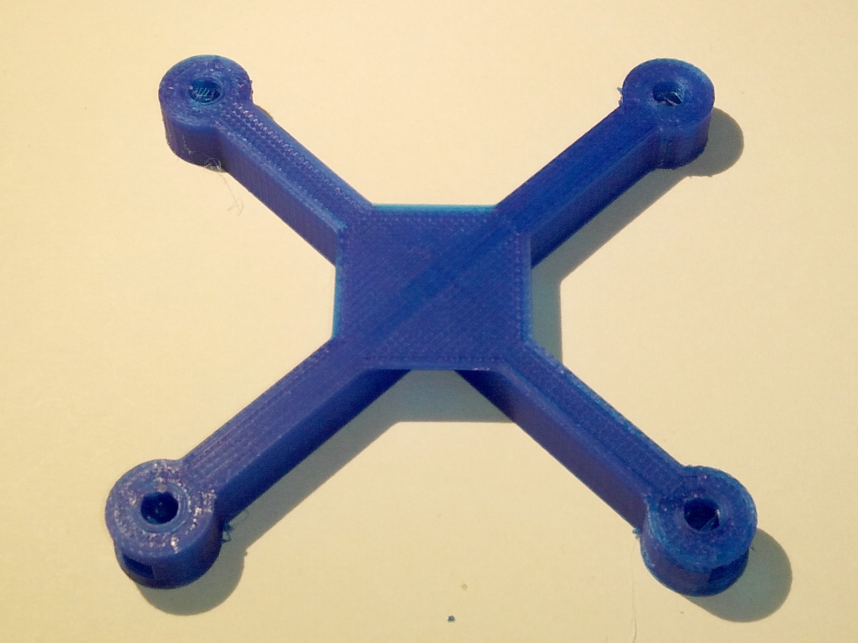 |  | M3x6 bolt + washer | 4 | 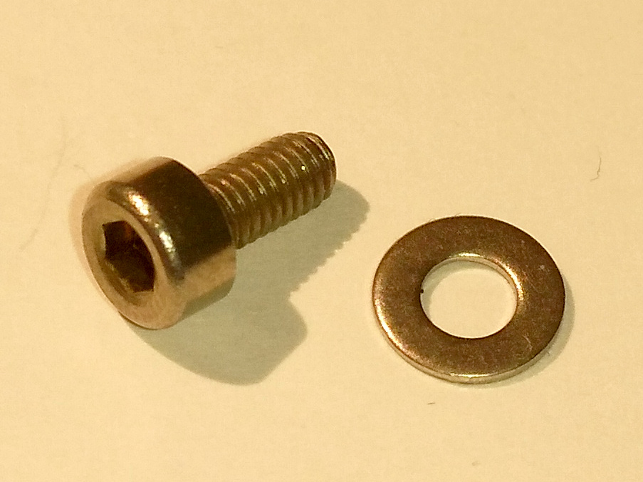
Board Joint | 2 | 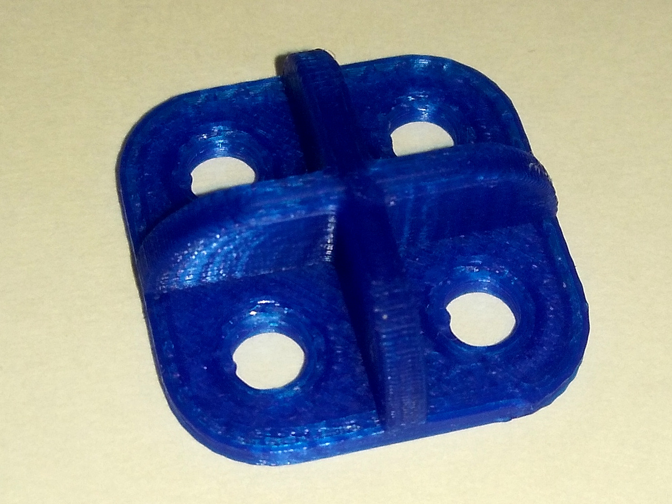 |  | M3 nut | 4 | 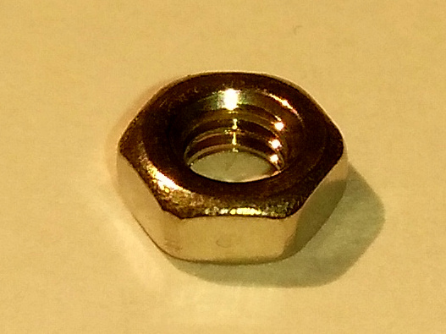
Small Bread Board | 4 | 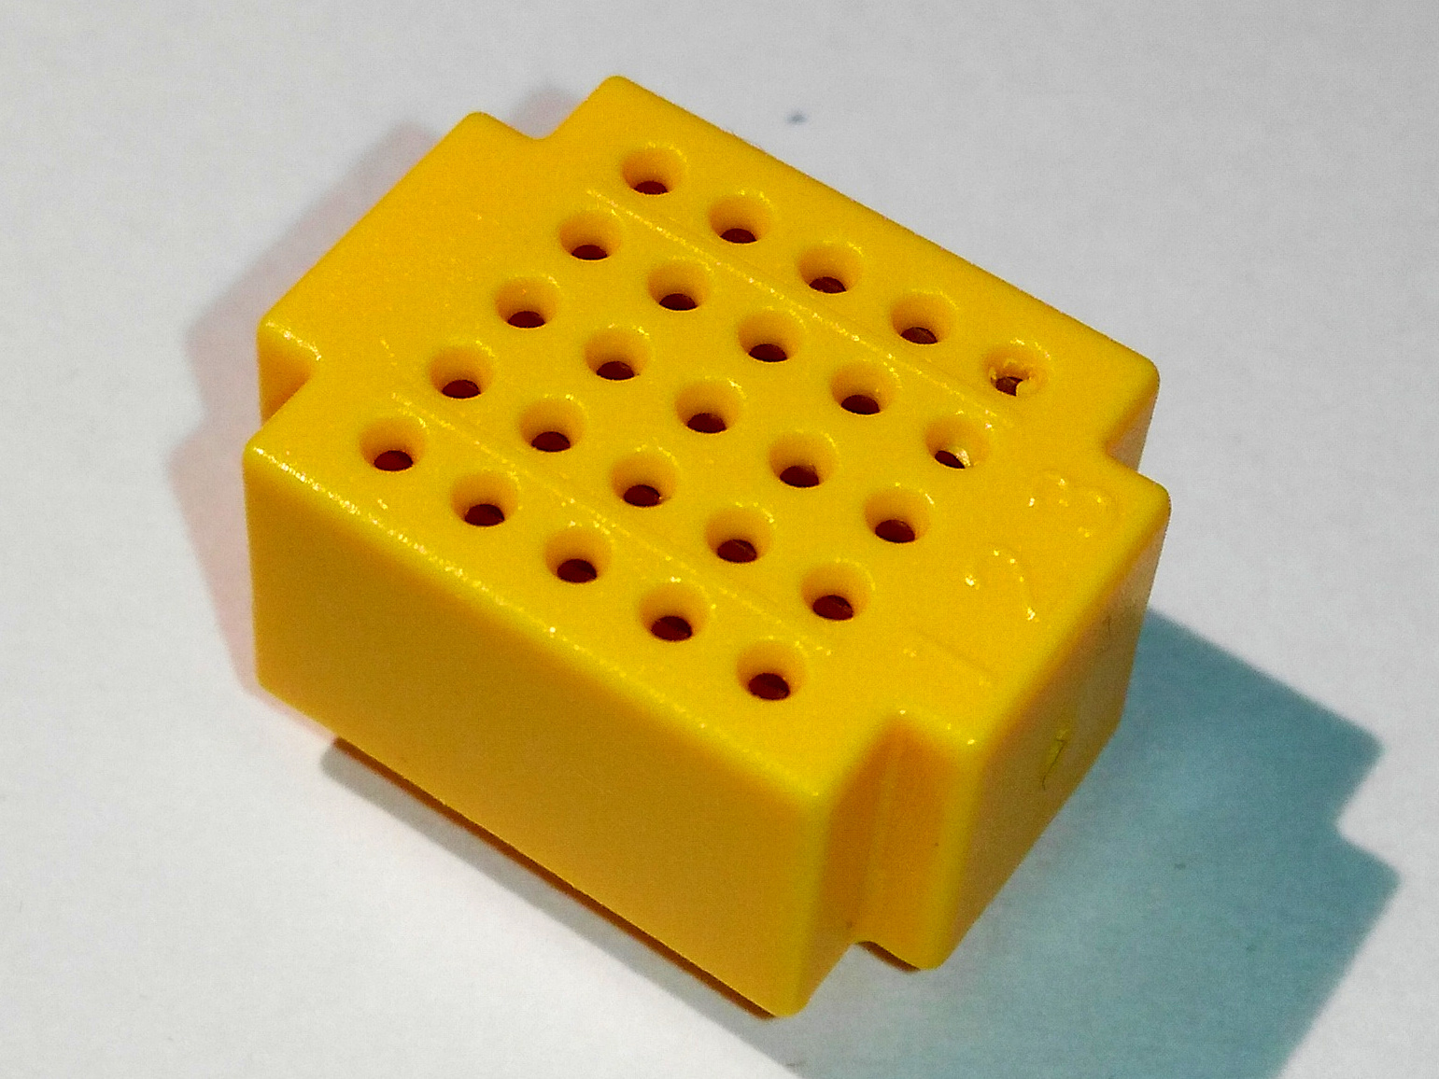
Table 1: Mechanical components
Reference | Pcs | Value | case
C1, C10, C3 | 3 | 4u7 | SMD 0805 | 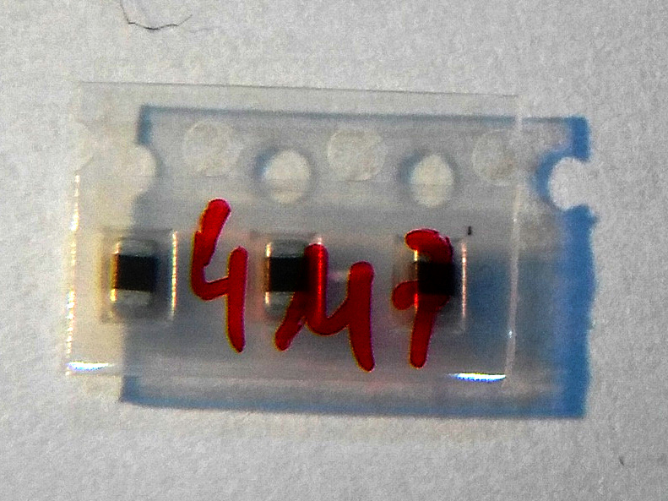
C12, C13 | 2 | 220u | EIA-7343-20 | not populated
C14, C15 | 2 | 2pF | SMD 0805 | 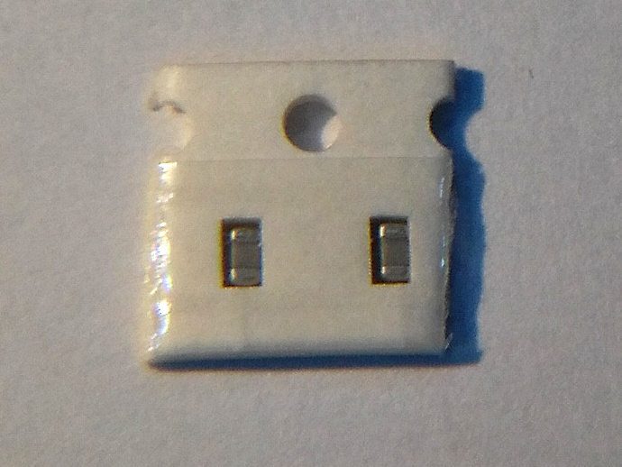
C11, C2, C4 | 3 | 100n | SMD 0805 | 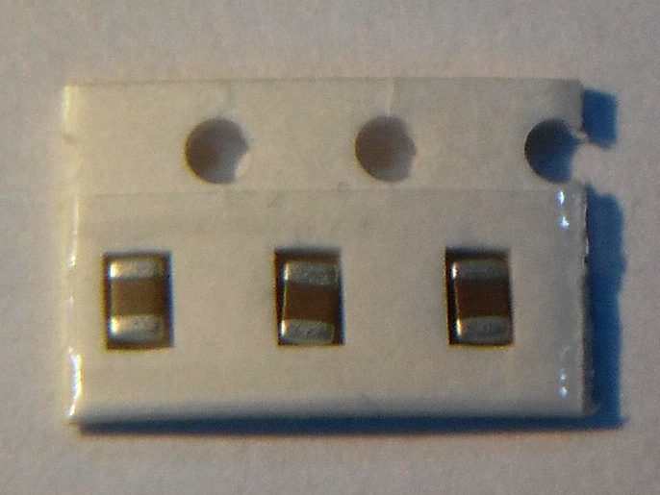
C6, C7, C8, C9 | 4 | 100n | SMD 0805 | 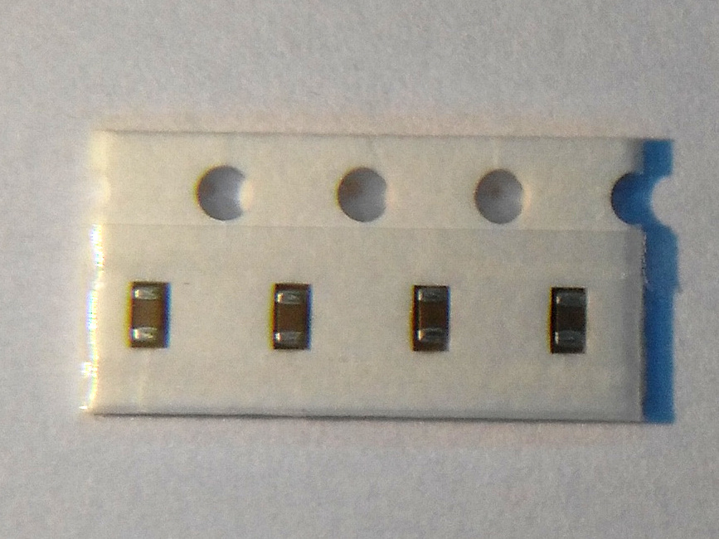
D1, D2 | 2 | Shottky | SOD-123 | 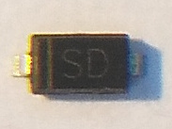
D5 | 1 | LED | SMD 0805 | 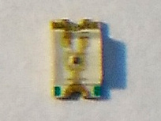
D6 | 1 |  | LED_8x8_60x60 | 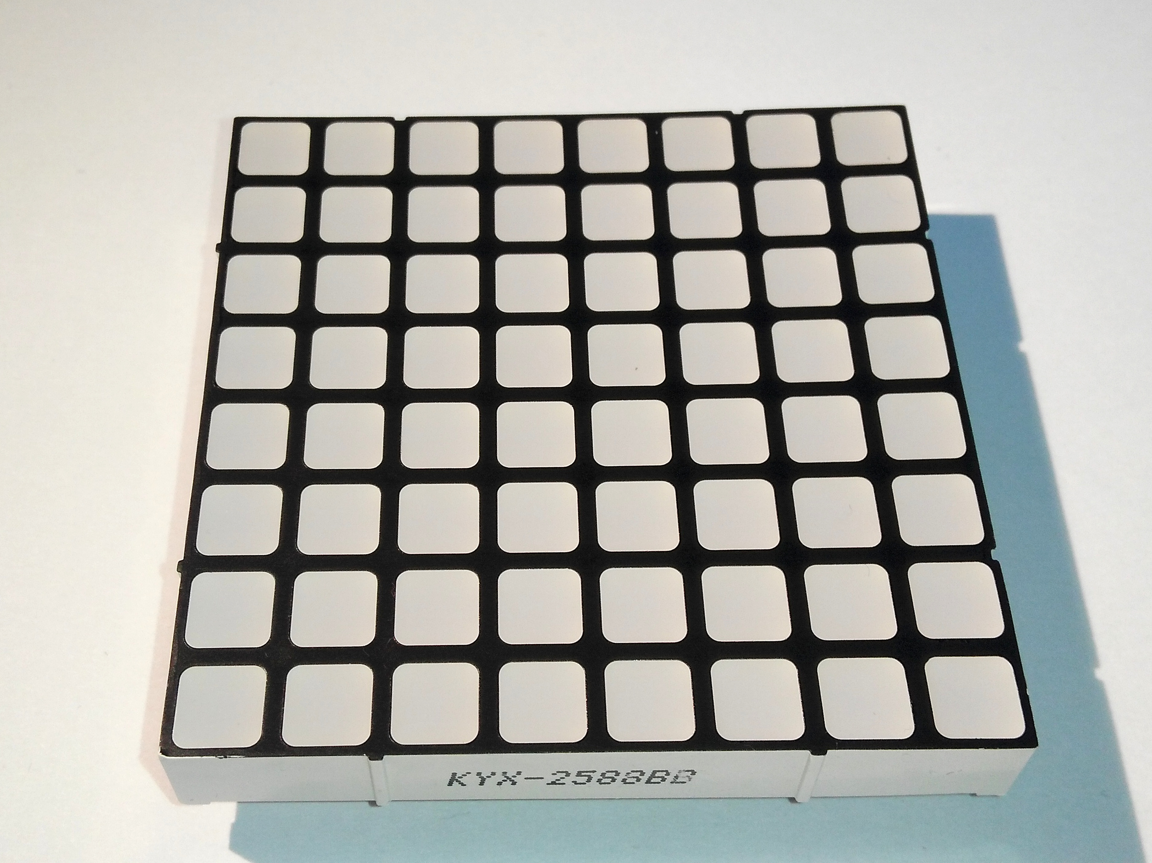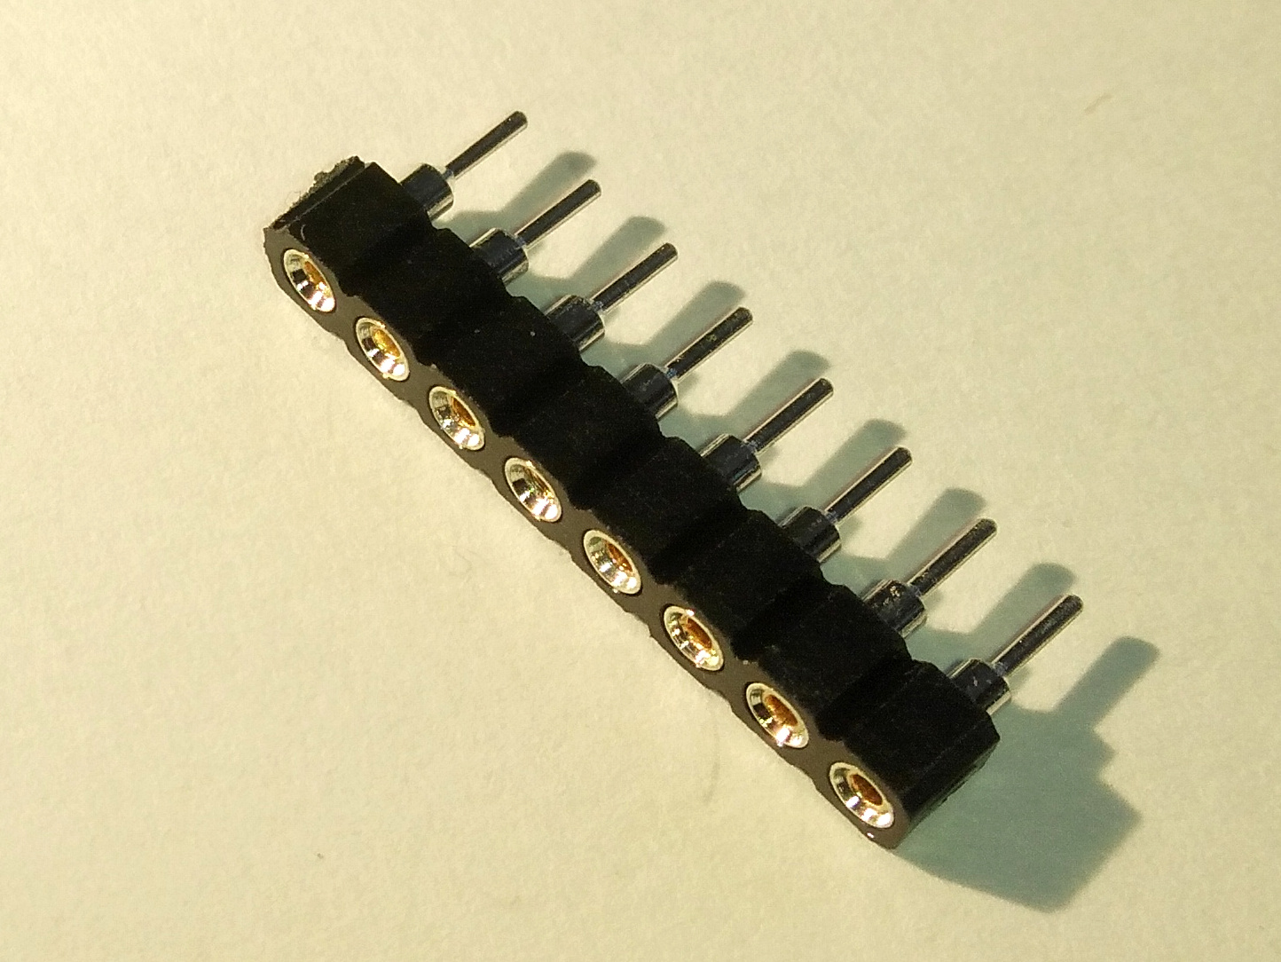
J1, J2, J4, J5, J6, J7, J8, J9 | 8 |  | Hdr_1x05_2.54 | 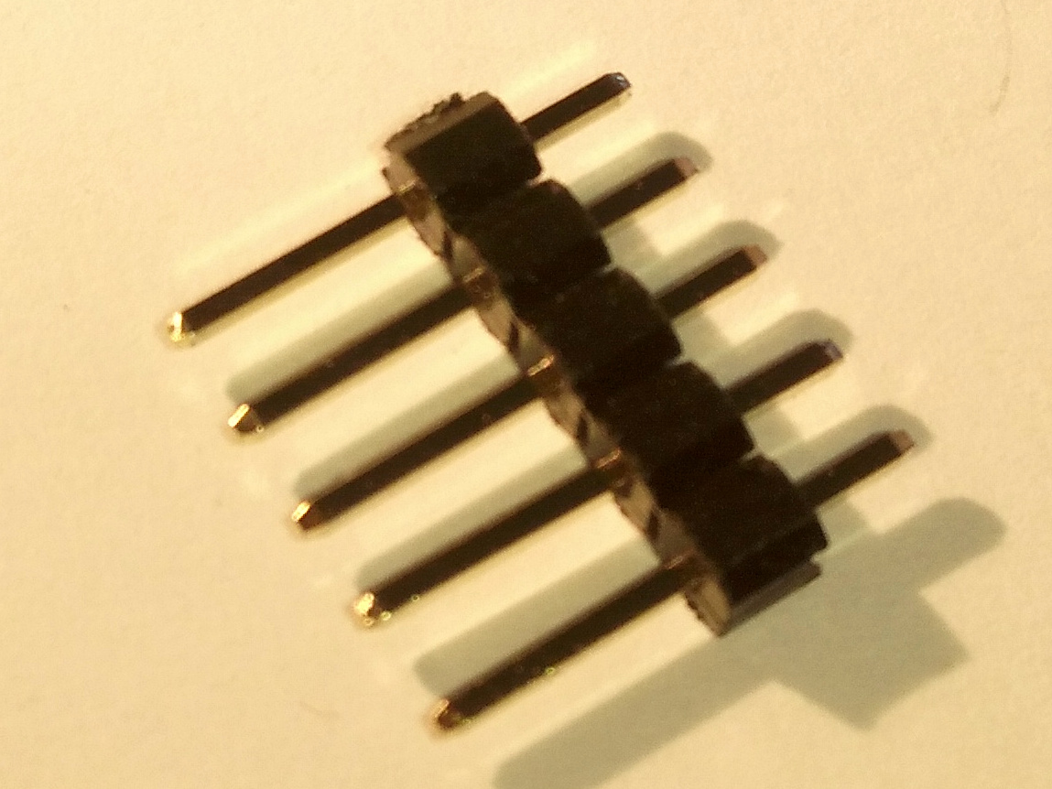
J15 | 1 |  | hdr_1x04_2.54 angled | 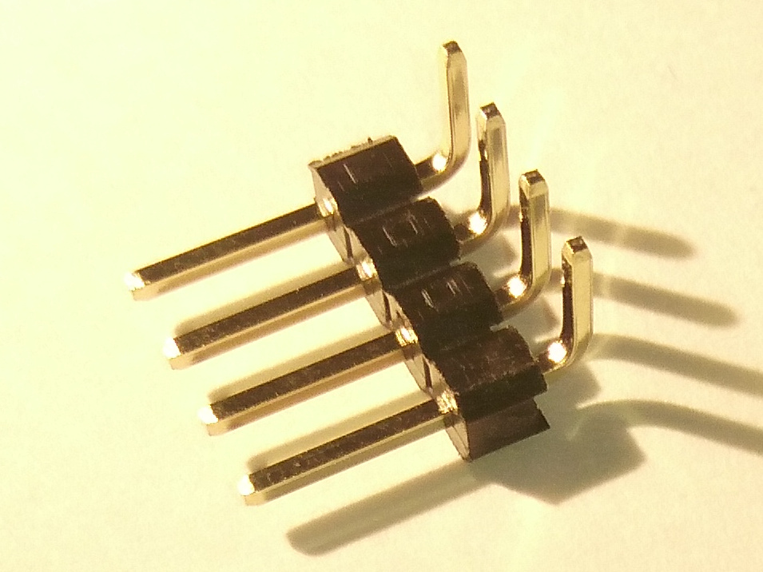
J3 | 1 |  | USB_Micro-B | 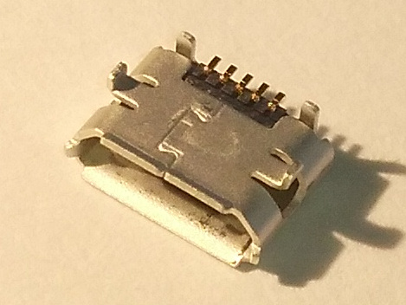
Q1 | 1 | BSS138 | SOT-23 | 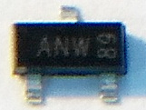
Q2 | 1 | IRLML6402 | SOT-23 | 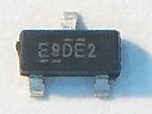
R14, R2 | 2 | 220k | SMD 0805 | 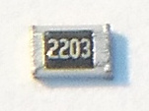
R15, R17 | 2 | R | SMD 0805 | not populated
R16 | 1 | 820k | SMD 0805 | 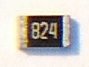
R1, R13, R4 | 3 | 10k | SMD 0805 | 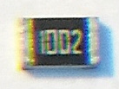
R3, R5 | 2 | 1k | SMD 0805 | 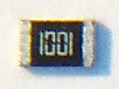
SW1, SW2, SW3 | 3 |  | switch  K2-1112SA | 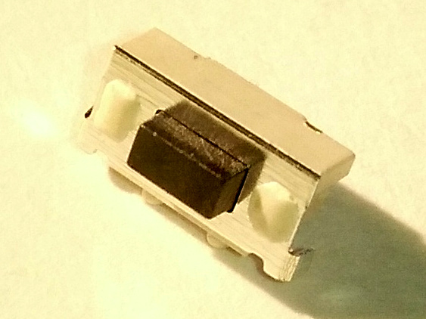
U1 | 1 | RT9166-33GVL | SOT-23 | 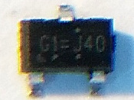
U2 | 1 | STM32F070CBTx | LQFP-48 | 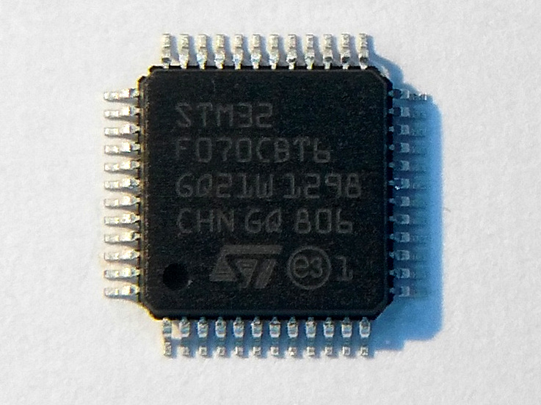
U3 | 1 | 74HC595 | SO-16-N | 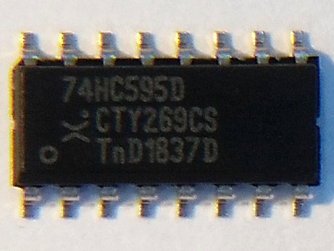
U4 | 1 | TD62783AFG | SOIC-18W | 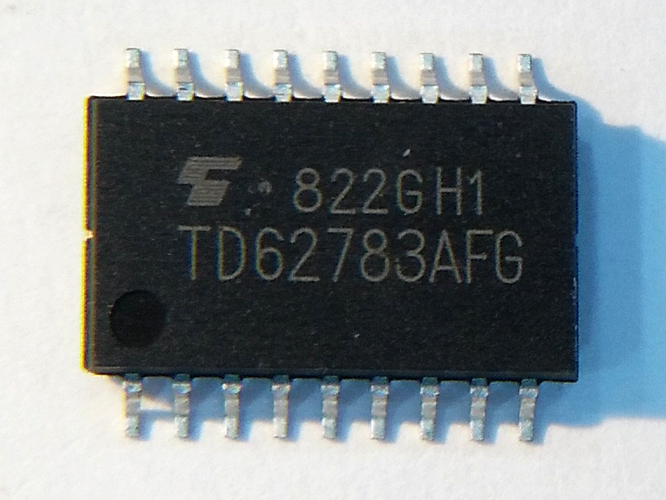
U5 | 1 | TLC5916 | SO-16-N | 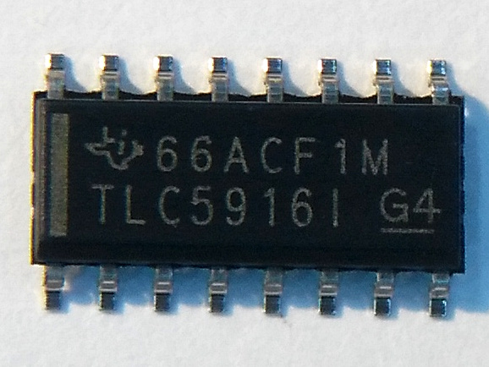
Y1 | 1 | Resonator | CSTCE_G | 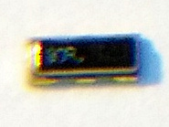
Y2 | 1 | ABS07-120-32.768kHz-T | ABS07-120-xx | 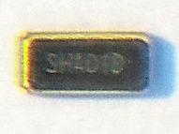
Table 2: Components list

