class4.R

yaniviny

2025-01-16

x <- 1:50  
plot(x, sin(x))

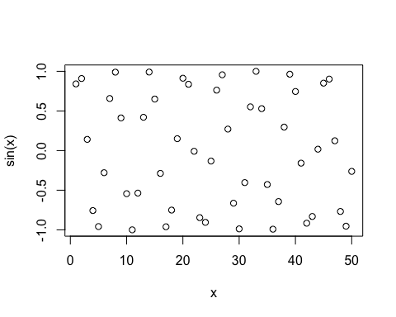

# make this nicer   
plot(x, sin(x), col="pink", type="l",lwd=3)

