**Ad Hoc Wi-Fi Network Simulator**

The simulator uses OMNET++/Mixim standard components and builds the 802.11g and needed application specific layers.

In OMENT++ the simulation is configured using a file named “omnetpp.ini”, since there are additional configurations needed from the Scheduler and Mobility-Generator application then a small application called “IniGen” is created on-order to create a configuration for the simulator.

This IniGen creates a file named omnetpp.ini.include which is then included from the main omnetpp.ini , this file contains the network structure and related parameters.

The network simulator itself reads the scheduling and requests file formats in order to perform the simulation, overall this is the class layers of the simulator:

* VideoStreamAppl – application layer per node which controls all channels/streams of the node and performs needed routing and statistics gathering
* AdHocWiFiApplLayer – implementing the application layer per channel which is control of :
  + Switching rounds every round time using event messages
  + Send/Receive of video messages
  + Handling of application/MAC addressing
  + Creation of initial video messages based on unique ID
* AdHocWiFiMsg – implementing message being passed by the system, this class holds information of each message (sender/receiver as well message ID and etc.)
* AdHocWiFiMac – implementing MAC layer , this is done for capturing TX over messages in order to compute actual TX send end time , this classes extends Mac80211g which is used to extend the built in MAC to 802.11g protocol
* AdHoxWiFiPhyLayer – implementing PHY layer , overriding message good/bad decider
* AdHocWiFiDecider - implementing packet accept decider for 802.11g based on different MCS rates as described in [1]
* AdHocWiFiPathLossModel – implementing the Path loss model formula which leads to attenuation over RX signal

Note: The implementation defines the AdHocWiFi NED package, this prefix is also used for all other implementation files, for simplicity running this package can be done by placing it inside Mixim examples directory.

**IniGen compilation**

The IniGen is a simple project for creating network topology and initial parameters for the simulator.

The IniGen uses the same source files as the Scheduler project.

This project is placed inside the IniGen directory and in order to build it one can use the “make” command from shell.

The IniGen directory should be placed under the following directory:

<OMNET-BASE-DIR>/samples/MiXiM/examples/AdHocWiFi

**IniGen run**

Running the IniGen is done by running inside the IniGen directory the bin/gen.exe executable and passing the name of the main parameters file which is used by the scheduler (commonly called params1.txt)

The output of this process is a file named omnetpp.ini.include

For example run: bin/gen.exe params1.txt

Another option (recommended) is to add also a parameter for the base directory of the scenario files, in this case the tools assumed the file names inside the parameters files are inside this directory, for example if the scenario+schedule files are inside a directory named scenario1 one directory above the IniGen directory then run:

bin/gen.exe params1.txt ../scenario1

This would enable having the scenario+schedule files in one directory without any copying of files.

**Simulator compilation**

The simulator AdHocWiFi directory should be placed under:

<OMNET-BASE-DIR>/samples/MiXiM/examples

Notice the OMNET++ make files are directory full-path dependent therefore one needs to regenerate them upon switching paths.

There are two scripts created for this:

1. Run: “AdHocWiFi/gen_make_top.sh” from the <OMNET-BASE-DIR>/samples/MiXiM/examples directory
2. Run: “gen_make.sh” from the <OMNET-BASE-DIR>/samples/MiXiM/examples/AdHocWiFi directory

The simulator can then be compiled either inside OMNET++ (Eclipse) environment by using the “build” command or using “make” from shell inside the AdHocWiFi directory.

To open the simulator start a command line shell and change into the OMNET++ installation directory <OMNET-BASE-DIR>,run "mingwenv.cmd" , the shell would switch to MinGW shell (Linux like), now enter "omnetpp &" – The GUI should now start , you can confirm the location of the default workspace.

For building inside Eclipse right-click on the Mixim project tree on the left panel and then select "Build project" as shown below:

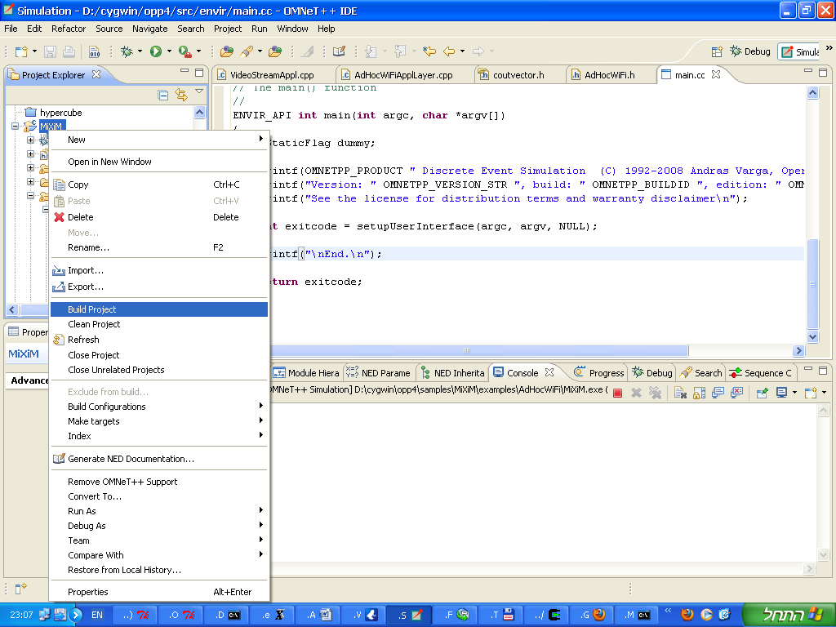

**Simulator run**

The simulation can be run either inside OMNET++ (Eclipse) environment by using the “run” command over the AdHocWiFi configurations or by command line using the “run.sh” from shell.

To setup and run from the Eclipse GUI:

1. Select "Run "Configurations…" from the "Run" menu

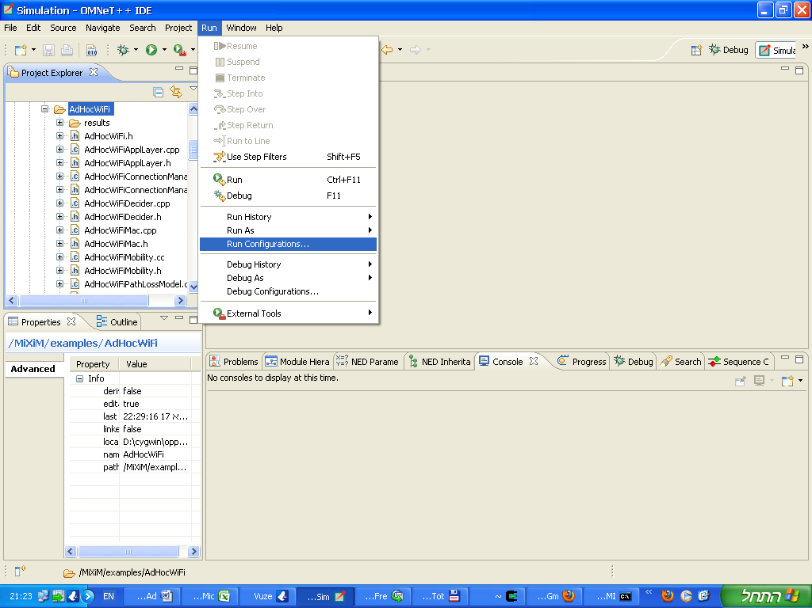

1. A new Dialog titled "Run Configurations" would open, click on the top-left button ("New launch configuration")

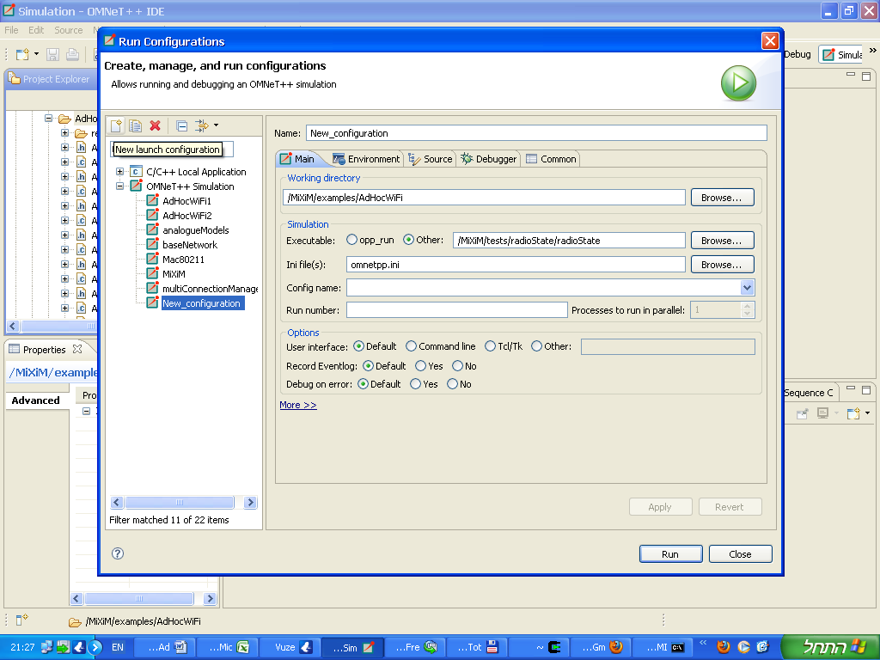

1. Fill in the details as following:

Name: AdHocWiFi1

Working directory: /MiXim/examples/AdHocWiFi

Executable: /MiXiM/examples/AdHocWiFi/MiXiM

Ini File(s): omnetpp.ini

Config name: Rescue

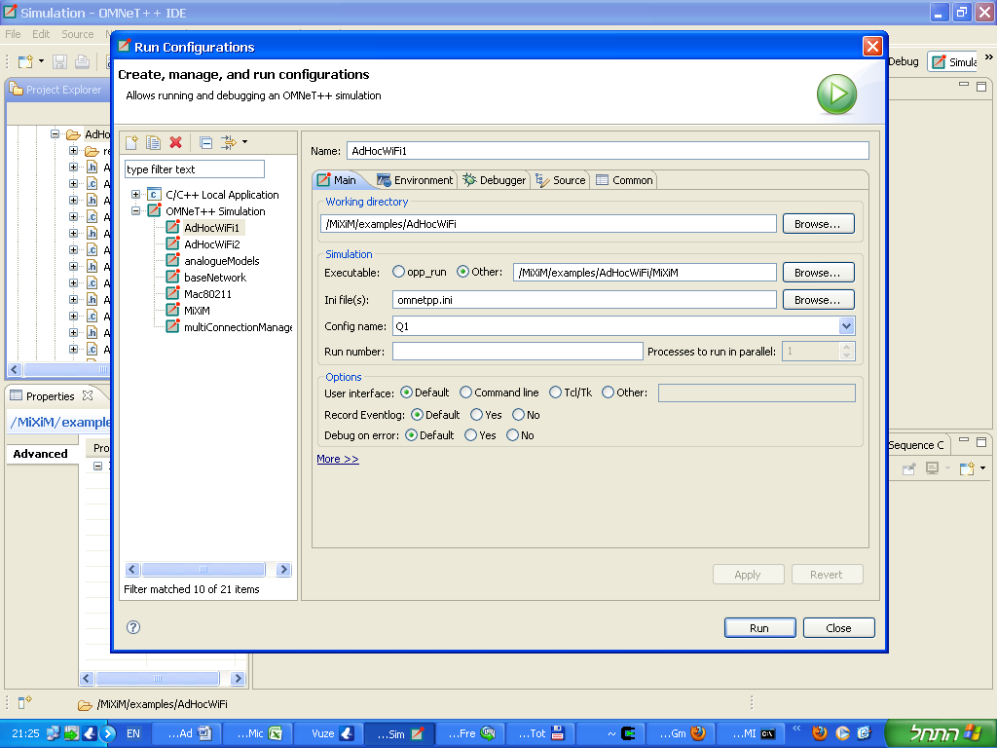

Click on the bottom-right "Run" button to run this configuration

* Following runs can be done by clicking on the "Run" icon:

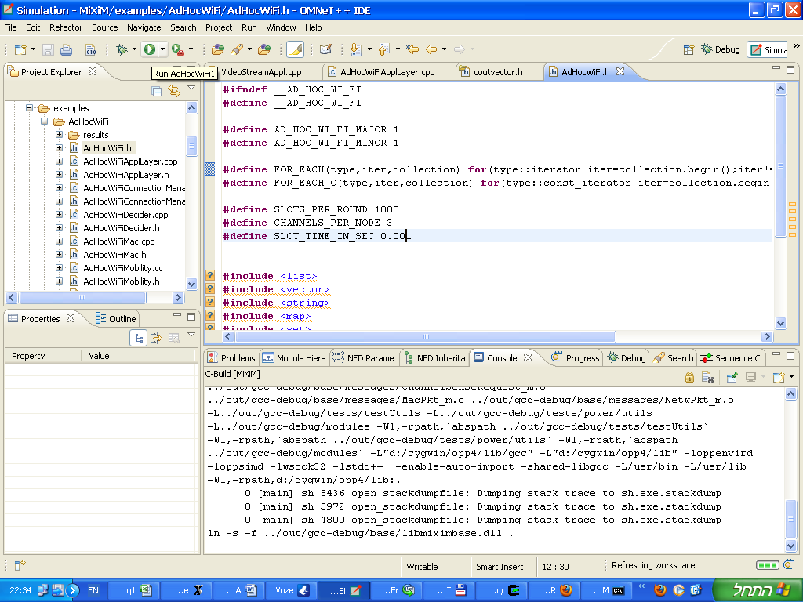

1. After starting the run the simulator GUI window would open similar to the following:

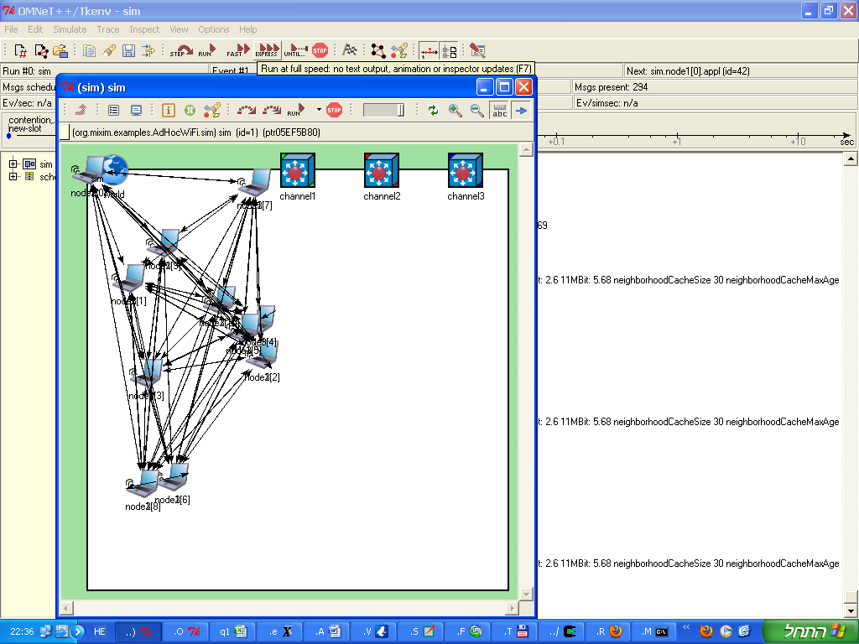

You can press the "Run" button for interactive mode but notice it may be slow, press the "Express" mode for full running speed.

Once simulation completes a pop-up message would show up, after closing the simulator windows the output files would be generated.

**Statistics collection**

The statistics is gathered using the OMNET++ standard vector/scalar file format, this data is later processed using OMNET++ scavetool to produce the needed graphs, specifically comma-separated CSV text format is exported which later can be imported by spreadsheet tools to produce graphs, Additional graphing tools can be used to produce graphs from the OMNET++ format.

In order to generate this statistics use the “make –C results gen_csv” from the base directory (<OMNET-BASE-DIR>/samples/MiXiM/examples/AdHocWiFi) , the <CONFIG-NAME>.csv file would be generated inside the results directory.

This .csv file can be imported into common tools such as MS Excel by simply dragging it to the Excel window.

Additionally there are Matlab/Octave tools which process this data and described later on.

There are two .csv files which are generated:

results/Rescue.csv – general parameters

event_log.csv – messages events log

**First time environment build instructions**

1. Checkout the repository omnetpp tar and unpack it to a directory and move into this directory (this is referred later as <OMNET-BASE-DIR>) in a command line shell
2. Run mingw.env from command-line
3. Run: “./configure” and then “make”, this would build Omnet++ libraries (may take several minutes)
4. Place the MiXiM directory from the repository into the <OMNET-BASE-DIR>/samples/MiXiM/ directory and move into this directory.
5. Run: “make -f makemakefiles CONFIGNAME=gcc-debug” and them “make all”, this would build the MiXiM libraries (may take several minutes)
6. Change into the <OMNET-BASE-DIR>/samples/MiXiM/examples/ directory, run: “AdHocWiFi/gen_make_top.sh”
7. Change into the <OMNET-BASE-DIR>/samples/MiXiM/examples/AdHocWiFi directory and run: “./gen_make.sh”
8. Run: “make”
9. Change into the <OMNET-BASE-DIR>/samples/MiXiM/examples/AdHocWiFi/IniGen directory, start a cygwin shell and run: “make” (this step isn’t required since Windows compiled executable is included in the repository unless you want to compile this executable which isn’t part of MiXiM)

**Command line full running flow for scenario**

* The following assumes the first environment build is complete
* Create a new directory under the <OMNET-BASE-DIR>/samples/MiXiM/examples , for example "scen/scenario1"
* Run the scenario generator and scheduler in this directory

The schedule, requests and coordinates file should be created

Use a file named “params1.txt” as the parameter file for the scenario.

* Start MinGW command line shell by running mingwenv.cmd inside the <OMNET-BASE-DIR> from either command line or windows explorer.
* Change into the AdHocWiFi directory (<OMNET-BASE-DIR>/samples/MiXiM/examples/AdHocWiFi) and run:

"make –C results TEST=../scen/scenario1/ COPY=1"

This would run the simulation in batch mode and produce a file named Rescue.csv and event_log.csv copied to test directory (../scen/scenario1)

* Create the graphs by running from within Matlab/Octave inside the <OMNET-BASE-DIR>/samples/MiXiM/examples/AdHocWiFi/analyze directory:

“AdHocWiFi(‘../results/Rescue.csv’,'../event_log.csv')

This step would create figures and also JPG files with the figures.

Running the simulator basic test

The basic test contains two nodes where node "1" sends to node "2" 8 streams each in different MCS for 1/10 of a second, during this time node "2" gets farther from node "1" in 5meter/sec.

This test is under <OMNET-BASE-DIR>/samples/MiXiM/examples/scen/line8 and it should be run exactly as in the above instructions where TEST=../scen/line8 in the make command.

Moreover to generate the graphs change into the ../scen/line8 directory and run from MatLab/Octave the command:

per2snr('Rescue.csv','event_log.csv')

The basic test should show a graph of Throughput per MCS in the simulation compared to the analysis and also a graph of PER to SNR for different MCS.

Dependencies:

* OMNET++

The simulator depends on OMNET++ and was tested with version 4.1

To download follow <http://www.omnetpp.org/> and check out the installation guide.

In general after extracting to a local directory (referred above as <OMNET-BASE-DIR>) you need to change to this directory and run from a command line run:

./configure

make

* MIXIM++

The wireless model library used is MiXiM version 1.1, To download follow <http://mixim.sourceforge.net/> and check the installation guide.

In general you need to extract the downloaded file into the <OMNET-BASE-DIR>/samples directory

Mixim would be built upon built of the simulator the first time.

Note: In order to extend MiXiM to 802.11g model the following file needs to be changed:

<OMNET-BASE-DIR>/samples/MiXiM/modules/mac/Mac80211.h

<OMNET-BASE-DIR>/samples/MiXiM/modules/mac/Mac80211.cc

<OMNET-BASE-DIR>/samples/MiXiM/modules/utility/Consts80211.h

These file should be updated according to the release in the repository to affect changes and updates done in order to support 802.11g rates suitable for our model (only 802.11g nodes).

* Matlab
  + Matlab can be used when analyzing simulation results.
  + Matlab is a commercial tool from MathWorks.
  + A free replacement named “Octave” can be used inside windows/cygwin (see below) or Linux.
* Cygwin/Octave
  + Cygwin is required in order to compile on windows shell, it isn’t required for running
  + Octave can be used to generate graphs of simulation results
  + To install Cygwin follow the instructions from <http://cygwin.com> , when installing include also the packages: make,gcc,xinit,xterm,octave
  + When running octave run within the X-Cygwin terminal

**Changing simulation parameters:**

Some parameters are related to the simulation only and are places inside the omnetpp.ini file inside the AdHocWiFi directory.

For example the statisticsMode parameter can be changed from "part" or "full", or "enableArbitration" can be set to true in order to enable arbitration between multiple tasks in the same slot.

Notice the parameters of the scenario are processed by the IniGen and are placed inside the IniGen/omnetpp.ini.include file.

References:

[1] <http://vega.unitbv.ro/~sorin.cocorada/omnetpp/>