the
Large
Hadron
Collider
project
CERN
CH-1211 Geneva 23
Switzerland
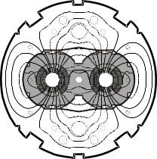
Functional Specification
VideO STREAM NETWORK SIMULATION

Design Specifications

Abstract

In order to efficiently use video stream application over a wireless network a novel scheduling algorithm has been developed, The performance of this algorithm will be evaluated by simulation. The simulator models Wi-Fi communication in which the nodes are capable of synchronous hopping between frequency channels. The simulator is developed using OMNeT++.

Yaniv Fais

Version 0.1 – 15-May-2010 [Draft]

Table of Contents
1. IntroductioN 3
1.1. Document Outline 3
1.2. Document Description 3
1.2.1. Introduction 3
1.2.2. System Overview 4
2. Design Considerations 4
2.1. Assumptions and Dependencies 4
2.2. General Constraints 5
2.3. Goals and Guidelines 5
2.4. Development Methods 5
3. Architectural Strategies 6
4. System Architecture 7
5. Policies and Tactics 8
6. Detailed System Design 9
7. Glossary 10
7.1.1. Mobile Ad Hoc Networks 10
7.1.2. Video Stream: 10
7.1.3. IEEE 802.11 : 10
7.1.4. WiFi: 10
7.1.5. MPEG: 10
7.1.6. OMNET++: 10
7.1.7. Mixim: 11
8. Bibliography 11

Introduction

A novel scheduling algorithm [1] has been developed in order to efficiently use a wireless network for streaming video transmission over the network, an OMENT++ [2] simulation model will be used to test and quantify this algorithm, this document would serve as a design specification for this network simulator subsystem.

Document Outline

The following document will describe the wireless network simulation application, it will include a description of the application goals, system and simulation model as well as design details.

Document Description

This document serves as a high level design for the network simulation sub-project of the video stream project. The document can serve for definition and overview of the project interfaces and goals. The design document is to be reviewed prior to implementation and then finalized and serve as an implementation guide for the project.

Introduction

Wireless networks have become very popular in recent years through the IEEE 802.11 (Wi-Fi) standard and they are now very common in many devices for many applications.
Ad Hoc networks enable formation of changing network, while those networks are very robust they suffer from bandwidth problem due to interference from neighboring nodes.
Network traffic can be generally characterized into priorities according to band width requirements and delay considerations , while some traffic (such as email ) usually requires low bandwidth and can complete in some future time other forms of traffic such as video streams require both high bandwidth and require real-time performance thus highly effected by network congestion.
A novel scheduling algorithm has been developed in order to enable usage of video streams over wireless networks, the scope of this project is to use this algorithm and simulate its network video traffic using a network simulator and test the results in a video player.

System Overview
Video File
Wireless Network
Simulation
Video Player
Scenario generator
Scheduler

The project system is composed of a scenario generator, a scheduling algorithm and network simulator, The first two components are external and are considered inputs to the simulator.
The output of the simulator is the actual network traffic, this output can be used to compose a video from input video stream traffic, and this video can be then played using a video player.

Design Considerations

Assumptions and Dependencies

In order to divide and distribute the video networking usage several assumptions need to be made:
- The main problem of network traffic is for "real-time" video data information, therefore control information such as nodes requirements and network formation are considered low bandwidth and can be synchronized in low frequency, we thus assume the network and loads are in steady state and this state change is ignored. (The synchronization is available through accurate clock in each node due to GPS availability, we assume clock skew is negligible).
- The traffic can be characterized by video, audio and data , we focus on video of MPEG H.264 type which can be partitioned into two types of frames: I and P… [TODO: need to clarify this after follow-up meeting]
- The network simulator is dependent on the existence of the scenario generator and the scheduler applications to provide inputs.
- The network simulator is dependent on OMNET++ and its wireless model (Mixim [3]) accuracy and speed.

General Constraints

Processing video streams in a large network is done by several parallel and fast processors (CPU's,WiFi cards and etc..), a simulation model is used in order to simulate the entire system on a single processor in a serial way using an event based simulation algorithm, this means the performance of the simulation would be much slower than the real system.
In the real system the video should be viewed in real-time however in the simulation environment a single video can be processed , collected and later viewed, since only the viewing part is required to be in "real-time" the simulation can be much longer however to have meaningful results we need to have some reasonable ratio such that it may take hours/days to transfer seconds/minutes of video (in other words the transmission of several frames in a simulation wall clock month time isn't reasonable).

Goals and Guidelines

The goal of the simulator is to enable quantifying the capabilities of the scheduling algorithm and in different scenarios, in order to enable this the system has been partitioned into a scenario generator and a scheduler application which provide inputs to the simulator, the simulator can then be used in order to check the network traffic according to the scenario and scheduling and accumulate a video stream in the destination nodes, this video stream can then be viewed by a video player, since video players employ advanced techniques to compensate on poor input data quality the subjective viewing of the video will be used to measure to effectiveness of the scheduler in the given scenario.

Development Methods

The development would be done using the free and open-source network simulator OMNET++ and its wireless model Mixim, the video processing would be done using the free open-source Video LAN Player (VLC) [4].
The above components are publicly available free of charge for academic usage and enable easy adoption for multiple developers and are mostly suitable for academic research purposes.
The network simulator has been used by several research projects and its documentation and support is available publicly [5], several projects usage results has also been published [6].
The network simulator developments components can be added using C++ code to enable additional capabilities, this environment can be used in Linux or Windows systems.
The network simulator has a rich GUI development and run environment as well as statistics processing capabilities.

Architectural Strategies

In order to test the system in different scenarios and for development to be done by different groups the system was decomposed into the scenario generator and the scheduler who feed the network simulator.
This architecture should enable the testing the system in different scenarios, the network simulator itself needs to allow flexibility in scenario building and network model.
The network model needs to be flexible in order to enable additional network flow control algorithms on nodes.
The simulation would be done in two modes – real video processing and generic data processing, in case a real video is processed it should be provide as input and in case a generic data is processed the transmitted data is assumed to be arbitrary, in this case the output would only be the rate statistics

System Architecture

The network simulator system is partitioned into several components according to input/output processing and common network layers modeling.

Input Video Stream

Application Layer
Video
Stream
Accumulation

Scheduler
Mac Layer
Input Reader
Phy Layer
Scenario Generator

Video Player
Statistics processing

- Input scenario reader
The input of the simulator is the scenario generator and the scheduling table.
The scenario generator should provide parameters to the network model whereas the scheduler should provide the transmission table to nodes.
The input scenario should use reader from parameter files similar to the scheduler where possible, if not possible the input reader should generate the OMNET++ parameters and network configuration.
- Optional input video reader
If the simulation is done in real video processing mode then an input video would be provided, in this case the video would be converted into packets and be correlated to the scenario and schedule table
- Network Physical (PHY) Layer and Analogue Model
As described in [7] the Phy and Analogue Models are responsible for simulating the attenuation (like shadowing, fading and path loss) of a received signal. The Radio module simulates the physical characteristics of the radio, like switching times and simplex / duplex capabilities and the Decider is responsible for evaluation (classification as noise or signal) and demodulation (bit error calculation) of the received messages. Additionally, it provides channel sensing information to the MAC layer. These models will implement the specific path loss model as decided in the project definition and a decider based on SINR model , implement BER rate according to modulation and provides statistical information such as reception SINR and times.
- Network Media Access Control (MAC) Layer
The MAC layer would simulate the 802.11 media access control protocol, this includes carrier sensing, request to send and etc.
As this protocol doesn't employ flow control additional enhancements to this layer may be needed in order to add flow control to the network if needed.
- Video Application Layer
The application layer should implement:
  - receive and accumulate of packets to compose a video frame
  - scheduled send according to table of video data
In case the application mode is not real video then simple data would be send and receive according to defined bandwidth
- Output video stream accumulation
Once video frames are accumulated in a receiver node application it would be composed as an input stream (time+data) in a format suitable for the video player
- Statistics processing
Simulation results would be saved to file and later processes to report summary tables and graphs of needed statistics

Policies and Tactics

OMNET++ statistics data format would be used to save any statistics of the network simulation, this output textual data format would then be processed in order to create summary tables and graphs.
The OMNET++ scavetool would be used in order to convert the data to CSV format or matlab in order to be processed.
The statistics which is required is:
  - Obtained bandwidth vs. required bandwidth per stream (Application Layer).
  - Actual queue length per stream (Application Layer).
  - Packet error rate per stream per node (Channel Layer). Every failure is labeled with the cause of the failure, i.e.,
    - Due to interference (P/N ok but P/(N+I) too small).
    - Due to low reception power (P/N too small).
  - Packet delay from end to end (Channel Layer).
  - Jitter buffer delay (Application Layer).
  - "Black Screen" time as a function of the jitter buffer length (Application Layer).

Detailed System Design

- Input scenario reader
  - NedCreator - class used for creating an input OMNET++ configuration file of type .ned
This class would parse scenario input files and convert it to the needed .ned format
- Input video reader
  - VideoReader – class responsible for reading video and forming data packets from them, these packets would be formed into queue of data which would then be used by the node application layer for sending
- Phy Layer
  - VidStreamPhyLayer – wrapping class for analogue models and path loss model,derived from 80211PhyLayer
  - VidStreamDecider – class used to decide whether a Mixim AirFrame can be used to receive a packet or considered as noise
  - VidStreamPathLossModel – class implementing the attenuation formula of the wireless network
- Mac Layer
  - VidStreamMac – class implementing MAC layer , derived from 80211MacLayer
Additional packet types would be added and the necessary receive frame methods would be overloaded if flow control implementation would be needed according to queue size
- Application Layer
  - VidStreamApplication – class implementing the video application
    - This class would read the scheduler table, each node according to its ID would send if needed a packet according to the video stream data as filled by the video reader or route according to received packets
- Video stream accumulator
  - VidStreamCreator – a class responsible for creating a stream (data/time) format for the video player according to destination application received WiFi packets
- Statistics processing – OMNET++ data format would be used for saving statistics of simulation, OMNET++ scavetool would be used for converting this format to CSV or MATLAB format where the summary statistics would be processesed
This requires an additional external component – possible a Perl or Matlab script
NedCreator
readNetwork()
readCommunication()
readParameters()
writeNed()

VidStreamPhyLayer

handleMessage()

PhyLayer (Mixim)
..
….
VidStreamMacLayer
Initialize()
handleLowerControl()
sendPause()

MAC80211 (Mixim)
..
….
VidStreamDecider
Threshold : float-
calculateDuration()
isPacketOK()
checkIfSignalOK()

Decider80211 (Mixim)
..
….
VidStreamPathLostModel
alpha,beta : float-
filterSignal(Signal)

AnalogModel (Mixim)
..
….
BaseApplLayer(Mixim)
…
…
VidStreamApplLayer
InputStreamFifo : list<packet>
routeStreamFifo: list<packet>
handleLowerMsg()
sendMessage()

…
…
VideoReader
file name: string
packets : list<uint8*>
readFile()
createPackets()

VideoStreamAccumulator
packets : list<uint8*>
writeStreamFile()

1
1
1
1
1
1
1
1
1
1

Glossary

Mobile Ad Hoc Networks
A mobile ad hoc network is a self configuring network of mobile devices connected by wireless links. Each device (called node) may act as an independent router and be free to move independently in any direction. Therefore, it allows reconfiguration around broken or blocked paths.
The node mobility causes a frequently change of transfer path.

Video Stream:
Live video presented to the end-user, while being delivered by a streaming provider.

IEEE 802.11 :
IEEE organization's set of standards for wireless local area network (WLAN) computer communication. Most popular standards are: 802.11a, 802.11b, 802.11g, 802.11n.

WiFi:
Wi-Fi is a trademark owned by the Wi-Fi Alliance (WFA) trade group. Wi-Fi networks use the IEEE 802.11 standard for providing secure, reliable and fast wirless connectivity.

MPEG:
The Moving Picture Experts Group (MPEG) is ISO's standards for audio and video compression and transmission. (Video compression is used for reducing the quantity of data used to represent digital video images.)

OMNET++:
OMNET++ is a discrete event simulation environment. Its primary application area is the simulation of communication networks.
Although OMNET++ is not a network simulator itself, it is currently gaining widespread popularity as a network simulation platform in the scientific community as well as in industrial settings, and building up a large user community.
One of its strengths is being a currently developed open source environment, allowing the team to take part in the future development of the environment.

Mixim:
MiXiM (mixed simulator) is a simulation framework for wireless and mobile networks using the OMNeT++ simulation engine. Mixim Framework shall be used for IEEE 802.11 and complex routing implementations.

Bibliography

  - Frequency and Time Slot Assignment Algorithm Report By Guy Even, Moni Shahar, Alexander Zadorojniy.
[2] OMENT++ (http://www.omnepp.org)
[3] MIXIM (http://mixim.sourceforge.net/)
[4] VLC – (http://www.videolan.org)
[5] OMNET++ support group (http://groups.google.com/group/omnetpp)
[6] OMENT++ projects publications – (http:://www.omnet-workshop.org)
[7] MiXiM – The Physical Layer An Architecture Overview (Karl Wessel, Michael Swigulski, Andreas Köpke, Daniel Willkomm - Technische Universität Berlin, Telecommunication Networks Group - Berlin, Germany)
[8] - Simulating Wireless and Mobile Networks in OMNeT++ - The MiXiM Vision
(A. Köpke, M. Swigulski,K. Wessel, D. Willkomm - Technische Universität Berlin , Germany)
[9] Simulation of Ad Hoc Routing Protocols using OMNeT++ - A Case Study for the DYMO Protocol (Christoph Sommer , Isabel Dietrich , Falko Dressle)
[10] An IEEE 802.11g simulation model with extended debug capabilities (Sorin Cocorada)

Appendix A – input files format
// input files
COMMUNICATION_GRAPH_FILENAME, string, CommGraph.txt
INTERFERENCE_GRAPH_FILENAME, string, InterfGraph.txt
COORDS_FILENAME, string, Coords.txt
REQUESTS_FILENAME, string, Requests.txt

N_FREQS_FOR_SCHEDULE, int, 3

// output period and resolution
TIME_PERIOD, int, 600
TIME_RESOLUTION, int, 1

// number of clients
N_CLIENTS, int, 100

// number of requests from each type
N_NEAR_REQUEST, int, 5
N_FAR_REQUEST, int, 7
// definition of when a request is considered far
FAR_THRESHOLD, double, 0.3

// 3 km square - the program select points in the unit square,
// and then scales them up
SCALE_IN_METERS, int, 70000

// dynamic model (velocities are normalized to unit square)
// so 0.2 for a square of 30km means 6 km / h
MEAN_VELOCITY, double, 0.2
STD_VELOCITY, double, 0.1
MAX_VELOCITY, double, 0.4

// communication parameters
// in GHZ
FREQUENCY, double, 2.4
TRANSMISSION_POWER_IN_MILI_WATTS, double, 0.1

NOISE_IN_DBM, double, -101.7
SNR_TO_PER_FILE_NAME, string, snr2per.txt
// In meters (different model before and after)
D_BREAKPOINT, double, 20.
// STD in DB
SF_BEFORE_BREAKPOINT, double, 3.
SF_AFTER_BREAKPOINT, double, 6.
// Arbitrary - to get yes no for and edge instead of distribution
NUM_STD_FOR_DECAY, double, 3.

// Sensitivity parameters - for communication and interference (in db)
MIN_SNR_FOR_COMMUNICATION, double, 20.
MIN_SNR_FOR_INTERFERENCE, double, 10.

// protocol parameters - data size are in kbyte, other lengths in bits, times are in micro-seconds, rates are in mbit/sec
HEADER_TIME, double, 4.
PREAMBLE_TIME, double, 16.
MAC_SERVICE_TRAILER_TIME, double, 8
MAC_HEADER_LEN, double, 240.
MAC_FCS_LEN, double, 32.
MAC_RTS_LEN, double, 160.
MAC_CTS_LEN, double, 112.
MAC_ACK_LEN, double, 112.
DIFS_TIME, double, 28.
SIFS_TIME, double, 10.
CW_TIME, double, 135.
// this means 2kbytes = 16 kbits of data before encoding
PAYLOAD, double, 2.
Appendix B - Tables Format
- A communication graph table consists from an edge number, both its nodes i and j, edge capacity and PER. The graph is undirected and defines which nodes can communicate and at what conditions.
The delimiter is used to separate the fields in all the tables is comma ”,”. In the header (first row) of the table the number of edges and nodes will appear.
Edge number, i ,j , Capacity ,PER, MCS

- An interference graph (internal for an algorithm part) table consists from an edge
number and both its nodes i and j. The graph is undirected and defines which nodes interfere to each other. In the header of the table the number of edges will appear.
Edge number , i , j

- A coordinates table consists from a node number, its (x,y) at time zero and its velocity (speed and angle). In the header of the table the number of nodes will appear.
Node number , X , Y , V , A

- A location table consists from a node number and its (x,y) location in the plane.
Node number , X , Y

- A requests table consists from stream number, source node, required bandwidth, destinations number and list of destinations. Required bandwidth is a requirement for an actual rate in Mbps. In the header of the table the number of requests will appear.
Stream number , Source node , Required rate , Number of destinations

- A scheduler table consists from the time slot number, frequency for communication,
transmitter node, stream number, receivers number, receivers list, transmission rate and MCS index.
A transmission rate is a flow obtained by the algorithm on the edges between the transmitter and the receivers . We assume that the number of frequencies is 3, but the algorithm is capable to get the number of frequencies as a parameter. In the header of this table will appear the number of time slots in 1 second and a payload size. We assume that the same payload size is chosen for all transmissions in the table the header corresponds.
Slot , Frequency , Transmitter , Stream Number , number of Receivers , receivers list , Transmission rate

Appendix C – additional parameters
- Max transmission power [mW]
- Application – header length
- MAC - headerLength, slotDuration [sec], difs [sec] , maxTxAttempts, rtsCtsThreshold, neighborhoodCacheSize [sec] , neighborhoodCacheMaxAge [sec] , txPower [mW]
- Phy - thermalNoise [mW] , sensitivity [dBm] , timeRXToSleep [sec] , timeTXToRX [sec] ,timeTXToSleep [sec], timeSleepToRX [sec] , timeSleepToTX [sec]
- Decider – SINR threshold
- PathLossModel - Alpha , Beta
Appendix D – preliminary results
2 node setting – node A sends to node B
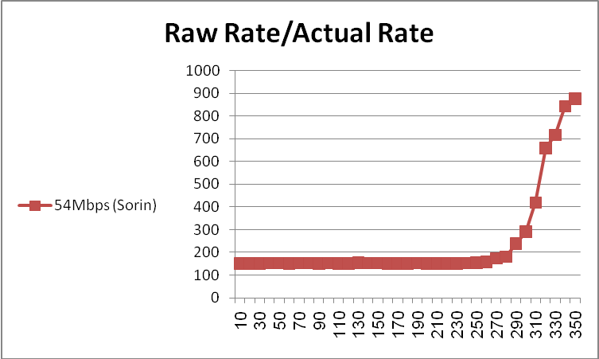
Distance [meters]
Notes:
- The raw rate is calculated based on "theoretical rate" , i.e – the rate in MAC bit rate , effectively the sender rate is limited by the receiver since ACK frames are required
- The actual rate is computed based on receiver frames start to frames end times multiplied by frames size
- in the given decider the packet loss is occurring only at some fixed range based on parameters
- Mixim doesn't model preamble , there is modeling for protocol different packets (ACK/DATA/RTS/CTS) however they can't be sent in different rates
- As can be seen from the graphs the rate decreases as a function of distance since the actual rate is decreasing due to latency and result of increased noise , once reaching a certain distance all the packets are lost and the rate is effectively infinity
Distance [meters]
4 nodes setting on a rectangle – node A/A' send to B/B'
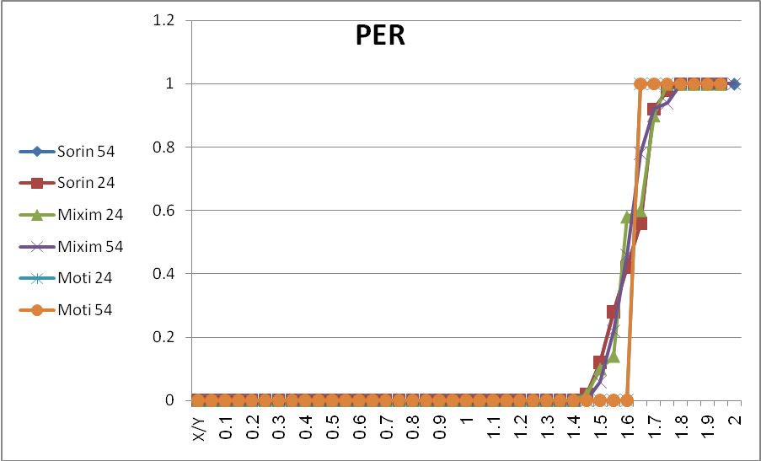
X/Y

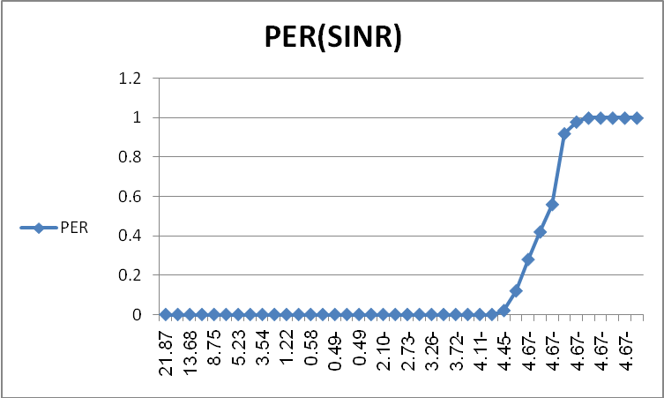
SINR[dB]

- Since our model uses hard decision and the attenuation model is distance based packet loss is occurring only at some distance
- Effectively SINR decreases by logarithmic fashion and the protocol handles the existence of another node by waiting for it to complete transmission, this leads to constant good packet error rate however the transmission rate is drastically decreasing
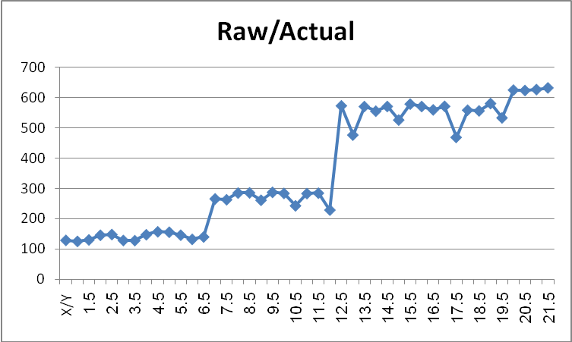

- Implementation
The implementation is done based on OMNET ++/Mixim Tutorials and examples, It consists of C++ and Ned basic implementation of network components.
The implementation is fully parameterizable and places the parameters in OMNET++ standard files – the omnetpp.ini file and the config.xml (for the Analog Modules).
The implementation is done in one set of files with two configurations:
- Q1 – two nodes
- Q2 – four nodes

In each configuration the node/nodes with even identification number (A/A') are sending frames to the node/nodes with odd identification number (B/B').
Moreover in order to simulate different ranges the simulation is partitioned into rounds, in each round the statistics are initialized and nodes with odd identification number move away from the sender nodes (the round time is very long , the movement itself is very slow ~ 5m/1.5h and propagation delay isn't modeled so this shouldn't influence the protocol).

For example configuration Q1 looks like:
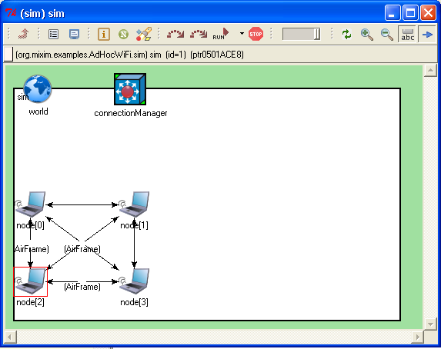
Where node[0] sends messages to node[1] and node[2] to node[3], in each round node[1] and node[3] are moving farther distance.
The implementation is done in the following files:
- AdHocWiFiApplLayer – implementing the application layer which is control of :
  - Switching rounds every round time using event messages
  - Send/Receive of test messages, the test messages are in fixed size
    - Actual rate is computed using messages arriving to application layer, the total number of messages is gathered in this module
    - Message send is done in bursts, the messages are send to MAC queue in the beginning of the "round" to mimic maximal send rate
  - Handling of application/MAC addressing

- AdHocWiFiMac – implementing MAC layer , this is done for capturing TX over messages in order to compute actual TX send end time
- AdHoxWiFiPhyLayer – implementing PHY layer , this is done for capturing the RX start messages in order to compute the actual receive time
- AdHocWiFiDecider - implementing packet accept decider, derived from Decider80211 which implements simple hard decision (SINR>Th), the packet BER modeling of Decider80211 is eliminated. The decider also stores SINR's for each round in order to gather statistics
- AdHocWiFiPathLossModel – implementing the Path loss model formula which leads to attenuation over RX signal

Note: The implementation defines the AdHocWiFi NED package, this prefix is also used for all other implementation files, for simplicity running this package can be done by placing it inside Mixim examples directory.

Statistics collection
The statistics is gathered using the OMNET++ standard vector/scalar file format, this data is later processed using OMNET++ scavetool to produce the needed graphs, specifically comma-separated CSV text format is exported which later can be imported by spreadsheet tools to produce graphs, Additional graphing tools can be used to produce graphs from the OMNET++ format.

