**A:** Clear

**A:** Help Command

**A:** $

**A:** Write-Output

**A:** Help -full Command

**A:** Get-Location

**A:** String of text

**A:** A variable with multiple values

**A:** .ps1

**A:**  Left to Right

**A:**  |

**A:**  Get-Content

**A:**  Get-member

**A:**

if (condition) {output}

elseif (condition) {output}

else{output}

Open questions PowerShell:

1. Write program in PowerShell that take two numbers from user and return as result the sum of them

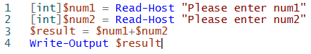**A:**

1. Write program in PowerShell that take username and password and put them into file

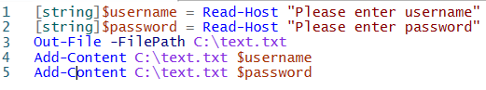**A:**

1. Write program that get the current running processes and return list of the running programs (just the name of the processes)

**A:**

1. Based on point 3 put all the output into file all the list of processes into file

**A:**

1. Write program that check application events list in windows and return them.

**A:**

1. Write program that close the calculator if its already running

**A:**

1. PowerShell go over process and print the process name only

**A:**

1. Open chrome and close it using PowerShell command.

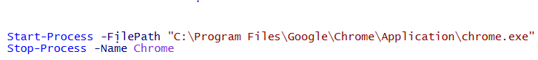**A:**

Open questions Bash:

1. Create new directory in Linux system write the step below:

**A:**

1. Is everything in Linux is file? true/false

**A:** True

1. Is Linux case sensitive Operation system? True/false.

**A:** True

1. 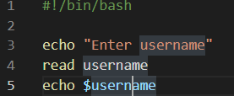Write shell script that take user input (for example username) and print the input into the screen  
   **A:**
2. 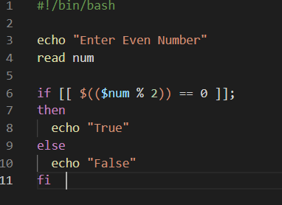Write shell script that ask user to enter a number, then check if number is even and print true false as result  
   **A:**
3. What is the command in Linux WSL to open the current directory in windows?

**A:**

**Open questions:**

1. What is bootstrap process explain it in your words?

**A:** **bootstrapping process sets up the execution environment**

1. What it is cmdlets

**A: is a special type of command provided in the Windows PowerShell command line environment**

1. What is CPU?

**A: Central Processing Unit – CPU process input, store data, and output results**

1. What its IO?

**A: Input and output - the communication between an information processing system**