RS Automation

Configuration:

Vscode, Python 3.0+, R, R Studio, R extension, Python extension in VSCODE

Configure VSCODE Python running environment.

Open VSCODE setting and put C:\Users\Ywang36\AppData\Local\Programs\R\R-4.2.1\bin\R.exe in r.rterm windows.

Need to install and import all the libraries first to run Automation.py successfully. Need to put ms_graph.py under the same folder with Automation.py

On command line:

Py -3 -m pip install requests

Py -3 -m pip install xlwings

…

Python functions createdir() is for creating new directories for further data processing, the parameter is the full path of the new directory.

The Python functions rmfilesfromdir() is for removing all files under certain directory, the parameter dir is the full path of the directory. It will empty the whole directory.

Python functions rmonefile() is for removing certain file under certain directory, the parameter dir is the full path of the directory.

Python functions copyonefile() is for copying one certain file from certain directory to the destinated directory, the parameter src is the source file path, the parameter dst is the destinated file path.

Python functions copyallfile() is for coping everything from certain directory to the destinated directory, the parameter srcdir is the source directory path, the parameter dstdir is the destinated directory path.

Python functions countfiles() is for counting files number under certain directory to see if there are missing files, the parameter srcdir is the source directory path.

The Python function copy_files_byfilename() is for copying files from source directory to destinated directory.

The Python function extract_first_six_chars() is for extracting the unique school number under certain directory to compare PDF and XLS reports count to find the missing files that don’t generated successfully.

The Python function RelatedServices() is for running SESIS CSD and Charter school level pdf reports, it creates the folders needed and delete previous week’s XLS and PDF files, the copy Mandated_Distribution_SY22-23 to the local C or D for faster and stable file processing. When the Access file is opened, click ‘Run’ to generate the PDF filles, Python time.sleep(50*60) is used to set up the running time, usually it takes 50 minutes to finish running the CSD PDF reports, afterwards the files are copied to destination folder and archive folder for backup. The CSD PDF file counts are usually around 1600, it may change week by week a little bit, so it’s normal to see it ranges from 1602/1601/1600. The Charter PDF file counts 275.

The Python function R_Process() is for running XLS SESIS CSD and Charter school level reports, it copy RS_Reports_2022_2023.R and RS_Reports_2022_2023_Charter.R to the local directory for faster and stable file processing. Click ‘Run’ button on VSCODE code editor or open R Studio to run RS_Reports_2022_2023.R, time.sleep() is to set up running time, XLS files for CSD school usually takes 35 minutes to finish running but it can be super slow when the network has traffic. After running it copied all XLS CSD reports to its destination folder and archive folder for backup. XLS files for Charter school usually take 5 minutes to finish running, after running it copied all XLS Charter school reports to its destination folder and archive folder for backup.

The Python function rerun_R() is for comparing pdf reports count and xls reports count, if pdf count == xls count, unique elements in the folder PDF and XLS both return an empty list, we are all good to move on; if pdf count > xls count, we miss some files from R_Processing and we need to re-run this step. If just a few files are missing, we can re-run them one by one by finding the missing school number according to the school number returning from unique elemens in the folder PDF.

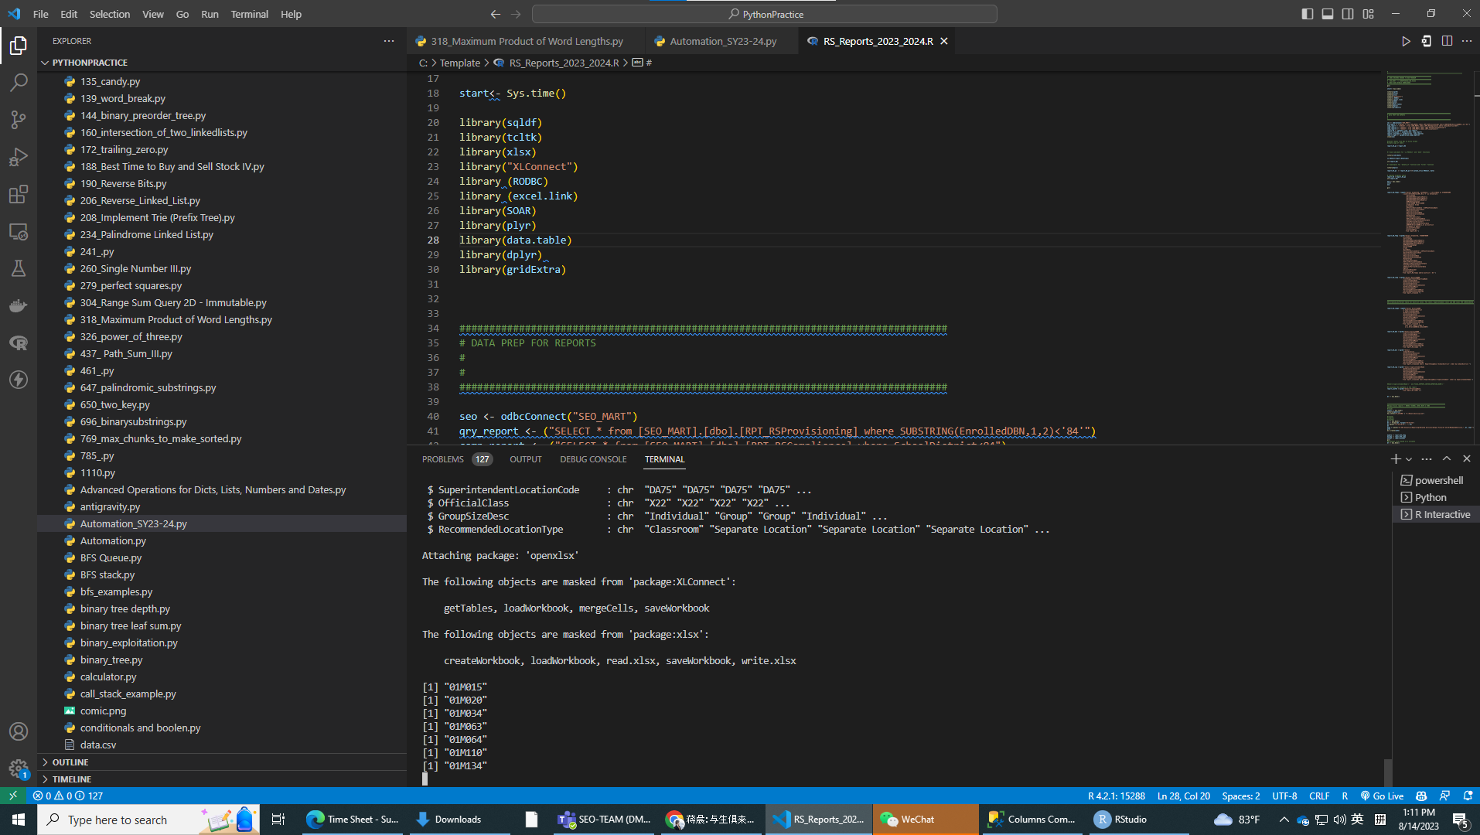

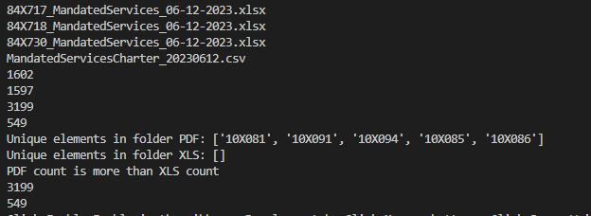

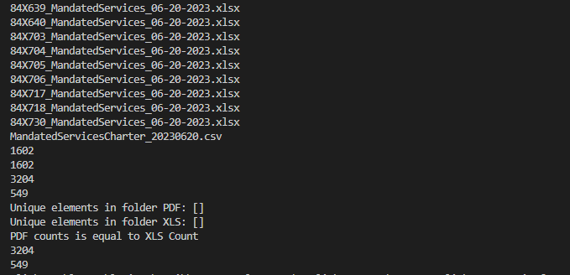

The Python function MandatedServicesAuto() is for generating SESIS Mandate reports, it open SESIS Mandate excel report and run the macro “ThisWorkbook.Mandated_Services_Weekly_Processing”. It takes less than 5 minutes to finish.

The Python function ms_send_outlook_email() sends email to users after weekly borough level reports are done.

The Python function rs_charter_send_outlook_email() sends email to users after weekly charter related services report is done.

The Python function rs_compliace_send_outlook_email() sends email to users after weekly borough level reports are done.

The Python function archive_rs_boriygh() is for archiving the dashboard and Powerpoint reports by borough that go on Sharepoint.

Put the Python functions need to be used in if__name__==’__main__’:

Python functions run in sequence, comment the function not needed to run.

