

《编译原理》课程实验报告

课程实验题目： 语法分析器
学 院： 计算机学院
班 级： 软件1705班
学 号： 0417140
姓 名： 付彦开
指导教师姓名： 陈 燕
完 成 时 间 ： 11月21日

一、实验目的
- 了解语法分析器的工作步骤
- 实现语法分析器的工作步骤
- 实验要求
- 输入任意一个文法G
- 输出由文法G构造的FIRST集算法
- 输出FIRST集
- 输出由文法G构造的FOLLOW集算法
- 输出FOLLOW集
- 实验内容
- 将输入的文法进行预处理，根据“|”分隔成两部分，构成新的文法；
- 根据“->”符号对文法进行分割，构成非终结符表；
- 根据终结符表再对文法进行处理，得到终结符表；
- 根据文法产生式和终结符和非终结符构造FIRST集；
- 根据文法产生式和终结符和非终结符构造FOLLOW集；
- 算法描述
- 识别非终结符
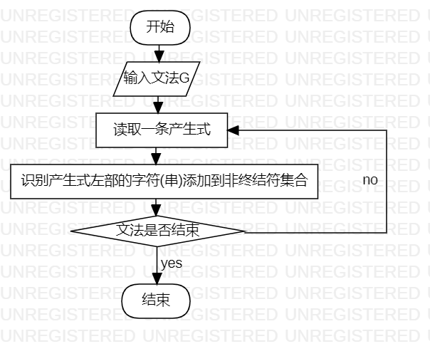
图1 识别非终结符
- 识别终结符
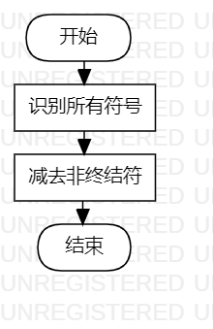
图2 识别终结符
- 构造FIRST集
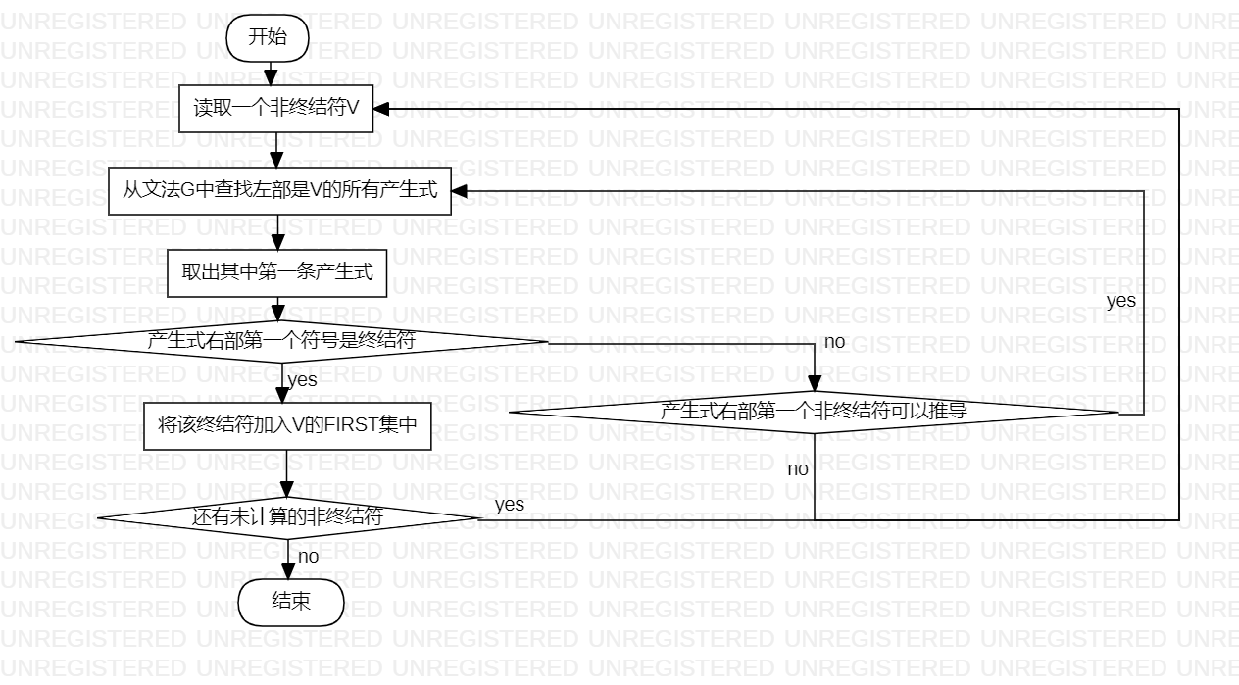
图3 构造FIRST集

- 构造FOLLOW集
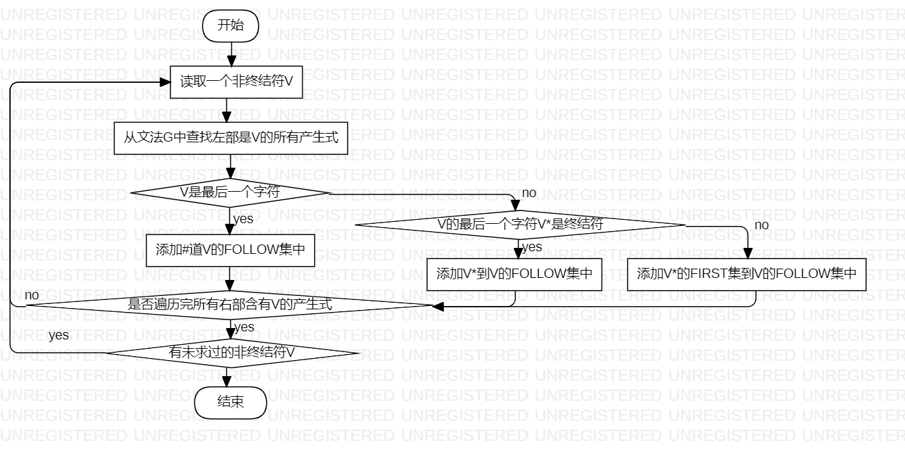
图4 构造FOLLOW集
- 运行结果
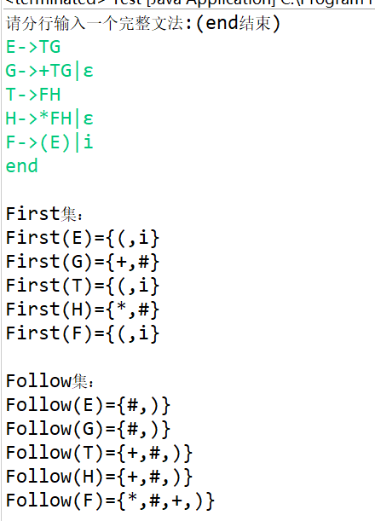
图6 运行结果

- 调试情况
第一次的时候没想到可以用总符号表减去非终结符号表得到终结符号表，写了很多冗余代码，跟同学讨论后突然想到这种更简单的方法。刚开始构造FIRST集和FOLLOW集的时候当右部第一个是可推导的非终结符时总是不能把它的FIRST集加入到前一个，后来改进算法才得以实现。总的来说FIRST集和FOLLOW集的构造不算复杂，只要细心即可。
- 设计技巧及体会
我负责的是构造FIRST集和FOLLOW集，因为这两个老师上课已经重点讲过了，所以实现起来没有多少困难，主要是细心，保证每次调用和进栈出栈顺序的正确。我是先自己在草稿纸上写了一遍，然后又用“死去活来法”先模拟过程实现了一个非常简单的文法FIRST集和FOLLOW集，最后把能扩展的地方再重新写一边，稍微调试下就可以了。
通过这次实验，更加了解了如何构造FIRST集和FOLLOW集，也更加了解了LL(1)的工作流程。
- 源程序清单（电子版）
import java.util.ArrayList;
import java.util.Scanner;
import java.util.StringTokenizer;

public class test {
public ArrayList<String[]> in = new ArrayList<String[]>();
public ArrayList<String[]> first = new ArrayList<String[]>();
public ArrayList<String[]> follow = new ArrayList<String[]>();
public ArrayList<String[]> track = new ArrayList<String[]>();

public test() {
Scanner sc = new Scanner(System.in);
System.out.println("请分行输入一个完整文法:(end结束)");
String sline = "";
sline = sc.nextLine();
while (!sline.startsWith("end")) {
StringBuffer buffer = new StringBuffer(sline);
int l = buffer.indexOf(" ");
while (l >= 0) {// 去空格
buffer.delete(l, l + 1);
l = buffer.indexOf(" ");
}
sline = buffer.toString();
String s[] = sline.split("->");
if (s.length == 1)
s = sline.split("→");
if (s.length == 1)
s = sline.split("=>");
if (s.length == 1) {
System.out.println("文法有误");
System.exit(0);
}
StringTokenizer fx = new StringTokenizer(s[1], "|︱");
while (fx.hasMoreTokens()) {
String[] one = new String[2];
one[0] = s[0];
one[1] = fx.nextToken();
in.add(one);
}
sline = sc.nextLine();
}
// 求First集过程
this.process("First");
/*
* 打印First集算法和First集
*/
// System.out.println("\nFirst集算法：");
// this.print(track);// 打印First集算法
System.out.println("\nFirst集：");
for (int i = 0; i < first.size(); i++) {
String[] r = first.get(i);
System.out.print("First(" + r[0] + ")={");
for (int j = 1; j < r.length; j++) {
System.out.print(r[j]);
if (j < r.length - 1)
System.out.print(",");
}
System.out.println("}");
}
track.clear();// 因为下面还要用，这里就先清空了
// 求Follow集过程
this.process("Follow");
// System.out.println("\nFollow集算法：");
// for (int i = 0; i < track.size(); i++) {
// String[] one = track.get(i);
// System.out.print("Follow(" + follow.get(i)[0] + "):\t");
// for (int j = 0; j < one.length; j++)
// System.out.print(one[j] + "\t");
// System.out.println();
// }

System.out.println("\nFollow集：");
for (int i = 0; i < follow.size(); i++) {
String[] r = follow.get(i);
System.out.print("Follow(" + r[0] + ")={");
for (int j = 1; j < r.length; j++) {
System.out.print(r[j]);
if (j < r.length - 1)
System.out.print(",");
}
System.out.println("}");
}
}

public void process(String firstORfollow) {
for (int i = 0; i < in.size(); i++) {
boolean bool = true;
for (int j = 0; j < i; j++)
if (in.get(j)[0].equals(in.get(i)[0]))
bool = false;
if (bool) {
ArrayList<String> a = null;
if (firstORfollow.equals("First"))
a = this.getFirst(in.get(i)[0], "First(" + in.get(i)[0] + ")/");
else if (firstORfollow.equals("Follow"))
a = this.getFollow(in.get(i)[0], in.get(i)[0], "");
String[] sf = new String[a.size() / 2 + 1];
String[] st = new String[a.size() / 2];
sf[0] = in.get(i)[0];
for (int j = 0; j < a.size(); j++) {
if (j % 2 == 0)
sf[j / 2 + 1] = a.get(j);
else
st[j / 2] = a.get(j);
}
if (firstORfollow.equals("First"))
first.add(sf);
else if (firstORfollow.equals("Follow"))
follow.add(sf);
track.add(st);
}
}
}

public ArrayList<String> getFirst(String s, String track1) {
ArrayList<String> result = new ArrayList<String>();
ArrayList<String> result1 = new ArrayList<String>();
if (Character.isUpperCase(s.charAt(0))) {
for (int i = 0; i < in.size(); i++) {
String[] one = in.get(i);
if (s.equals(one[0])) {
if (track1.substring(0, track1.length() - 9).indexOf("First(" + s + ")") >= 0)
;
else if (one[1].length() == 1 || one[1].charAt(1) != '\'' && one[1].charAt(1) != '’')
result1 = getFirst(one[1].charAt(0) + "", track1 + "First(" + one[1].charAt(0) + ")/");
else if (one[1].length() > 1 && one[1].charAt(1) == '\'' || one[1].charAt(1) == '’')
result1 = this.getFirst(one[1].substring(0, 2),
track1 + "First(" + one[1].substring(0, 2) + ")/");
result = addArrayString(result, result1);
result1.clear();
}
}
} else {
if (s.equals("ε"))
result1.add("#");
else
result1.add(s);
result1.add(track1);
result = result1;
}
return result;
}

public ArrayList<String> getFollow(String s, String element, String track1) {
ArrayList<String> result = new ArrayList<String>();
ArrayList<String> result1 = new ArrayList<String>();
if (Character.isUpperCase(s.charAt(0))) {
for (int i = 0; i < in.size(); i++) {
String[] one = in.get(i);
int slen = s.length();
int olen = one[1].length();
if (element.equals(in.get(0)[0])) {
result1.add("#");
result1.add(in.get(0)[0] + "→" + in.get(0)[0] + "\t");
result = addArrayString(result, result1);
result1.clear();
}
if (one[1].indexOf(s) >= 0 && track1.indexOf((char) ('a' + i) + "") >= 0)
;
else if (one[1].indexOf(s) >= 0
&& (olen - slen == one[1].indexOf(s) || slen == 2 || one[1].charAt(one[1].indexOf(s) + 1) != '’'
&& one[1].charAt(one[1].indexOf(s) + 1) != '\'')) {
int index = -1;
index = one[1].indexOf(s, 0);
while (index >= 0) {
if (olen - slen == index) {
result1 = getFollow(one[0], element, track1 + (char) ('a' + i));
result = addArrayString(result, result1);
result1.clear();
} else {
int t = index + slen;
result1 = returnFirstofFollow(s, element, track1, one[0], one[1], index, t);
result = addArrayString(result, result1);
result1.clear();
}
index = one[1].indexOf(s, index + 1);
} // endwhile
}
if (one[1].endsWith(element)) {
result1.add("#");
result1.add(in.get(0)[0] + "→" + one[1] + "\t");
result = addArrayString(result, result1);
result1.clear();
}
} // endfor
}
return result;
}

public ArrayList<String> returnFirstofFollow(String s, String element, String track1, String one0, String one1,
int index, int t) {
ArrayList<String> result = new ArrayList<String>();
ArrayList<String> result1 = new ArrayList<String>();
ArrayList<String> beckFirst;
String lsh;
if (t + 1 < one1.length() && (one1.charAt(t + 1) == '’' || one1.charAt(t + 1) == '\''))// 如果随后的非终结符还带了一撇符
lsh = one1.substring(t, t + 2);
else
lsh = one1.substring(t, t + 1);
String[] ls = null;
int beflen = 2;
if (track1.length() > 0) {
ls = in.get((int) (track1.charAt(track1.length() - 1) - 'a'));
if (Character.isUpperCase(ls[1].charAt(ls[1].length() - 1)))
beflen = 1;
}
beckFirst = this.getFirst(lsh, "First(" + lsh + ")/");
for (int j = 0; j < beckFirst.size() / 2; j++) {
String lh = "";
if (beckFirst.get(j * 2).equals("#")) {
result1.add(beckFirst.get(j * 2));
if (ls == null)
lh = in.get(0)[0] + "→" + one1 + "→" + one1.substring(0, index) + element + "ε"
+ one1.substring(t + lsh.length(), one1.length());
else
lh = in.get(0)[0] + "→" + one1 + "→" + one1.substring(0, index) + ls[1]
+ one1.substring(index + s.length(), one1.length()) + "→." + element + "ε"
+ one1.substring(t + lsh.length(), one1.length());
result1.add(lh);
result = addArrayString(result, result1);
result1.clear();
if (1 + index + lsh.length() < one1.length())
result1 = returnFirstofFollow(s, element, track1, one0, one1, index, t + lsh.length());
else
result1 = getFollow(one0, element, track1);
} else {
if (Character.isUpperCase(one1.charAt(t))) {
if (ls == null)
lh = in.get(0)[0] + "→" + one1 + "→" + one1.substring(0, index) + element + beckFirst.get(j * 2)
+ one1.substring(t + lsh.length(), one1.length());
else
lh = in.get(0)[0] + "→" + one1 + "→" + one1.substring(0, index) + ls[1]
+ one1.substring(index + s.length(), one1.length()) + "→." + element
+ beckFirst.get(j * 2) + one1.substring(t + lsh.length(), one1.length());
} else {
if (ls == null) {
if (element == in.get(0)[0] || s.equals(element))
lh = in.get(0)[0] + "→" + one1.substring(0, index) + element
+ one1.substring(t, one1.length()) + "\t";
else
lh = in.get(0)[0] + "→" + one1 + "→" + one1.substring(0, index) + element
+ one1.substring(t, one1.length()) + "\t";
} else {
if (ls[1].length() == 1 || ls[1].length() == 2 && !ls[1].endsWith("’") && !ls[1].endsWith("\'"))
lh = in.get(0)[0] + "→" + one1 + "→" + one1.substring(0, index) + element
+ one1.substring(t, one1.length());
else
lh = in.get(0)[0] + "→" + one1 + "→" + one1.substring(0, index) + ls[1]
+ one1.substring(index + s.length(), one1.length()) + "→." + element
+ one1.substring(t, one1.length()) + "!";
}
}
result1.add(beckFirst.get(j * 2));
result1.add(lh);
}
}
result = addArrayString(result, result1);
result1.clear();
return result;
}

public ArrayList<String> addArrayString(ArrayList<String> a, ArrayList<String> b) {
ArrayList<String> result = new ArrayList<String>();
for (int i = 0; i < a.size(); i += 2) {
String s = a.get(i);
if (result.contains(s) || s.equals("")) {
int index = result.indexOf(s);
if (result.get(index + 1).length() > a.get(i + 1).length()) {
result.set(index, s);
result.set(index + 1, a.get(i + 1));
}
continue;
}
result.add(s);
result.add(a.get(i + 1));
}
for (int i = 0; i < b.size(); i += 2) {
String s = b.get(i);
if (result.contains(s) || s.equals("")) {
int index = result.indexOf(s);
if (result.get(index + 1).length() > b.get(i + 1).length()) {
result.set(index, s);
result.set(index + 1, b.get(i + 1));
}
continue;
}
result.add(s);
result.add(b.get(i + 1));
}
return result;
}

public void print(ArrayList<String[]> list) {
for (int i = 0; i < list.size(); i++) {
String[] one = list.get(i);
String[][] strings = new String[one.length][];
String[] finals = new String[one.length];
int number = 0;
int max = 0;
for (int j = 0; j < one.length; j++) {
strings[j] = one[j].split("/");
if (strings[j].length > max)
max = strings[j].length;
}
for (int j = 0; j < max; j++) {
number = 0;
for (int k = 0; k < strings.length; k++) {
String lsh = "";
if (j >= strings[k].length) {
lsh = strings[k][strings[k].length - 1];
} else {
lsh = strings[k][j];
}
int m = 0;
for (m = 0; m < number; m++) {
if (lsh.equals(finals[m]))
break;
}
if (m == number) {
finals[number] = lsh;
number++;
}
}
for (int k = 0; k < number; k++) {
System.out.print(finals[k]);
if (k != number - 1)
System.out.print(" + ");
}
if (j < max - 1)
System.out.print(" = ");
}
System.out.println();
}
}

public static void main(String[] args) {
new test();
}
}

