Appendix 3: Modelling turgor changes and symplasm water content variations from total water potential by using the PV curve equations
To produce the simulations accounting for the turgor loss related stomatal closure and thus E regulation, we inverted the pressure volume curves to predict turgor pressure from water potential, and used it to modulate the pre-set maximal transpiration (:
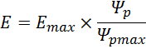
Where is the leaf turgor pressure under well-watered conditions (i.e. for the corresponding to ) and is the actual leaf turgor pressure (at a given ). was computed for predicted by the model, by rearranging the well-known pressure-volume (PV) curve equations (Tyree & Hammel 1972) by using the analytical solutions proposed by (Bartlett et al. 2012; Vitali et al. 2016).
Pressure volume equations characterize the relationship between total bulk leaf water potential (Ψ_{l}) and cellular water volume (or more generally its proxy the relative water content, RWC) in a leaf undergoing dehydration. This is achieved by separating the different components of Ψ_{l} in the osmotic potential of the cell content () and the turgor potential supporting the cell walls ():
Both and can be computed based on the water content of the symplasmic fraction of the leaf (with a_{f} the apoplasmic fraction), and the parameters of the PV curves (Bartlett et al. 2012). The expression for is:
Where is the osmotic potential at full turgor and is the modulus of elasticity. corresponds to the slope of the relationship between RWC_{s} and (see further discussion in (Bartlett et al. 2012)). The following formula is also given for by assuming a constant solute content:
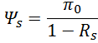
In order to obtain an expression for as a function of total water potential, Vitali et al 2016 (Vitali et al. 2016), rearranged equations 2 and 3 into equation 1 and obtained the following quadratic equation :
With the discriminant, equation has two different solutions (see Vitali et al 2016). When (i.e. when ):
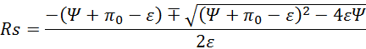
For () (i.e. when has overpassed the turgor loss point, ):
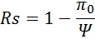

The relations obtained are depicted in Figure A3-1 below, for a typical pressure volume curve.
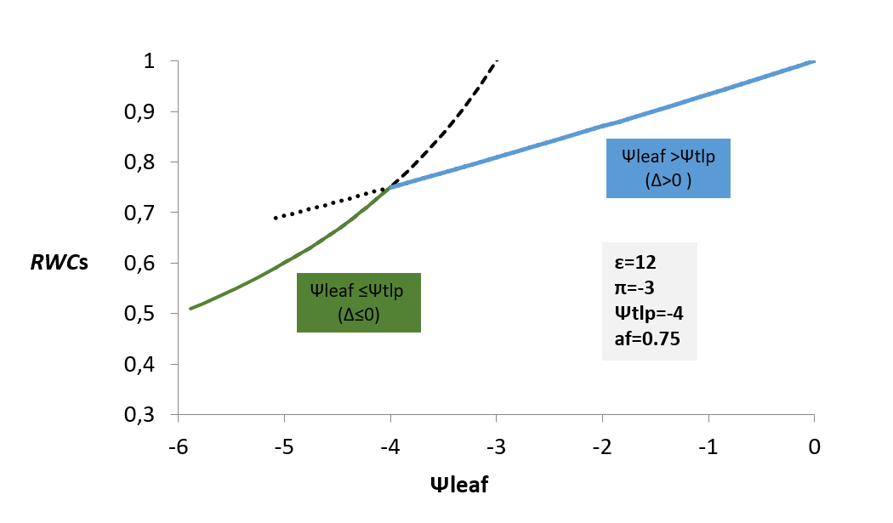
Figure A3-1: plot of the predicted RWCs from total leaf water potential for the two solutions of the equation (blue and green). The example is given for a typical pressure volume that parameters are indicated in the grey insert

REFERENCES:
1.Bartlett, M.K., Scoffoni, C. & Sack, L. (2012). The determinants of leaf turgor loss point and prediction of drought tolerance of species and biomes: A global meta-analysis. Ecol. Lett., 15, 393–405
2.Tyree, M.T. & Hammel, H.T. (1972). The Measurement of the turgor pressure and the water relations of plants by the pressure-bomb technique. J. Exp. Bot., 23, 267–282
3.Vitali, M., Cochard, H., Gambino, G., Ponomarenko, A., Perrone, I. & Lovisolo, C. (2016). VvPIP2;4N aquaporin involvement in controlling leaf hydraulic capacitance and resistance in grapevine. Physiol. Plant., 158, 284–296

