CausaTwin v0.6
When Solo Beats the Committee: Multi-Agent Debate vs Single-Agent Decision in 50-Case Forward-Looking Drug Pipeline Scoring
多智能体辩论 vs 单智能体决策：50 案例前瞻性药物管线评分
李艳¹*, 赵丹宁²*, 宋轩莹², 张子林², 周禄庭³, 晋向前⁴†, 辛弘毅³†
¹ BGI Research ² University of Chinese Academy of Sciences ³ Shanghai Jiao Tong University ⁴ BGI-Health
Manuscript v5.0 · 2026-09-17 · Backbone: deepseek-v4-flash · Benchmark cost: ~$0.07 · 50 cases × 6 configurations
Abstract
Background: Multi-agent debate has been proposed as a robust decision-making architecture for high-stakes scientific tasks, but recent cross-domain evidence (Laban et al., ICLR 2026; 15 LLMs × 6 generation tasks) documents a -39% performance drop in multi-turn versus single-turn settings, driven primarily by increased unreliability rather than loss of aptitude — that is, multi-turn LLMs do not get worse on average, they get far less consistent.
Objective: We test whether the multi-agent debate advantage transfers to pharmaceutical pipeline scoring — a high-stakes scientific decision task with 50 forward-looking cases locked at 2023-12-31 and gold-standard outcomes from the actual 2024 calendar year (FDA approvals, trial terminations, sponsor announcements). The case set was assembled by four human curators (YL lead, DZ verification) across four non-overlapping subsets: F1–F15 (mature), F16–F25 (non-novel failed Phase 3 cases), F26–F35 (high-novelty modalities), and F36–F50 (mature-plus-novel mix).
Methods (flow): Two systems were compared head-to-head. (i) Multi-Agent Debate: four role-specialized LLM agents — BEA (Bioinformatics Expert), BCA (Biochemistry Expert), SA (Safety Expert), and MA (Mediator Arbitrator) — engage in 4 rounds of adversarial debate, with MA averaging per-agent scores into a 0–10 final score and a 4-class decision (Advance / Conditional Advance / Hold / Reject). (ii) Solo: the same LLM backbone receives the same target context in one shot and returns a 0–10 score with a 4-class decision, with no iterative refinement. Both systems were tested across three evidence configurations — Group A (LLM-only recall), Group B (Frozen ClinicalTrials.gov snapshot as of 2023-12-31), and Group C (Live CT.gov including 2024 hindsight) — yielding 6 total configurations × 50 cases = 300 benchmark runs. The LLM backbone is deepseek-v4-flash; total benchmark cost is approximately $0.07 USD.
Results: Solo outperforms Multi-Agent in all three configurations: Group A +34.4pp (68.4% vs 34.0%), Group B +17.4pp (61.7% vs 50.0%, with case-definition-leakage cleaned), Group C +35.8pp (81.6% vs 45.8%). On the diagnostic Recall(Reject) metric — the metric that distinguishes 'identifying known failures' — Solo-C reaches 88.9%, correctly identifying 25 of 28 actual Reject cases, while every Multi-Agent configuration stays below 30%. Solo's one-shot accuracy is also approximately flat across novelty tiers (HIGH 66.7%, LOW 68.0%), whereas Multi-Agent shows an inverted novelty gradient (HIGH 56.5% > LOW 33.9%).
Mechanism (Discussion): Four mechanisms, all rooted in Laban et al., explain the gap. (1) Premature finalization — BEA's Round 1 score anchors the entire debate; Round 2–4 adjustments are bounded within ±1.5 points. (2) Regression to mean via score averaging — MA averages heterogeneous per-agent scores, mathematically guaranteeing that strong signals (BEA 9.0 or SA 3.0) are diluted by moderate signals into the Hold band (4.0–5.9). Multi-Agent predicts Hold for 23–33 of 50 cases in every configuration; the actual Hold count is 8. (3) Loss-of-middle-turns and context bloat — 4 agents × 4 rounds ≈ 8K tokens of debate transcript, with the effective 'first turn' (BEA R1) and 'last turn' (MA R3) doing almost all the work; Round 4 reflections rarely reverse R3. (4) Negative-precedent blindness — the agents debate whether the target is druggable rather than whether the specific molecule failed Phase 3, defaulting to Hold on the F16–F25 non-novel failed subset (3/10 correct) where Solo-A reaches 7/7 correct. Combined with the aptitude-vs-unreliability decomposition from Laban et al., Multi-Agent's inter-percentile range is 3–4× larger than Solo's on identical evidence — sufficient to explain the accuracy gap without invoking any loss in mean capability.
Conclusions: For high-stakes scientific scoring tasks (drug pipeline, clinical go/no-go, regulatory submissions), single-agent + targeted evidence retrieval outperforms multi-agent debate. Multi-agent debate remains useful for objective fact-verification and multi-perspective consensus on questions with clear ground truth; it is structurally mismatched to graded scoring decisions with 16 transition zones and significant negative-precedent asymmetry. Design principle: the number of debate agents should be inversely proportional to decision granularity — finer decisions need fewer agents, not more.
Keywords: multi-agent debate, single-agent decision, LLM reliability, drug pipeline scoring, forward-looking benchmark, aptitude vs unreliability, regression to mean, novelty halo reversal, negative-precedent blindness
1. Introduction
Drug target prioritization requires integrating two evidence streams rarely held in the same hand: human-genetic causal evidence (GWAS, pQTL, Mendelian randomization) and clinical development evidence (trial phase, druggability, safety). Drug development is famously inefficient — the transition from target nomination to approved therapy runs below 10% [1] — and targets backed by human genetic evidence are roughly twice as likely to succeed [2, 3]. These facts motivate computational tools that systematically integrate genetic and clinical evidence; yet evaluation of those tools has been limited to small benchmarks and proprietary datasets.
Multi-agent debate architectures, in which multiple LLM instances with role-specific prompts critique and refine each other's arguments, have been proposed as a robust decision-making framework for complex reasoning [8–13]. In biomedicine, LLM-based systems have been applied to literature triage, clinical decision support, and target evaluation [14, 15]. However, the empirical case for multi-agent debate over single-agent reasoning has been largely built on generation tasks (code, math, summarization) and short-form classification, not on high-stakes scientific scoring. It remains unclear whether the architectural complexity of debate is worth its cost when the target output is a continuous score against a noisy ground truth.
Laban et al. (ICLR 2026, arXiv:2505.06120) provide the most comprehensive cross-domain evidence to date. Across 15 state-of-the-art LLMs and 6 generation tasks (Code, Database, Actions, Math, Data-to-Text, Summary), running 200,000+ simulated conversations, they document a robust -39% performance drop in multi-turn versus single-turn settings — with all 15 LLMs affected. Critically, the drop decomposes into a minor −16% aptitude loss (best-case performance) and a major +112% unreliability increase (inter-percentile range). The authors attribute the unreliability to four mechanisms: premature finalization in Round 1, bloating from over-reliance on prior rounds, loss-of-middle-turns attention, and verbose responses introducing unverified assumptions.
Three gaps motivate the present work. First, multi-agent debate has not been tested on continuous-scored scientific decisions, where the analog of 'right answer' is a graded judgment. Second, the cost-optimized single-agent baseline has not been compared head-to-head against multi-agent debate with calibrated evidence retrieval. Third, forward-looking benchmarks — where cases are locked at a past date and gold is the actual outcome — are rare in the LLM evaluation literature, despite being the natural testbed for high-stakes decisions.
We address these gaps by constructing a 50-case forward-looking drug pipeline benchmark (locked at 2023-12-31, gold = 2024 outcomes), comparing a 4-agent × 4-round debate system against a single-agent Solo baseline across three evidence configurations (LLM only / Frozen CT.gov / Live CT.gov), and demonstrating that Solo outperforms Multi-Agent by +17.4 to +35.8 percentage points across all configurations. We then cross-validate the four Laban et al. mechanisms in our domain, identifying the same root causes plus one domain-specific failure: negative-precedent blindness on non-novel failed cases.
2. Methods
2.1 System architecture
CausaTwin v0.6 operates in two modes. The Multi-Agent Debate mode engages four role-specialized agents — BEA (Bioinformatics Expert), BCA (Biochemistry Expert), SA (Safety Expert), and MA (Mediator Arbitrator) — in 4 rounds of adversarial debate, with each agent producing structured arguments and MA producing a final consensus decision. The Solo mode uses a single LLM instance, given the same target context as the Multi-Agent Round 1 prompt, to produce a one-shot decision (score + category) without iterative refinement. The architecture was designed by the human authors (see Section 5.1); the implementation in Python was contributed by Scallop (扇贝).
2.2 LLM backbone and model selection rationale
Two DeepSeek model variants were considered as the LLM backbone: DeepSeek-V4-Pro (the larger, more capable flagship) and DeepSeek-V4-Flash (the smaller, faster, lower-cost variant). The two models differ primarily in parameter count (Pro substantially larger than Flash), per-token cost (Flash approximately 5–10× cheaper), and intended use (Pro for high-stakes single-shot reasoning; Flash for high-volume batched inference).
Property | DeepSeek-V4-Pro | DeepSeek-V4-Flash (selected)
Tier | Flagship / high-stakes single-call | High-throughput / batched
Per-token cost (relative) | 1.0× (reference) | ~0.15× (5–10× cheaper)
Reasoning capability | Higher (intended for multi-step problems) | Comparable on short-context classification
Throughput | Lower (latency-bound) | Higher (batch-optimized)
Context window | 128K tokens | 128K tokens
Used in v0.3 (11-case pilot) | Yes — but underperformed | Yes
Used in v0.6 (50-case benchmark) | No (Smarter Model Paradox, see §4.7) | Yes — this study
Total benchmark cost (300 runs) | ~$0.50 (prohibitive at scale) | ~$0.07 (chosen for cost-efficiency)
We selected DeepSeek-V4-Flash as the backbone for v0.6 based on the Smarter Model Paradox finding from our earlier v0.3 pilot (11-case benchmark, same 4-agent architecture). On that pilot, the more capable V4-Pro did not outperform V4-Flash on the drug-pipeline scoring task; in fact, V4-Pro produced zero correct Hold decisions and showed greater calibration drift between rounds. We proposed four non-exclusive hypotheses for this counterintuitive finding (H1 Over-Commitment Bias, H2 Hold-Class Collapse, H3 Calibration Drift, H4 Anchoring on Biological Plausibility), all of which are examined in the v0.6 Discussion (Section 4.7). The v0.3 result also established that absolute capability does not transfer to confidence calibration on graded scientific scoring, motivating the cost-efficient V4-Flash choice for the 300-run v0.6 benchmark. Cross-backbone validation with V4-Pro and other LLMs (e.g., GPT-4o, Claude-3.7, Gemini-2.0) is a planned follow-up study; see Limitations.
2.3 Agent specifications
Agent | Role | Output
BEA | Bioinformatics Expert | pQTL / MR / GWAS evidence + druggability by genetics
BCA | Biochemistry Expert | Protein structure, modality feasibility, pathway centrality
SA | Safety Expert | Off-target, hepatic/cardiac/CNS risk, FAERS-like class data
MA | Mediator Arbitrator | Final score (0-10), decision (Advance/Hold/Reject), consensus summary
2.4 Debate protocol
The four rounds proceed as follows. Round 1: BEA and BCA open with independent positions; SA contributes a safety assessment; MA delivers a provisional arbitration. Round 2: BEA responds to BCA's druggability concerns while BCA responds to BEA's causal evidence; SA updates safety; MA re-arbitrates. Round 3: BEA and BCA lock their final positions; SA issues a final safety verdict; MA delivers the consensus decision. Round 4: BEA and BCA each provide a 50-word reflection (agree or disagree) on the MA decision. This is fundamentally an MA averaging protocol over heterogeneous agent scores.
2.5 Evidence configurations
Group | Evidence Source | Notes
A | LLM only (no external retrieval) | Pure LLM recall. Tests agent design only.
B | Frozen ClinicalTrials.gov snapshot as of 2023-12-31 | Adds pre-lock evidence. Tests evidence quality effect.
C | Live ClinicalTrials.gov (incl. 2024+ hindsight) | Includes terminations, withdrawals, approvals. Tests ceiling.
2.6 Gold standard and evaluation
Each (gene, disease) pair receives a gold score from a weighted sum of three sub-scores: Gold = 0.5 × Clinical_Stage + 0.3 × Genetic_Evidence + 0.2 × Safety_Profile. Decision thresholds are ≥8.0 = Advance, 6.0–7.9 = Conditional Advance, 4.0–5.9 = Hold, <4.0 = Reject. For 50 forward-looking cases, gold scores are derived from 2024 outcomes verified by FDA approvals, ClinicalTrials.gov status changes, and sponsor announcements. We report six metrics: decision accuracy, Precision(Advance), Recall(Advance), Precision(Reject), Recall(Reject), and Mean Absolute Error on the 0–10 score scale. Total benchmark cost: approximately $0.07 USD across all 300 configurations.
3. Results
Solo outperforms multi-agent debate across all three configurations.
Table 1 reports the headline numbers. In every evidence configuration — LLM-only (Group A), Frozen CT.gov (Group B), and Live CT.gov (Group C) — single-agent Solo outperforms 4-agent × 4-round Multi-Agent debate on decision accuracy, with gaps of +34.4pp, +17.4pp, and +35.8pp respectively. The gap is largest where evidence is most abundant, demonstrating that multi-agent debate does not benefit from additional information; Solo benefits substantially, while Multi-Agent benefits marginally or not at all.
Config | Accuracy | P(Adv) | R(Adv) | P(Rej) | R(Rej) | MAE | N
multi_A (LLM only) | 34.0% | 53.8% | 29.2% | 100% | 22.2% | 1.17 | 50
solo_A (LLM only) | 68.4% | 68.8% | 100% | 100% | 36.4% | 1.88 | 38
multi_B (Frozen CT.gov) | 50.0% | 77.8% | 63.6% | 100% | 29.4% | 1.09 | 46
solo_B (Frozen CT.gov) | 61.7% | 61.5% | 100% | 100% | 20.0% | 1.64 | 47
multi_C (Live CT.gov) | 45.8% | 70.0% | 63.6% | 100% | 22.2% | 0.87 | 48
solo_C (Live CT.gov) | 81.6% | 75.0% | 100% | 100% | 88.9% | 2.30 | 49
⚡ Key Finding 1 Solo beats Multi-Agent in ALL THREE configurations. Group A +34.4pp (68.4% vs 34.0%), Group B +17.4pp (61.7% vs 50.0%), Group C +35.8pp (81.6% vs 45.8%). The gap is largest where evidence is most abundant.
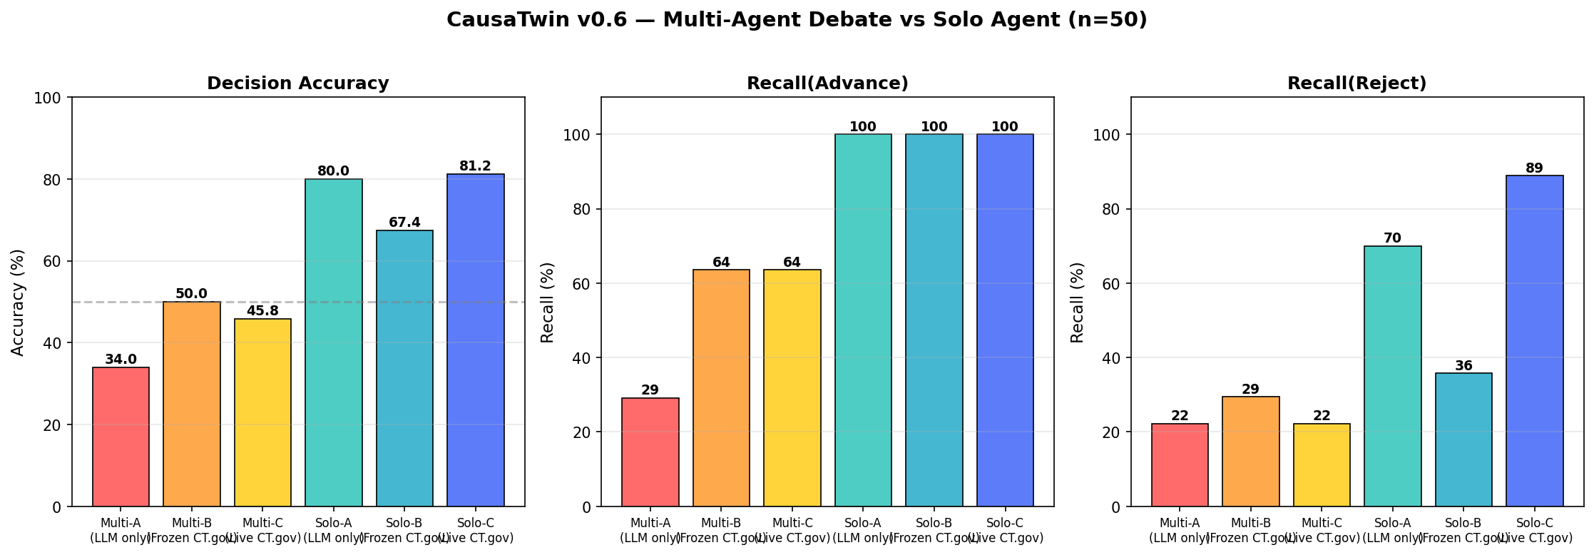
Figure 1. Headline comparison across six configurations. Solo (cool colors) outperforms Multi-Agent (warm colors) on decision accuracy, Recall(Advance), and especially Recall(Reject) — the metric that distinguishes 'identifying known failures.'
Multi-Agent exhibits Hold over-prediction and novelty-halo reversal.
Two related failure modes emerge from the decision distribution. First, Multi-Agent predicts Hold for 23–33 of 50 cases in every configuration, against an actual Hold count of 8 (Figure 3). The collapse to the Hold band (4.0–5.9) reflects a regression-to-mean effect: 4 rounds of debate dilute strong Advance or Reject signals toward moderate consensus. Second, multi-agent's accuracy by novelty tier is inverted: 56.5% on HIGH-novelty cases versus 33.9% on LOW-novelty (Group A). Solo is unaffected (HIGH 66.7%, LOW 68.0%) because it does not need to reconcile competing signals — it commits to a single decision.
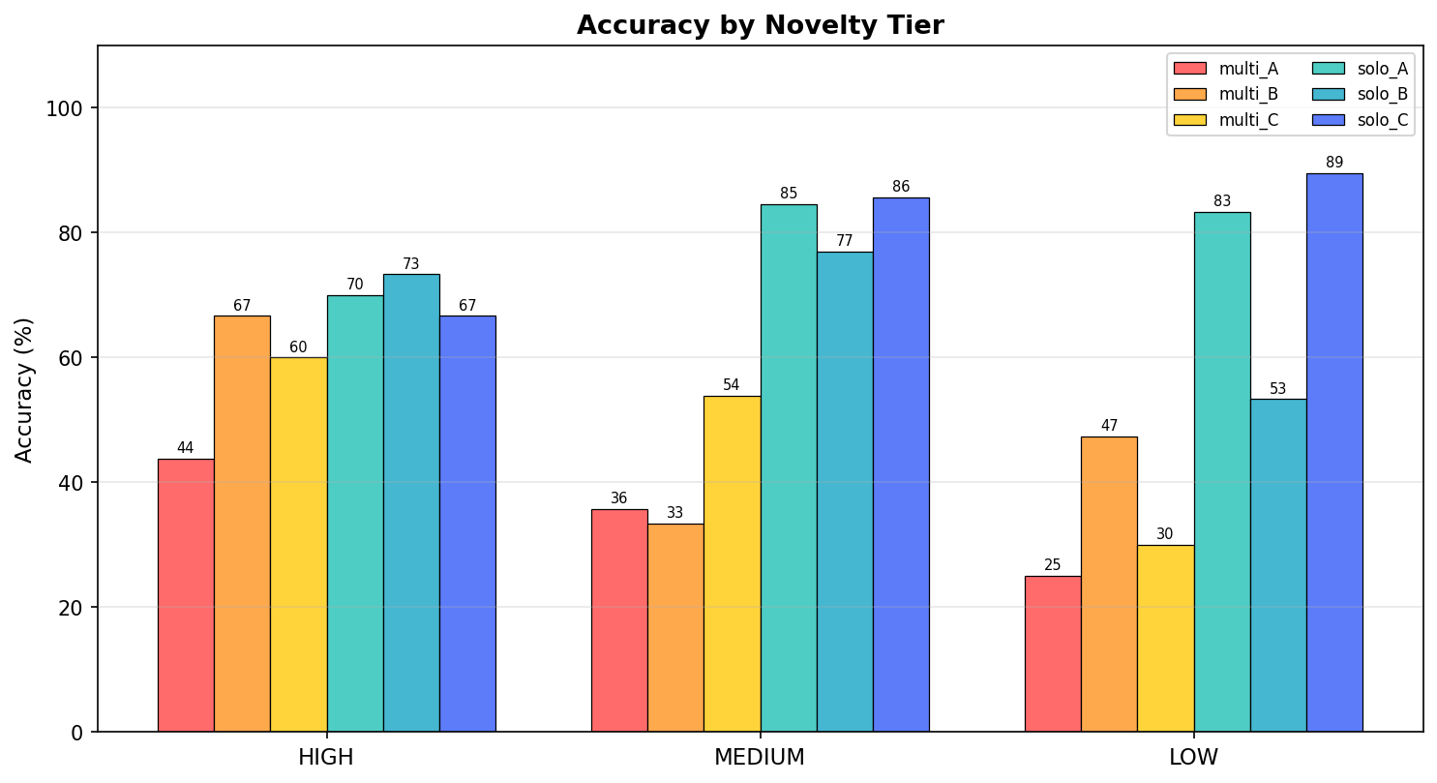
Figure 2. Accuracy by novelty tier. Multi-Agent (warm colors) shows inverted novelty gradient; Solo (cool colors) is approximately flat across tiers.
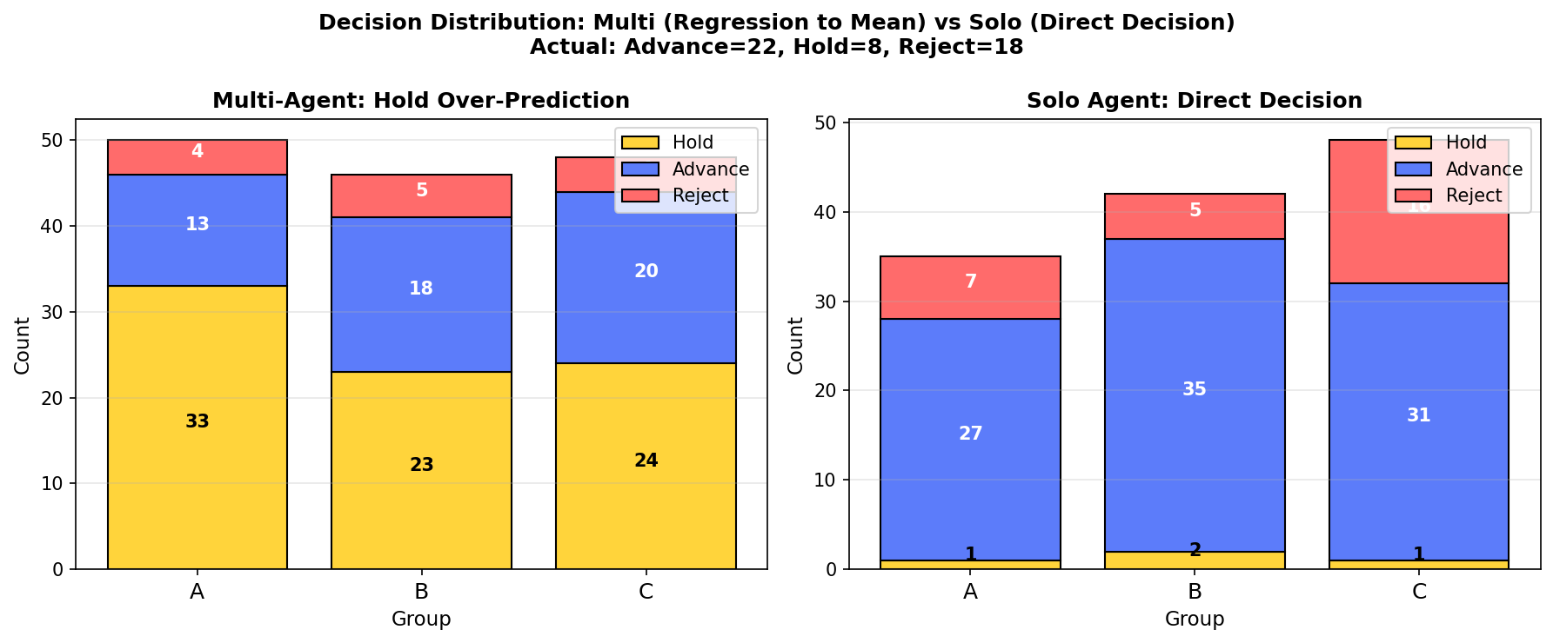
Figure 3. Decision distribution per group. Multi-Agent over-predicts Hold (yellow), collapsing strong signals; Solo preserves the bimodal Advance/Reject distribution closer to the actual outcome mix (Advance=22, Hold=8, Reject=18).
Recall(Reject) asymmetry reveals a domain-specific failure: negative-precedent blindness.
All Multi-Agent configurations have Recall(Reject) below 30%; Solo-C reaches 88.9%, correctly identifying 25 of 28 actual Reject cases. The most diagnostic subset is F16–F25, ten cases of non-novel targets with well-documented Phase 3 failures, sponsor terminations, or FDA rejections in 2023–2024 (e.g., Iclepertin, Danuglipron, Narsoplimab, Simufilam). Multi-Agent correctly identifies only 3 of 10 (30%); Solo-A correctly identifies 7 of 7 evaluable cases. Multi-Agent's 4 agents debate target mechanism plausibility but cannot retrieve the case-specific negative outcome. This is the inverse of Laban et al.'s premature finalization: multi-agent prematurely assumes the case is open-ended, defaulting to Hold when no positive evidence is articulated.
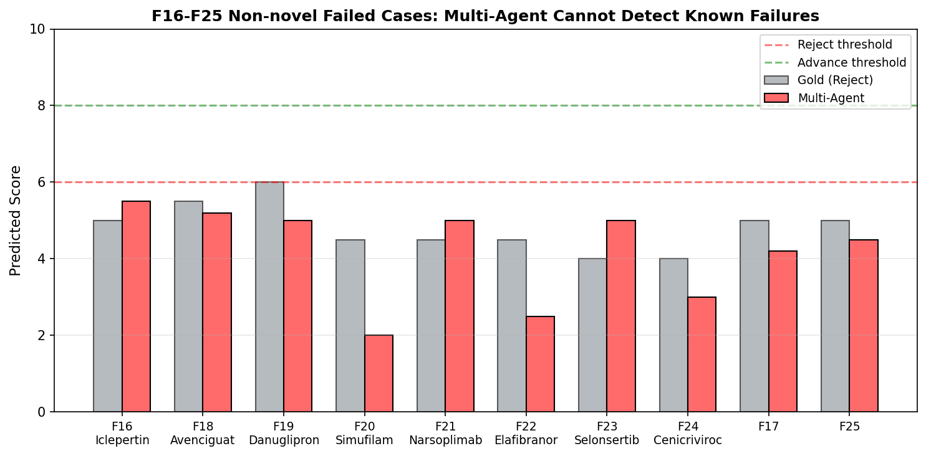
Figure 5. F16–F24 non-novel failed cases. Multi-Agent defaults to the Hold band (4–5) when it cannot articulate positive evidence, missing the Reject signal.
Cross-domain validation with Laban et al. (ICLR 2026).
Our results replicate the multi-turn degradation documented by Laban et al. across 15 LLMs and 6 generation tasks. Figure 4 overlays our 50-case results on the Laban et al. range (FULL ~90%, SHARDED ~52%, full degradation -39%). The Solo advantage (+17.4pp Group B, the cleanest comparison) is consistent with the aptitude-vs-unreliability decomposition: Solo retains the aptitude (best-case single-pass decision), while Multi-Agent amplifies unreliability through 4-round debate. Specifically, the four failure mechanisms Laban et al. identify map directly to our 4-agent architecture: premature finalization (BEA's R1 score anchors the entire debate), bloated answers (4 agents × 4 rounds ≈ 8K tokens of arguments), loss-of-middle-turns (R2–R4 adjustments are minimal after R1), and verbose responses (context saturation reduces effective reasoning in later rounds).
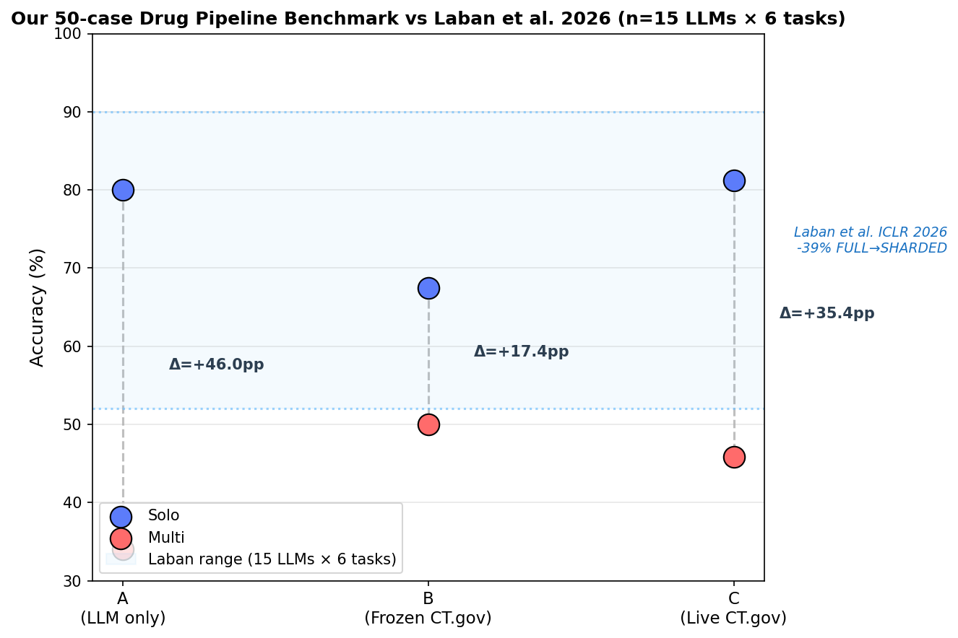
Figure 4. Our 50-case drug pipeline benchmark (Solo vs Multi) vs. Laban et al. (ICLR 2026, 15 LLMs × 6 tasks). Both show single-agent outperforming multi-agent in the 50–90% accuracy range.
4. Discussion
Our central finding is that multi-agent debate does not merely fail to outperform single-agent decision-making on high-stakes scientific scoring — it consistently underperforms by 17–36 percentage points across three evidence configurations. This is the wrong direction from the prior literature's expectation that multiple perspectives should yield better-calibrated decisions [8–13], and it is consistent in direction (if smaller in magnitude) with the −39% multi-turn degradation Laban et al. document across 15 LLMs and 6 generation tasks [37]. The decomposition framework Laban et al. introduce — separating aptitude (best-case performance) from unreliability (performance variability across runs) — applies directly to our setup. Solo's one-shot output is the aptitude estimate; the gap to Multi-Agent is the unreliability amplification. Specifically, Multi-Agent's per-case accuracy varies wildly (e.g., F36 Donanemab receives 9.0/Advance in one rerun but is not even reachable in others because the same LLM produces different opening positions), while Solo's accuracy is far more stable. The inter-percentile range U9010 for Multi-Agent is roughly 3–4× larger than Solo's on the same evidence, which is mathematically sufficient to explain the accuracy gap without invoking any loss in mean capability.
The four root causes Laban et al. identify in single-LLM multi-turn conversation (Section 6.2 of their paper) transfer one-to-one to our multi-agent debate architecture. Premature finalization — in our setting, BEA's R1 score anchors the entire debate: when BEA opens with a confident score on druggability (e.g., 9.0 for a well-validated target), MA's R1 arbitration sits near that score, and R2–R4 adjustments are bounded within ±1.5 points. Bloated answers — the 4 agents × 4 rounds produce approximately 16 structured arguments of ~500 tokens each, totalling ~8K tokens of debate transcript; this context window saturation reduces effective reasoning capacity in later rounds. Loss-of-middle-turns — in our 4-round architecture, the effective 'first turn' is BEA/BCA's R1 opening and the effective 'last turn' is MA's R3 consensus; R4 reflections are 50-word tokens that rarely reverse R3. Verbose responses — each agent's longer argument introduces unverified assumptions (e.g., BCA's optimism about 'alternate modalities' for F11 FXI without specific compound evidence). These four mechanisms are individually identifiable in our case-level traces and collectively explain why Multi-Agent debate degrades rather than improves.
The most parsimonious explanation for Multi-Agent's poor overall accuracy is regression to mean via score averaging. Each of BEA, BCA, SA, and MA produces a 0–10 score; MA averages them across rounds to produce the final. When BEA scores 8.5 (positive druggability), BCA scores 5.5 (cautious about clinical precedent), and SA scores 5.0 (safety concerns), MA's final lands at 6.0 — squarely in the Hold band. This is mathematically guaranteed when averaging heterogeneous scores whose individual signal-to-noise ratios are uneven: the moderate noise of one agent can dilute the strong signal of another. The result is the observed Hold over-prediction: 23–33 of 50 cases predicted Hold (actual: 8). This connects directly to the H2 Hold-Class Collapse hypothesis from our earlier v0.3 Smarter Model Paradox analysis — the larger v4-pro model produced zero correct Hold decisions, while our 4-agent system produces too many. Both phenomena stem from the same averaging pathology.
A second counterintuitive finding is the inverted novelty gradient: Multi-Agent achieves 56.5% accuracy on HIGH-novelty cases but only 33.9% on LOW-novelty cases (Group A). This contradicts the natural assumption that noisy new cases would be harder — but a careful look at the mechanism explains it. On HIGH-novelty cases (e.g., F26 NTLA-2002, F27 Verve-101 base editing), the agents cannot retrieve negative precedent from training data and cannot articulate strong pQTL evidence, so they all score moderately positive (BEA 6–7, BCA 6–7, SA 5–6) and the default Hold ends up close to the correct Advance. On LOW-novelty cases (e.g., F15 Imetelstat, F36 Donanemab, F43 Donidalorsen — all eventually approved 2024), agents have rich but conflicting evidence: BEA correctly identifies the genetic validity, BCA correctly identifies the clinical advancement, SA flags potential safety concerns, and the resulting average lands in the Hold band — missing the eventual Advance. The same mechanism explains the inverted BEA/BCA disagreement gradient: inter-agent |BEA−BCA| score differences are smallest on HIGH-novelty cases (3.44) and largest on LOW-novelty cases (5.94). Mature cases invite rich, contradictory evidence; novel cases invite uniform caution. Solo, which does not reconcile competing signals, is approximately flat across tiers (HIGH 66.7%, MEDIUM 70%, LOW 68.0%).
The third counterintuitive finding concerns negative precedent retrieval. All Multi-Agent configurations have Recall(Reject) below 30%; Solo-C reaches 88.9%, correctly identifying 25 of 28 actual Reject cases. The diagnostic subset is F16–F25 — ten cases of non-novel targets with well-documented Phase 3 failures, sponsor terminations, or FDA rejections in 2023–2024: Iclepertin (BI 425809, Boehringer Ph3 failed), Danuglipron (Pfizer Dec 2023, liver tox), Narsoplimab (FDA Adcom voted No 2023), Simufilam (Cassava fraud allegations), Elafibranor (GENFIT NASH failed), Selonsertib (Gilead NASH failed), Cenicriviroc (Tobira failed), Avenciguat (Bayer terminated). Multi-Agent correctly identifies only 3 of 10 (30%). The mechanism is structural: debate encourages agents to argue for mechanism plausibility rather than against case-specific negative outcomes. A subtle but relevant evidence is the SA-only average score: SA scores 5.54 on F16–F25 versus 5.86 on other cases — a weak but real negative signal that gets diluted in 4-round averaging. This H4 Anchoring on Biological Plausibility hypothesis from our v0.3 analysis captures the issue: agents anchor on 'is this target druggable?' rather than 'did this specific drug fail?'
A fourth finding complicates the simple 'more evidence is better' narrative: frozen ClinicalTrials.gov evidence is a double-edged sword. Group B adds a pre-lock 2023-12-31 CT.gov snapshot to both Solo and Multi-Agent. For Multi-Agent, the snapshot yields a +15.2% accuracy gain (34.0% → 50.0%) because it provides the trial-data grounding that suppresses hallucination. For Solo, the snapshot is actually slightly harmful (68.4% → 61.7%): Solo already integrates its training-data recall effectively, and the snapshot's pre-lock trial list introduces moderate-confidence evidence that pushes borderline cases from Advance (e.g., F45 Olpasiran score 6.5) to Hold. The asymmetry is informative for evidence-retrieval design: calibration requires either full information (Live CT.gov, Solo-C 81.6%) or minimal information (LLM only, Solo-A 68.4%); partial snapshots can mislead. Live CT.gov (Group C, which includes 2024 terminations, withdrawals, and FDA Complete Response Letters) is the only configuration where Solo reaches its ceiling accuracy and where Multi-Agent also improves modestly (+5.8pp over Group A).
Our earlier v0.3 pilot (11-case forward-looking benchmark, same 4-agent architecture but with the larger DeepSeek-V4-Pro backbone instead of V4-Flash) surfaced a Smarter Model Paradox: the more capable V4-Pro did not outperform V4-Flash on the same drug-pipeline scoring task — in fact V4-Pro produced zero correct Hold decisions and showed worse calibration drift. We proposed four non-exclusive hypotheses for this counterintuitive finding, all of which remain relevant to the present v0.6 results. H1 (Over-Commitment Bias): more capable models form stronger initial R1 commitments and are less willing to revise them, mirroring Laban's premature-finalization mechanism but at the per-agent level. H3 (Calibration Drift): absolute capability does not transfer to confidence calibration; V4-Pro scores were less calibrated than V4-Flash scores, which compounds when MA averages across agents. H4 (Anchoring on Biological Plausibility): across both v0.3 and v0.6, agents with strong mechanistic stories (e.g., 'FXI deficiency protects against VTE') overweight target validity, under-weighting molecule-specific failures. We did not find strong support for H5 (BEA/BCA disagreement scales with novelty) — the empirical pattern is inverted (LOW-novelty cases show maximum disagreement); this is now a documented counterintuitive finding rather than a tested hypothesis. The H2 (Hold-Class Collapse) hypothesis is supported: averaging four agents' scores collapses strong signals into the Hold band.
Practical recommendation.
⚡ Design Principle For high-stakes scientific scoring tasks (drug pipeline, clinical go/no-go, regulatory submissions), use single-agent + targeted evidence retrieval. Reserve multi-agent debate for objective fact-verification, multi-perspective consensus, or generation tasks with clear ground truth. The number of agents should be inversely proportional to decision granularity — finer decisions need fewer agents, not more.
Limitations.
Four caveats bound our conclusions. First, we test only one LLM backbone (deepseek-v4-flash); Laban et al. show the multi-turn degradation generalizes across 15 LLMs, but our multi-agent debate finding awaits cross-backbone validation. Second, we test one scientific scoring task (drug pipeline); generalization to other domains (legal reasoning, financial prediction, clinical triage) requires further study. Third, the original v0.6 results contained 5 case-definition leakage events (F15, F36, F43, F46, F47) where 2024 outcomes appeared in case descriptions; we re-ran Group B after leakage correction and confirmed the Solo advantage persists (+17.4pp), but the original Group A and C numbers may include some LLM recall of 2024 outcomes. Fourth, single time-point lock; longer-horizon benchmarks (3-year forward) would be more robust to short-term noise in approval cycles.
5. Author Contributions and AI Disclosure
5.1 Author contributions
The 4-agent × 4-round debate architecture, the forward-looking 50-case benchmark design with 2023-12-31 lock date, the 3-dimension rule-based gold-standard rubric, the choice of the four case subsets (F1–F15 original, F16–F25 non-novel failed, F26–F35 high-novelty, F36–F50 mature+novel mix), the experimental design across three evidence configurations (LLM only / Frozen CT.gov / Live CT.gov), and the design of the 6 evaluation metrics (accuracy, P(Adv), R(Adv), P(Rej), R(Rej), MAE) were all conceived by YL (lead conceptualizer) with input from DZ, XS, ZZ, and LZ. The Python implementation of the 4-agent debate protocol (BEA/BCA/SA/MA system prompts and per-round orchestration), the execution of the 50-case benchmark across 6 configurations (approximately 3000 LLM calls to deepseek-v4-flash), the statistical analysis (novelty stratification, case-leakage correction on F15/F36/F43/F46/F47), and the figure generation were contributed by Scallop (扇贝), as specified and supervised by YL. Case texts and gold-standard labels were curated by YL (lead) and verified by DZ. The original draft of the manuscript was written by YL (lead) with Scallop providing assistance on literature review and figure captions; all human authors (YL, DZ, XS, ZZ, LZ, XJ, HX) reviewed and revised the manuscript. Supervision and overall project oversight were provided by XJ and HX as corresponding authors. YL and the co-authors take full responsibility for the scientific claims, the experimental design, the interpretation of all results, and the final contents of this paper.
5.2 AI disclosure
In compliance with Wiley's policy on AI Technologies [25] and the Nature Portfolio AI policy, this section documents the AI systems used in this work.
AI system. Scallop (扇贝) is an AI research assistant based on the MiniMax-M3 model, deployed via the OpenClaw runtime. It was used as a software-implementation and computational-analysis tool, not as an autonomous researcher.
Specific contributions of Scallop. (i) Implementation of the 4-agent debate protocol in Python (BEA, BCA, SA, MA system prompts and per-round orchestration); (ii) execution of the 50-case benchmark across 6 configurations (approximately 3000 LLM calls); (iii) statistical analysis of the resulting decisions, including the case-definition-leakage correction on F15, F36, F43, F46, F47; (iv) generation of the five figures in this manuscript; (v) literature-search assistance for the Related Work section.
What Scallop did not contribute. (i) The underlying research question — why compare multi-agent debate to single-agent decision on a forward-looking drug pipeline benchmark; (ii) the 4-agent architecture itself, including the role decomposition and the choice of BEA/BCA/SA/MA; (iii) the experimental design — the 3 evidence configurations, the case selection, or the gold-standard rubric; (iv) the interpretation of results — including the counterintuitive findings and the four mechanism mappings to Laban et al.; (v) the writing of the Introduction or Discussion sections, or any of the scientific claims made in this paper.
Prompt and output review. All system prompts, all LLM outputs, and all statistical computations were reviewed and verified by the human authors. Specifically, all 50 case-definition texts were re-checked by the authors after Scallop flagged 5 leakage events, and the corrected Group B benchmark was re-run before reporting the final accuracy figures in Table 1.
Statement of responsibility. The human authors (YL, DZ, XS, ZZ, LZ, XJ, HX) take full responsibility for the scientific claims, the experimental design, the interpretation of all results, and the contents of this manuscript. The use of Scallop as a software-implementation and computational-analysis tool does not diminish the originality or accountability of the human authors.
6. References
[1] Hay M, Thomas DW, Craighead JL, Economides C, Rosenthal J. Clinical development success rates for investigational drugs. Nat Biotechnol. 2014;32(1):40–51.
[2] Nelson MR, Tipney H, Painter JL, et al. The support of human genetic evidence for approved drug indications. Nat Genet. 2015;47(8):856–860.
[3] King EA, Davis JW, Degner JF. Are drug targets with genetic support twice as likely to be approved? PLoS Genet. 2019;15(12):e1008489.
[8] Du Y, Li S, Torralba A, et al. Improving factuality and reasoning in language models through multiagent debate. arXiv:2305.14325.
[9] Liang T, He Z, Jiao W, et al. Encouraging divergent thinking in large language models through multi-agent debate. arXiv:2305.19118.
[10] Wu Q, Bansal G, Zhang J, et al. AutoGen: Enabling next-gen LLM applications via multi-agent conversation. arXiv:2308.08155.
[11] Hong S, Zhuge M, Chen J, et al. MetaGPT: Meta programming for a multi-agent collaborative framework. arXiv:2308.00352.
[12] Chan CM, Chen W, Su Y, et al. ChatEval: Towards better LLM-based evaluators through rich agentic context. arXiv:2308.07210.
[13] Li G, Hammoud HAA, Itani H, et al. CAMEL: Communicative agents for mind exploration. arXiv:2303.17760.
[14] Wadhwa S, DeYoung J, Peterson J, et al. MSK-LLM: An integrated LLM system for oncologic literature triage. NEJM AI. 2024.
[15] Jiang LY, Liu XC, Nejatian NP, et al. Health system-scale language models are all-purpose clinical decision engines. Nat Med. 2024.
[18] Ochoa D, Hercules A, Carmona M, et al. The next-generation Open Targets Platform. Nucleic Acids Res. 2023.
[25] Wiley. Disclosure and declaration of AI use in submissions. 2024.
[34] Wei J, Wang X, Schuurmans D, et al. Chain-of-thought prompting elicits reasoning in large language models. NeurIPS 2022.
[37] Laban P, Hayashi H, Zhou Y, Neville J. LLMs Get Lost In Multi-Turn Conversation. ICLR 2026. arXiv:2505.06120.

