Intro
At its core, the question contrasts two opposing systems: capitalism, where private enterprises operate for profit in a free market, and socialism or state-driven models, where enterprises are publicly or charitably owned and guided by social welfare goals.
Adam Smithʼs concept of the “Economic Manˮ (Smith, 1776) assumes individuals pursue self-interest, which unintentionally benefits society through the “invisible handˮ. As he said, we expect our dinner not from the benevolence of the butcher, but from their self-interest. However, Marxʼs labor theory of value (Marx, 1867) argues that capitalism exploits workers by extracting surplus value—paying them less than the value they create—concentrating wealth, deepening inequality, and trapping the majority in poverty, undermining social well-being.
This essay explores three dimensions: first, the behaviours, benefits and cost driven by the hope of profit; second, the contrasting traits of government- or charity-owned enterprises. Finally, through the case of Shenzhen, I argue that a “hybrid” model combining free market system with help of SOE and charities achieves both prosperity and equity.

Thesis 1： The Power and Pitfalls of Profit

Beneficial behaviours engendered by hope of profit
The hope of profit encourages two main behaviours: entrepreneurship and innovation. First, individuals are incentivised to start new businesses, responding to market signals by increasing the supply of goods and services where shortages occur or adapting to shifting consumer preferences. As Joseph Schumpeter (Schumpeter, 1942) described, entrepreneurs act as agents of "creative destruction", replacing outdated models with innovative alternatives. Individuals also collaborate to pursue profit collectively, benefiting from comparative advantage and economies of scale. According to Coase (Coase, 1960), firms emerge to reduce transaction costs; those that allocate resources more efficiently survive and grow.
This behaviour brings wide societal benefits. For consumers, entrepreneurship improves market responsiveness and product variety, while competition reduces prices and raises quality. It also enhances the global competitiveness of domestic products, boosting exports and reducing the risk of a current account deficit. For governments, it generates tax revenues, lowers unemployment, and reduces reliance on welfare systems—triggering multiplier effects that alleviate poverty and improve public well-being. These fiscal surpluses can then be reinvested in public or merit goods like infrastructure, education, and healthcare. At a macroeconomic level, entrepreneurship facilitates the reallocation of resources to their most productive uses, driving both productive and Pareto efficiency and minimising deadweight loss across the economy. Thus, profit- driven entrepreneurship is a key engine for efficiency and economic development.
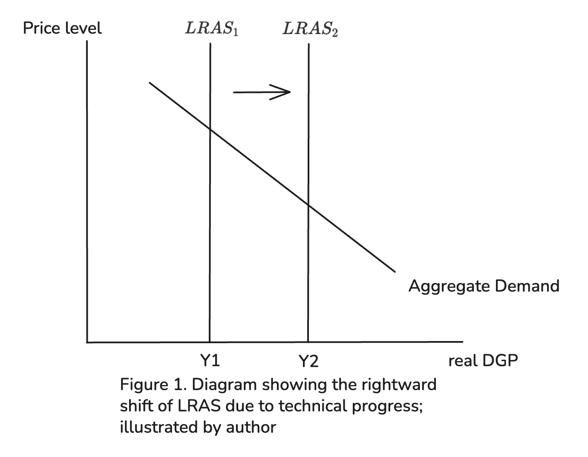
Second, the hope of profit motivates innovation and technological progress. In competitive markets, firms try to gain greater market share by innovate to differentiate their products, with profit serving as a reward for successful R&D and product development. Simultaneously, intense price competition incentivises firms to achieve productive efficiency—operating at the lowest point of average total cost—by adopting cost-reducing technologies and specialisation of labour. Innovation is also a form of capital deepening, lowering long-term costs and boosting firm competitiveness. For example, Xiaomi has delivered technologically advanced yet affordable smartphones, meeting demand through efficient innovation and cost management.
These innovation-driven behaviours produce macroeconomic and structural benefits. According to the Solow Growth Model (Robert Solow & Trevor Swan, 1956), reinvested profits in automation and digital infrastructure raise output per worker, driving long-run economic growth and shifting the long-run aggregate supply curve rightward(Fig.1). Technological progress also reduces production costs and inflationary pressure, while creating positive externalities in fields like clean energy and medicine. Moreover, innovation restructures economies by shifting labour and capital into high-value sectors such as AI, biotech, and green tech—boosting global competitiveness and generating skilled employment. Ultimately, profit-driven innovation strengthens economic resilience and underpins sustainable development, making it central to modern economic success.

Exploring the disadvantages
However, profit-driven behaviour also has several downsides. To consumers, one notable issue is planned obsolescence, where firms design products with limited durability to encourage repeated purchases, eroding consumer surplus. Firms also manipulate customers through bundling, exaggerated advertising, and prestige pricing. Moreover, firms may price discriminate due to asymmetric information, extracting more consumer surplus without increasing utility, creating moral hazard and adverse selection. While consumers are also workers, they face intense competition pressures. To cut costs, some firms enforce exploitative cultures—such as China’s “996” schedule—causing burnout and mental health issues.
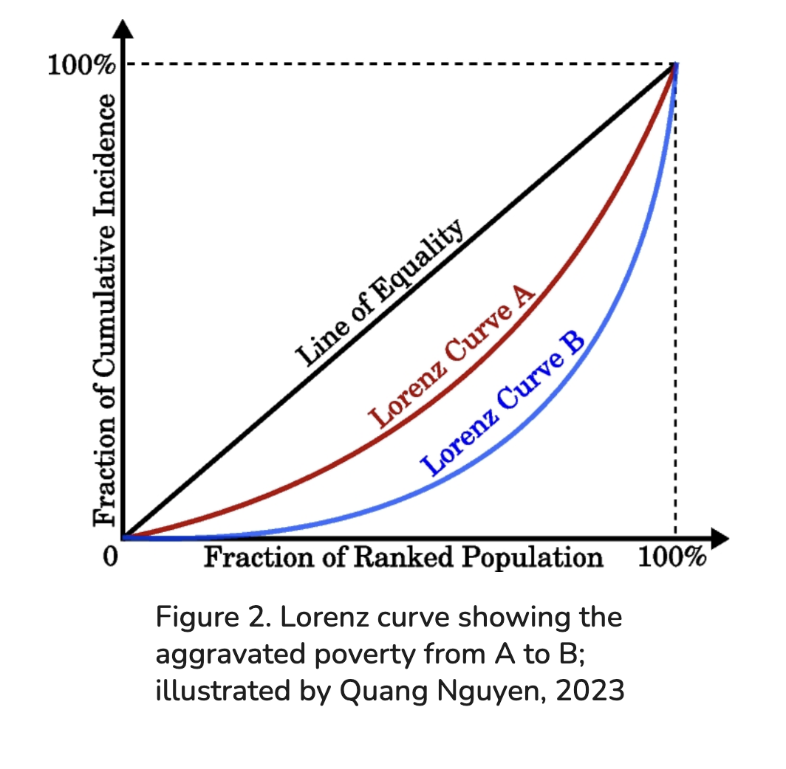
For producers, intense competition can drive prices unsustainably low, challenging start-ups and stifling innovation. In such a survival-of-the-fittest environment, firms with accumulated wealth may entrench their advantage by using tactics like predatory pricing or aggressive mergers, eventually establishing monopoly power. This weakens market competition, leads to allocative inefficiency, and squeezes out smaller firms.
From the governmentʼs perspective, wealth often concentrates among few people, exacerbating inequality —as shown by rising Gini coefficients (Gini, 1915) and a more bowed Lorenz curve(Fig.2 from A to B). Many remain trapped in poverty, putting pressure on public welfare resources. Private firms also underinvest in public goods, leaving gaps for state funding.
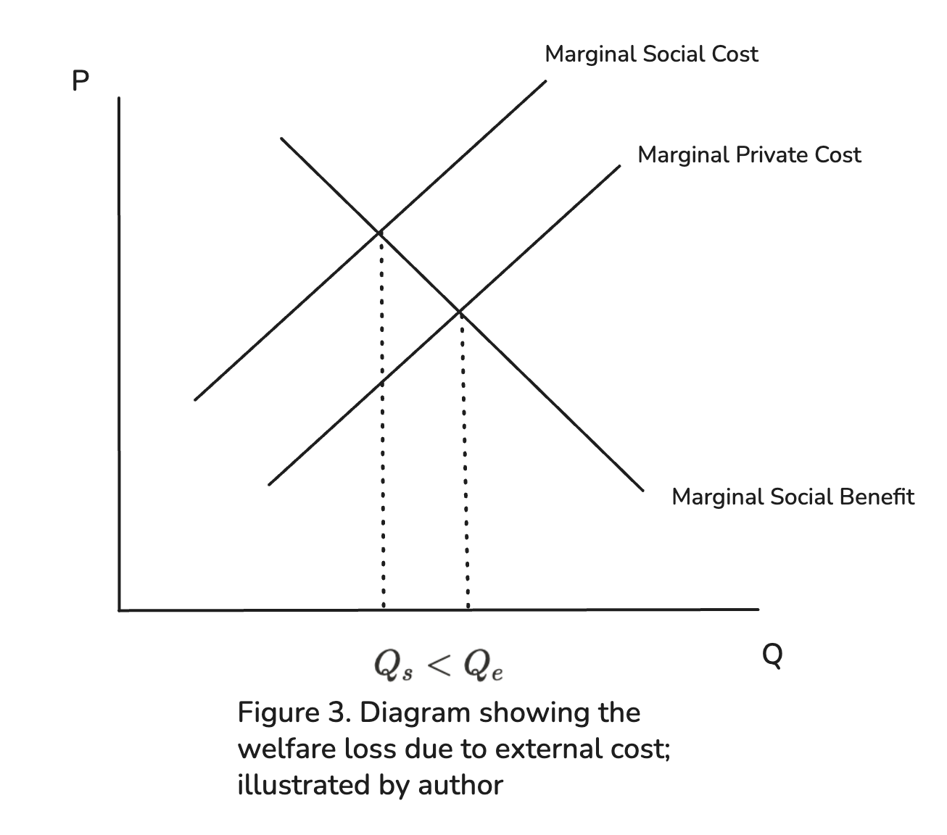
Moreover, monopolistic firms may exploit their power to raise prices, fuelling inflation. In cutting costs, profit-maximising firms may ignore ethics, generating negative externalities where marginal social cost exceeds marginal private cost, causing pollution and public health issues. Governments must then impose costly regulations to counter these short-term behaviours, which often sacrifice long-term sustainability.
In light of these limitations, it becomes crucial to consider alternative models— such as state-owned enterprises and charities—whose behaviour, guided by public interest, offers different strengths in addressing collective welfare.

Thesis 2： Public Purpose over Profit: The Role of SOEs and Charities
Unlike profit-driven private firms, state-owned enterprises (SOEs) and charitable organisations primarily aim to maximise social welfare rather than financial returns. Their behaviour is guided by public interest objectives such as equitable service provision, poverty reduction, environmental protection, and the delivery of public and merit goods like healthcare and education. These behaviours spread wide-reaching benefits throughout the entire economy.

Advantages engendered from the behaviour of SOEs and charities

For consumers, SOEs and charities promote greater equity in access to essential goods and services. For instance, China’s nine-year compulsory education and basic health insurance have significantly improved literacy and health, helping poorer populations escape poverty and achieve upward mobility. Since prices under public or charitable provision are based on cost-recovery or social affordability rather than profit, services are often subsidised or free. This boosts consumer surplus and reduces the financial burden on low-income households. These organisations also prioritise long-term social outcomes over short-term profits, investing in areas such as environmental protection, disaster preparedness, and public health. With no profit pressure, they are less likely to use manipulative practices like exaggerated advertising, bundling, or price discrimination, reducing the risks of asymmetric information and moral hazard.
Consumers are also workers, and employment in SOEs or charitable organisations often comes with better job security, fairer wages, and more supportive working conditions due to weaker market pressures. With less emphasis on cost-cutting, employees benefit from greater stability, which fosters social cohesion, financial resilience, and steady consumer spending.

For producers, public ownership reduces market volatility and profit uncertainty. Production often aligns with government strategies, providing a more predictable setting for long-term investment and planning. In certain sectors, the government may support natural monopolies—such as in water or electricity—where one provider can operate more efficiently than multiple competing firms. These large-scale operations benefit from significant economies of scale, operating with extremely low marginal costs while maintaining national infrastructure standards.

For governments, SOEs and charities align directly with goals like poverty reduction, infrastructure development, and green transition. By supporting employment and consumption, they help reduce unemployment and maintain social stability. Providing public and merit goods corrects allocation inefficiencies and promotes fairer income distribution, easing pressure on welfare systems. Their long-term approach also limits negative externalities like pollution and underinvestment in human capital. Less exposed to market shocks, these organisations contribute to macroeconomic stability and generate consistent tax revenues, enabling better fiscal planning and public service delivery.

Disadvantages engendered from the behaviour of SOEs and charities
While SOEs and charitable institutions prioritise social benefit, their structure can also generate inefficiencies. For consumers, the absence of profit incentives and limited competition can lead to productive inefficiency and a lack of innovation, resulting in stagnant product quality, outdated services, and limited variety. These organisations often fail to respond flexibly to evolving consumer preferences, leading to allocation inefficiency. Bureaucratic delays and impersonal service are also common, especially in heavily centralised sectors. In China, for instance, SOEs in sectors like tobacco, oil and telecommunications often prioritise political directives over consumer satisfaction, as they are not held accountable for profit or loss. This reduces service quality and long-term consumer surplus.

For producers, limited market exposure discourages efficiency improvements and R&D investment. Fixed production targets and state subsidies often shield them from competitive pressures, weakening innovation and productivity. Resource misallocation can arise when inputs are distributed based on political goals rather than real-time market demand, leading to shortages in some sectors and oversupply in others. Price distortions caused by administrative pricing further disrupt firm profitability and discourage efficiency. Labour productivity also tends to stagnate under these conditions, as guaranteed employment weakens incentives to improve performance or reduce waste.

For governments, maintaining full ownership of enterprises often demands substantial fiscal support, which can strain public budgets. Without rigorous oversight, these organisations risk corruption, as political influence may distort resource allocation and undermine economic efficiency. Moreover, the lack of competitive pressure weakens incentives for innovation, cost control, and responsiveness, resulting in low productivity growth. Additionally, inflexible, centralised planning frequently fails to respond to real-time market signals, causing persistent inefficiencies that burden the economy.

Thesis 3： Shenzhen’s Hybrid Model: Harmonizing Profit and Purpose
While profit-driven behaviours of private sectors fosters innovation, efficiency, and responsiveness, it leads to inequality, short-termism, and market failure. Conversely, governments or charities emphasise equity, stability, and public welfare but often suffer from inefficiency and lack of innovation. Therefore, the optimal system should be balancing the strengths of both. The following example proves this point.

Case Study – Shenzhen
As Chinaʼs first testing ground for market reform, Shenzhenʼs transformation— from a fishing village to a global megacity—demonstrates the power of a hybrid economy built on complementary strengths. Where Adam Smithʼs “invisible handˮ meets Marxʼs critique, and Keynesian intervention aligns with Hayekʼs market freedom, Shenzhenʼs development reveals that true economic wisdom lies in harmonising the productivity of profit, the security of equity, and the compassion of public welfare. With GDP rising from ¥1.96 billion in 1979 to ¥3.68 trillion in 2024, Shenzhen exemplifies a system where SOEs lay the foundation, private firms drive growth, and charities close the gaps(Shenzhen Municipal People’s Government, 2025)
- Private Sector: The Engine of Growth
Shenzhenʼs private enterprises have driven four waves of industrial upgrading— from manufacturing to electronics, telecoms, and high-tech exports. In 2023, they contributed 86% of the cityʼs international patents, with patent ownership far exceeding national averages. Huaqiangbeiʼs merchant ecosystem forms one of the worldʼs most efficient electronics supply chains, where a chip moves from design to prototype in days(Li & Zhang, 2024). This vibrant private sector shows how profit incentives fuel innovation, flexibility, and efficiency.
- SOEs: The Safety Net for Risky Innovation
State-owned enterprises support innovation by providing infrastructure and absorbing market shocks. Shenzhen Metro built one of the worldʼs densest subway systems, cutting transport costs for businesses. Shenzhen Capital Group set up a ¥100 billion venture fund to support startups. During the Huawei sanctions crisis, over 30 SOEs collaborated to protect jobs and supply chains(Chen, 2024). SOEs here act not as passive bureaucracies, but as stabilizing forces and enablers of private success.
- Charities: Stitching Market Gaps
Charities enhance social inclusion and long-term capacity building. Tencent Foundationʼs training programs improve industrial skills, while nonprofit institutes help SMEs cut R&D costs. Others support green technology and disability employment. These organisations fill in what the market misses—offering not only efficiency boosts but also compassion and equity for the cityʼs residents.

Conclusion
In conclusion, neither profit-driven capitalism nor state-led socialism alone can address modern economic complexities. While private firms drive innovation and efficiency, they often neglect equity and long-term welfare. Conversely, SOEs and charities prioritize social goals but may lack responsiveness. As Shenzhen illustrates, the optimal path lies in integrating the strengths of all three—leveraging market dynamism, public stability, and charitable compassion—to build a balanced, resilient, and inclusive model of sustainable development.

Bibliography

- Smith, A. (1776). An inquiry into the nature and causes of the wealth of nations. W. Strahan and T. Cadell.
- Shenzhen Municipal People’s Government. (2025, June ).from https://jr.sz.gov.cn/gkmlpt/content/12/12192/post_12192877.html#2819
- Marx, K. (1867). Capital: A critique of political economy (Vol. 1). Verlag von Otto Meisner.
- Schumpeter, J. A. (1942). Capitalism, socialism and democracy. Harper & Brothers.
- Coase, R. H. (1960). The problem of social cost. Journal of Law and Economics, 3, 1–44.
- Solow, R. M., & Swan, T. W. (1956). Technical change and the aggregate production function. Review of Economics and Statistics, 39(3), 312–320.
- Shenzhen Municipal Public Security Bureau. (2025, June 18). 2025 年 4 月深圳市金融统计数据报告 [2025 April Shenzhen financial statistics report] (PDF). Retrieved June 30, 2025, from https://www.safe.gov.cn/shenzhen/file/file/20250618/58a8ae61e90e405ab8868a91c73df360.pdf
- Gini, C. (1915). Memorie di metodologia statistica (Vol. 2). Libreria Eredi Virgilio Veschi.
- Keynes, J. M. (1936). The general theory of employment, interest, and money. Macmillan.
- Hayek, F. A. (1944). The road to serfdom. Routledge.
- Shenzhen Municipal People’s Government. (2025). Shenzhen 2024 Annual Economic Report.
- Li, X., & Zhang, Y. (2024). Huaqiangbei supply chain dynamics: Speed from design to prototype. Journal of Innovation & Technology, 5(2), 34–48.
- People's Bank of China Shenzhen Head Office. (n.d.). Financial statistical report. Retrieved June 30, 2025, from http://shenzhen.pbc.gov.cn/shenzhen/122786/5672964/index.html
- Chen, L. (2024). SOE coordination during the Huawei sanctions crisis. China Economic Review, 76, 102–118.
- National Bureau of Statistics of China. (2024). China statistical yearbook 2023. China Statistics Press.
- World Intellectual Property Organization (WIPO). (2024). PCT international patent filings: 2023 statistics. WIPO.
- Tencent Foundation. (2023). Annual report on SME capacity-building initiatives. Tencent Foundation.

