**Lab 4: Image Filtering Report**

**ECE 5470**

**Computer Vision**

**Name: Yanling Wu**

**NetID: yw996**

**Section 2: Frequency Domain Filtering**

***Q1: What are the two channels?***

After processed by FFT, every pixel value in frequency domain will become complex number, which has real part and imaginary part. The two channels are the magnitude part and phase part of image in frequency domain.

***Q2: In the above steps how did we manage to visualize the magnitude data?***

The first step is used to make all pixel value become float type number and make all pixel value subtract the mean 110.366, then do the Fast Fourier Transformation to this image. The second step is used to get the real part of the image that was done FFT which is the magnitude of the image that was done FFT and then do logarithm to every magnitude of image. Hence, the magnitude data is visualized.

***Q3: How was the value for the bf= parameter selected?***

The value of the bf is the mean of all the pixel values of the original image. By minoring the mean of all pixel values, we can remove the DC component in order to avoid the big value at the location of f = 0 in frequency domain.

***Q4: What does the first line accomplish?***

The first line command generates the binary image and the width and length of background are 128 and the foreground is a cycle with radius of 32 and pixel value of 1. Also, use float data type to represent every pixel value.

***Q5: Why is*** *vchan* ***being used?***

Because the image generated by the first line only has one channel and use this vchan command can merge the first image and the second image to give two channels to fil. So, we can use fil to continue the filter in frequency domain.

***Q6: Display the resulting image and comment on its filter characteristics.***

The left image of figure 1.1 shows the image that we use “vgenim” command to generate and this image only has one channel. Then we use the command of “vchan” to merge the two images and the fil has two channels as the right image of figure 1.1 shown. Finally, we multiple the fil image to ted.fft, which is a kind of filtering in frequency domain.

The figure 1.2 shows the result of filtering to ted.fft. When amplifying the image to see the pixel value, we can see the background of the ted.fft that has not been filtered by fil, varies but after filtering, the pixel values of background are the same. And the pixel values of central image do not change as the figure 1.3 and figure 1.4 shown.

This filtering method is one way to filter high frequency. Because after FFT, the low frequency information will be in the central area in frequency domain. And this cycle structure of filtering image can keep the central value unchanged and make the edge area of image keep the same value to filter some high frequency information.

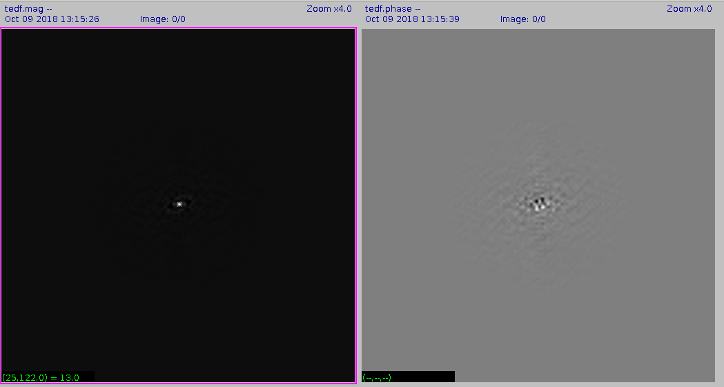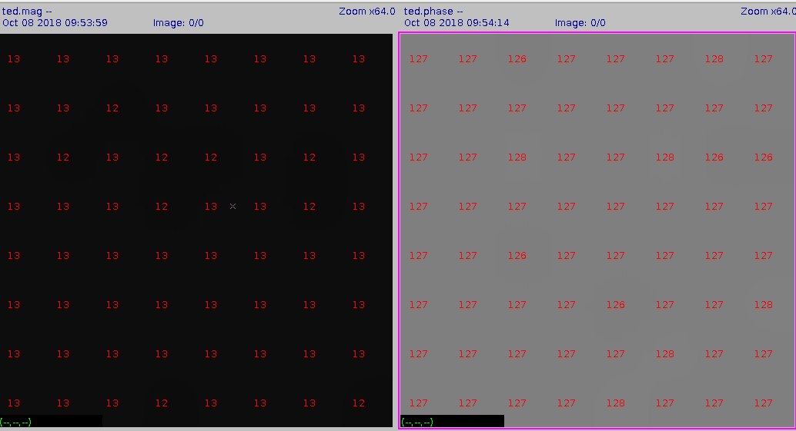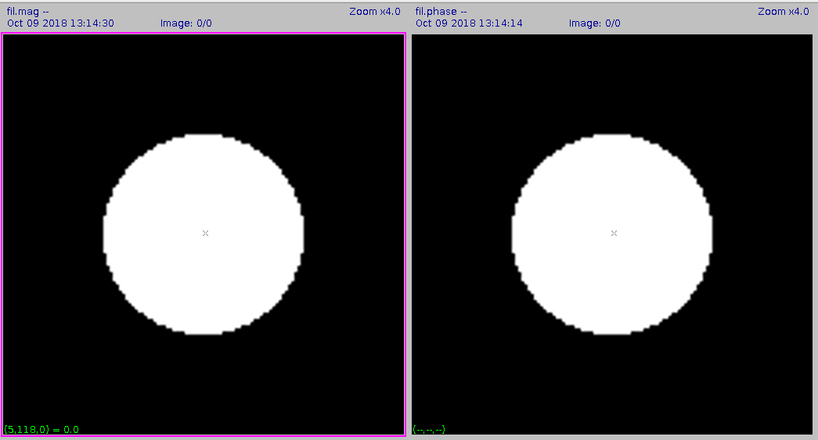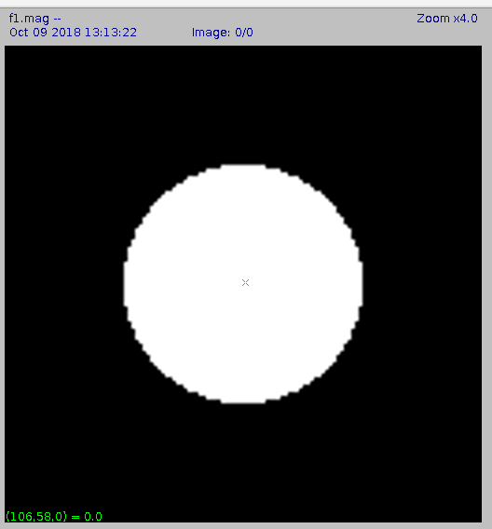

*Figure 1.3 The part pixel values of magnitude and the phase of ted.fft*

*Figure 1.2 The magnitude and the phase parts of tedf.fft*

***Figure 1.1*** *Left image is the magnitude part of f1.*

*The right images are the magnitude and the phase parts of fil*

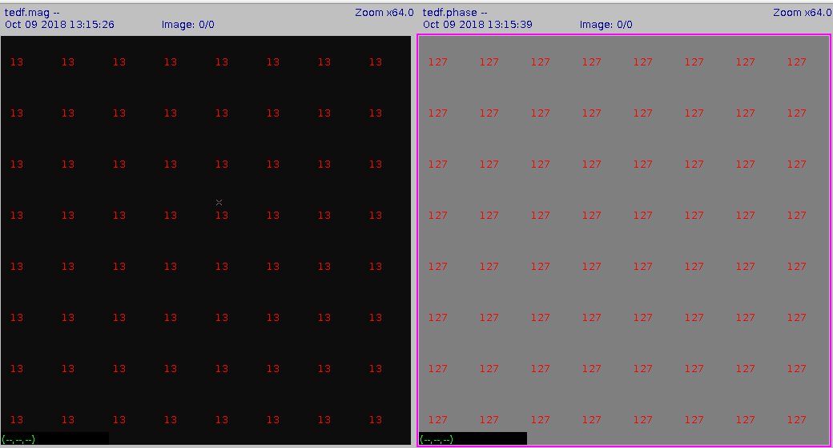

*Figure 1.4 The part pixel values of magnitude and the phase of tedf.fft*

***Q7: Discuss the differences between the original and the filtered image.***

The below figure1.5 and figure 1.6 are the comparison images of the original and filtered images of ted and shuttle.

We can see after filtering, the images become smoother and the textures of the images change very regularly. The “ripple” gradually becomes smaller as the shape of the boundary. This ripple phenomenon is the Gibbs phenomenon. We can see the Gibbs phenomenon in figure 1.5 and figure 1.6.

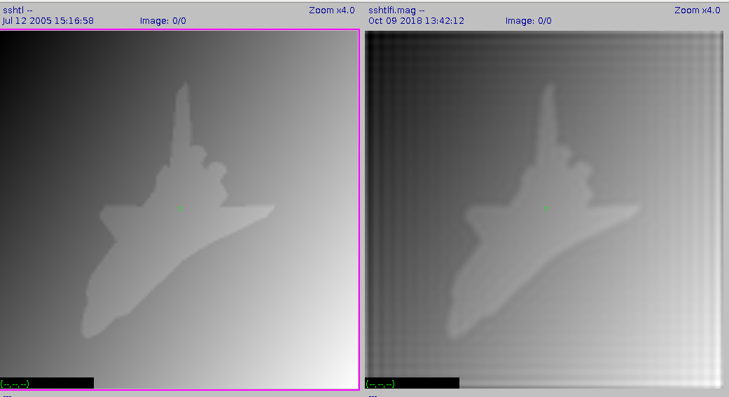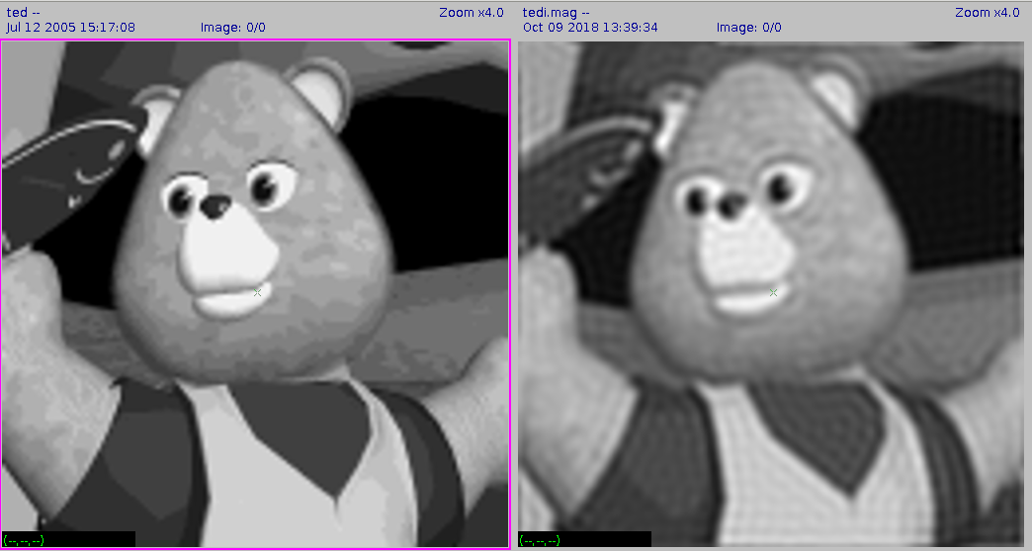

*Figure 1.6 The comparison images of original and filtered shuttle image*

*Figure 1.5 The comparison images of original and filtered ted image*

**Section 3: Spatial Domain Filtering**

***Q1: What does the spatial filter look like?***

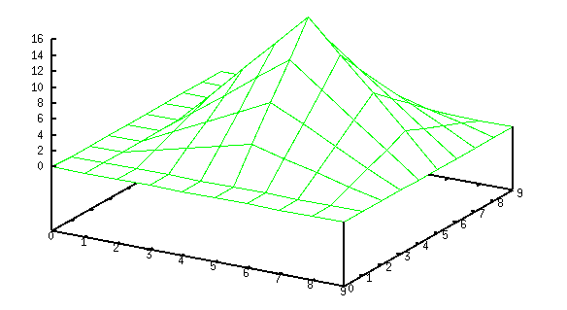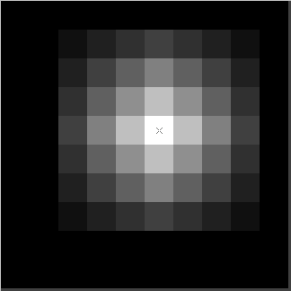 The spatial filter kernel looks like the below images. The left one is 2D figure and the right one is 3D figure.

Figure 3.0 The images of special kernel

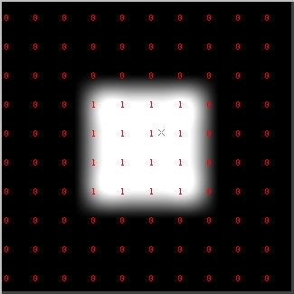***Q2: How was it created?***

This kernel is generated by the right image convolving with itself.

***Q3: How was the above value of the tf= parameter selected?***

In order to keep the lightness of image unchanged, we need to guarantee the sum of the values of the kernel equal to 1, so the mean of the kernel’s value should be 1/100, which is 0.01. However, the original mean of kernel value is 2.53, so we need to make every value multiply 0.01/2.53 = 0.0039. This is the way to pick up this tf parameter.

***Q4: Discuss the differences between the original and the filtered image.***

The left picture below is the original image and the right one is filtered image. We can see the filtered image become blur. The filtered image loses many details. For example, the shape on the sleeve almost disappear in the filtered image. And the roughness of face in the original also become smooth. The change of the background is getting soft.

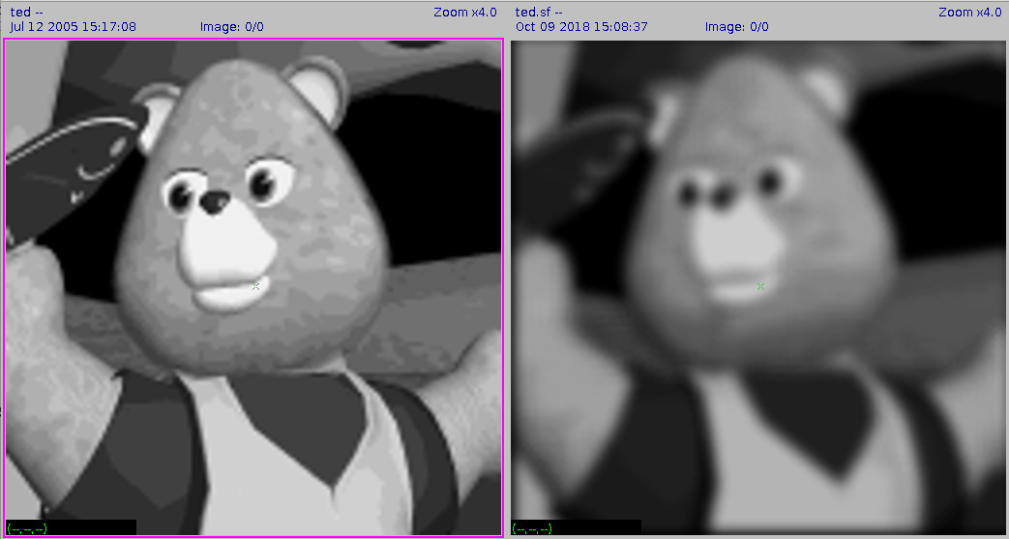

*Figure 2.1 The comparison images of spatial filtering ted*

***Q5: Compare ted.sf with ted.f and discuss the differences.***

The left image below is ted.sf and the right one is magnitude image of ted.f. The biggest difference is there is Gibbs phenomenon in the ted.f. This is because We processed the image using the method like square wave in the frequency domain. By this way, it is easy to show the Gibbs phenomenon. So, the image in spatial domain, there will be ripple on the image. However, there is no ‘ripple’ on the ted.sf and the image became smooth and the edge of image became more blur than the left one’s.

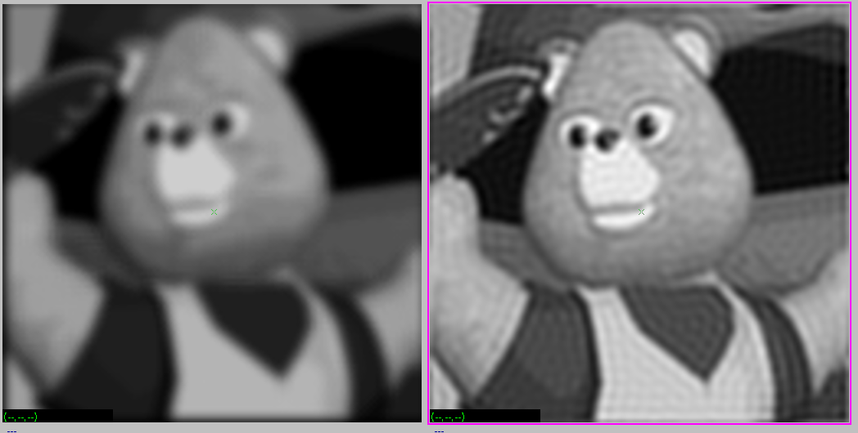

*Figure 3.2 The comparison images filtered by two way*

***Q6: What does the image fil look like in the spatial domain? Can you make a good 2D graph of it?***

The image fil in the spatial domain is the left image below and it looks like the sinc function rotation in 2D which is like the water wave. The right image below is the one I used “vplot” to plot this image in 3D.

The figure 3.4 is the one I make a good 2D graph of it and the 3D graph of it.

Firstly, I used the command of “*vfft -I if=fil of=fili.f*” to make inverse FFT to the fil image. Secondly, I used the command of “*vexfft -m -l fili.f of=fili.xlmag*” to make the image visualizable and enhance the contrast of image. Thirdly, I used the command of “*vclip xl=42 xh=85 yl=42 yh=85 fili.xlmag of=fili_clip.xlmag*” to acquire the central part of the original image and we can see the detail of the image.

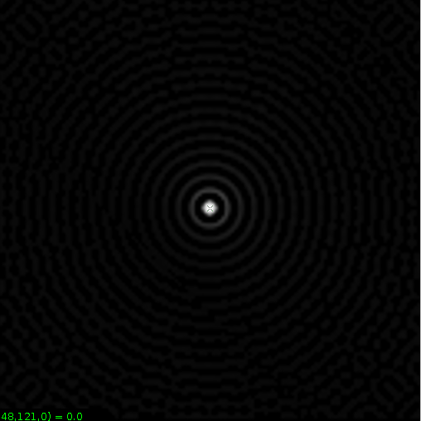

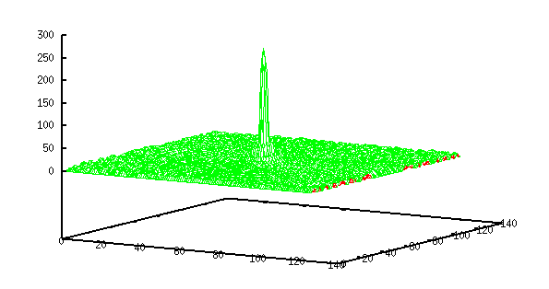

*Figure 3.3 The image of fil in spatial domain*

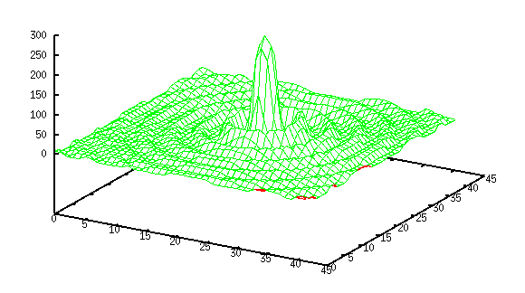

*Figure 3.4 The good image of fil in spatial domain*