**Azure Incentive Proof Of Execution Template**

Proof of Execution validates the technical implementation services that partners complete as part of their motion to drive Azure Consumption. Proof of Execution ensures we reward our partners who have invested time and resources to drive world class solution motions to our shared customers and prospects.

|  |  |  |
| --- | --- | --- |
|  |  |  |
| **Section 1: Partner and Customer Information** | | | |

|  |  |
| --- | --- |
| **Partner Name** | SUPERPOP HK LIMITED |
| **Partner MPN ID** | 6725437 |
| **Customer Name** | Sandwich Lab Al HK Limited |

|  |  |  |
| --- | --- | --- |
|  |  |  |
| **Section 2: Azure Architecture Diagram** | | | |

**Network architecture：**

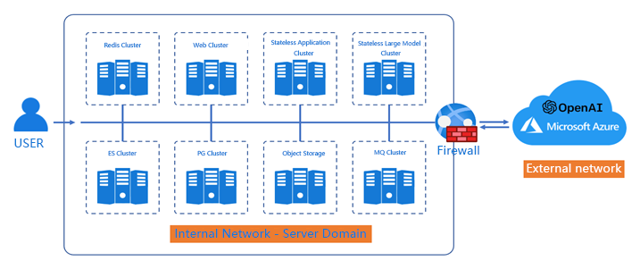

**Cloud architecture：**

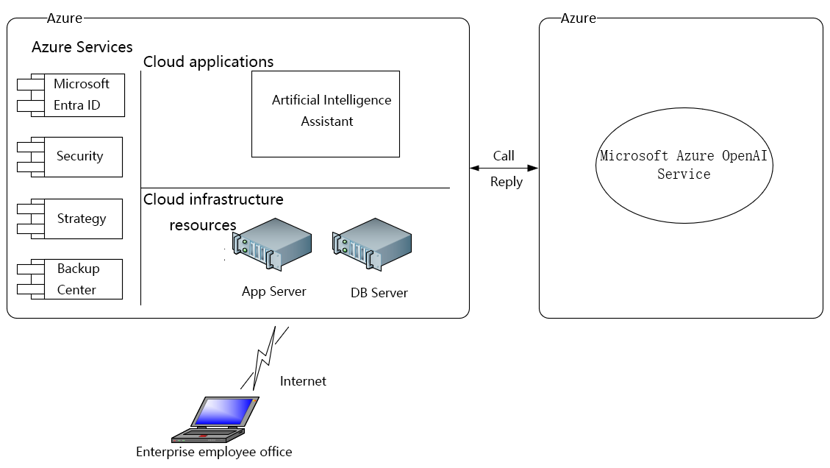

|  |  |  |
| --- | --- | --- |
|  |  |  |
| **Section 3: Customer system interface display** | | | |

**Artificial Intelligence Chat Interface：**

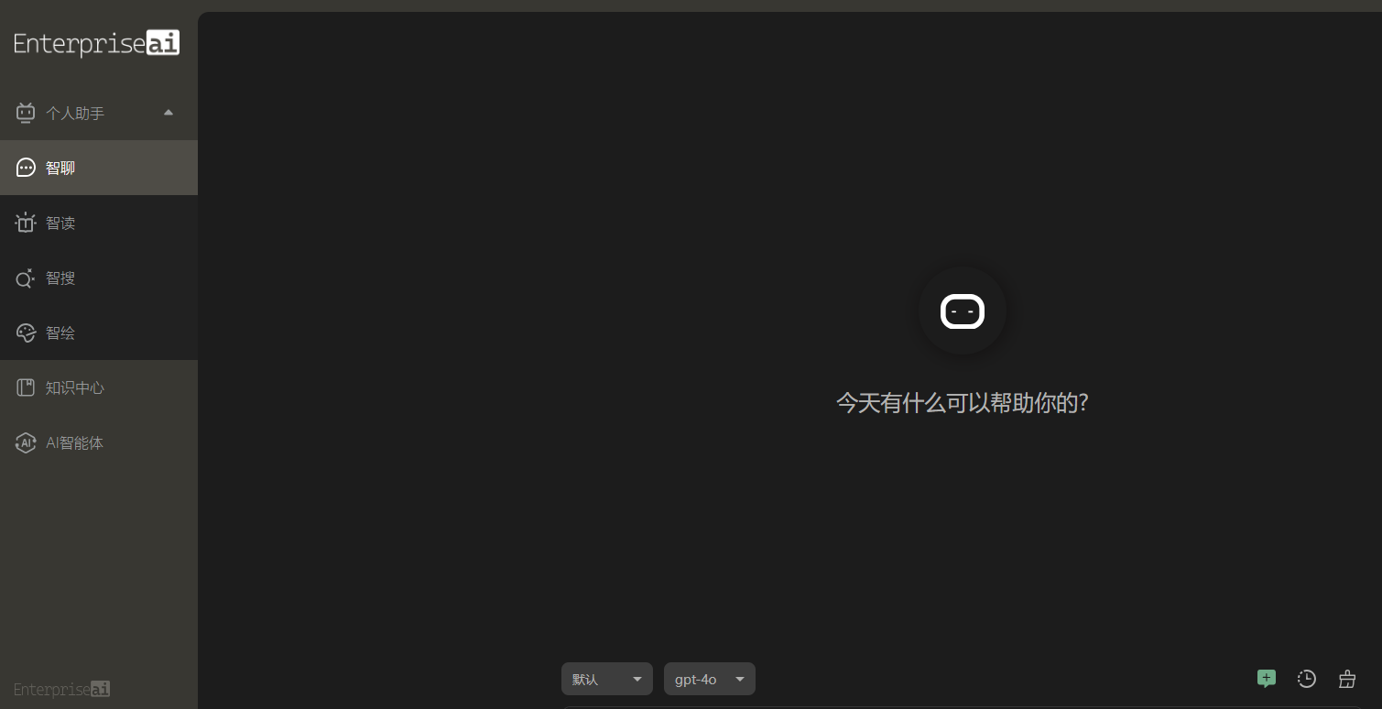

**Artificial Intelligence AOAI Painting Interface：**

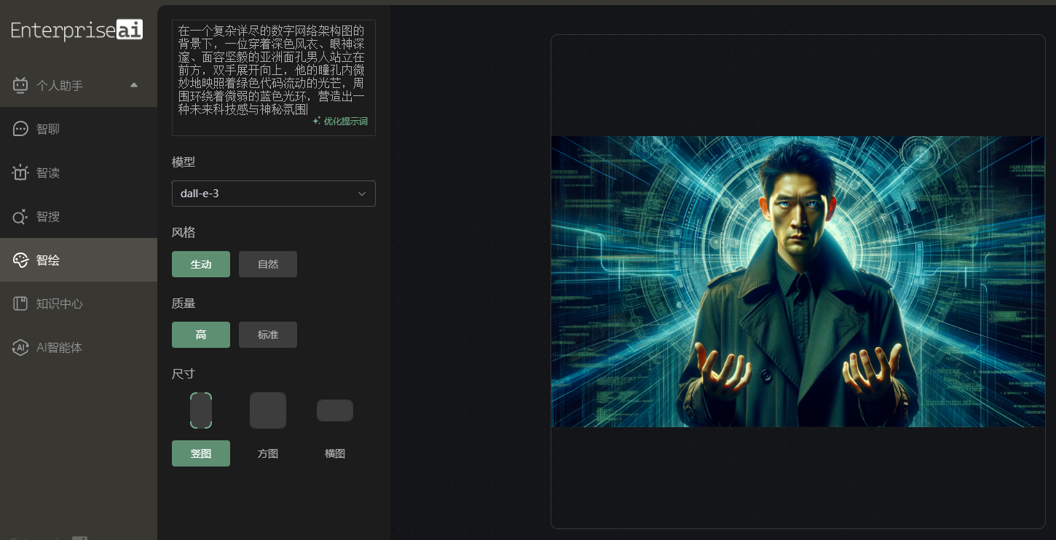

**Artificial Intelligence Knowledge Base Interface：**

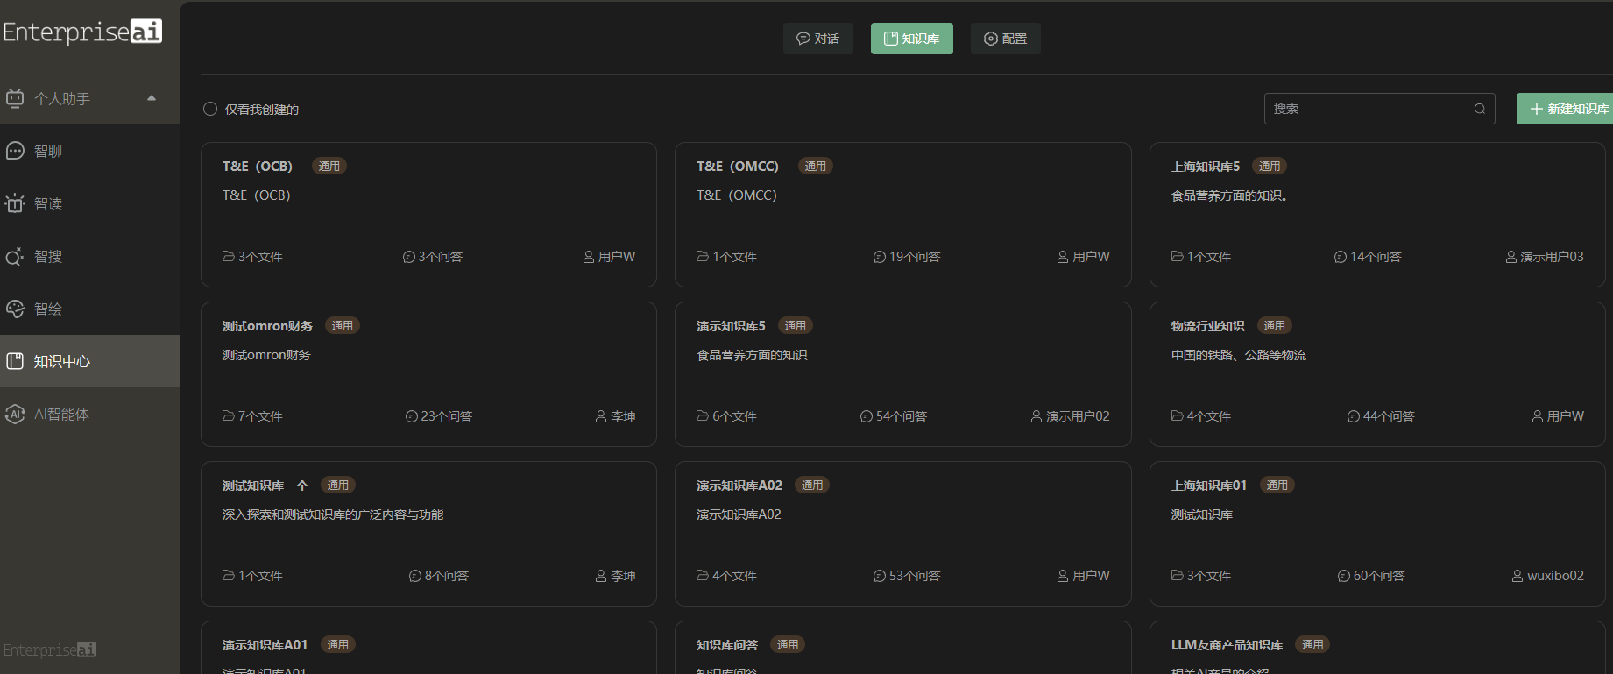

**Artificial Intelligence AI Agent Interface：**

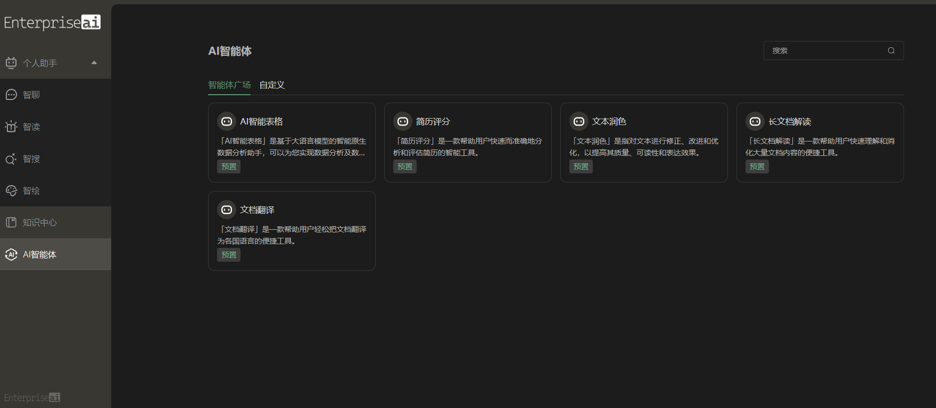

**Artificial intelligence assistant calls model code：**

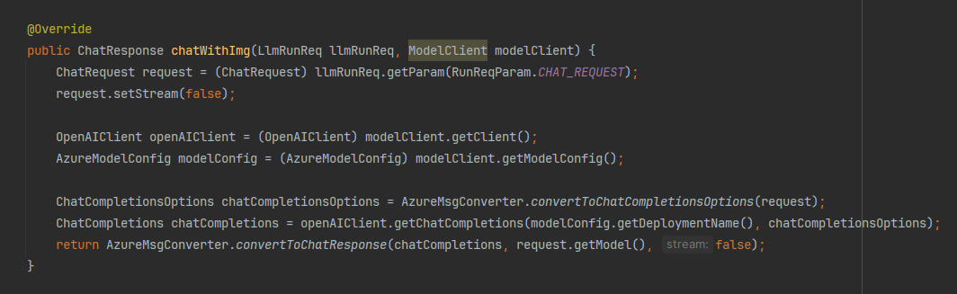

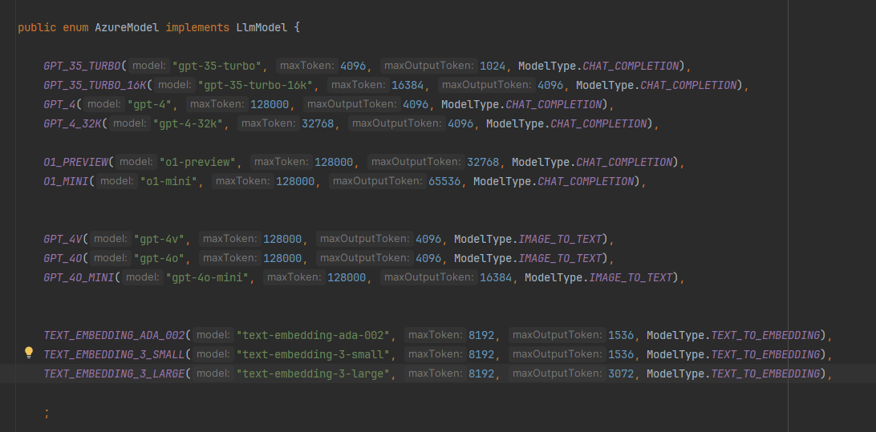

|  |  |  |
| --- | --- | --- |
|  |  |  |
| **Section 4: Customer Workload Detail** | | | |

|  |  |
| --- | --- |
| **1- Introduce the above solution/end-user requirements for the workload** | 1. The company's use of cloud computing helps to reduce investment costs for hardware equipment and infrastructure.  2. The company uses cloud computing to quickly adjust resources according to business needs, providing the ability for elastic expansion and contraction, enabling the enterprise to better respond to changes in business and growth in demand.  3. Companies should utilize the rich services and tools provided by cloud computing platforms to help enterprises quickly build and deploy application systems, improve business response speed and efficiency, and also provide more possibilities for enterprise innovation.  4. By leveraging Azure openAI Service and establishing applications such as an "AI+" enterprise knowledge base, employee experience and knowledge can be centrally managed and shared, avoiding duplicate work and resource waste, thereby improving overall productivity. |
| **2- Introduce the end-user benefits of the aforementioned Workload** | 1. No additional hardware investment is needed locally.  2. Utilizing the convenience of templates to quickly deploy POC environments significantly improves production efficiency.  3. Building a project system on Azure greatly improves stability and security.  4. Resources are easier to manage.  5. The elasticity and scalability of Azure public cloud enable the rational utilization of enterprise resources.  6. The improvement of enterprise knowledge management capabilities enables R&D and marketing teams to acquire knowledge more efficiently. |
| **3-Introduce or provide a copy of the implementation plan for the aforementioned Workload, which should include the unit price of labor hours and a summary of the workload** | 1. Discuss user needs, 1 person/day  2. Plan network architecture, application architecture, security environment architecture, and management architecture, 2 people/day  3. POC builds APP cluster server and DB cluster server environment, 3 people/day;  4. Optimize the status and operation results of POC servers, identify and fill in gaps; 3 people/day  5. POC builds front-end security resources, 2 people/day  6. POC server backup resources and POC recovery, 2 people/day  7. POC builds server monitoring and alert resources; 1 person/day 8. POC health recovery deployment resources, 2/person/day  9. Provide Azure system administrators and operational demonstrations; 1 person/day  Total: 17 people/day |

|  |  |  |
| --- | --- | --- |
|  |  |  |
| **Section 5: Milestones/Delivery Schedule** | | | |

| **Brief Service Description of Each Milestone Completed by the Supplier** | **Working Hours** | **Completion Date** | **Type of Implementation Personnel** | **$/working hours** |
| --- | --- | --- | --- | --- |
| 1 Requirement Research  1.1 POC Requirement Research 1.2 Assessing the Feasibility of Customer POC | 12 | October 18, 2024 | Tech V - Senior Principal-On Client Premises | 37 |
| 2 POC Design  2.1 POC Network Architecture Design  2.2 POC Application Architecture Design  2.3 POC Security Environment Architecture Design  2.4 POC Management Architecture Design  2.5 POC Server Configuration and Quantity Planning | 24 | October 21, 2024 To October 22, 2024 | Tech V - Senior Principal-On Client Premises | 37 |
| 3 POC Environment Deployment 3.1 Configuring POC Network Environment, Storage.  3.2 Configuring POC Application Servers, Database Servers.  3.3 Configuring POC Cluster | 36 | October 23, 2024 To October 25, 2024 | Tech V - Senior Principal-On Client Premises | 37 |
| 4 POC Server Optimization 4.1 Optimizing POC Application Server Access Rate  4.2 Optimizing POC Database Server Data Synchronization and Retrieval Rate  4.3 Optimizing POC Cluster Frontend Access Rate  4.4 Optimizing POC Backend Connection AOAI Model Transmission Rate  4.5 Optimizing POC Data Input Cleaning Mode  4.6 Deploying POC Caching Service | 36 | October 28, 2024 To October 30, 2024 | Tech V - Senior Principal-On Client Premises | 37 |
| 5 POC Deployment of Network Protection  5.1 Deploying Firewall for POC  5.2 Deploying DDOS Protection Components for POC  5.3 Deploying AAD Identity Authentication Integration for POC | 24 | October 31, 2024 To November 1, 2024 | Tech V - Senior Principal-On Client Premises | 37 |
| 6 POC Data Backup Service 6.1 Creating Backup Repository  6.2 Backup all application virtual machine servers  6.3 Backup all database servers  6.4 POC for data recovery | 32 | November 4, 2024 To November 5, 2024 | Tech V - Senior Principal-On Client Premises | 37 |
| 7 POC deployment of server monitoring and alert services  7.1 POC deployment of Azure Monitor service  7.2 POC configuration of information output reception address  7.3 POC deployment of Activity Log service | 16 | November 6, 2024 | Tech V - Senior Principal-On Client Premises | 37 |
| 8 Write a recovery deployment script  8.1 Write a POC application server one-click deployment script  8.2 Write a POC data server one-click deployment script 8.3 Write a firewall, DDOS protection Powershell deployment command script 8.4 Write a data backup command script | 24 | November 7, 2024 To November 8, 2024 | Tech V - Senior Principal-On Client Premises | 37 |
| 9 Training/POC feature summary  9.1 Writing of POC documentation.  9.2 Azure administrator training.  9.3 Transfer of Azure administrator and various POC server administrator accounts | 12 | November 11, 2024 | Tech V - Senior Principal-On Client Premises | 37 |
| **Total** | 216 |  |  |  |