Open HEC-RAS - Draft

Goal: This is a function to load the HEC-RAS data.

Input: The .g0X file (geometry) and the xml file (results). To obtain the xml file:

* Load the model in HEC-RAS (after it was run).
* Click on File, Export Geometry and Result (RAS Mapper)
* Export the needed variables and simulations.

This function works with steady and unsteady data.

Call: [height, velocity] = open_hecras_xml(name_geo, name_xml, path_to_file)

**Function –Summary**

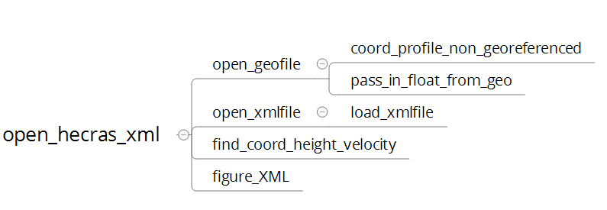

### Special Cases

* Data in HEC-RAS can be geo-referenced or not georeferenced. It is advised to geo-reference all model in HEC-RAS[1]. If the model is not geo-referenced, the function makes some assumptions to load the data: 1) the river profile are straight and perpendicular to the river. 2) the last profile is at the end of the river.
* Numerical data are sometime not separated (0.4556 0.3453233.454 05.343). In this case, the number of digit is assumed to be 8 for the profile and 16 for the river coordinates.
* Part of the profile can be vertical: The function also functions in this case.
* There is sometimes more than one reach in the modelled river and these reaches sometimes form loops: The function load each reach one after the other.
* The river reaches are sometimes not in the same order in the xml file and in the .goX file. The order of the .goX is used by the function. Reach are automatically re-ordered.
* If the river is straight, the coordinates of the river are given differently. The function try to load the river in the “straight” style if the usual style fail.
* The .goX file includes data on bridges and culvert. Currently, the function neglects this information.
* Sometimes distances between profiles are not given in the .goX file. The function neglects the distance data of this profile as long as it is not the last profile.
* The velocity data for the end and the beginning of the river profile is indicated by a large number (example 1.23e35 or -1.234e36). The function considers that velocity info is situated at the start of the profile if x>-1e30 and at the end of the profile if x> 1e30.
* There are two concepts called “profile” in HEC-RAS: The river profiles and the simulation profiles. The river profiles are the geometry perpendicular to the river and the simulation profile are the different simulations.
* Data in many of the example cases of HEC-RAS are in foot and miles. 1 miles = 5280 foot, and not 1000 foot.

1. To geo-reference a model: In the “geometric data” window, GIS tool, GIS Cut Line, Accept Display location, choose all profile