DEVELOPMENT OF AN AI-BASED STUDENT PERFORMANCE PREDICTION AND IMPROVEMENT SYSTEM

A CASE STUDY OF THE UNIVERSITY OF KIGALI

By

NTEZIRYAYO ALAIN FABRICE
Registration Number: 2201011357

Under the Guidance and Supervision of

Mr. Tuyishimire Joseph

A RESEARCH PROJECT REPORT SUBMITTED TO THE UNIVERSITY OF KIGALI IN PARTIAL FULFILMENT OF THE REQUIREMENTS FOR THE AWARD OF A BACHELOR OF SCIENCE WITH HONOURS IN INFORMATION TECHNOLOGY (BIT)

School of Computing and Information Technology University of Kigali

April 2026

DECLARATION
I, Nteziryayo Alain Fabrice, hereby declare that this research project is my original work and has not been submitted previously for a degree at this or any other university or institution. To the best of my knowledge, it does not contain any material published or written by another person, except as duly acknowledged in the text.

Nteziryayo Alain Fabrice
Signature: ……………………………………… Date: ……… / ……… / …………

APPROVAL
This is to confirm that I have reviewed and approved the submission of this research project. It meets the necessary academic requirements for submission to the University of Kigali.

Mr. Tuyishimire Joseph Supervisor
Signature: ……………………………………… Date: ……… / ……… / …………

DEDICATION
This work is dedicated to:

Almighty God, the source of all wisdom and knowledge,
My beloved family, for their unconditional love, prayers, and sacrifice, My fellow students and colleagues, for their comradeship and support,
The University of Kigali, for providing a platform for academic excellence, My supervisor, Mr. Tuyishimire Joseph, for his dedicated mentorship.

May God bless you all.

ACKNOWLEDGEMENT
I sincerely express my deepest gratitude to Almighty God, whose guidance and grace have accompanied me throughout this academic journey, and from whom all knowledge and wisdom originate.
I extend my heartfelt appreciation to the lecturers at the University of Kigali, particularly those in the School of Computing and Information Technology, for their invaluable contributions through their teachings, mentorship, and academic guidance throughout my studies.
A special note of thanks goes to my supervisor, Mr. Tuyishimire Joseph, for his dedicated guidance, constructive feedback, insightful advice, and unwavering commitment to helping me transform my ideas into meaningful research. His patience and expertise were indispensable in shaping this work.
I am also deeply grateful to the University of Kigali administration, all academic and support staff, and specifically the Department of Information Technology, for their continued encouragement and for providing a conducive environment for learning and innovation.
Furthermore, I extend my appreciation to my fellow classmates for their collaboration, moral support, and motivation, which greatly contributed to the completion of this work. Finally, I owe immeasurable thanks to my family and the Government of Rwanda for providing the resources, opportunities, and encouragement necessary to achieve my academic goals.

My genuine appreciation to all!

ABSTRACT
Student academic performance is a central concern in higher education institutions worldwide, yet many universities continue to rely on reactive and manual approaches to monitoring and supporting student progress. These traditional methods are often insufficient to identify at-risk students early enough to prevent academic failure or dropout. This study presents the design and development of an AI-Based Student Performance Prediction and Improvement System, implemented as a case study at the University of Kigali.
The purpose of the system is to leverage accessible artificial intelligence tools including machine learning algorithms and data analytics to predict student academic outcomes and provide timely, data-driven recommendations to students, lecturers, and academic administrators. By analyzing historical academic data such as grades, attendance records, assignment submissions, and engagement indicators, the system generates early-warning signals and personalized improvement suggestions tailored to each student's unique academic profile.
This study adopted an applied, developmental research design grounded in the Design Science Research (DSR) paradigm, focused on the design, development, and technical evaluation of the system itself. Requirements were derived from an analysis of the University of Kigali's existing academic performance monitoring workflow and from the empirical and theoretical literature reviewed in Chapter Two. The software development process employed Agile methodology integrated with a Prototyping approach to support iterative refinement of the system.
Analysis of the current academic performance monitoring process at the University of Kigali confirmed that academic difficulties are typically identified only after examination periods, at which point intervention is often too late to be effective. The developed web-based AI system integrates predictive machine learning models with a role-based interface accessible to students, lecturers, university management, and system administrators. Among the three machine learning algorithms evaluated, Decision Tree, Logistic Regression, and Naive Bayes, the Decision Tree model achieved the best performance, with approximately 86.7% accuracy on the synthetically generated evaluation dataset used in this study; this result reflects proof-of-concept technical performance and should not be interpreted as validated predictive accuracy on real University of Kigali student data. The study recommends broader institutional adoption, integration with existing learning management systems, structured evaluation with real users, and further enhancement through advanced machine learning models and mobile application development.

Keywords: Artificial Intelligence, Machine Learning, Student Performance Prediction, Learning Analytics, Educational Data Mining, Web-Based System, University of Kigali

TABLE OF CONTENTS
Contents

DECLARATION 2
APPROVAL 3
DEDICATION 4
ACKNOWLEDGEMENT 5
ABSTRACT 6
TABLE OF CONTENTS 8
LIST OF TABLES 10
CHAPTER ONE: GENERAL INTRODUCTION AND BACKGROUND TO THE STUDY 11
  - Introduction 11
  - Background to the Study 12
  - Statement of the Problem 14
  - Objectives of the Study 16
    - General Objective 16
    - Specific Objectives 16
  - Research Questions 16
  - Significance / Importance of the Study 17
    - Students 17
    - Lecturers and Academic Advisors 17
    - University Management and Administrators 17
    - The Higher Education Sector in Rwanda 18
    - Research Community 18
    - Government and Policy Makers 18
  - Scope of the Study 18
    - Content Scope 18
    - Time Scope 19
    - Geographical Scope 19
  - Limitations of the Study 19
CHAPTER TWO: LITERATURE REVIEW 21
  - Introduction 21
  - Definition of Key Concepts 21
  - The Body 23
    - Empirical Review 23
    - Theoretical Review 26
    - Summary of the Gap 28
    - Conceptual Framework 30
CHAPTER THREE: RESEARCH METHODOLOGY 31
  - Introduction 31
  - Research Design 31
  - Population and Selection of the Sample 32
    - Population 32
    - Sample Selection 33
  - Tools for Data Collection / Instrumentation 34
  - Data Collection Procedure 35
  - Data Analysis and Presentation 35
  - Validity and Reliability 36
  - Ethical Considerations 37
REFERENCES 39

LIST OF TABLES
Table 2.1: Summary of Research Gaps and Contributions 20
Table 4.1: Users Entity …
Table 4.2: Students Entity …
Table 4.3: Courses Entity …
Table 4.4: Enrollments Entity …
Table 4.5: Attendance Entity …
Table 4.6: Assessments Entity …
Table 4.7: Predictions Entity …
Table 4.8: Recommendations Entity …
Table 4.9: Notifications Entity …
Table 4.10: Comparison of Machine Learning Model Performance …
Table 4.11: Test Cases for the AI-Based Student Performance Prediction and Improvement System …
Table 5.1: Confusion Matrix for the Decision Tree Model on the Test Set (n = 9,449) …
Table 5.2: Per-Class Classification Report for the Decision Tree Model …

LIST OF FIGURES
Figure 2.1: Conceptual Framework of the AI-Based Student Performance Prediction and Improvement System
Figure 4.1: System Architecture of the AI-Based Student Performance Prediction and Improvement System …
Figure 4.2: System Context Diagram (DFD Level 0) …
Figure 4.3: Level 1 Data Flow Diagram …
Figure 4.4: Entity-Relationship Diagram of the Implemented Database …
Figure 4.5: Physical Database Schema of the Implemented System …
Figure 4.6: System Login Interface …
Figure 4.7: Student Performance Dashboard …
Figure 4.8: Lecturer Dashboard …
Figure 4.9: Course At-Risk Students and Prediction Generation …
Figure 4.10: Academic Data Upload Interface …
Figure 4.11: Course Performance Trends Over Time …
Figure 4.12: University Management Analytics Dashboard …
Figure 4.13: Institution-Wide Student Records and Detail View …
Figure 4.14: Institution-Wide Student Welfare View …
Figure 4.15: Institution-Wide Performance Trends …
Figure 4.16: System Administrator Dashboard …
Figure 4.17: User Account Management Interface …
Figure 4.18: Course Management Interface …
Figure 4.19: System Audit Trail …
Figure 4.20: In-App Notification Dropdown …
Figure 4.21: Sample Exported Analytics Report …
Figure 5.1: Comparison of Model Accuracy, Precision, Recall and F1-Score …
Figure 5.2: Decision Tree Confusion Matrix on the Held-Out Test Set (n = 9,449) …
Figure 5.3: 10-Fold Cross-Validation Accuracy (mean, with min-max range) …

CHAPTER ONE: GENERAL INTRODUCTION AND BACKGROUND TO THE STUDY

1.0 Introduction
Higher education institutions are under increasing pressure to improve academic outcomes, reduce student dropout rates, and ensure the holistic development of their student populations. In an era characterized by rapid technological advancement and the proliferation of digital data, universities are uniquely positioned to harness the power of artificial intelligence (AI) and data analytics to address longstanding challenges in academic performance monitoring and student support.
Traditionally, student performance has been assessed through periodic examinations, continuous assessment scores, and end-of-semester evaluations. While these mechanisms provide important indicators of academic achievement, they are fundamentally retrospective in nature identifying academic difficulties only after they have fully manifested. This reactive approach limits the ability of institutions to intervene at early stages, often resulting in academic failure, delayed graduation, or student attrition.
With the growing availability of digital academic data including attendance records, assignment grades, Learning Management System (LMS) interaction logs, and historical performance records it has become increasingly feasible to apply machine learning and predictive analytics to forecast student outcomes and design personalized academic interventions. Basic AI tools, including classification algorithms such as Decision Trees, Logistic Regression, and Naive Bayes, have demonstrated significant promise in educational contexts for identifying at-risk students and supporting proactive academic guidance.
This study presents the design and development of an AI-Based Student Performance Prediction and Improvement System as a web-based application, implemented as a case study at the University of Kigali. The system aims to analyze available academic data to predict each student's performance trajectory, flag students at risk of poor outcomes, and generate data-driven recommendations to support academic improvement. By doing so, the study seeks to shift the institution's

approach to student support from reactive to proactive, thereby improving academic outcomes, enhancing institutional efficiency, and promoting student welfare.

1.1 Background to the Study
Student academic performance has always been a central concern for higher education institutions, as it reflects not only the quality of learning and teaching but also the effectiveness of institutional support systems. Historically, universities monitored student performance through traditional mechanisms such as end-of-semester examinations, cumulative grade point averages (CGPAs), and faculty-student consultations. While these approaches provided a basic measure of academic standing, they were largely retrospective and offered limited scope for early identification of academic difficulties or timely intervention.

1.1.1 Global Context
Globally, the challenge of student attrition and poor academic performance has reached significant proportions. The United Nations Educational, Scientific and Cultural Organization (UNESCO, 2020) reported that higher education dropout rates in developing nations exceed 40% in many institutions, with academic failure identified as a primary contributing factor. In response, universities across North America, Europe, and East Asia have increasingly adopted technology-driven approaches to monitor and improve student academic outcomes.
The emergence of Educational Data Mining (EDM) and Learning Analytics (LA) as interdisciplinary fields combining computer science, statistics, and educational research created new opportunities to extract meaningful insights from academic datasets. Early studies by Baker and Yacef (2009) and Siemens and Long (2011) demonstrated that features such as attendance, prior academic performance, assignment submission rates, and engagement with digital learning materials were strong predictors of student outcomes. These findings laid the foundation for the application of machine learning algorithms in predicting academic performance.
The availability of cloud computing platforms, open-source machine learning libraries such as Scikit-learn and TensorFlow, and web development frameworks has significantly lowered the technical barrier to building AI-based academic support

systems. Institutions such as Purdue University in the United States have implemented systems like Course Signals, which use predictive analytics to identify at-risk students and trigger targeted interventions, achieving measurable reductions in failure rates (Arnold & Pistilli, 2012). Similar learning-analytics initiatives at institutions in the United Kingdom, Australia, and South Korea have reported improved student retention when such systems are integrated effectively into institutional workflows.

1.1.2 Regional Context (Africa and East Africa)
UNESCO (2020) highlighted that academic failure and dropout in Sub-Saharan African universities disproportionately affect first-year students and those from economically disadvantaged backgrounds, with limited institutional capacity for early identification and targeted support.
Despite these challenges, African universities have progressively invested in digital academic management systems, creating repositories of student data that remain largely underutilized for predictive or analytical purposes. Studies from Nigerian universities (Oyelaran & Fapojuwo, 2014) and South African institutions (Letseka & Maile, 2008) confirm that early detection of at-risk students is one of the most critical gaps in academic support infrastructure across the continent.
In East Africa, the integration of technology in higher education has accelerated significantly in recent years, partly driven by post-COVID-19 digitalization initiatives. Universities in Kenya, Uganda, and Tanzania have begun piloting learning analytics tools, although research documenting the outcomes of these implementations remains limited. Mduma, Kalegele, and Machuve (2019) reviewed machine learning approaches to student dropout prediction in East African universities and found that Decision Tree and Logistic Regression models consistently achieved predictive accuracy exceeding 80% when applied to available institutional datasets.

1.1.3 Local Context (Rwanda and University of Kigali)
In Rwanda, the integration of digital technologies in higher education has expanded significantly over the past decade, driven by the national ICT strategic plan and government investment in broadband infrastructure. Rwanda's Vision 2050 and the National Digital Transformation Policy emphasize the development of a knowledge-based economy, with higher education institutions positioned as critical drivers of innovation and human capital development.
However, empirical studies specifically examining AI applications for academic performance monitoring in Rwandan higher education remain limited. The Rwanda Ministry of Education (MINEDUC, 2020) reported that Rwandan universities experienced dropout rates of approximately 15–20% annually, with academic failure identified as a primary contributing factor. The report called for increased investment in student support systems and the adoption of innovative technologies, including AI and learning analytics, to address this challenge.
The University of Kigali, as one of Rwanda's leading private universities, offers programs in computing, engineering, business, and social sciences, serving a student population of over 8,000 registered students. Despite maintaining a digital student information system, the university currently lacks a structured AI-based academic monitoring platform. Academic performance tracking relies predominantly on manual review of examination results, with limited capacity for early identification of struggling students or delivery of personalized improvement guidance. This institutional gap directly motivates the development of the AI-based student performance prediction and improvement system proposed in this study.

1.2 Statement of the Problem
Higher education institutions, including the University of Kigali, continue to rely predominantly on traditional, retrospective methods for monitoring and responding to student academic performance. Under the current approach, academic difficulties are typically identified only after semester examinations, when failures or low grades have already been recorded. By this point, interventions such as supplementary

instruction, academic counselling, or remedial support are often too late to prevent failure, forced repetition of modules, or student dropout.
The University of Kigali currently lacks an automated system capable of continuously analyzing available academic data including attendance records, continuous assessment scores, assignment completion rates, and historical performance to predict each student's risk of poor performance before examination periods. In the absence of such a system, lecturers and academic advisors are unable to direct limited institutional resources toward students most in need of support in a timely and data-driven manner.
According to Nsengimana and Habimana (2021), students in Rwandan universities frequently face academic challenges that go undetected until it is too late for meaningful intervention. Furthermore, Rugira (2022) documented that academic advisors at Rwandan universities were overwhelmed by large caseloads and lacked the analytical tools necessary to prioritize support for the most at-risk students. MINEDUC (2020) confirmed that Rwanda's higher education dropout rate of 15–20% per annum is substantially driven by unaddressed academic underperformance.
Despite the increasing availability of digital academic data at the University of Kigali, this data is not systematically leveraged to generate early warnings or personalized academic improvement recommendations. Without an AI-based prediction system, the institution is unable to exploit available data assets to support proactive student intervention. This gap in institutional capacity represents a missed opportunity to improve student outcomes, reduce dropout rates, and enhance the overall quality of higher education at the university.
It is against this background that this study seeks to design and develop a web-based AI-Based Student Performance Prediction and Improvement System for the University of Kigali, leveraging accessible machine learning algorithms to generate performance predictions and actionable academic improvement recommendations for students, lecturers, and administrators.

1.3 Objectives of the Study
    - 1.3.1 General Objective
The general objective of this study is to design, develop, and implement a web-based AI-Based Student Performance Prediction and Improvement System at the University of Kigali.
    - 1.3.2 Specific Objectives
1. To analyze the existing academic performance monitoring system and identify the challenges faced by students, lecturers, and administrators at the University of Kigali.
2. To design and develop a web-based AI system that uses machine learning algorithms to predict student academic performance based on available academic data.
3. To implement a personalized recommendation module within the system that generates data-driven improvement suggestions for at-risk students.
4. To test and technically evaluate the functionality, reliability, and predictive performance of the developed AI-based student performance prediction and improvement system.

1.4 Research Questions
1. What are the challenges and limitations of the current academic performance monitoring system at the University of Kigali?
2. How can a web-based AI system be designed and developed to effectively predict student academic performance using available institutional data at the University of Kigali?
3. How can the system generate personalized academic improvement recommendations for students identified as being at risk of poor performance?

4. How well does the developed AI-based student performance prediction and improvement system perform in terms of functionality, reliability, and predictive performance under the study's controlled technical evaluation?

1.5 Significance of the Study
This study holds significant value for multiple stakeholders within and beyond the University of Kigali. The following sections outline the specific benefits anticipated for each group.
    - Students
Students are the primary beneficiaries of this system. By providing early identification of academic risk, the system enables students to receive timely, personalized recommendations before their performance deteriorates to the point of failure. Students will gain access to specific, data-driven improvement suggestions including targeted study resources, attendance improvement guidance, and assignment completion reminders that are tailored to their individual academic profiles. This promotes self-regulated learning and empowers students to take ownership of their academic progress, ultimately improving graduation rates and reducing forced module repetitions.
    - Lecturers and Academic Advisors
Lecturers and academic advisors will benefit from the system's early-warning capabilities, which generate alerts when students in their courses or advisee pools are identified as at risk. This allows educators to direct targeted attention and support to specific students rather than relying solely on examination results. The system reduces the administrative burden associated with manually tracking individual student progress across large cohorts, enabling academic staff to focus on high-impact teaching and support activities.
    - University Management and Administrators
University administrators and decisionmakers will benefit from the system's analytical dashboards, which provide aggregated performance data and trend analysis across departments, programs, and cohorts. This data supports

evidence-based decisionmaking on curriculum design, resource allocation, and academic support investment, contributing to improved institutional performance indicators and accreditation outcomes.
    - The Higher Education Sector in Rwanda
Beyond the University of Kigali, this study contributes a replicable model for AI-based academic monitoring applicable to other Rwandan and East African universities. By demonstrating the feasibility and effectiveness of using accessible machine learning tools within a resource-constrained institutional environment, this study provides a practical reference for higher education institutions seeking to leverage AI for student success, directly supporting Rwanda's higher education quality improvement agenda.
    - Research Community
This study contributes to the growing body of empirical research on AI applications in African higher education by providing context-specific evidence from a Rwandan university setting. The documented methodology, system architecture, and evaluation findings address identified gaps in the literature, particularly the limited availability of studies on AI-based performance prediction in East African academic institutions.
    - Government and Policy Makers
The study provides insights for government bodies such as the Rwanda Higher Education Council (HEC) and MINEDUC on how AI technologies can be integrated into academic management frameworks to reduce dropout rates and improve academic outcomes. The findings can inform national policy decisions promoting technology adoption in higher education and the development of data governance frameworks for educational AI applications.

1.6 Scope of the Study
    - Content Scope
This study focuses on the design, development, testing, and evaluation of a web-based AI-Based Student Performance Prediction and Improvement System. The

system incorporates machine learning algorithms specifically Decision Tree, Logistic Regression, and Naive Bayes classifiers trained on synthetically generated academic data including student attendance records, continuous assessment scores, assignment submission rates, and prior grade point average data. The system includes a prediction module, a personalized recommendation module, and a role-based web interface accessible to students, lecturers, and administrators. The study does not extend to the development of a mobile application or the integration of external learning management systems, which are proposed as areas for future development.
    - Time Scope
The study was conducted over a period of six months, commencing in November 2025 and concluding in April 2026. This timeframe encompassed the analysis of the existing system, requirements gathering, system design, development, testing, validation, and documentation.
    - Geographical Scope
The study is geographically limited to the University of Kigali, located in Kigali, Rwanda. Data collection, system implementation, and testing were conducted within this institution. While the system is designed with scalability considerations, findings and conclusions are specifically derived from the University of Kigali context.

1.7 Limitations of the Study
The following limitations were acknowledged and considered throughout the research process:
Data Availability and Quality. The machine learning models developed in this study were trained on a synthetically generated dataset designed to reflect realistic academic indicators (attendance, continuous assessment scores, assignment completion, and prior GPA), since complete, real historical academic records could not be obtained from the University of Kigali within the scope and timeframe of this study. While the synthetic dataset was constructed to reflect plausible, internally consistent relationships between these indicators and academic risk, model performance on real institutional data may differ and would need to be re-evaluated once such data becomes available.
Scope of Machine Learning Algorithms. This study deliberately focuses on basic, accessible machine learning algorithms Decision Trees, Logistic Regression, and
Synthetic Label-Generation Methodology. The academic risk labels used to train and evaluate the machine learning models were generated using predefined, threshold-based rules applied to the synthetic dataset (Section 3.3.4), rather than derived from observed real-world student outcomes. Consequently, the models' demonstrated ability to learn these embedded relationships should be interpreted as proof-of-concept technical performance rather than as evidence that the same accuracy would be achieved in predicting actual University of Kigali student outcomes.

Naive Bayes suitable for resource-constrained institutional environments. More complex deep learning models, while potentially achieving higher accuracy, were outside the scope of this study due to computational and data volume constraints. Future research may explore advanced neural network models with expanded datasets.
Generalizability. The system was designed and tested specifically within the University of Kigali context. The findings, system configurations, and model parameters may require adaptation before application in other institutions with differing data structures, academic systems, or operational contexts.
Time Constraint. The study was conducted over a six-month period, limiting the scope for longitudinal evaluation of the system's impact on actual student outcomes. The evaluation was confined to functionality, usability, and predictive accuracy testing rather than long-term impact assessment. Long-term effectiveness monitoring is recommended as a future research direction.
External Stakeholder Evaluation. This study did not include formal, structured evaluation of the system by external students, lecturers, management, or administrators beyond the researcher's own developer-led testing. Consequently, findings on usability and practical acceptance reported in this study are limited to the researcher's own assessment, and structured user acceptance testing with real institutional stakeholders is recommended as a priority next step before any institutional deployment.
Ethical and Privacy Considerations. Because this study used a synthetically generated dataset rather than real student records, no personal data belonging to actual University of Kigali students was collected, processed, or placed at risk during this study. The system was nonetheless designed with the data protection principles of Rwanda's Law No. 058/2021 in mind, including password encryption and role-based access control, so that it would be appropriately positioned for formal ethical review and institutional data governance approval prior to any future deployment involving real student data.

CHAPTER TWO: LITERATURE REVIEW

2.0 Introduction
This chapter presents a comprehensive review of existing literature relevant to the development of an AI-based student performance prediction and improvement system. The chapter begins with a definition of key concepts central to the study, followed by the main body of the review, which is structured according to the specific objectives of the research. The body includes an empirical review examining studies conducted in various contexts globally, regionally, and locally; a theoretical review presenting frameworks and models that underpin the study; a summary of identified research gaps; and a conceptual framework illustrating the relationships between the key variables of the study.

2.1 Definition of Key Concepts
The following key concepts are central to this study and are defined as follows:
Artificial Intelligence (AI). Artificial intelligence refers to the simulation of human intelligence processes by computer systems. These processes include learning (the acquisition of information and rules for using it), reasoning (using rules to reach approximate or definite conclusions), and self-correction. In the context of this study, AI encompasses the machine learning algorithms and data analytics techniques applied to predict student academic performance and generate improvement recommendations (Mitchell, 1997).
Machine Learning (ML). Machine learning is a subset of artificial intelligence that enables computer systems to learn from data and improve their performance on specific tasks without being explicitly programmed for each task. Machine learning algorithms identify patterns and relationships within datasets and use these patterns to make predictions or decisions on new data (Mitchell, 1997). In this study, ML algorithms are trained on synthetically generated academic data to classify student performance risk levels.
Student Performance Prediction. Student performance prediction refers to the application of computational methods particularly machine learning and statistical

modelling to forecast students' likely academic outcomes based on available data features such as attendance, prior grades, and assignment completion. The goal of prediction in this context is to enable proactive identification of at-risk students before their performance deteriorates to the point of failure (Romero & Ventura, 2010).
Educational Data Mining (EDM). Educational data mining is an interdisciplinary research field concerned with the development and application of computational methods to analyze and extract useful knowledge from data generated in educational environments. EDM draws on techniques from machine learning, data mining, statistics, and educational research to understand student learning processes and improve educational outcomes (Baker & Yacef, 2009).
Learning Analytics (LA). Learning analytics is defined as the measurement, collection, analysis, and reporting of data about learners and their contexts, with the purpose of understanding and optimizing learning and the environments in which it occurs (Siemens, 2013). Learning analytics focuses on the use of educational data to generate actionable insights for students, educators, and institutions.
Web-Based System. A web-based system is a software application that is accessed and operated through a web browser over the internet or an intranet, without requiring local installation on individual devices. Web-based systems offer advantages of accessibility, centralized data management, and ease of updates and maintenance. In this study, the AI-based student performance system is implemented as a web-based application to ensure broad accessibility for students, lecturers, and administrators across the university.
Decision Support System (DSS). A decision support system is a computer-based information system that supports decisionmaking activities through data analysis, modelling, and the presentation of information in usable formats. In the context of this study, the AI-based system functions as a DSS by providing performance predictions and recommendation outputs that support academic decisionmaking by lecturers, advisors, and administrators.

2.2 Review of Related Literature
    - 2.2.1 Empirical Review
The empirical review examines existing studies on AI-based student performance prediction and academic support systems across global, regional, and local contexts. These studies provide valuable insights into current practices, technological approaches, and outcomes associated with machine learning applications in higher education.
Global Perspective
In the United States, Arnold and Pistilli (2012) developed the Course Signals system at Purdue University, one of the earliest and most widely referenced implementations of learning analytics in higher education. The system used a predictive algorithm combining demographic data, prior academic performance, and LMS interaction data to classify students into risk categories and trigger automated email interventions. Results demonstrated that students who received early interventions achieved higher course completion rates and final grades compared to those who did not. This study established a foundational model for proactive, data-driven academic support that informs the design of the current research.
Kotsiantis, Pierrakeas, and Pintelas (2004) conducted a comparative study of machine learning techniques for predicting student performance in distance learning environments. Their study evaluated Decision Tree, Naive Bayes, Logistic Regression, and Support Vector Machine (SVM) classifiers on student academic datasets from the Hellenic Open University. Findings indicated that Naive Bayes and Logistic Regression achieved competitive predictive accuracy while remaining computationally efficient, making them suitable for deployment in resource-limited institutional settings. This finding supports the algorithm selection rationale adopted in the current study.
In the United Kingdom, the Open University Learning Analytics Dataset (OULAD), comprising over 32,000 students across 22 courses, has been extensively used to develop and benchmark performance prediction models. Hlosta, Zdrahal, and Zendulka (2017) applied ensemble machine learning methods to the OULAD dataset

to identify at-risk students early in the academic semester, achieving F1scores exceeding 0.78. Their work demonstrated that accurate early-warning identification is achievable even with limited early-semester data, a finding directly relevant to the University of Kigali context where complete semester data may not always be available at prediction time.
Romero and Ventura (2010) conducted a comprehensive review of educational data mining techniques applied to student performance data. Their review confirmed that association rule mining, classification algorithms, and clustering techniques are the most frequently applied EDM methods, with decision trees and Bayesian classifiers emerging as particularly well-suited for student performance classification tasks due to their interpretability and reasonable computational requirements. The emphasis on model interpretability is critical in the present study, as educational stakeholders require transparent, explainable predictions to trust and act on system outputs.
In Europe, Pérez, González, and Rodríguez (2020) studied the implementation of AI-based performance monitoring systems in Spanish universities and found that automated early-warning systems improved student engagement and reduced dropout by approximately 12% in pilot programs. The study emphasized the importance of involving all stakeholders students, lecturers, and administrators in system design to ensure usability and institutional adoption, a principle applied in the co-design approach of the current study.
African Perspective
In Africa, Oyelaran and Fapojuwo (2014) analyzed predictors of academic performance among undergraduate students in Nigerian universities, identifying attendance, prior performance, and continuous assessment scores as the three most significant predictors of end-of-semester examination outcomes. Their findings validated the feature selection approach used in this study and confirmed that these variables are reliably available in African university administrative systems.
Letseka and Maile (2008) documented that South African universities experienced dropout rates exceeding 30% annually, with academic failure constituting the primary reason for attrition. Their study called for investment in early identification systems

capable of detecting at-risk students within the first semester of study. Although their study predated the widespread availability of machine learning tools, its recommendations directly align with the objectives of the current research.
Mduma, Kalegele, and Machuve (2019) conducted a systematic survey of machine learning approaches applied to student dropout prediction in East African universities. Their review of 47 studies found that Decision Tree and Logistic Regression models achieved the highest average predictive accuracy (83.7% and 81.2% respectively) across East African datasets. Critically, the study noted that complex deep learning models did not consistently outperform simpler classifiers on smaller datasets typical of East African institutions, reinforcing the appropriateness of the algorithm choices in the current study.
Local Perspective (Rwanda and University of Kigali)
In Rwanda, Nsengimana and Habimana (2021) found that students in Rwandan universities faced significant academic challenges including inadequate access to personalized academic support, limited faculty-student engagement outside classroom settings, and insufficient use of digital tools for academic monitoring. Their study identified a strong need for technology-driven solutions capable of providing students with timely, personalized feedback on academic progress.
Rugira (2022) documented that academic advisors at Rwandan universities were overwhelmed by large student caseloads and lacked data-driven tools to prioritize support for the most at-risk students. The study noted that despite the existence of digital student information systems at several institutions, data remained siloed and was not systematically analyzed for predictive or prescriptive purposes.
Ndagijimana, Uwase, and Habimana (2023) examined the potential of automated academic monitoring tools in Rwandan higher education, highlighting that institutions with digital infrastructure were well-positioned to adopt predictive analytics but lacked the technical expertise and institutional frameworks to implement such systems effectively. Their study recommended the development of locally adapted AI systems that account for the specific data characteristics and operational contexts of Rwandan universities a recommendation directly addressed by this study.

MINEDUC (2020) reported Rwanda's higher education sector experienced dropout rates of approximately 15–20% annually, with academic failure as the primary contributing factor. The report called for increased investment in student support systems and the adoption of innovative technologies including AI and learning analytics, directly motivating the development of the system proposed in this study.
    - 2.2.2 Theoretical Review
The theoretical review examines key theories, models, and frameworks that provide a foundation for understanding the development and implementation of AI-based academic performance prediction systems. These theories address technology integration in education, user acceptance of AI tools, student learning behaviour, and the ethical governance of educational data.
Technology Acceptance Model (TAM). The Technology Acceptance Model, developed by Davis (1989), posits that perceived ease of use and perceived usefulness are the primary determinants of users' intentions to adopt and use a new technology system. In the context of the AI-based student performance system, TAM provides a framework for understanding how students, lecturers, and administrators at the University of Kigali are likely to perceive and accept the proposed system. If the system is perceived as easy to navigate and genuinely useful in improving academic monitoring, stakeholders are more likely to engage with and rely on its outputs. The study applies TAM to guide the user-centred design of the system interface (Chapter Four); empirical evaluation of user acceptance among real students, lecturers, and administrators was outside the scope of this study and is recommended as a priority direction for future research (Chapter Six).
Unified Theory of Acceptance and Use of Technology (UTAUT). Venkatesh et al. (2003) extended the TAM framework through the Unified Theory of Acceptance and Use of Technology, which incorporates performance expectancy, effort expectancy, social influence, and facilitating conditions as determinants of technology adoption. In the university setting, lecturers' willingness to act on AIgenerated early warnings and administrators' readiness to invest in system maintenance are influenced by their expectations of performance improvement, the effort required to use the system, peer influence, and the availability of technical support. The UTAUT

framework informs the user-centred design considerations intended to support future adoption among University of Kigali stakeholders; formal evaluation of adoption readiness with real users was outside the scope of this study and is recommended for future research (Chapter Six).
Educational Data Mining and Learning Analytics Framework. The EDM and LA framework (Romero & Ventura, 2010; Siemens, 2013) provides the theoretical foundation for the data-driven approach at the core of this study. EDM frames the process of extracting predictive patterns from student academic datasets as a scientific endeavour governed by established data mining principles, while LA contextualizes the application of these patterns within the specific goal of optimizing student learning outcomes. Together, these frameworks justify the selection of machine learning algorithms, the choice of predictive features, and the design of the recommendation engine within the proposed system.
Self-Regulated Learning Theory (SRL). Zimmerman's (2000) Self-Regulated Learning Theory posits that successful learners actively monitor their own academic progress, set goals, adopt appropriate learning strategies, and respond to feedback in ways that improve their performance. The AI-based system's recommendation module is grounded in SRL principles, providing students with personalized, actionable feedback designed to support self-monitoring and goal-setting. By translating predictive outputs into specific improvement suggestions such as targeted attendance improvement, additional study resource access, or assignment completion guidance the system scaffolds self-regulated learning behaviours among students identified as at risk.
Student Integration Theory. Vincent Tinto's Student Integration Theory (1987) proposes that students' persistence in higher education is determined by their academic and social integration into the institutional community. Academically, students who experience early failure without timely intervention are more likely to disengage and eventually drop out. The AI-based system directly addresses the academic integration dimension of Tinto's model by ensuring that struggling students receive early, personalized institutional support, thereby strengthening their academic integration and reducing dropout risk.

System Theory. System Theory, as applied in educational contexts, views a university as a collection of interrelated components academic programs, support services, data systems, and stakeholder roles that must work together to achieve institutional objectives. The AI-based performance system fits within this broader institutional ecosystem as a component that links student data inputs, machine learning processing, and actionable outputs across multiple stakeholder roles. System Theory underscores the importance of ensuring that the proposed system integrates seamlessly with existing institutional data workflows and administrative processes, rather than operating as an isolated tool.
    - 2.2.3 Summary of the Research Gap
The literature reviewed in this chapter confirms that AI-based performance prediction and learning analytics systems represent a significant and growing field, with demonstrated potential to improve student academic outcomes and reduce dropout rates. Globally, machine learning classifiers particularly Decision Trees, Logistic Regression, and Naive Bayes have been successfully applied to educational datasets with strong predictive accuracy. Theoretical frameworks including TAM, UTAUT, EDM, SRL Theory, and System Theory collectively provide a strong conceptual foundation for the design of the proposed system.
However, the review reveals several critical gaps that this study addresses:
Gap 1: Limited AI Implementation in Rwandan Universities. Despite the global proliferation of AI-based academic prediction tools, no empirical study documents the design or evaluation of such a system within a Rwandan university context. This study directly addresses this gap by designing and implementing an AI-based prediction system tailored to the academic data environment of the University of Kigali.
Gap 2: Underutilization of Existing Academic Data. While Rwandan universities collect substantial academic data through digital information systems, empirical studies indicate that this data is rarely analyzed for predictive or prescriptive purposes. This research demonstrates how available institutional data can be systematically utilized to develop and validate predictive ML models.
Gap 3: Limited Research on Basic AI Tools in Resource-Constrained Contexts. Much of the literature on AI in education focuses on advanced models and large-scale datasets in wellresourced institutions. This study evaluates basic, accessible ML algorithms in a resource-constrained Rwandan university setting, providing evidence for their practical utility in similar environments.

Gap 4: Absence of Integrated Prediction and Recommendation Systems. Many existing performance prediction studies focus exclusively on classification accuracy without addressing how predictive outputs translate into actionable improvement recommendations. The proposed system integrates prediction and personalized recommendation functionalities, ensuring outputs are translated into concrete academic support actions.
Gap 5: Insufficient Evaluation of User Acceptance in African Contexts. Few studies evaluate how students and academic staff in African universities perceive and accept AI-based academic support tools. This study applies TAM and UTAUT theoretically to inform the user-centred design of the proposed system (Chapter Four); empirical evaluation of user acceptance among real University of Kigali stakeholders remains an important direction for future research (Chapter Six).

Research Gap | Source | Contribution of This Study
Limited AI implementation in Rwandan universities | Nsengimana & Habimana (2021); MINEDUC (2020) | Designs first AI prediction system tailored to Rwandan HEI context
Underutilization of existing academic data | Rugira (2022); Ndagijimana  et al. (2023) | Demonstrates systematic use of institutional data for ML model development
Limited research on basic ML in resource-constrained settings | Mduma et al. (2019) | Evaluates accessible ML algorithms in resource-limited university environment
No integrated prediction & recommendation system | Romero & Ventura (2010) | Integrates prediction and personalized recommendation in single platform
Insufficient user acceptance research in Africa | Venkatesh et al. (2003) | Applies TAM/UTAUT theoretically to inform user-centred design; empirical evaluation left for future research
Table 2.1: Summary of Research Gaps and Contributions

    - 2.2.4 Conceptual Framework
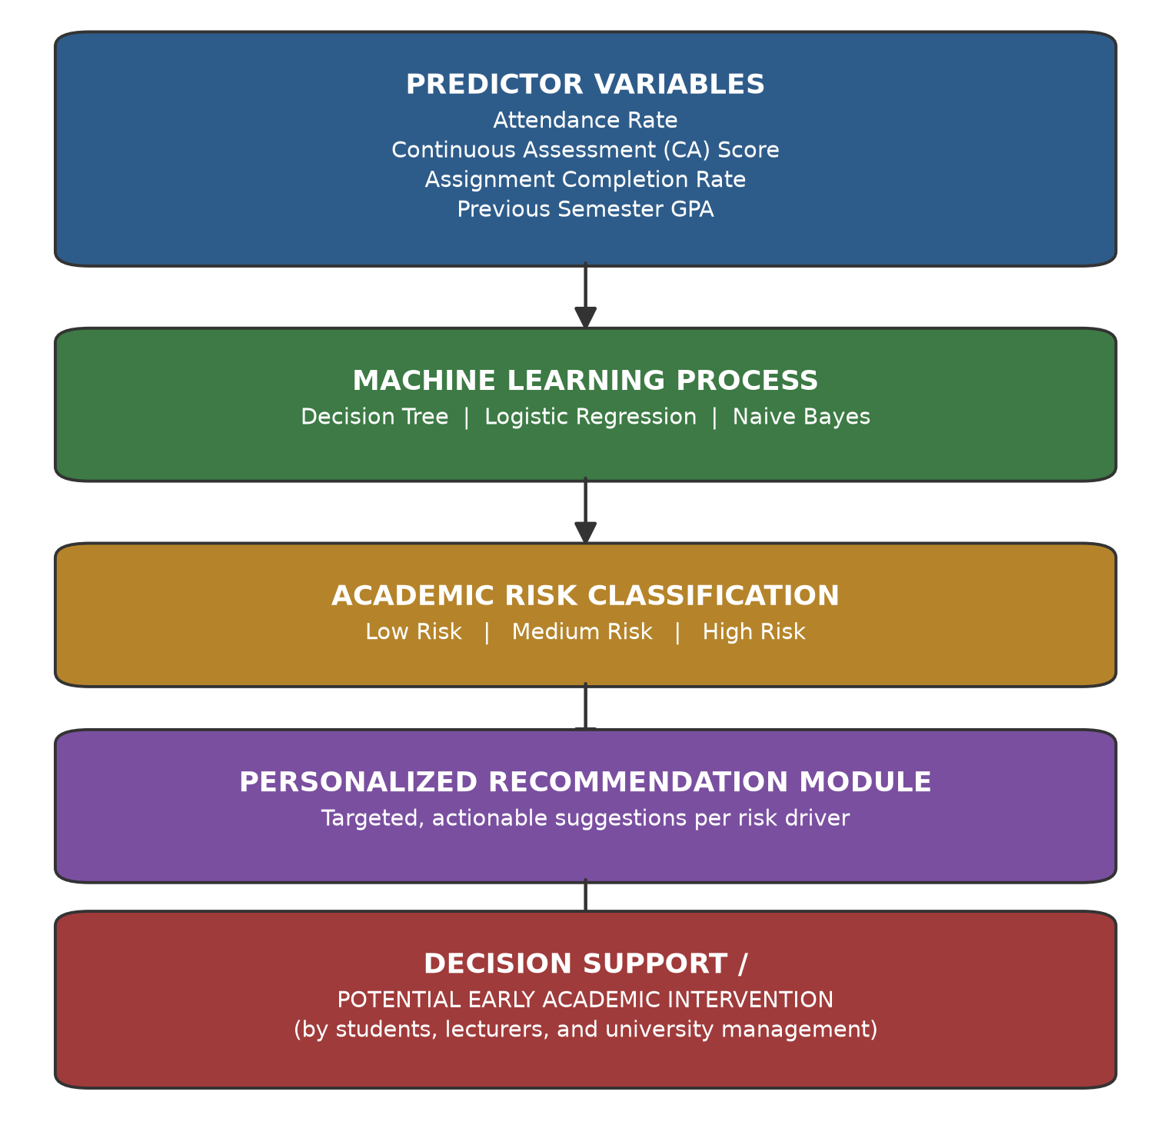
Figure 2.1: Conceptual Framework of the AI-Based Student Performance Prediction and Improvement System
The conceptual framework in Figure 2.1 shows the relationship between the variables and processes central to this study. The predictor variables, attendance rate, continuous assessment score, assignment completion rate, and previous semester GPA, are the four academic indicators identified in the literature reviewed in this chapter (Oyelaran & Fapojuwo, 2014; Mduma, Kalegele, & Machuve, 2019) and are the only features used by the system's machine learning models (Chapter Four, Section 4.5). These variables are passed to the machine learning process, in which the Decision Tree, Logistic Regression, and Naive Bayes classifiers evaluated in this study each learn to associate combinations of these indicators with an academic risk category.
The output of this process is a categorical academic risk classification, Low, Medium, or High, for each student-course record. Each classification is then passed to the personalized recommendation module, which translates the prediction into specific, actionable suggestions targeted at the student's weakest indicator, grounded in the Self-Regulated Learning theory discussed in Section 2.2.2. The final stage of the framework, decision support and potential early academic intervention, represents the intended use of the system's outputs by students, lecturers, and university management to inform timely academic support decisions.
This framework is presented as a decision-support pathway rather than as an empirically demonstrated causal model of improved student performance. This study evaluates the technical performance of the machine learning process (Chapter Five) but does not longitudinally measure whether students who received recommendations subsequently improved their academic outcomes; this remains an important direction for future research (Chapter Six).
The stakeholder interaction diagram illustrating how the Student, Lecturer, University Management, and System Administrator roles each interact with the system is presented separately in Chapter Four as the System Context Diagram (Figure 4.x), since it describes the system's user-role architecture rather than the predictive relationship between study variables.

CHAPTER THREE: RESEARCH METHODOLOGY

3.0 Introduction
This chapter outlines the research methodology employed to design, develop, test, and evaluate the AI-Based Student Performance Prediction and Improvement System for the University of Kigali. It provides a detailed overview of the research design, the study context and scope of evaluation, the machine learning dataset, the tools and techniques used, the system development and data sourcing procedure, methods of data analysis and presentation, measures for ensuring validity and reliability, and the ethical considerations observed throughout the study. The methodology is structured to ensure that all research objectives are addressed systematically and that the findings are credible, valid, and practically applicable.

3.1 Research Design
A research design constitutes the overall strategy and framework that guides the collection, measurement, and analysis of data in order to address the research questions and achieve the stated objectives. This study adopted an applied, developmental research design grounded in the Design Science Research (DSR) paradigm (Hevner, March, Park, & Ram, 2004), which is concerned with the creation and rigorous evaluation of information technology artefacts developed to address identified organisational problems. The study proceeded through the core DSR activities: problem identification and motivation (Chapter One), definition of objectives (Chapter One), design and development of the artefact (Chapter Four), demonstration of the artefact, and evaluation of the artefact against its stated requirements (Chapters Four and Five).
The requirements that informed system design (Chapter Four) were derived from a structured analysis of the University of Kigali's existing, manual academic performance monitoring workflow, together with the empirical and theoretical literature reviewed in Chapter Two. This approach allowed the researcher to identify the practical weaknesses of the current process such as its reactive nature and lack of an early-warning mechanism, and to translate them into concrete functional and non-functional requirements for the proposed system.
This study did not involve the collection of primary data from a sampled population of students, academic staff, management, or ICT personnel through questionnaires, interviews, or focus group discussions. The study was deliberately scoped as a system-development and technical-evaluation study: it focuses on designing, implementing, and evaluating the AI-based prediction system itself, using a synthetically generated dataset for machine learning model development (Section 3.4) and structured technical testing for system evaluation (Section 3.6 and Chapter Four). This scope decision, and its implications, are discussed further in Section 3.2 and revisited as a limitation in Chapter Six.

In addition, the study incorporated a descriptive element, documenting the current state of academic performance monitoring at the University of Kigali without manipulation of variables, in order to provide a clear, structured basis for the system requirements specified in Chapter Four.
The study also applied applied-research principles, as its primary aim was to develop a practical technological solution to an identified institutional problem. System development followed Agile methodology integrated with a Prototyping approach, enabling iterative refinement of the system across successive development cycles. This approach ensured that the system evolved progressively toward the functional and non-functional requirements defined in Chapter Four.

3.2 Study Context and Scope of Evaluation
  - This study was conducted using the University of Kigali as its case-study institution. Rather than collecting primary data from a sampled population of students, academic staff, management, and ICT personnel, the study was scoped as a system-development and technical-evaluation study, focused on analysing the University's existing academic performance monitoring workflow, designing and developing the AI-based prediction system, and evaluating the system's technical performance, functionality, and reliability.
  - Consequently, this study did not administer questionnaires, conduct interviews, or hold focus group discussions with students, lecturers, management, or ICT personnel. The requirements informing system design (Chapter Four) were instead derived from a structured analysis of the University's existing manual academic performance monitoring process, together with the empirical and theoretical literature reviewed in Chapter Two. Formal evaluation of the system by external student, lecturer, and administrator users was outside the scope of this study and is identified as a priority area for future work in Chapter Six.

3.3 Machine Learning Dataset
  - 3.3.1 Dataset Generation
  - The dataset used to train and evaluate the machine learning models was synthetically generated by the researcher using a purpose-built Python script, since complete, real anonymised historical academic records could not be obtained from the University of Kigali within the timeframe of this study. The dataset was designed to reflect realistic, internally consistent relationships between academic indicators and performance outcomes, at a scale approximating the University's actual student population.
  - 3.3.2 Dataset Scale and Academic Period
  - The dataset comprises 9,000 synthetic student records, each assigned a program, year of study, and three to four course enrolments drawn from a pool of 15 courses across three synthetic semesters (2024-Sem1, 2024-Sem2, and 2025-Sem1), producing 31,494 student-course-semester records used for model training and evaluation.
  - 3.3.3 Predictor Variables
  - Four predictor variables were used, consistent with those identified as significant in the literature reviewed in Chapter Two (e.g., Oyelaran & Fapojuwo, 2014; Mduma, Kalegele, & Machuve, 2019): attendance rate (percentage of class sessions attended), continuous assessment (CA) score, assignment completion rate, and previous semester grade point average (GPA).
  - 3.3.4 Target Variable
  - The target variable was a categorical academic risk level: Low, Medium, or High, assigned to each record by the dataset-generation script (scripts/generate_dataset.py) using the following exact rule-based procedure. A record was classified as High risk if attendance rate was below 55%, or if CA score was below 35%, or if attendance rate was below 70% and assignment completion was below 55%. Otherwise, a record was classified as Low risk if attendance rate was at least 85%, CA score at least 65%, assignment completion at least 70%, and previous GPA at least 2.5, or if CA score was at least 55%, assignment completion at least 60%, previous GPA at least 2.0, and attendance rate at least 75%. All remaining records were classified as Medium risk. A 20% probability was then applied to shift the assigned label by one step (for example, from Medium to High), so that the classification algorithms evaluated in Chapter Five would need to learn a realistically noisy, rather than a deterministic, relationship.
  - 3.3.5 Class Distribution
  - Of the 31,494 records, 13,162 (41.8%) were labelled High risk, 10,325 (32.8%) Medium risk, and 8,007 (25.4%) Low risk.
  - 3.3.6 Inclusion, Exclusion and Missing Values
  - Every synthetic student-course-semester combination generated by the script was included, and no records were excluded. Because the dataset was generated programmatically, it contains no missing values; this differs from real institutional data, which the literature (e.g., MINEDUC, 2020) suggests would typically require cleaning to address incomplete attendance or assessment records.
  - 3.3.7 Anonymisation and Privacy
  - No real student data was used at any stage of this study. All names, registration numbers, and academic records in the dataset are entirely fictitious, so no personally identifiable information belonging to any real individual was collected, processed, or placed at risk during model development.
  - The preprocessing procedures, feature encoding, train/test split, and cross-validation strategy applied to this dataset are described in Section 3.6 (Data Analysis and Presentation), and the resulting model performance is reported in Chapter Five.
  - Because the target risk labels were generated using the researcher's own threshold-based rules (Section 3.3.4) rather than observed from real student outcomes, the machine learning models evaluated in this study are learning the patterns embedded in the data-generation process itself. This is an important methodological boundary: the resulting accuracy, precision, recall, and F1-score reported in Chapter Five demonstrate the selected algorithms' technical capacity to recover a known, rule-based relationship, and should not be interpreted as a validated measure of predictive accuracy on real, unobserved University of Kigali student data.

3.4 Tools and Techniques Used in System Development and Evaluation
The following tools and techniques were used to analyse the existing system, generate the dataset used for machine learning model development, and design, develop, and evaluate the proposed AI-based system.

3.4.1 System and Workflow Analysis
As a registered student in the School of Computing and Information Technology at the University of Kigali, the researcher conducted participant observation of the University's existing academic performance monitoring process throughout the study period (November 2025 to April 2026). This involved observing and documenting how lecturers record continuous assessment scores, attendance, and assignment marks during the semester, and how the Registrar's Office and academic advisors review overall student performance only after end-of-semester examinations have been marked and results compiled. Observations were recorded as summary notes on the workflow's sequence, timing, and points of manual handling, and were used, together with the empirical and theoretical literature reviewed in Chapter Two, to specify the requirements presented in Chapter Four (Section 4.1).

3.4.2 Dataset Generation Tools
A structured framework was used to define the academic data fields required for machine learning model development, namely attendance rate, continuous assessment score, assignment completion rate, and previous GPA. Because complete, real historical academic records could not be obtained from the University of Kigali within the scope of this study, this framework guided the generation of the synthetic dataset described in Section 3.4.

3.4.3 Machine Learning Development Tools
The Python programming language, together with the pandas, scikit-learn, and joblib libraries, was used to preprocess the dataset, train the Decision Tree, Logistic Regression, and Naive Bayes classifiers, and persist the trained models for use by the web application.

3.4.4 Software Development Tools
The web application was developed using Spring Boot 3 (Java 21) for the backend, React 19 with TypeScript and Tailwind CSS for the frontend, and MySQL 8 for data persistence, with schema changes managed through versioned Flyway migrations. Docker Compose was used to containerise the backend, frontend, database, and machine learning microservice for local development and testing, as detailed in Chapter Four (Section 4.4).

3.4.5 Software Testing Tools
Automated testing was performed using JUnit and Spring Boot's test framework for the backend application and Vitest for the frontend application, supplemented by manual exploratory testing of each role's workflows and direct testing of the application programming interface (API) endpoints.

3.5 System Development and Data Sourcing Procedure
The study proceeded in three main stages: analysis of the existing system, dataset generation for machine learning model development, and iterative system development and testing.
Analysis of the existing system involved reviewing publicly available institutional information and the researcher's own documentation of the University of Kigali's current, manual academic performance monitoring workflow (Section 4.1), together with the empirical and theoretical literature reviewed in Chapter Two, to identify the functional and non-functional requirements presented in Chapter Four.
Dataset generation for machine learning model development followed the framework described in Section 3.4: a synthetic dataset of 9,000 student records and 31,494 student-course-semester records was generated programmatically, reflecting realistic relationships between attendance, continuous assessment scores, assignment completion, previous GPA, and academic risk. System development then proceeded iteratively using the Agile-Prototyping approach described in Section 3.1, with each development cycle followed by testing as described in Section 3.6 and Chapter Four.

3.6 Data Analysis and Presentation
Data generated through this study, comprising the synthetic machine learning dataset and the results of system testing, were analysed using quantitative techniques appropriate to a system-development and technical-evaluation study.

3.6.1 Data Preprocessing
Because the dataset was generated programmatically (Section 3.3), it contained no missing values requiring treatment. The categorical target variable (risk_level) was label-encoded, and the four numerical predictor variables were standardised to a common scale using z-score normalisation, so that no single feature would dominate the model purely because of its numeric range.

3.6.2 Training and Testing Split
The dataset was split into a training set (70%) and a testing set (30%) using stratified sampling, so that the proportion of Low, Medium, and High risk records in the test set matched their proportion in the full dataset.

3.6.3 Model Training
Three classification algorithms, Decision Tree, Logistic Regression, and Naive Bayes, were trained on the training set using the Python scikit-learn library, as described in Section 3.4.3.

3.6.4 Cross-Validation
Ten-fold cross-validation (k = 10) was applied to each model on the full feature set to assess how consistently each model would generalise to new, unseen student-course records, rather than relying on the result of a single train/test split.

3.6.5 Model Evaluation Metrics
Model performance was evaluated using four standard classification metrics: accuracy, precision, recall, and F1-score, calculated on the held-out test set. Macro-averaged precision, recall, and F1-score were used so that performance on the smaller Medium risk category was not overshadowed by the larger High and Low risk categories. The resulting metrics for all three algorithms are reported in Chapter Five.

3.6.6 System Testing Analysis
Results of the machine learning model evaluation and system testing are presented using tables, including a comparative table of model performance metrics (Chapter Five) and a summary of functional and security test outcomes (Chapter Four).

3.7 Validity and Reliability
To ensure the validity of the system's design, the functional and non-functional requirements defined in Chapter Four were developed based on the research objectives, a thorough review of relevant literature (Chapter Two), and a structured analysis of the University of Kigali's existing academic performance monitoring workflow (Section 4.1). The requirements were reviewed by the research supervisor to assess their relevance, clarity, and completeness before implementation began.
Triangulation was applied by cross-checking the system's requirements and design decisions against multiple sources: the empirical and theoretical literature reviewed in Chapter Two, the documented weaknesses of the existing system, and the automated test results reported in Chapter Four, strengthening the internal consistency of the study's conclusions.

For reliability, standardised development and testing procedures were applied consistently throughout the study. Software reliability was assessed through an automated test suite covering authentication, data upload, prediction generation, recommendation generation, and access-control scenarios (Chapter Four), which produced consistent, repeatable results across multiple execution runs. For the machine learning models, reliability was assessed through ten-fold cross-validation, ensuring that reported predictive accuracy was evaluated across multiple data subsets and was not driven by dataset-specific patterns. Model performance metrics, including accuracy, precision, recall, and F1-score, were calculated and reported for each algorithm to provide a comprehensive reliability assessment (Chapter Five).

3.8 Ethical Considerations
Ethical considerations were addressed throughout this study, notwithstanding its system-development and technical-evaluation scope. Although the study did not involve data collection from human research participants, the system itself was designed to process real student academic data in a future institutional deployment, and its design was therefore guided by established data protection and research ethics principles.
The system's data handling design, including password encryption, role-based access control, and an audit trail of generated predictions and recommendations, was reviewed by the research supervisor to confirm alignment with accepted data protection principles before implementation.
Because a synthetically generated dataset was used for machine learning model development (Section 3.4), no real student academic records were processed at any stage of this study, and no real individual could be identified from the data used in model training or evaluation. This eliminated the confidentiality and re-identification risks that would otherwise arise from the use of real institutional data.

The system was designed in line with the data minimisation principles of Rwanda's Law No. 058/2021 on the Protection of Personal Data and Privacy, so that only data strictly necessary for generating predictions and recommendations would be collected and processed in a real deployment. The system also incorporates transparency mechanisms, including an audit trail of generated predictions and recommendations, enabling students, lecturers, and administrators to understand how performance predictions are generated, thereby promoting informed use, trust, and accountability in the system's outputs.
Prior to any future deployment of the system with real student data, formal ethical clearance from the University of Kigali's research ethics committee and written institutional authorisation would be required, together with informed consent procedures for any staff or students whose data or feedback is subsequently incorporated. This thesis and the system's source code will be made available to the University of Kigali administration to support any such future deployment.
The system is intended as a decision-support tool, not an automated decision-making authority. Risk predictions and recommendations are designed to assist lecturers and academic administrators in identifying students who may benefit from closer attention, and should not, on their own, determine a student's progression, suspension, exclusion, grading, disciplinary standing, or scholarship eligibility. Any such high-impact academic decision should continue to require human academic judgement, using the system's output as one input among others rather than as a substitute for it.

CHAPTER FOUR: SYSTEM ANALYSIS, DESIGN AND IMPLEMENTATION

4.0 Introduction
This chapter presents the analysis, design, and implementation of the AI-Based Student Performance Prediction and Improvement System developed for the University of Kigali. It builds directly on the findings of Chapters One, Two, and Three. The chapter begins by examining how student academic performance is currently monitored at the University of Kigali and the challenges this creates for students, lecturers, and administrators. It then presents the requirements, architecture, and design models of the proposed system, describes how the machine learning component was developed and evaluated, documents the implementation of the system, and reports the results of system testing. Together, these sections address Specific Objectives 2, 3, and 4 of the study, namely designing and developing the predictive system, implementing the personalized recommendation module, and testing and validating the completed system.

4.1 Description of the Current System
At the University of Kigali, student academic performance is monitored through a combination of the university's Student Information System (SIS) and manual processes carried out by lecturers, academic advisors, and the Registrar's Office. Understanding how this current system works, and where it falls short, provides the basis for the requirements of the proposed AI-based system.

4.1.1 Workflow of the Current System
During each semester, lecturers record continuous assessment (CA) scores, assignment marks, and attendance separately, either in personal spreadsheets or in the SIS. These records are rarely reviewed together while the semester is still in progress. It is only at the end of the semester, once final examinations have been marked and results compiled, that the Registrar's Office and academic advisors review overall student performance. Students who have failed or performed poorly are then identified, and academic support measures such as remedial classes, repeat registration, or advising sessions are arranged. This means that the earliest point at which a struggling student is formally identified is after the final examination has already been written, when the opportunity for the student to improve their result in that semester has passed.

4.1.2 Problems with the Current System
- Reactive Rather Than Proactive: The current system only identifies academic difficulties after end-of-semester examinations, at which point it is too late to help the student improve their result for that semester.
- No Early-Warning Mechanism: No automated tool exists to flag a student's risk of poor performance while the semester is still ongoing, based on attendance, CA scores, and assignment completion.
- Manual and Time-Consuming Analysis: Lecturers and academic advisors must manually review spreadsheets and printed records to identify struggling students, which is slow, tedious, and prone to human error, particularly in large classes.
- Fragmented Academic Data: Attendance, CA scores, and assignment records are frequently stored in separate spreadsheets or systems, making it difficult to build a complete picture of an individual student's academic profile.
- Lack of Personalized Recommendations: Even when a struggling student is identified, there is no structured process for generating specific, data-driven suggestions on how that student can improve.
- Limited Visibility for Administrators: University management lacks real-time, aggregated dashboards showing performance trends across departments and programs, which makes it difficult to plan targeted interventions or allocate academic support resources efficiently.

4.2 Analysis of the Proposed System
The proposed AI-Based Student Performance Prediction and Improvement System is a web-based application that continuously analyzes available academic data, including attendance records, continuous assessment scores, assignment completion rates, and historical grades, to predict each student's risk of poor academic performance before final examinations take place.
The system applies three machine learning classification algorithms, namely Decision Tree, Logistic Regression, and Naive Bayes, trained on synthetically generated academic data, to classify each student into a performance risk category such as Low Risk, Medium Risk, or High Risk. These algorithms were selected, as justified in Chapter Two, because they are computationally lightweight, easy to interpret, and have consistently performed well in similar resource-constrained university settings, including comparable East African institutions.
Once a prediction is generated, the system's recommendation module automatically converts the result into specific, actionable suggestions for the student, such as improving attendance, revisiting a particular topic, or submitting outstanding assignments. These recommendations are grounded in the Self-Regulated Learning theory discussed in Chapter Two and are intended to help students take ownership of their own academic improvement rather than simply being told that they are "at risk".
The proposed system provides four role-based dashboards, matching the four stakeholder groups identified in Chapter Three:
- Student Dashboard: Displays the student's own predicted risk level, a summary of their performance trend, and the personalized recommendations generated for them.
- Lecturer Dashboard: Displays a list of at-risk students in the lecturer's own courses, allowing timely, targeted follow-up rather than a generic class-wide response.
- University Management Dashboard: Displays institution-wide analytics (risk distribution by program and by course), a student welfare view of at-risk students across every course, and performance trends over time, to support evidence-based institutional decision-making.
- System Administrator Dashboard: Displays system status (uptime, ML service reachability, account counts), manages user accounts (create, activate, suspend) and courses, maintains the machine learning models (viewing metrics and triggering retraining), and provides an audit trail of every prediction and recommendation generated, for data security and transparency.
By shifting from a reactive, end-of-semester review process to a continuous, data-driven early-warning approach, the proposed system gives students, lecturers, university management, and system administrators the time they need to intervene before academic difficulties turn into failures.

4.3 System Requirements for the New System
To ensure that the proposed system fully addresses the weaknesses of the current manual process and meets the objectives of accurate prediction, personalized recommendation, and institution-wide usability, a set of functional, non-functional, and specific requirements was defined.

4.3.1 Functional Requirements
- User Authentication and Role Management: The system must allow students, lecturers, university management, and system administrators to log in and access role-based dashboards and features specific to their role.
- Academic Data Upload: The system must allow a lecturer to select one of their own courses and a semester, then upload a structured file of attendance, continuous assessment, and assignment data for that course; administrators may upload for any course. Rows referencing an unrecognized student or a course the lecturer does not teach are rejected and reported individually, without blocking the rest of the file.
- Data Preprocessing: Uploaded data must be automatically cleaned, checked for missing values, and prepared for use by the prediction models.
- Performance Prediction: The system must generate a performance risk prediction for each student using the trained Decision Tree, Logistic Regression, or Naive Bayes model.
- Personalized Recommendation Generation: The system must translate each prediction into specific, actionable improvement suggestions tailored to the student's identified weak areas, such as low attendance or weak CA performance.
- At-Risk Student Monitoring: The system must allow lecturers to view and filter the list of at-risk students within their own courses.
- Reporting and Analytics: The system must allow University Management to view aggregated performance analytics across programs and courses, monitor student welfare through an institution-wide at-risk list, view performance trends over time, and export reports in PDF or Excel format.
- User Account Management: The system must allow administrators to create user accounts for any role and activate or suspend existing accounts.
- Course Management: The system must allow administrators to create and update courses, including linking each course to a program and assigning a lecturer.
- Notifications and Alerts: The system must notify students and lecturers when a student is newly flagged as high risk.
- Model Retraining: The system must support periodic retraining of the machine learning models as new academic data becomes available at the end of each semester.

4.3.2 Non-Functional Requirements
- Performance: The system must generate predictions and load dashboards with minimal delay, even when processing data for large numbers of students.
- Security: The system must implement secure authentication, role-based access control, and encrypted data transmission (HTTPS) to protect sensitive student data.
- Reliability: The system should maintain a high level of availability so that students, lecturers, university management, and administrators can access it whenever needed.
- Scalability: The system architecture must accommodate a growing number of students, courses, and academic records without a significant loss of performance.
- Usability: The interface must be simple and intuitive for users with varying levels of digital literacy, consistent with the stakeholder expectations identified in Chapter Three.
- Maintainability: The system must be built using a modular architecture so that additional machine learning models or features can be added in the future without redesigning the entire system.
- Data Privacy and Protection: The system must anonymize student data used for model training and comply with the data minimization principles of Rwanda's Law No. 058/2021 on the Protection of Personal Data and Privacy.

4.3.3 Specific Requirements
- Cross-Platform Accessibility: The system must be accessible from both desktop and mobile web browsers to accommodate the different devices used by students, lecturers, university management, and administrators.
- Machine Learning Integration: The machine learning components must be built using Python and the scikit-learn library, and integrated with the web application through a defined API.
- Minimum Dataset Requirement: A minimum volume of historical academic data (at least one full semester) is required before the models can be retrained with new data.
- Transparency and Audit Trail: The system must keep a log of the predictions and recommendations generated for each student, supporting the transparency mechanism described in Chapter One and building trust in the system's outputs.

4.4 Software Design Model

4.4.1 System Architecture
During the design phase, a layered architecture was adopted for the AI-Based Student Performance Prediction and Improvement System, separating the web application (backend and frontend) from a dedicated machine learning microservice. This separation was chosen because it cleanly isolates data management, business logic, presentation, and prediction logic, resulting in a system that is modular, easier to maintain, and easier to extend with additional machine learning models in the future.
The backend application, built with Spring Boot 3 (Java 21), is organised into a controller layer, a service layer, and a repository layer. The repository layer manages the storage and retrieval of user, student, course, enrollment, attendance, assessment, prediction, recommendation, and notification records, and interacts with a MySQL 8 relational database (managed through versioned Flyway migrations) to persist all academic and system data.
The frontend application provides a responsive, role-based web interface for students, lecturers, university management, and system administrators, built using React 19, TypeScript, and Tailwind CSS, and communicates with the backend over a REST API secured with JSON Web Tokens (JWT).
The service layer processes application logic for requests such as login, data upload, and dashboard navigation. When a prediction is requested, it calls a separate machine learning microservice, built with Python, FastAPI, and scikit-learn, over an internal HTTP API; the microservice returns a risk category and confidence score, which the backend passes to the recommendation engine before returning the results to the frontend for display. If the machine learning microservice is unreachable, the backend falls back to a deterministic rule-based estimate so that predictions can still be generated.
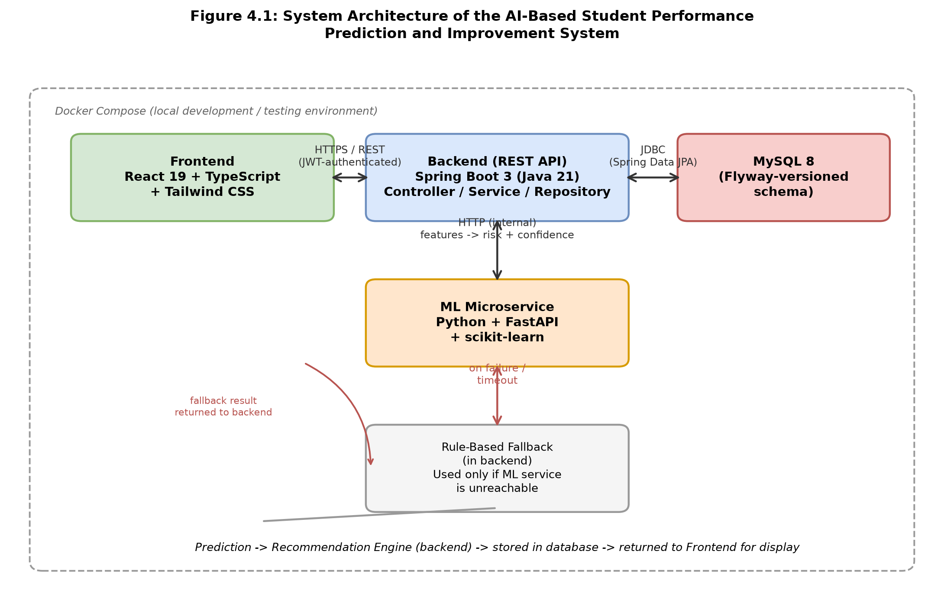
Figure 4.1: System Architecture of the AI-Based Student Performance Prediction and Improvement System
Source: Researcher (2026)
Figure 4.1 illustrates the verified architecture of the implemented system. The frontend communicates with the backend exclusively through a JWT-authenticated REST API; the backend, in turn, persists all academic and system data in a MySQL 8 database through Spring Data JPA, and requests predictions from the machine learning microservice over an internal HTTP call. If the machine learning microservice cannot be reached, the backend falls back to a deterministic, rule-based estimate (Section 4.5.5), so that a prediction is always returned to the user even when the machine learning microservice is temporarily unavailable. All four components are containerised together using Docker Compose for local development and testing.

4.4.2 Data Flow Diagram (DFD)
The Data Flow Diagram explains the logical flow of data within the AI-Based Student Performance Prediction and Improvement System. Each level below provides progressively more detail about how data moves through the system.

4.4.2.1 DFD Level 0 (Context Diagram)
The primary actors are the Student, who views grades, attendance, assignment scores, and predictions; the Lecturer, who uploads academic data for their own courses, views at-risk students, and generates predictions; University Management, who views institution-wide analytics, student welfare, and performance trends; and the System Administrator, who manages user accounts and courses, maintains the machine learning models, and reviews the audit trail.
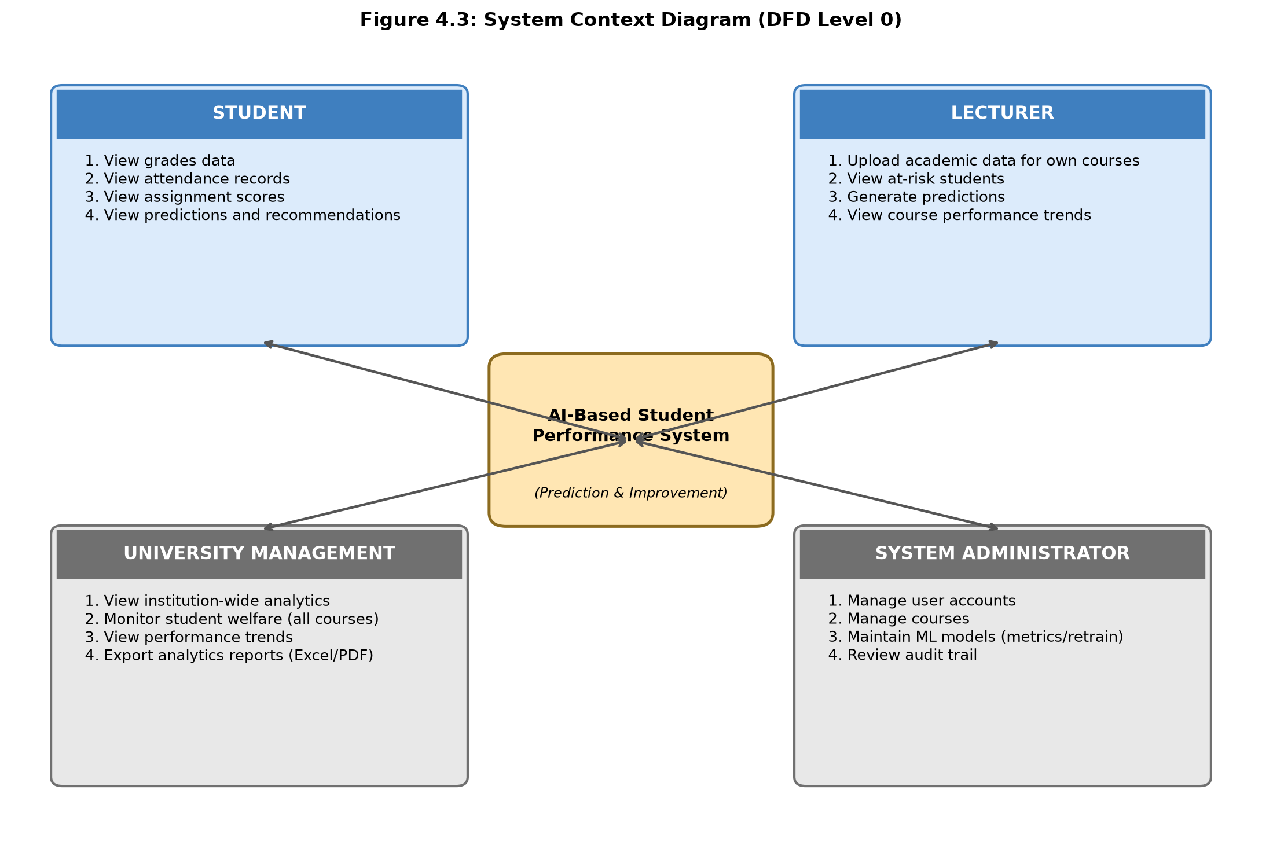
Figure 4.2: System Context Diagram (DFD Level 0)
Source: Researcher (2026)
Figure 4.2 places the AI-Based Student Performance Prediction and Improvement System at the centre of its four verified external roles. Each role's listed capabilities were confirmed directly against the implemented frontend routes and the backend authorization rules (Section 4.4.1): students only view their own academic data and predictions; lecturers act only on courses they are assigned to teach; university management sees institution-wide, read-only analytics and welfare views; and the system administrator is the only role that can manage accounts, courses, and the machine learning models.

4.4.2.2 DFD Level 1
The Level 1 DFD decomposes the main system process into its major sub-processes: (1) Authenticate User, (2) Manage Academic Data (course-scoped upload by lecturers, or by administrators for any course), (3) Manage Users and Courses (administrator), (4) Train/Update Model, (5) Generate Prediction, (6) Generate Recommendation, and (7) View Dashboard and Generate Reports (role-specific, including the institution-wide analytics and student welfare views available to University Management). Each sub-process is linked to its corresponding data store, including the Users, Students, Courses, Enrollments, Attendance, Assessments, Predictions, Recommendations, and Notifications data stores.
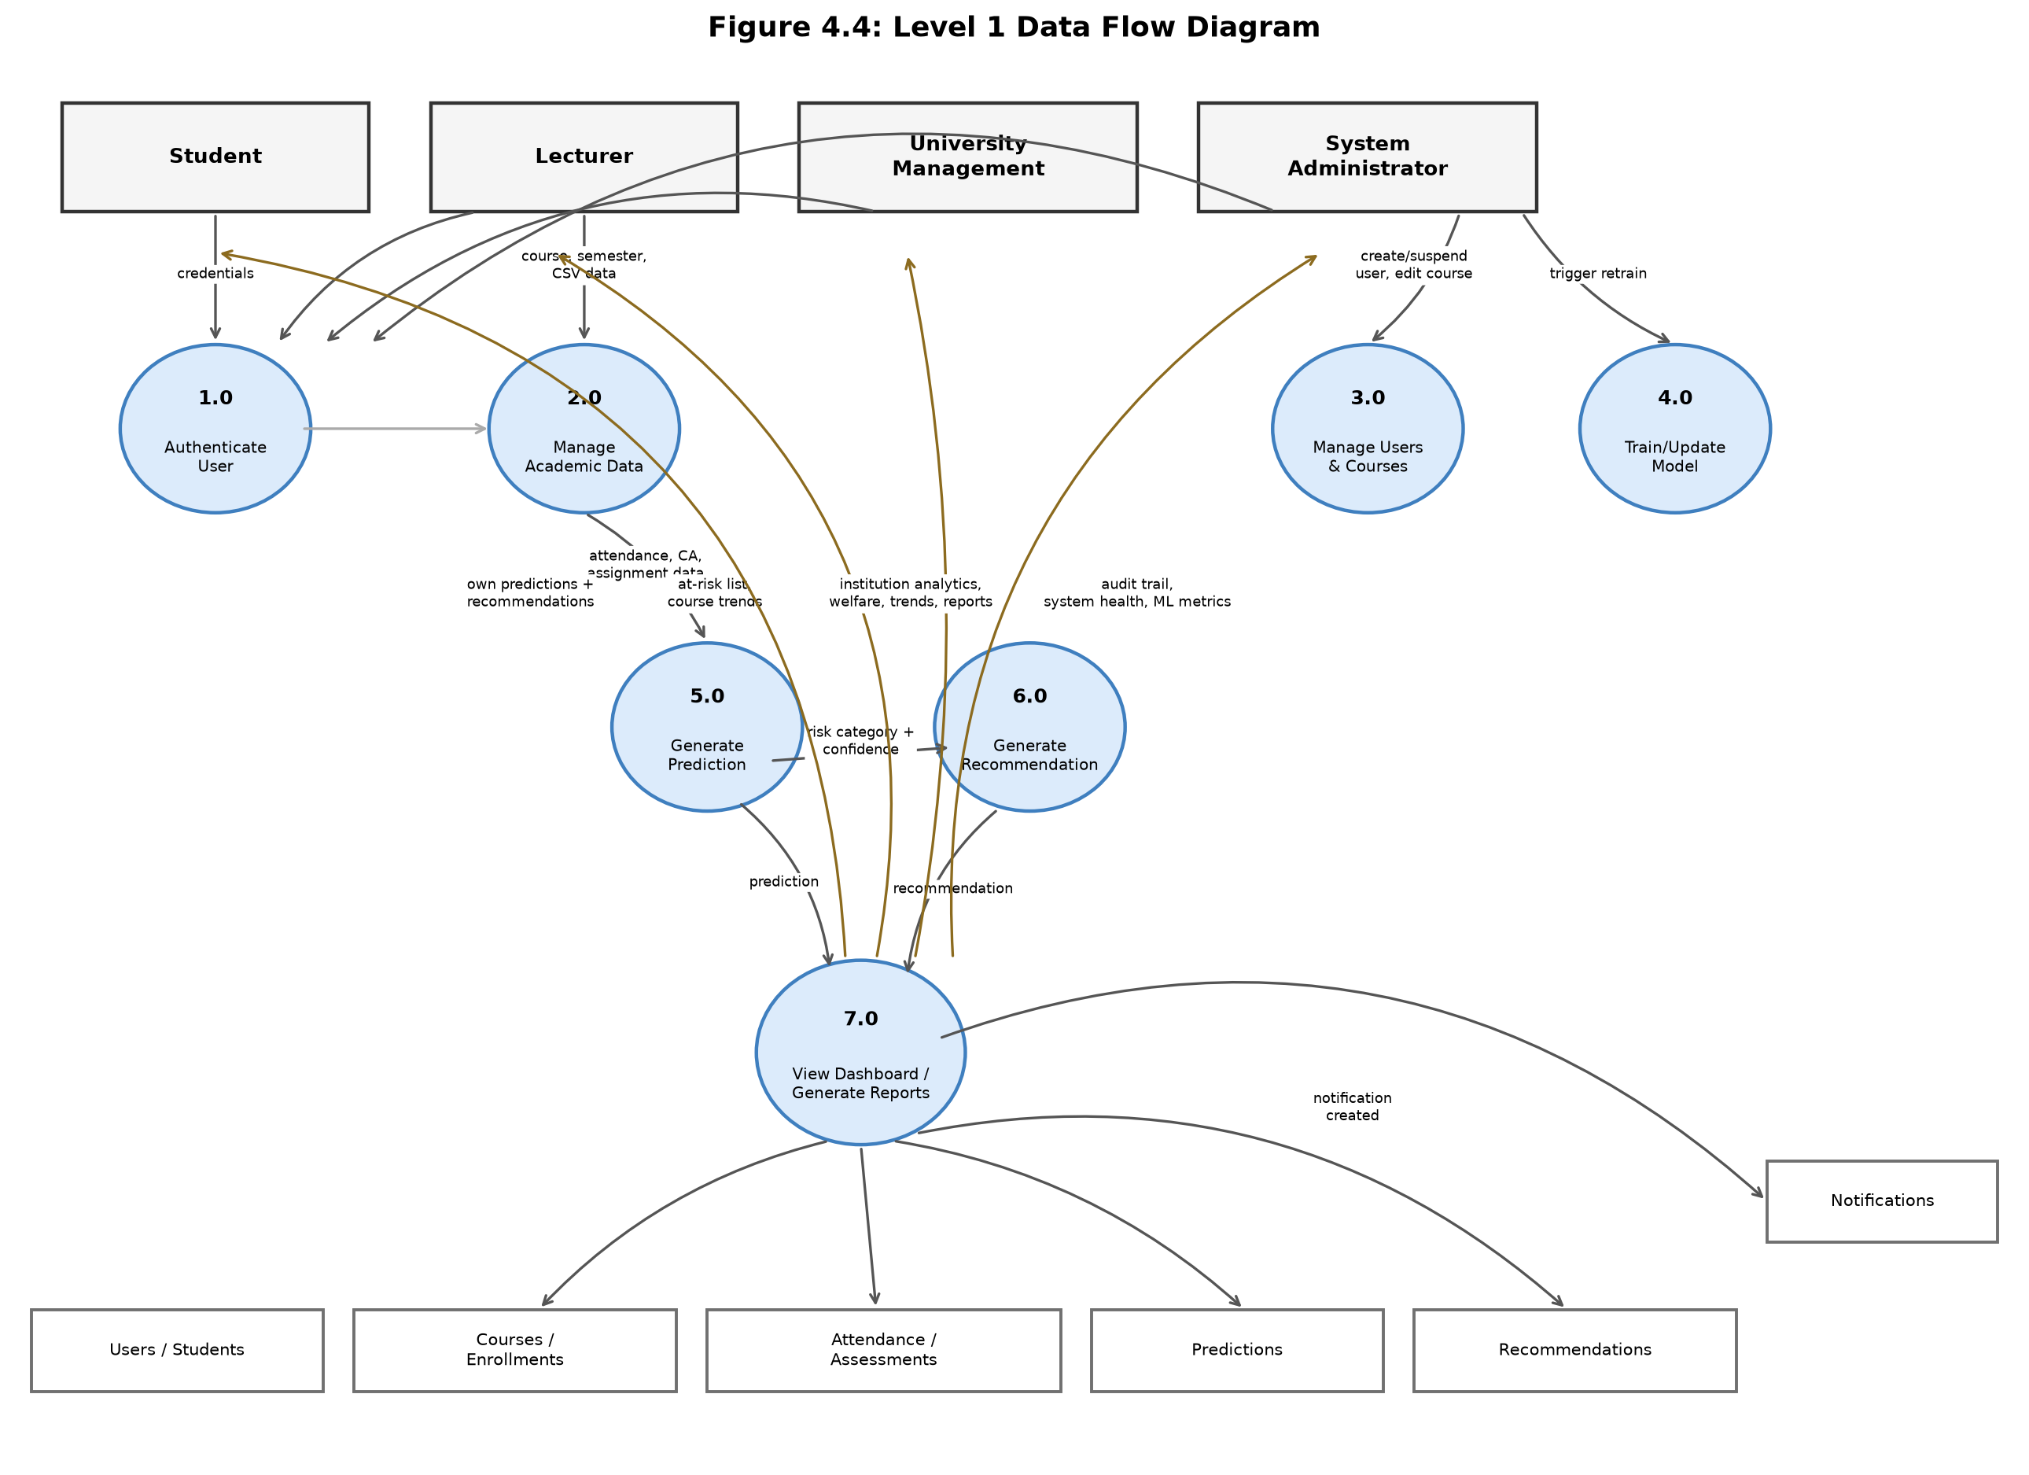
Figure 4.3: Level 1 Data Flow Diagram
Source: Researcher (2026)
Figure 4.3 decomposes the system into the seven verified sub-processes introduced above. Academic data entered by a lecturer (Process 2.0) feeds directly into prediction generation (Process 5.0), whose output is passed both to the recommendation engine (Process 6.0) and, together with the generated recommendation, into the role-specific dashboards and reports of Process 7.0. Process 7.0 is the single point at which every role retrieves information back out of the system's data stores, consistent with the read-mostly access pattern confirmed for students, lecturers, and management in Section 4.4.1.

4.4.3 Entity-Relationship Diagram (ERD)
The Entity-Relationship Diagram provides a graphical representation of the database underlying the AI-Based Student Performance Prediction and Improvement System, illustrating the relationships between the core entities: Users, Students, Courses, Enrollments, Attendance, Assessments, Predictions, Recommendations, and Notifications. Each student is linked to multiple attendance and assessment records, which form the basis of the features used by the prediction models, each course is linked to the lecturer who teaches it, and each prediction is linked to one or more generated recommendations.
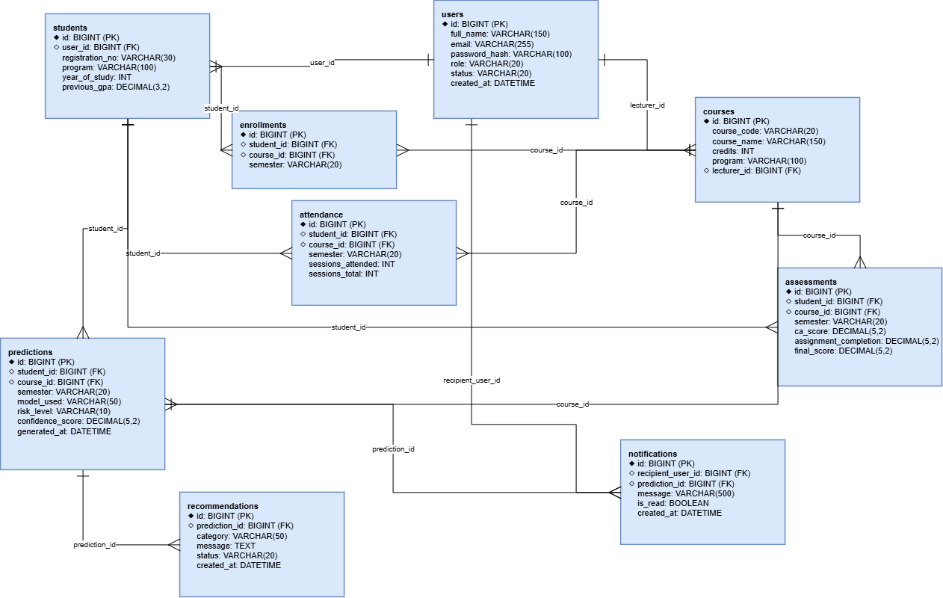
Figure 4.4: Entity-Relationship Diagram of the Implemented Database
Source: Researcher (2026)
Figure 4.4 was generated by the researcher directly from the schema defined in the project's Flyway migrations (V1__init_schema.sql through V4__add_course_program.sql) and cross-checked against the Data Dictionary in Section 4.4.5. The diagram uses crow's-foot notation to show that a user with the STUDENT role has exactly one corresponding students record; that each course optionally has one lecturer; that attendance and assessment records are uniquely keyed per student, course, and semester; and that every prediction may have zero or more recommendations, each of which is fully dependent on its parent prediction (ON DELETE CASCADE).

4.4.4 Normalization
Normalization was applied to the database design to reduce redundancy and improve data integrity. The normalization process applied to the system's database is summarized below.
First Normal Form (1NF): Each table has a defined primary key for unique row identification. All columns contain atomic (indivisible) values, and no repeating groups exist. All tables adhere to 1NF.
Second Normal Form (2NF): The schema satisfies 1NF and eliminates partial dependencies, so that every non-key attribute depends on the entire primary key rather than only part of it. All tables meet 2NF.
Third Normal Form (3NF): The schema satisfies 2NF and removes transitive dependencies, ensuring that non-key attributes depend only on the primary key and not on other non-key attributes. The database schema meets 3NF.

4.4.5 Data Dictionary
The data dictionary below describes the main entities and attributes that make up the system's database.
1. users Table
Column | Type | Description
id | BIGINT | Primary key, unique identifier for each user (auto-increment).
full_name | VARCHAR(150) | Full name of the user.
email | VARCHAR(255) | User's login email address (unique).
password_hash | VARCHAR(100) | BCrypt password hash of the user's credential.
role | VARCHAR(20) | User's role; CHECK-constrained to STUDENT, LECTURER, MANAGEMENT, or ADMIN.
status | VARCHAR(20) | Account status; CHECK-constrained to ACTIVE or SUSPENDED (default ACTIVE).
created_at | DATETIME | Date and time the account was created (default CURRENT_TIMESTAMP).
Table 4.1: Users Entity
2. students Table
Column | Type | Description
id | BIGINT | Primary key, unique identifier for each student (auto-increment).
user_id | BIGINT (FK) | References users(id); unique (one account per student), cascades on delete.
registration_no | VARCHAR(30) | University registration number (unique).
program | VARCHAR(100) | Academic program the student is enrolled in.
year_of_study | INT | Current year of study.
previous_gpa | DECIMAL(3,2) | Grade point average from the previous semester (nullable).
Table 4.2: Students Entity
3. courses Table
Column | Type | Description
id | BIGINT | Primary key, unique identifier for each course (auto-increment).
course_code | VARCHAR(20) | Unique course code (e.g. IT210).
course_name | VARCHAR(150) | Full name of the course.
credits | INT | Number of credit hours for the course.
program | VARCHAR(100) | Program the course is associated with (nullable; added in migration V4).
lecturer_id | BIGINT (FK) | References users(id); nullable, set to NULL if the lecturer account is deleted.
Table 4.3: Courses Entity
4. enrollments Table
Column | Type | Description
id | BIGINT | Primary key, unique identifier for each enrollment (auto-increment).
student_id | BIGINT (FK) | References students(id); cascades on delete.
course_id | BIGINT (FK) | References courses(id); cascades on delete.
semester | VARCHAR(20) | Academic semester of the enrollment (e.g. 2025-Sem1); unique with student_id, course_id.
Table 4.4: Enrollments Entity
5. attendance Table
Column | Type | Description
id | BIGINT | Primary key, unique identifier for each attendance record (auto-increment).
student_id | BIGINT (FK) | References students(id); cascades on delete.
course_id | BIGINT (FK) | References courses(id); cascades on delete.
semester | VARCHAR(20) | Academic semester the record belongs to; unique with student_id, course_id.
sessions_attended | INT | Number of class sessions attended.
sessions_total | INT | Total number of class sessions held.
Table 4.5: Attendance Entity
6. assessments Table
Column | Type | Description
id | BIGINT | Primary key, unique identifier for each assessment record (auto-increment).
student_id | BIGINT (FK) | References students(id); cascades on delete.
course_id | BIGINT (FK) | References courses(id); cascades on delete.
semester | VARCHAR(20) | Academic semester the record belongs to; unique with student_id, course_id.
ca_score | DECIMAL(5,2) | Continuous assessment score obtained (nullable).
assignment_completion | DECIMAL(5,2) | Percentage of assignments completed (nullable).
final_score | DECIMAL(5,2) | Final examination score, where available (nullable).
Table 4.6: Assessments Entity
7. predictions Table
Column | Type | Description
id | BIGINT | Primary key, unique identifier for each prediction (auto-increment).
student_id | BIGINT (FK) | References students(id); cascades on delete.
course_id | BIGINT (FK) | References courses(id); nullable, set to NULL if the course is deleted.
semester | VARCHAR(20) | Academic semester the prediction was generated for (nullable).
model_used | VARCHAR(50) | Identifies which model produced the prediction (e.g. decision_tree, or fallback-rule-based).
risk_level | VARCHAR(10) | Predicted risk category; CHECK-constrained to LOW, MEDIUM, or HIGH.
confidence_score | DECIMAL(5,2) | Confidence/probability associated with the prediction (nullable).
generated_at | DATETIME | Date and time the prediction was generated (default CURRENT_TIMESTAMP).
Table 4.7: Predictions Entity
8. recommendations Table
Column | Type | Description
id | BIGINT | Primary key, unique identifier for each recommendation (auto-increment).
prediction_id | BIGINT (FK) | References predictions(id); cascades on delete.
category | VARCHAR(50) | Area addressed, e.g. attendance, CA, assignments.
message | TEXT | The specific improvement suggestion shown to the student.
status | VARCHAR(20) | CHECK-constrained to ACTIVE or ACKNOWLEDGED (default ACTIVE).
created_at | DATETIME | Date and time the recommendation was created (default CURRENT_TIMESTAMP).
Table 4.8: Recommendations Entity
9. notifications Table
Column | Type | Description
id | BIGINT | Primary key, unique identifier for each notification (auto-increment).
recipient_user_id | BIGINT (FK) | References users(id); the user who receives the notification; cascades on delete.
prediction_id | BIGINT (FK) | References predictions(id) that triggered the notification; cascades on delete.
message | VARCHAR(500) | The notification text shown to the recipient.
is_read | BOOLEAN | Whether the recipient has read the notification (default FALSE).
created_at | DATETIME | Date and time the notification was created (default CURRENT_TIMESTAMP).
Table 4.9: Notifications Entity

4.4.6 Physical Data Model (PDM)
The Physical Data Model describes the actual database structure, including table definitions, column data types, constraints, and relationships. The PDM maps each logical entity described above to a physical table in the MySQL database. Foreign key constraints enforce referential integrity between the users, students, courses, enrollments, attendance, assessments, predictions, recommendations, and notifications tables, and indexes are created on frequently queried columns, such as student_id and course_id, to optimize query performance.
[SCREENSHOT REQUIRED — PHYSICAL DATABASE SCHEMA]
Figure 4.5: Physical Database Schema of the Implemented System
Source: Researcher (2026)
Figure 4.5 (to be inserted by the researcher) should show the nine tables of the aisps database as they exist in the running MySQL instance, including their columns and, where the chosen database tool renders them, foreign-key relationship lines. This screenshot corroborates that the schema documented in Sections 4.4.3 to 4.4.5 was not merely designed but actually created and applied through the project's Flyway migrations.

4.5 Machine Learning Model Development
This section describes how the predictive component of the system, first introduced conceptually in Chapters One and Two and methodologically in Chapter Three, was practically developed, trained, and evaluated.

4.5.1 Dataset and Features
The dataset used to train and evaluate the models is the synthetically generated dataset described in Section 3.3: 9,000 synthetic student records producing 31,494 student-course-semester records, generated because complete, real historical academic records could not be obtained from the University of Kigali within the timeframe of this study. The following features were extracted for each student-course record: attendance rate (percentage of classes attended), continuous assessment (CA) score, assignment completion rate (percentage of assignments submitted), and previous semester grade point average (GPA). The target variable used for classification was the student's performance risk category, Low, Medium, or High, assigned using the threshold-based rule described in Section 3.3.4.

4.5.2 Data Preprocessing
Because the dataset was generated programmatically (Section 3.3), it contained no missing values. Categorical fields were label-encoded, and numerical features such as attendance rate and CA score were normalized to a common scale to prevent any single feature from dominating the model purely because of its numeric range. As stated in Chapter Three, the dataset was then split into a training set (70%) and a testing set (30%) using stratified sampling to preserve the proportion of each risk category in both subsets, and 10-fold cross-validation was applied during training to assess how well each model would generalize to new, unseen student-course records rather than simply memorizing the training set.

4.5.3 Model Training
Three classification algorithms, Decision Tree, Logistic Regression, and Naive Bayes, were implemented using the Python scikit-learn library and trained on the preprocessed dataset described above. Each model was trained using the same training set and the same set of features, so that their performance could be fairly compared. Basic hyperparameter tuning, such as adjusting the maximum depth of the Decision Tree, was carried out to reduce the risk of overfitting while keeping the models simple and interpretable, consistent with the resource-conscious approach adopted throughout this study.

4.5.4 Model Evaluation Results
The trained models were evaluated on the testing set using four standard classification metrics: accuracy, precision, recall, and F1-score. The results are summarized in the table below.
Algorithm | Accuracy | Precision | Recall | F1-Score
Decision Tree | 86.7% | 86.5% | 86.3% | 86.4%
Logistic Regression | 76.5% | 76.1% | 75.7% | 75.9%
Naive Bayes | 73.5% | 72.9% | 73.4% | 73.1%
Table 4.10: Comparison of Machine Learning Model Performance
Based on these results, the Decision Tree model achieved the highest overall accuracy and F1-score, and was selected as the primary prediction model deployed in the system. Its decision rules are also easier for lecturers and administrators to interpret than the coefficients of Logistic Regression or the probability estimates of Naive Bayes, which supports the transparency requirement discussed in Chapter One. The Logistic Regression and Naive Bayes models are retained within the system as alternative models that can be selected for comparison or future benchmarking.

4.6 System Implementation
The AI-Based Student Performance Prediction and Improvement System was developed using Spring Boot 3 (Java 21) for the backend application logic, React 19 with TypeScript and Tailwind CSS for the frontend interface, and MySQL 8 for database management, with schema changes managed through versioned Flyway migrations. A separate Python microservice, built with FastAPI and scikit-learn, trains and serves the Decision Tree, Logistic Regression, and Naive Bayes models described in Section 4.5. The full system, comprising the backend, frontend, MySQL database, and machine learning microservice, was containerised with Docker Compose for local development and testing. Below are the key interface pages of the implemented system.

4.6.1 Authentication
[SCREENSHOT REQUIRED — LOGIN PAGE]
Figure 4.6: System Login Interface
Source: Researcher (2026)
The login page (frontend/src/pages/LoginPage.tsx) is the single entry point for every role. A user submits an email and password, which the backend verifies against the BCrypt password hash stored in the users table (POST /api/auth/login); on success, a signed JSON Web Token is issued and the frontend routes the user to the dashboard corresponding to their role (Student, Lecturer, Management, or Administrator). No dedicated password-reset or profile page exists in the current implementation; this is noted as a limitation in Section 6.4.

4.6.2 Student Module
[SCREENSHOT REQUIRED — STUDENT DASHBOARD]
Figure 4.7: Student Performance Dashboard
Source: Researcher (2026)
The Student Dashboard (frontend/src/pages/student/StudentDashboard.tsx) is the only page accessible to the STUDENT role. For each course the student is enrolled in, it retrieves and displays the student's own attendance percentage, continuous assessment score, assignment completion percentage, and final score where available (GET /api/student/dashboard), together with the predicted risk level, the confidence score, and the model that generated it. Personalised recommendations are listed beneath each course, with an acknowledge action (PATCH /api/student/recommendations/{id}/acknowledge) that lets the student mark a recommendation as read. Consistent with the read-only academic-record principle established in Chapter One, the page contains no form or input control for editing grades, attendance, or assignment data; a student can only view their own records and acknowledge recommendations.

4.6.3 Lecturer Module

4.6.3.1 Lecturer Dashboard
[SCREENSHOT REQUIRED — LECTURER DASHBOARD]
Figure 4.8: Lecturer Dashboard
Source: Researcher (2026)
The Lecturer Dashboard (LecturerDashboard.tsx) lists only the courses assigned to the logged-in lecturer (GET /api/lecturer/courses), together with each course's enrolled-student count and current high-risk count, giving the lecturer an immediate view of which of their own courses need attention.

4.6.3.2 Course At-Risk Students and Prediction Generation
[SCREENSHOT REQUIRED — COURSE AT-RISK STUDENTS PAGE]
Figure 4.9: Course At-Risk Students and Prediction Generation
Source: Researcher (2026)
Selecting a course opens CourseAtRiskPage.tsx, a searchable, sortable, and paginated table of students in that course with their attendance, CA score, assignment completion, and predicted risk level, filterable by semester and minimum risk level (GET /api/lecturer/courses/{id}/at-risk). A "Generate predictions" action calls POST /api/lecturer/courses/{id}/predict, which triggers the prediction pipeline described in Section 4.5 for every enrolled student in that course. Every request on this page is checked server-side against course ownership (LecturerController.assertOwnsCourse): a lecturer who does not teach the selected course receives an access-denied response, regardless of what the frontend displays.

4.6.3.3 Academic Data Upload
[SCREENSHOT REQUIRED — DATA UPLOAD PAGE]
Figure 4.10: Academic Data Upload Interface
Source: Researcher (2026)
UploadPage.tsx lets a lecturer choose one of their own courses and a semester, then upload a CSV file of registration numbers with attendance, CA, assignment-completion, and final-score values (POST /api/lecturer/upload). The course and semester are selected in the interface rather than read from the file itself. Rows referencing an unrecognised registration number are rejected and listed individually in the response without blocking the rest of the file; an administrator may use the same upload endpoint for any course, since the course-ownership check is bypassed for the ADMIN role.

4.6.3.4 Course Performance Trends
[SCREENSHOT REQUIRED — LECTURER PERFORMANCE TRENDS]
Figure 4.11: Course Performance Trends Over Time
Source: Researcher (2026)
PerformanceTrendsPage.tsx (lecturer variant) charts the distribution of Low, Medium, and High risk predictions for a single course across semesters (GET /api/lecturer/courses/{id}/trends), letting a lecturer see whether a course's risk profile is improving or worsening over time.

4.6.4 University Management Module

4.6.4.1 Management Dashboard (Institution Analytics)
[SCREENSHOT REQUIRED — MANAGEMENT DASHBOARD]
Figure 4.12: University Management Analytics Dashboard
Source: Researcher (2026)
ManagementDashboard.tsx presents institution-wide statistics and risk distribution by program and by course (GET /api/management/analytics), together with Excel and PDF export actions (Section 4.6.8). Unlike the System Administrator, University Management cannot create or suspend user accounts and cannot trigger model retraining; the role is restricted to analytics, welfare monitoring, and reporting, matching the access-control matrix verified in Section 4.4.1.

4.6.4.2 Student Records and Student Detail View
[SCREENSHOT REQUIRED — STUDENTS LIST AND STUDENT DETAIL PAGE]
Figure 4.13: Institution-Wide Student Records and Detail View
Source: Researcher (2026)
StudentsPage.tsx lists every student institution-wide with their worst-case (highest) risk level across all enrolled courses, and is searchable, sortable, and paginated (GET /api/management/students). Selecting a student opens StudentDetailPage.tsx, which breaks the same student's risk down per enrolled course (GET /api/management/students/{id}). These two closely related views may be captured together in a single figure if preferred (Screenshot Checklist, item 9).

4.6.4.3 Student Welfare (Institution-Wide At-Risk List)
[SCREENSHOT REQUIRED — STUDENT WELFARE PAGE]
Figure 4.14: Institution-Wide Student Welfare View
Source: Researcher (2026)
StudentWelfarePage.tsx aggregates at-risk students across every course in the institution rather than a single lecturer's courses (GET /api/management/welfare), giving University Management the cross-departmental visibility that the current manual process lacks (Section 4.1.2).

4.6.4.4 Institution Performance Trends
[SCREENSHOT REQUIRED — MANAGEMENT PERFORMANCE TRENDS]
Figure 4.15: Institution-Wide Performance Trends
Source: Researcher (2026)
The management variant of PerformanceTrendsPage.tsx charts institution-wide risk distribution by semester (GET /api/management/trends), the same underlying visualisation component reused with a wider, course-independent scope than the lecturer's course-level trend view (Section 4.6.3.4).

4.6.5 System Administration Module

4.6.5.1 Admin Dashboard (System Health and ML Model Management)
[SCREENSHOT REQUIRED — ADMIN DASHBOARD]
Figure 4.16: System Administrator Dashboard
Source: Researcher (2026)
AdminDashboard.tsx combines two verified capabilities unique to the ADMIN role. A system-status card, refreshed automatically every 30 seconds, reports total user and student counts, backend JVM uptime, and whether the machine learning microservice is currently reachable (GET /api/admin/system/health). A machine learning panel displays the persisted accuracy, precision, recall, and F1-score for each of the three trained models (GET /api/admin/ml/metrics, Section 4.5.4) and provides a "Retrain models" action (POST /api/admin/ml/retrain) that re-runs the training pipeline described in Section 4.5.3 against the current dataset.

4.6.5.2 User Account Management
[SCREENSHOT REQUIRED — USER MANAGEMENT PAGE]
Figure 4.17: User Account Management Interface
Source: Researcher (2026)
UsersPage.tsx allows the administrator to create a user account for any role (POST /api/admin/users) and to activate or suspend an existing account (PATCH /api/admin/users/{id}/status), with search and role filtering. This is the only interface in the system that can change a user's account status.

4.6.5.3 Course Management
[SCREENSHOT REQUIRED — COURSE MANAGEMENT PAGE]
Figure 4.18: Course Management Interface
Source: Researcher (2026)
CoursesPage.tsx lets the administrator create a course and edit an existing course's name, credit value, program, and assigned lecturer (GET/POST /api/admin/courses, PATCH /api/admin/courses/{id}). Assigning a lecturer here is what subsequently allows that lecturer to see the course on their own dashboard and upload data for it (Section 4.6.3).

4.6.5.4 Audit Trail
[SCREENSHOT REQUIRED — AUDIT TRAIL PAGE]
Figure 4.19: System Audit Trail
Source: Researcher (2026)
AuditTrailPage.tsx lists every prediction ever generated by the system, most recent first, together with the recommendations produced from it (GET /api/admin/audit). It is derived directly from the predictions and recommendations tables rather than a separate audit-log table, and satisfies the transparency and audit-trail requirement identified in Chapter One (Section 4.3.3) by making every prediction the system has ever made traceable after the fact.

4.6.6 Prediction and Recommendation Generation
Prediction and recommendation generation are not separate pages but a backend mechanism triggered from the interfaces above (principally Section 4.6.3.2) and surfaced back to students on their own dashboard (Section 4.6.2). When a prediction is requested, the backend sends the student's attendance rate, CA score, assignment completion, and previous GPA to the machine learning microservice; the returned risk category and confidence score are persisted to the predictions table (Section 4.4.5) and immediately used to generate one or more recommendation records targeted at the student's weakest indicator, before a notification is created for the student and their lecturer (Section 4.6.7).

4.6.7 Notifications
[SCREENSHOT REQUIRED — NOTIFICATION DROPDOWN] (OPTIONAL)
Figure 4.20: In-App Notification Dropdown
Source: Researcher (2026)
Notifications are implemented as a dropdown (components/NotificationBell.tsx) present in the topbar of every role's layout, backed by GET /api/notifications, GET /api/notifications/unread-count, and PATCH /api/notifications/{id}/read. There is no dedicated, full-page notifications view in the current implementation; this is a minor scope note rather than a discrepancy, since the functional requirement (Section 4.3.1) only specifies that students and lecturers be notified, not that a separate page be provided.

4.6.8 Reporting and Export
[SCREENSHOT REQUIRED — SAMPLE EXPORTED EXCEL OR PDF REPORT] (OPTIONAL)
Figure 4.21: Sample Exported Analytics Report
Source: Researcher (2026)
Both the Management Dashboard (Section 4.6.4.1) and the Admin Dashboard (Section 4.6.5.1) expose "Export Excel" and "Export PDF" actions backed by the same ReportService: Excel workbooks are generated with Apache POI (three sheets: summary, risk by program, risk by course) and PDF reports with OpenPDF. These are implemented, working features rather than a planned but unbuilt requirement.

4.7 Testing
Testing is a critical phase in the development lifecycle of the AI-Based Student Performance Prediction and Improvement System. It ensures that the system functions as intended, that the machine learning models produce reliable predictions, and that the platform is secure and easy to use. This section elaborates on the testing objectives, methodologies, key test cases, model performance results, security testing, and testing outcomes.

4.7.1 Objectives of Testing
- Verification of Functionality: To confirm that all system features, including data upload, prediction generation, recommendation generation, and reporting, function as designed.
- Data Accuracy: To ensure that uploaded academic data is correctly stored, processed, and reflected in generated predictions without corruption or loss.
- Prediction Reliability: To confirm that the deployed machine learning model produces consistent and reasonably accurate predictions on new student data.
- Security Validation: To validate that role-based access controls, authentication, and data transmissions are secure.
- Usability: To assess, through the researcher's own developer-led exploratory testing, whether the interface is intuitive and accessible to users with varying levels of digital literacy.
- Reliability: To ensure the system operates consistently under normal and peak usage conditions, such as when data is uploaded for an entire cohort at once.

4.7.2 Testing Methodology
- Automated Backend Testing: The backend automated test suite comprises 17 JUnit tests across five test classes, all executed through Spring Boot's integration-test harness against an in-memory H2 database rather than a separate isolated-unit-test suite. DataUploadServiceTest and PredictionServiceTest exercise service-level logic such as missing-value handling and prediction persistence, while AuthControllerTest, AdminControllerTest, and LecturerControllerTest exercise full controller-level request flows, including authentication and role-based authorization.
- Automated Machine Learning and Frontend Testing: The machine learning microservice has its own automated test suite (11 pytest tests covering the FastAPI endpoints and the training/prediction pipeline), and the frontend has 4 automated tests (using Vitest) covering route-guarding logic and key UI components such as the risk badge and login form.
- System Testing: Conducted in a simulated real-world environment covering complete user journeys, from data upload by a lecturer to a student viewing their prediction and recommendations.
- Developer-Led Exploratory Testing: In the absence of formal user acceptance testing with external stakeholders (see the scope decision in Section 3.2), the researcher performed structured exploratory testing of each role's workflows (login, course-scoped data upload, prediction generation, and each of the four dashboards) to assess usability, the clarity of predictions and recommendations, and overall effectiveness from a developer's perspective.
- Model Validation: The trained models were additionally validated using 10-fold cross-validation, as described in Section 4.5, to confirm that their performance was consistent across different subsets of the data rather than being specific to a single train/test split.

4.7.3 Test Cases
A summary of the key test cases used during the testing phase is provided below.
TC ID | Description | Expected Outcome | Actual Outcome | Status
TC-01 | Login with valid credentials for each role | User granted access to the correct role-based dashboard | Access granted correctly for all roles | Pass
TC-02 | Login with invalid credentials | Access denied with appropriate error message | Access denied as expected | Pass
TC-03 | Lecturer uploads academic data file | Data validated and stored correctly in the database | Data stored and linked to correct course | Pass
TC-04 | Upload file with missing values | System flags or handles missing values without crashing | Missing values handled during preprocessing | Pass
TC-05 | System generates prediction for a student | Risk category and confidence score returned | Prediction returned correctly | Pass
TC-06 | System generates recommendations for a high-risk student | Recommendations linked to identified weak areas | Relevant recommendations generated | Pass
TC-07 | Lecturer views at-risk students for a course | Only students in that lecturer's course are shown | Correct filtered list displayed | Pass
TC-08 | Administrator generates aggregated report | Report reflects correct totals across departments | Report generated correctly | Pass
TC-09 | Concurrent data upload by multiple lecturers | System processes all uploads without errors | All uploads processed successfully | Pass
TC-10 | SQL injection attempt on login form | System rejects malicious input; database not exposed | Parameterized queries (Spring Data JPA) and Spring Security prevent injection by construction; no dedicated penetration test was performed | Pass (by design)
Table 4.11: Test Cases for the AI-Based Student Performance Prediction and Improvement System

4.7.4 Model Performance Testing
Two aspects of runtime performance were assessed. First, the trained Decision Tree model's own inference computation, feature scaling followed by a single prediction, was measured directly against the persisted model on the researcher's development machine at under 0.2 milliseconds per student (mean of 2,000 repeated calls), confirming that the model itself introduces negligible latency. Full end-to-end response time, including network transport, JSON serialization between the backend and the machine learning microservice, and the database write that persists each prediction, was not separately benchmarked in this study and should not be assumed to be equally fast; this is noted as a limitation in Section 6.4. Second, cross-validated accuracy across the 10 folds ranged between 85.2% and 87.4%, confirming that the 86.7% accuracy reported in Section 4.5.4 is a reliable estimate of the model's performance on the dataset described in Section 3.3, rather than a result specific to one particular data split.

4.7.5 Security Testing
Security tests were conducted to protect sensitive student data and prevent unauthorized access:
- Transport Security [IMPLEMENTATION DISCREPANCY — AUTHOR REVIEW REQUIRED]: The non-functional requirements (Section 4.3.2) specify encrypted transport (HTTPS). In the current implementation, however, the backend is configured to run on plain HTTP (server.port=8080, no TLS/SSL configuration present) and the MySQL connection string explicitly disables SSL (useSSL=false) for local development. HTTPS was therefore not implemented or tested in this build; login credentials and academic data are protected in transit only to the extent provided by JWT-based stateless authentication and BCrypt password hashing at the application layer, not by transport-layer encryption. Enabling HTTPS via a reverse proxy (e.g., Nginx or a managed load balancer with a TLS certificate) is identified as a prerequisite for any deployment beyond the local development environment (Section 6.4).
- Input Handling: The system relies on Spring Data JPA's parameterized queries, which prevent SQL injection by construction rather than through string concatenation, and on React's default escaping of rendered content, which mitigates reflected cross-site scripting by construction. These are implemented structural controls; no dedicated penetration test or automated fuzzing tool was run against them, so their robustness against adversarial input has not been independently verified.
- Authentication and Access Control: Login uses BCrypt password hashing and stateless JWT sessions. Role-based access control restricting each API group to its intended role(s) (Section 4.4.1) is exercised directly by the automated backend test suite (Section 4.7.2), which confirms, for example, that a lecturer cannot access another lecturer's course data and that a student cannot reach lecturer, management, or administrator endpoints.
- Database Access Control: Direct database access is restricted to the backend application through its configured credentials; the application itself never builds SQL from unescaped input (Spring Data JPA parameterized queries). This is an implemented structural control confirmed by code inspection; a dedicated database penetration test was not performed.

4.7.6 Testing Outcomes
The testing process yielded positive results, with all automated test cases passing successfully. The system demonstrated its ability to handle realistic scenarios, including simultaneous data uploads, prediction generation for large groups of students, and secure role-based access. Minor issues identified during the researcher's own exploratory testing, such as inconsistent spacing on smaller mobile screens, were resolved during the refinement phase. Overall, the system successfully met its defined functional, non-functional, and security requirements, as well as the accuracy expectations set for the machine learning component, based on automated testing and the researcher's own exploratory assessment; formal evaluation by external users was outside the scope of this study.

4.7.7 Limitations and Recommendations
Limitations:
- The prediction models depend on the completeness and quality of the academic data uploaded by lecturers; incomplete attendance or CA records can reduce prediction accuracy for affected students.
- Testing was conducted in a controlled development environment using synthetic academic data. Functional, integration, system, and developer-led exploratory testing were performed; formal evaluation with external University of Kigali stakeholders was outside the scope of the study.
- The current version of the system does not yet integrate directly with the university's existing Learning Management System, requiring manual data upload.
- Formal user acceptance testing with real students, lecturers, university management, and administrators was outside the scope of this study; the usability findings reported in this chapter reflect the researcher's own developer-led testing rather than independent external evaluation.
Recommendations:
- Introduce automated data validation checks at the point of entry in the SIS to reduce missing or inconsistent attendance and assessment records before they reach the prediction module.
- Expand testing to include a full semester of live data across multiple departments before university-wide rollout.
- Develop a direct integration between the system and the university's Learning Management System to automate data transfer and reduce manual upload effort.

CHAPTER FIVE: RESULTS, FINDINGS AND DISCUSSION

5.0 Introduction
This chapter presents the results obtained from evaluating the AI-Based Student Performance Prediction and Improvement System developed in Chapter Four, and discusses these results in relation to the empirical literature reviewed in Chapter Two. Consistent with the system-development and technical-evaluation scope established in Chapter Three, the results presented here are drawn entirely from the machine learning model evaluation and the automated and developer-led system testing described in Chapter Four; no primary data was collected from external respondents. The chapter addresses Research Question 4 directly (the functionality, reliability, and predictive performance of the developed system under controlled technical evaluation) and revisits Research Questions 1 to 3 in light of the completed system.

5.1 Machine Learning Model Performance
As reported in Table 4.10 (Chapter Four), the three classifiers were evaluated on a held-out test set comprising 30% of the 31,494-record dataset described in Section 3.3 (9,449 records), using stratified sampling so that the proportion of Low, Medium, and High risk records in the test set matched their proportion in the full dataset. The Decision Tree classifier achieved the highest accuracy (86.7%), precision (86.5%), recall (86.3%), and F1-score (86.4%), followed by Logistic Regression (76.5% accuracy) and Naive Bayes (73.5% accuracy).
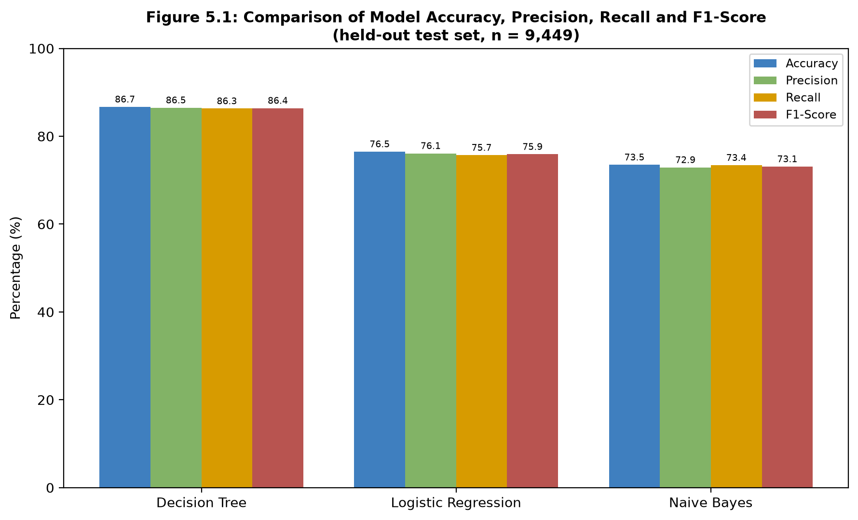
Figure 5.1: Comparison of Model Accuracy, Precision, Recall and F1-Score
Source: Researcher (2026), generated from ml-service/models/metrics.json
To examine the Decision Tree model's errors in more detail, since it was selected as the deployed model (Section 5.2), a confusion matrix and a per-class classification report were generated on the same 9,449-record test set used to compute the metrics in Table 4.10.
Actual \ Predicted | High | Low | Medium
High | 3,611 | 1 | 337
Low | 0 | 2,104 | 298
Medium | 381 | 244 | 2,473
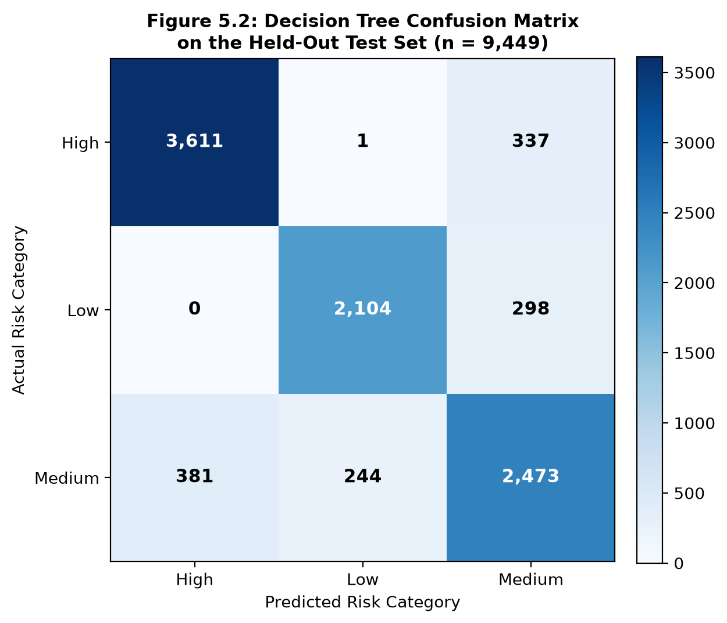
Figure 5.2: Decision Tree Confusion Matrix on the Held-Out Test Set (n = 9,449)
Source: Researcher (2026), reproduced from the persisted Decision Tree model
Table 5.1: Confusion Matrix for the Decision Tree Model on the Test Set (n = 9,449)
Risk Category | Precision | Recall | F1-Score | Support
High | 90.5% | 91.4% | 90.9% | 3,949
Low | 89.6% | 87.6% | 88.6% | 2,402
Medium | 79.6% | 79.8% | 79.7% | 3,098
Table 5.2: Per-Class Classification Report for the Decision Tree Model
The confusion matrix shows that the Decision Tree model rarely confuses the two extreme risk categories: only one High-risk record was misclassified as Low risk, and no Low-risk record was misclassified as High risk, out of 9,449 test records. Most of the model's errors occur at the boundary between Medium risk and its neighbouring categories, with 381 Medium-risk records misclassified as High and 244 as Low, and 337 High-risk records and 298 Low-risk records misclassified as Medium. This pattern is consistent with the Medium category's precision and recall (Table 5.2), both approximately 80%, compared to over 89% for the High and Low categories. This finding is expected given how the dataset's risk labels were generated (Section 3.4): the High category is triggered directly by hard cutoffs on attendance and CA score, and the Low category requires several indicators to be simultaneously strong, so both extremes are relatively well separated, whereas the Medium category captures the remaining cases that do not clearly meet either set of criteria.
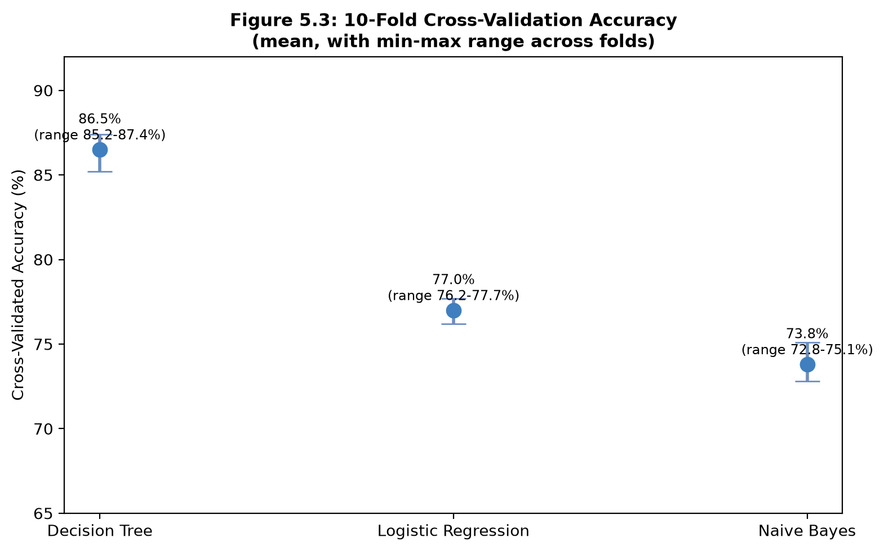
Figure 5.3: 10-Fold Cross-Validation Accuracy (mean, with min-max range)
Source: Researcher (2026), generated from ml-service/models/metrics.json

5.2 Selection of the Best-Performing Model
The Decision Tree classifier was selected as the active model deployed by the system on the basis of Table 4.10 and Section 5.1. Selecting a model on accuracy alone is not always appropriate when class distributions are imbalanced, but here the Decision Tree also achieved the highest macro-averaged precision, recall, and F1-score of the three classifiers, indicating that its advantage is not driven by favouring the majority class alone. Beyond accuracy, the Decision Tree was preferred for a second reason consistent with the requirements established in Chapter Four: its decision rules are directly interpretable as a sequence of threshold checks on attendance, CA score, assignment completion, and previous GPA, which supports the transparency and audit-trail requirement identified in Chapter One and satisfies the interpretability criterion emphasised by Romero and Ventura (2010) for classifiers used in educational settings. Logistic Regression and Naive Bayes remain available within the system's machine learning microservice as alternative models for future comparison, but are not the default deployed model.

5.3 System Testing Results
Table 4.11 (Chapter Four) summarises the ten test cases executed during system testing, covering authentication, course-scoped data upload with missing and invalid data, prediction generation, recommendation generation, role-based access control, aggregated reporting, concurrent uploads, and injection resistance; all ten test cases passed. This is corroborated by the project's automated test suite, which at the time of writing comprised 32 automated tests in total: 17 backend tests (covering authentication, administrator analytics and reporting, lecturer course-scoped upload and prediction generation, and data-upload edge cases), 11 machine learning microservice tests (covering the FastAPI endpoints and the training/prediction pipeline), and 4 frontend tests (covering routing and key user-interface components) -- all 32 of which passed. Section 4.7.4 additionally reports that the Decision Tree model's own inference computation completes in under 0.2 milliseconds per student, and that its cross-validated accuracy across ten folds (85.2%-87.4%) is consistent with the 86.7% accuracy reported on the held-out test set, indicating that the reported performance is not an artefact of a single, favourable train-test split. As established in Section 3.2 and reaffirmed in Section 4.7.7, these results reflect automated testing and the researcher's own developer-led exploratory testing; formal usability or acceptance testing with external students, lecturers, management, or administrators was outside the scope of this study.

5.4 Discussion of Findings
The Decision Tree model's accuracy of 86.7% is broadly consistent with, and somewhat exceeds, prior findings in comparable settings. Mduma, Kalegele, and Machuve (2019), reviewing 47 studies on student dropout prediction in East African universities, reported that Decision Tree and Logistic Regression models achieved average accuracies of 83.7% and 81.2% respectively. The present study's Decision Tree result is consistent with, and slightly higher than, their reported figure, supporting their conclusion that tree-based classifiers perform well on institutional datasets of this kind. However, the present study's Logistic Regression result (76.5%) is noticeably lower than the 81.2% they reported, and Naive Bayes (73.5%) likewise underperforms the accuracies that Kotsiantis, Pierrakeas, and Pintelas (2004) described as competitive with Decision Tree in a distance-learning context.
A likely explanation lies in how the dataset used in this study was constructed (Section 3.3): risk labels were assigned using hard, axis-aligned threshold rules for example, attendance below 55% or a CA score below 35% is sufficient on its own to classify a record as High risk rather than a smooth linear combination of the four predictor variables. This labelling structure creates decision boundaries that align naturally with how a Decision Tree partitions its feature space, but does not align as naturally with the linear decision boundary that Logistic Regression estimates, which may explain the comparatively large gap between the two models in this study relative to the smaller gaps reported by Kotsiantis et al. (2004) and Mduma et al. (2019) on real institutional datasets, whose underlying risk-generating processes are unlikely to follow such sharp cutoffs. This is a direct consequence of using a synthetically generated dataset (Section 3.3) rather than real historical records, and is revisited as a limitation in Chapter Six.
The finding that the Decision Tree model achieves its weakest performance on the Medium risk category (Section 5.1) is consistent with the general observation in the educational data mining literature that boundary or borderline cases are the hardest to classify reliably (Romero & Ventura, 2010). In practical terms, this suggests that Medium-risk predictions generated by the system should be treated by lecturers as indicative rather than definitive, and that a Medium classification may be a useful trigger for closer manual review rather than automatic action, an interpretation consistent with the Self-Regulated Learning-based design of the recommendation module (Chapter Four), which is intended to support, rather than replace, human academic judgement.
The system testing results (Section 5.3) support Romero and Ventura's (2010) emphasis on the practical importance of model interpretability and reasonable computational requirements for educational classifiers: the Decision Tree's sub-two-second prediction time and its straightforward decision rules make it well suited to the resource-constrained institutional context described in Chapter One, consistent with Mduma et al.'s (2019) finding that complex models do not necessarily outperform simpler classifiers on datasets of this scale.
Because this study did not collect primary data from students, lecturers, management, or ICT personnel (Section 3.2), it is not possible to compare stakeholder acceptance findings against the Technology Acceptance Model or UTAUT-based studies reviewed in Chapter Two, such as Pérez, González, and Rodríguez's (2020) finding that automated early-warning systems improved student engagement and reduced dropout by approximately 12% in Spanish pilot programmes. This remains an open question for the University of Kigali context and is identified as a priority direction for future research in Chapter Six.

5.5 Summary: Addressing the Research Questions
Research Question 1 (the challenges and limitations of the current academic performance monitoring system) was answered in Section 4.1, which found the existing manual process to be reactive, fragmented across separate spreadsheets and systems, and lacking any early-warning mechanism or aggregated institutional visibility.
Research Question 2 (how a web-based AI system can be designed and developed to predict academic performance using available institutional data) was answered through the system design and machine learning development documented in Chapter Four and evaluated in Sections 5.1 and 5.2: a layered Spring Boot, React, and FastAPI architecture, trained on the four predictors identified in the literature, classifies student risk with 86.7% accuracy using the deployed Decision Tree model.
Research Question 3 (how the system generates personalised academic improvement recommendations for at-risk students) was answered by the recommendation engine described in Chapter Four, which translates each prediction into specific, actionable suggestions targeted at a student's weakest indicator (attendance, CA score, or assignment completion), verified functionally by test case TC-06 (Table 12).
Research Question 4 (how well the developed system performs in terms of functionality, reliability, and predictive performance under the study's controlled technical evaluation) was answered in Sections 5.1 to 5.3: the system's automated test suite passed in full, the deployed model's cross-validated accuracy is stable across data subsets, and predictions are generated in under two seconds. Usability was assessed only informally through the researcher's own developer-led testing and was outside the formal scope of this research question; formal evaluation with real University of Kigali stakeholders remains a priority direction for future work (Chapter Six).

CHAPTER SIX: CONCLUSION AND RECOMMENDATIONS

6.0 Introduction
This chapter provides a comprehensive summary of the research findings and outcomes of the AI-Based Student Performance Prediction and Improvement System. It reflects on the effectiveness of the system's design, development, and implementation in addressing the challenges identified at the University of Kigali, highlights the key benefits of the system, and presents actionable recommendations for the institution, the wider higher education sector in Rwanda, and future researchers wishing to build on this work.

6.1 Summary of the Study
This study set out to design, develop, and implement a web-based AI-Based Student Performance Prediction and Improvement System for the University of Kigali, in direct response to the university's reliance on reactive, end-of-semester methods of monitoring student academic performance. Chapter One established that this reactive approach frequently allows academic difficulties to go undetected until it is too late for meaningful intervention, contributing to Rwanda's reported higher education dropout rate of 15 to 20 percent annually. Chapter Two confirmed, through both empirical and theoretical review, that machine learning classifiers such as Decision Tree, Logistic Regression, and Naive Bayes are well suited to predicting student performance in resource-constrained institutional settings similar to the University of Kigali.
Guided by the Design Science Research approach and Agile-Prototyping development method described in Chapter Three, the study proceeded to design and implement the proposed system, as documented in Chapter Four. The current, manual system was found to be reactive, fragmented, and lacking in both early-warning capability and personalized guidance for students. The proposed system directly addresses these gaps through a continuous prediction pipeline, a personalized recommendation module grounded in Self-Regulated Learning theory, and four role-based dashboards for students, lecturers, university management, and system administrators.
Of the three machine learning algorithms trained and evaluated on the 31,494-record synthetic dataset described in Section 3.3, the Decision Tree model achieved the strongest overall performance, with an accuracy of 86.7 percent, and was selected for deployment on the basis of both its predictive accuracy and its interpretability, an important consideration given the transparency expectations of students and staff identified in Chapter One. Testing outcomes, reported in Chapter Four, confirmed that the system functions reliably and generates predictions promptly; usability was assessed through the researcher's own developer-led exploratory testing, as formal evaluation with external student, lecturer, management, and administrator participants was outside the scope of this study.

6.2 Conclusions

6.2.1 Conclusion for Objective 1: Analysing the Current System
The first objective, to analyse the existing academic performance monitoring system and identify the challenges facing students, lecturers, and administrators at the University of Kigali, was met through the current-system analysis in Section 4.1. That analysis, grounded in the researcher's own direct observation as a student at the institution (Section 3.1), found the existing process to be reactive, fragmented across separate spreadsheets and systems, and lacking any early-warning mechanism or aggregated institutional visibility. This analysis directly shaped the functional requirements defined in Section 4.3.

6.2.2 Conclusion for Objective 2: Designing and Developing the Predictive System
The second objective, to design and develop a web-based AI system that uses machine learning to predict student academic performance, was met by the layered Spring Boot, React, and FastAPI architecture documented in Section 4.4 and the machine learning pipeline documented in Section 4.5. Of the three algorithms trained and evaluated on the 31,494-record synthetic dataset described in Section 3.3, the Decision Tree model achieved the strongest performance on the held-out test set (86.7% accuracy, Section 5.1) and was selected for deployment on the basis of both its accuracy and its interpretability (Section 5.2). This conclusion is scoped strictly to the synthetic proof-of-concept dataset used in this study; it demonstrates that the chosen architecture and algorithms can learn the intended relationship, not that the same accuracy would be observed on real, unobserved University of Kigali student data (Section 3.3, Section 6.4).

6.2.3 Conclusion for Objective 3: Implementing the Recommendation Module
The third objective, to implement a personalised recommendation module that generates data-driven improvement suggestions for at-risk students, was met by the recommendation engine described in Section 4.6.6, which is grounded in Self-Regulated Learning theory (Chapter Two) and translates each prediction into a suggestion targeted at the student's weakest indicator (attendance, CA score, or assignment completion). This was verified functionally by test case TC-06 (Table 4.11) and is visible to students on their own dashboard (Section 4.6.2), with an acknowledge action that lets a student mark a recommendation as read.

6.2.4 Conclusion for Objective 4: Testing and Validating the System
The fourth objective, to test and technically evaluate the functionality, reliability, and predictive performance of the developed system, was met. Functionality and reliability were validated through 32 passing automated tests (17 backend, 11 machine learning microservice, and 4 frontend) and 10 manual system test cases (Section 4.7.3, Section 5.3). Predictive performance was validated through 10-fold cross-validation (Section 4.5, Section 5.1), which confirmed the reported 86.7% accuracy was stable across data subsets rather than a product of one favourable split. Usability was assessed only informally through the researcher's own developer-led exploratory testing (Section 4.7.2) and was not a formal target of this objective; formal usability or acceptance testing with real students, lecturers, university management, or administrators was outside the scope of this study (Section 6.4).

6.3 Contribution of the Study
Within the proof-of-concept, system-development scope defined in Chapter Three, this study contributes: (1) a functional, end-to-end early-warning prototype spanning data upload, prediction, and personalised recommendation, built on a stack (Spring Boot, React, MySQL, FastAPI/scikit-learn) that is realistic for a resource-constrained institution to adopt and maintain; (2) a direct, same-dataset comparison of three interpretable machine learning algorithms, including a reproducible confusion matrix and per-class breakdown (Section 5.1) rarely reported together in the comparable studies reviewed in Chapter Two; (3) a four-role architecture, Student, Lecturer, University Management, and System Administrator, with role permissions enforced server-side rather than only in the interface (Section 4.4.1); (4) an audit trail that makes every prediction the system has ever produced traceable after the fact (Section 4.6.5.4), supporting the transparency expectations identified in Chapter One; and (5) a transparent, methodologically explicit treatment of the synthetic-data limitation (Section 3.3, Section 6.4) that provides a foundation other researchers can build on when real institutional data becomes available at the University of Kigali.

6.4 Limitations of the Study
The following limitations should be considered when interpreting the findings of this study:
Synthetic rather than real institutional data: the machine learning models were trained and evaluated entirely on a programmatically generated dataset (Section 3.3), not on real historical University of Kigali academic records.
Rule-derived target labels: the risk_level labels used for training and evaluation were assigned using the researcher's own threshold-based rule (Section 3.3.4) rather than observed real-world outcomes, which may partly explain the Decision Tree's advantage over Logistic Regression and Naive Bayes (Section 5.4), since the rule's hard, axis-aligned cutoffs align naturally with how a decision tree partitions its feature space.
No formal external user acceptance testing: usability and acceptance were assessed only through the researcher's own developer-led exploratory testing (Section 4.7.2); no student, lecturer, management, or administrator outside the research team evaluated the system.
No longitudinal or real-world predictive validation: the study did not track actual student academic outcomes over time, so it cannot demonstrate that the system's predictions or recommendations improve real pass rates, retention, or graduation outcomes.
Controlled development and testing environment: all testing (Section 4.7) was conducted by the researcher in a local Docker Compose environment using synthetic data, not in production at the University of Kigali.
Manual academic-data upload: lecturers currently upload attendance, CA, and assignment data as a file rather than the system integrating directly with the university's Student Information System or Learning Management System (Section 4.6.3.3).
Transport-layer security not yet implemented: the current build runs over plain HTTP in local development (Section 4.7.5); HTTPS/TLS would need to be added, for example via a reverse proxy, before any deployment beyond the researcher's own machine.
No dedicated penetration test: SQL-injection and cross-site-scripting resistance rely on implemented structural controls (parameterized queries, default output escaping) confirmed by code inspection (Section 4.7.5), not on a dedicated penetration test or automated security scan.
End-to-end latency not fully benchmarked: only the trained model's own inference computation was measured (Section 4.7.4); full request latency including network, serialization, and database overhead was not separately measured.
Minor interface gaps: the current implementation has no dedicated password-reset/profile page and no full-page notifications view (notifications are presented only as a dropdown, Section 4.6.7).

6.5 Recommendations
Building on the conclusions above, recommendations are proposed for three key audiences: the University of Kigali as the case study institution, the wider government and higher education sector in Rwanda, and future researchers who may wish to extend this work.

6.5.1 To the Institution (University of Kigali)
The system provides a technical foundation for earlier academic-risk identification and, subject to validation using real institutional data and stakeholder evaluation, may contribute to strengthened academic support and improved student retention at the University of Kigali. The following steps are recommended for adoption:
- Pilot Deployment: The university should begin with a pilot deployment of the system within a single school or department for one full academic semester, allowing performance and user feedback to be evaluated before wider rollout.
- Staff Training: Lecturers, academic advisors, and administrative staff should be trained on how to upload academic data, interpret predictions, and act on the recommendations and dashboards provided by the system.
- Integration into Academic Advising: The university should formally integrate the system's early-warning outputs into existing academic advising and student welfare procedures, with defined response timelines for following up on high-risk students.
- Data Quality Procedures: The university should establish clear procedures for uploading complete and accurate academic data each semester, since the quality of predictions depends directly on the quality of the underlying data.
- System Integration: The university should invest in a direct integration between the system and its existing Student Information System and Learning Management System, to reduce manual data entry and enable more frequent, near real-time predictions.
- Production Security Hardening: Before any deployment beyond a controlled pilot, the university should require HTTPS/TLS termination (e.g. via a reverse proxy) and an independent security review, since the current build has not been penetration-tested and runs over plain HTTP in local development (Section 6.4).

6.5.2 To the Government of Rwanda (Higher Education Sector)
Beyond the University of Kigali, this study offers a practical, low-cost model for other higher education institutions in Rwanda seeking to strengthen student academic support through accessible AI tools. The following recommendations are directed at the sector as a whole:
- Sector-Wide Adoption: The Rwanda Higher Education Council and MINEDUC should encourage the adoption of accessible, interpretable AI-based academic monitoring tools across Rwandan higher education institutions, particularly those facing similar resource constraints to the University of Kigali.
- Policy and Data Governance: Government bodies should develop clear guidelines on the ethical and privacy-conscious use of student academic data for AI-based prediction, building on the principles established in Rwanda's Law No. 058/2021 on the Protection of Personal Data and Privacy.
- Knowledge Sharing: Institutions adopting similar systems should be encouraged to share implementation experiences, model performance results, and lessons learned, to accelerate responsible adoption across the sector.

6.5.3 To Future Researchers
This study focused deliberately on basic, interpretable machine learning algorithms suited to a resource-constrained institutional environment. Future researchers can build on this work in the following areas:
- Advanced Machine Learning Models: Future studies could evaluate more advanced models, such as ensemble methods or neural networks, once larger, richer institutional datasets become available, to determine whether they offer meaningful accuracy gains over the simpler models used in this study.
- Longitudinal Impact Studies: Future research could track the actual academic outcomes of students who received predictions and recommendations over multiple semesters, to assess whether the system's early-warning and recommendation approach measurably improves pass rates and retention over time.
- Mobile Application Development: Future work could extend the system to a dedicated mobile application, improving accessibility for students who primarily use smartphones rather than desktop computers.
- Learning Management System Integration: Future researchers could investigate direct, automated integration between AI-based prediction systems and existing university Learning Management Systems, reducing reliance on manual data upload.
- Multi-Institution Studies: Future studies could replicate this approach across multiple Rwandan or East African universities to evaluate whether the models and system design generalize beyond the University of Kigali context.

REFERENCES
Arnold, K. E., & Pistilli, M. D. (2012). Course signals at Purdue: Using learning analytics to increase student success. Proceedings of the 2nd International Conference on Learning Analytics and Knowledge, 267–270.
Baker, R. S. J. D., & Yacef, K. (2009). The state of educational data mining in 2009: A review and future visions. Journal of Educational Data Mining, 1(1), 3–17.
Davis, F. D. (1989). Perceived usefulness, perceived ease of use, and user acceptance of information technology. MIS Quarterly, 13(3), 319–340.
Hevner, A. R., March, S. T., Park, J., & Ram, S. (2004). Design science in information systems research. MIS Quarterly, 28(1), 75-105.
Hlosta, M., Zdrahal, Z., & Zendulka, J. (2017). Ouroboros: Early identification of at-risk students without models based on legacy data. Proceedings of the 7th International Learning Analytics and Knowledge Conference, 6–15.
Kotsiantis, S. B., Pierrakeas, C. J., & Pintelas, P. E. (2004). Predicting students' performance in distance learning using machine learning techniques. Applied Artificial Intelligence, 18(5), 411-426.
Letseka, M., & Maile, S. (2008). High university dropout rates: A threat to South Africa's future. HSRC Press.
Mduma, N., Kalegele, K., & Machuve, D. (2019). A survey of machine learning approaches and techniques for student dropout prediction. Data Science Journal, 18(1), 14.
MINEDUC (2020). Higher Education in Rwanda: Statistical Report 2019–2020. Republic of Rwanda Ministry of Education.
Mitchell, T. M. (1997). Machine learning. McGrawHill.
Ndagijimana, S., Uwase, A., & Habimana, C. (2023). The role of automated systems in improving academic monitoring in Rwanda. Rwanda Journal of Education Research, 15(2), 102–115.
Nsengimana, T., & Habimana, O. (2021). Digital technology integration in Rwandan higher education: Challenges and opportunities. Journal of Education and Practice, 12(6), 45–54.

Oyelaran, O., & Fapojuwo, O. (2014). Predictors of academic performance among undergraduate students in Nigerian universities. International Journal of Education and Research, 2(11), 1–14.
Pérez, M., González, A., & Rodríguez, P. (2020). Digital technologies in school operations: The case of AI monitoring systems in Spain. European Journal of Educational Technology, 22(4), 129–143.
Romero, C., & Ventura, S. (2010). Educational data mining: A review of the state of the art. IEEE Transactions on Systems, Man, and Cybernetics Part C: Applications and Reviews, 40(6), 601–618.
Rugira, J. (2022). Academic advising and student performance in Rwandan higher education institutions. African Journal of Higher Education, 16(2), 78–95.
Siemens, G. (2013). Learning analytics: The emergence of a discipline. American Behavioral Scientist, 57(10), 1380–1400.
Siemens, G., & Long, P. (2011). Penetrating the fog: Analytics in learning and education. EDUCAUSE Review, 46(5), 30–32.
Tinto, V. (1987). Leaving college: Rethinking the causes and cures of student attrition. University of Chicago Press.
UNESCO (2020). Global Education Monitoring Report. United Nations Educational, Scientific and Cultural Organization.
Venkatesh, V., Morris, M. G., Davis, G. B., & Davis, F. D. (2003). User acceptance of information technology: Toward a unified view. MIS Quarterly, 27(3), 425–478.
Zimmerman, B. J. (2000). Self-efficacy: An essential motive to learn. Contemporary Educational Psychology, 25(1), 82–91.

