Yann Vladimir Bajeneza

ybajenez

COFFEE SHOP CONFIG PROJECT 1.2

Step 1.

1. Created a text file named: Shop_config.txt

1. Catching and Fixing errors

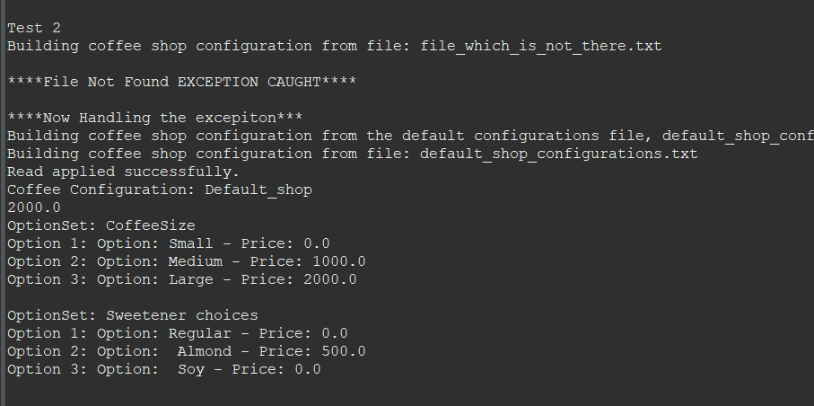

This is n example of catching the File not found exception and handling it by using default configurations saved in the default_shop_configurations.txt

1. Multithreading Without synchronization

In this screenshot of multithread without synchronization, we can see that it is causing different errors in data. (Full output of this is shared and named PizzaTestAPI_testing_without_synchronization)

1. Multithreading With Synchronization

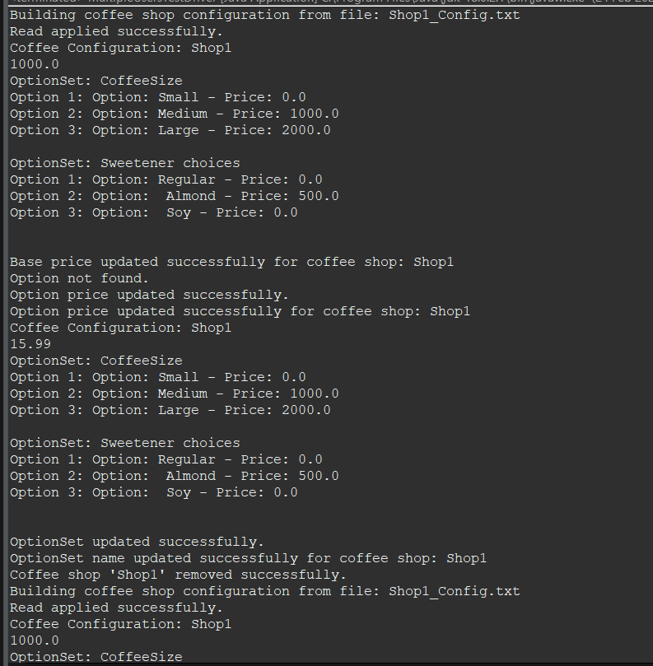

Now with sycnhronization, we can see that the thread gets executed and terminates ensuring that the program can run well concurrently. ( Full output of this is shared and named PizzaTestAPI_testing_without_synchronization)