Exploring global and local temperature since 1750

We extract data using the following queries:
select * from global_data;
Select * from citly_list;
select * from city_data;

For the calculation of the moving average I used google sheet. Copy paste and control D allows to copy paste the formula and therefore computing the moving averages of the consecutive days.

I started by plotting the average global temperature by year. For that purpose I marked my column of interests and generated the graph using the insert chart/graph function.

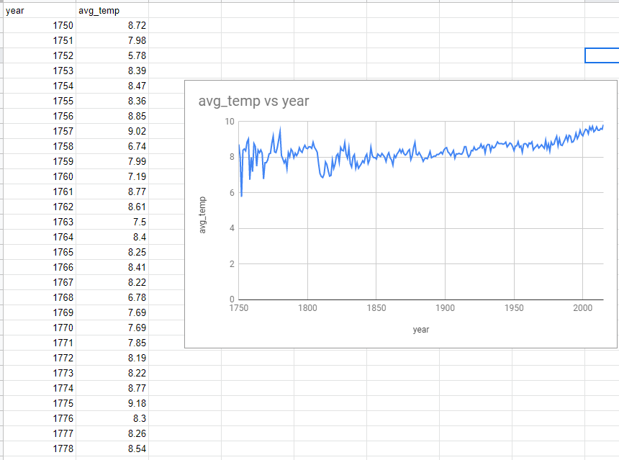
Figure: 1) Global average temperature since 1750

The next step is to look at the list of cities available in the country where I currently live. The closest city is Berlin.
I extracted all the information related to Berlin into another sheet.

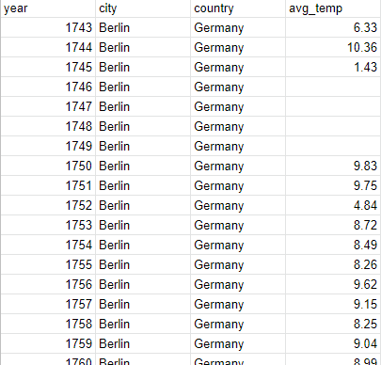
Figure: 2) Information related to my city

I decided to plot the average temperature in Berlin.
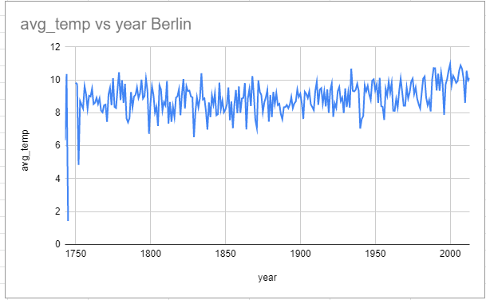
Figure: 3) average temperature in Berlin.

Observations:
-The first graph shows that at a global level the earth is getting warmer.
-At the city level , Berlin we have a lot of fluctuations. It is therefore hard to tell if the earth is really getting warmer.

I plotted the temperature of Berlin vs the global temperature and realized that Berlin seems warmer than the average global temperature.
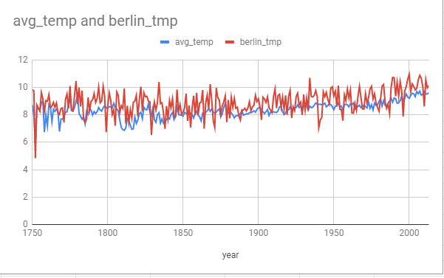
Figure: 4) average temperature in Berlin vs world

In order to confirm my observations and despite the volatility of the yearly temperature, I plotted the 10 year moving average for the earth and for Berlin. (See figure 4 )
The next step is therefore to compute the moving averages.
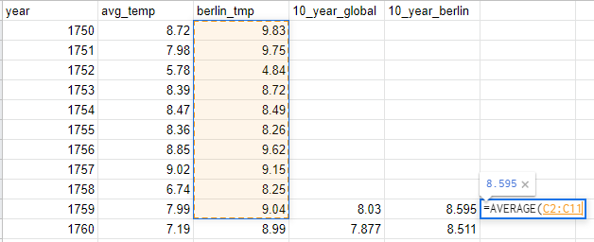

-I can confirm than Berlin is generally warmer than the average global temperature.
-Berlin is getting warmer as the earth does.

-Without plotting the moving average we are incapable to make clear statements because there are a lot of fluctuations from year to the other. The moving average is more significant.
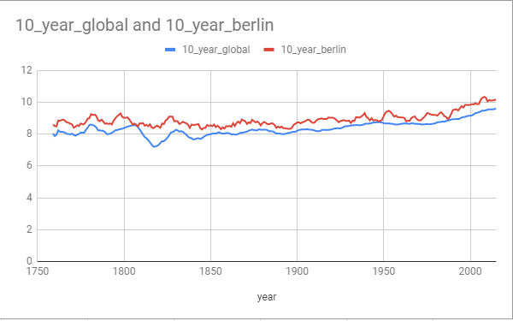

Figure 5) Moving 10 year average temperature in Berlin vs world

-Fifth and final observation: Greta Thunberg is right. It is getting warmer. Even if in winter it does not always feel that way.

Donald Trump statement on climate change is doubtful. One question remains. Can you thrust this data ?

Conclusion
-Berlin is warmer than the average global temperature even if it does not always feel that way.

-The planet is getting warmer.

-Because of the yearly fluctuation and the geographic location it is impossible to tell.

-We should take problems like climate change more seriously. /-

