Act-report

I consolidate all the information in a single dataframe using the merge function.
res_api.info()
The frame contains the following information.
Data columns (total 28 columns):
tweet_id 2331 non-null int64
timestamp 2331 non-null datetime64[ns, UTC]
source_x 2331 non-null object
expanded_urls 2272 non-null object
rating_numerator 2331 non-null int64
rating_denominator 2331 non-null int64
name 2331 non-null object
pupper 2331 non-null object
jpg_url 2059 non-null object
img_num 2059 non-null float64
p1 2059 non-null object
p1_conf 2059 non-null float64
p1_dog 2059 non-null object
p2 2059 non-null object
p2_conf 2059 non-null float64
p2_dog 2059 non-null object
p3 2059 non-null object
p3_conf 2059 non-null float64
p3_dog 2059 non-null object
created_at 2331 non-null datetime64[ns, UTC]
favorite_count 2331 non-null int64
id 2331 non-null int64
is_quote_status 2331 non-null bool
retweet_count 2331 non-null int64
retweeted 2331 non-null bool
source_y 2331 non-null object
user_id 2331 non-null objec

I decided to define a rating attribute.

res_api['rating'] = res_api['rating_numerator'] / res_api['rating_denominator']
res_api.sample(3)
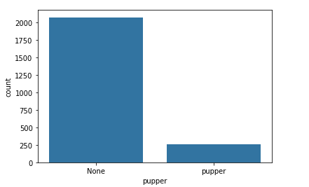
Pupper is the smallest category

There is a strong correlation between retweets and favorites.
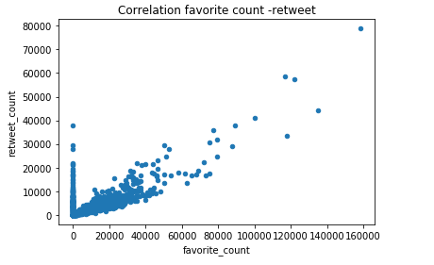

The 3 best rated classes of dogs according to p1:

