Story Y02: Search function Projects.

I want to be able to find what projects are going on on what date.

## Wireframes:

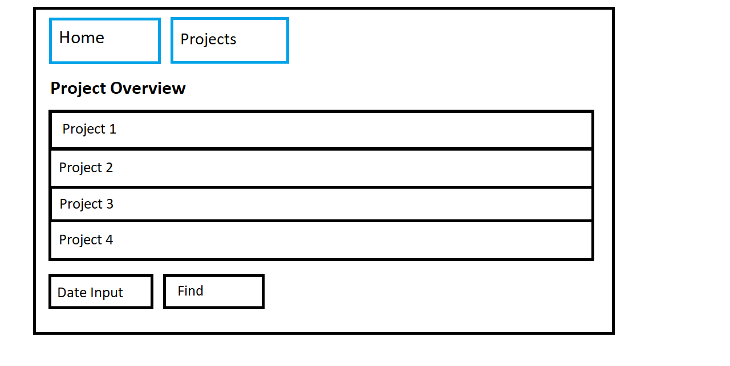

## Acceptance Criteria:

* From the Project Overview page I should be able to insert a date I want to search.
* After clicking the find button and thus submitting the form I should be taken to a different page where I can see the projects that fit the date I inserted.

## Technical Criteria:

* When inserting a date that doesn’t match any projects, I don’t leave the page and my filled in information stays the same.
* The find button doesn’t change any of the projects in the table itself.