Story Y03: Sorteerfunctie Project.

I want to be able to sort the Work Order overview table by date.

## Wireframes:

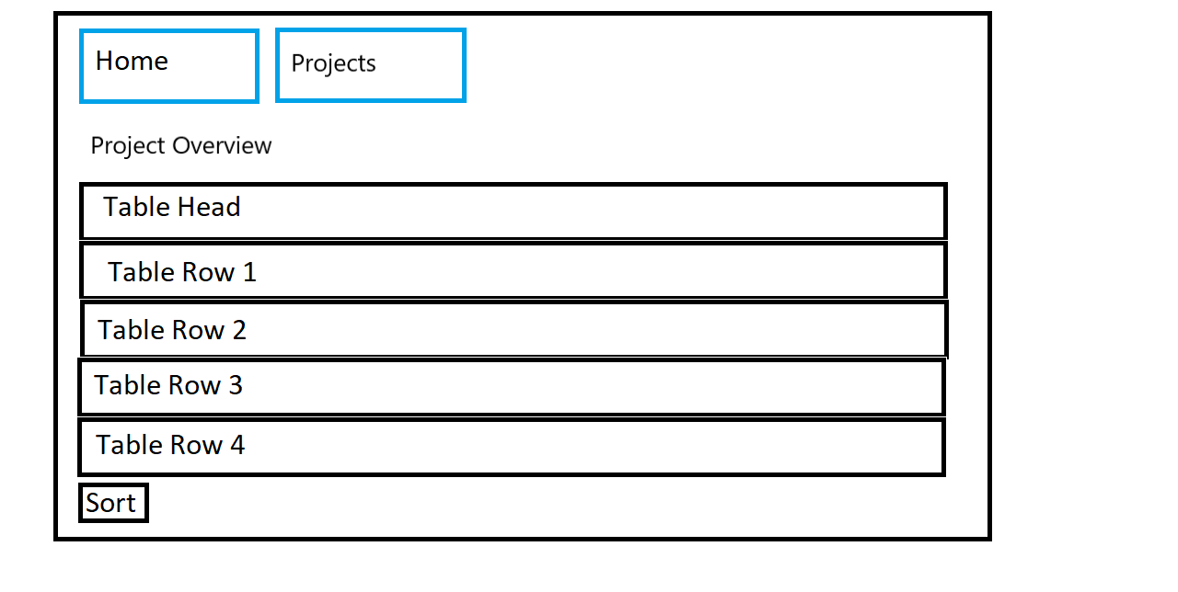

## Acceptance Criteria:

* From the Project Overview page I should be able to click a button to sort the information
* After submitting the form I should be able to see the same information except in a sorted table.

## Technical Criteria:

* The sort button should sort the data ascending or descending by date depending on which option was selected.