Story Y04: Sort function Work Order.

I want to be able to sort the Work Order overview table by date.

## Wireframes:

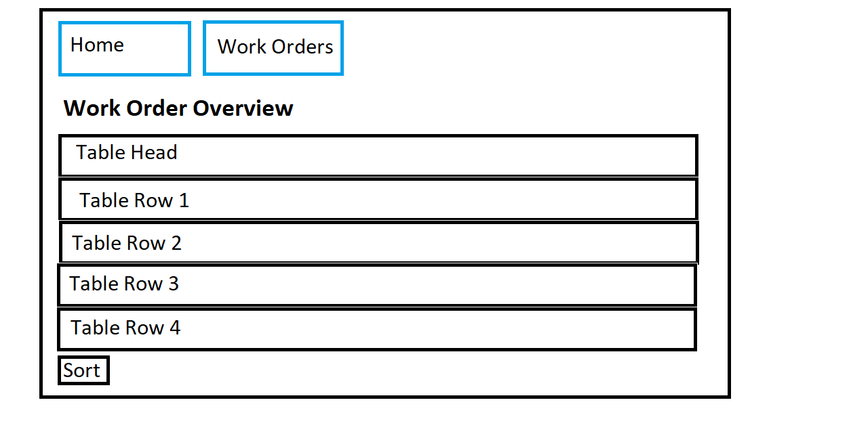

## Acceptance Criteria:

* From the Order Overview page I should be able to navigate to a page where I can choose to sort the information
* After submitting the form I should be able to see the same information except in a sorted table.

## Technical Criteria:

* The sort button should take me to a page with a form to specify on how specifically to sort the data.