Story Y05: Zoekfunctie Work Orders.

I want to be able to find what work orders are going on on what date.

## Wireframes:

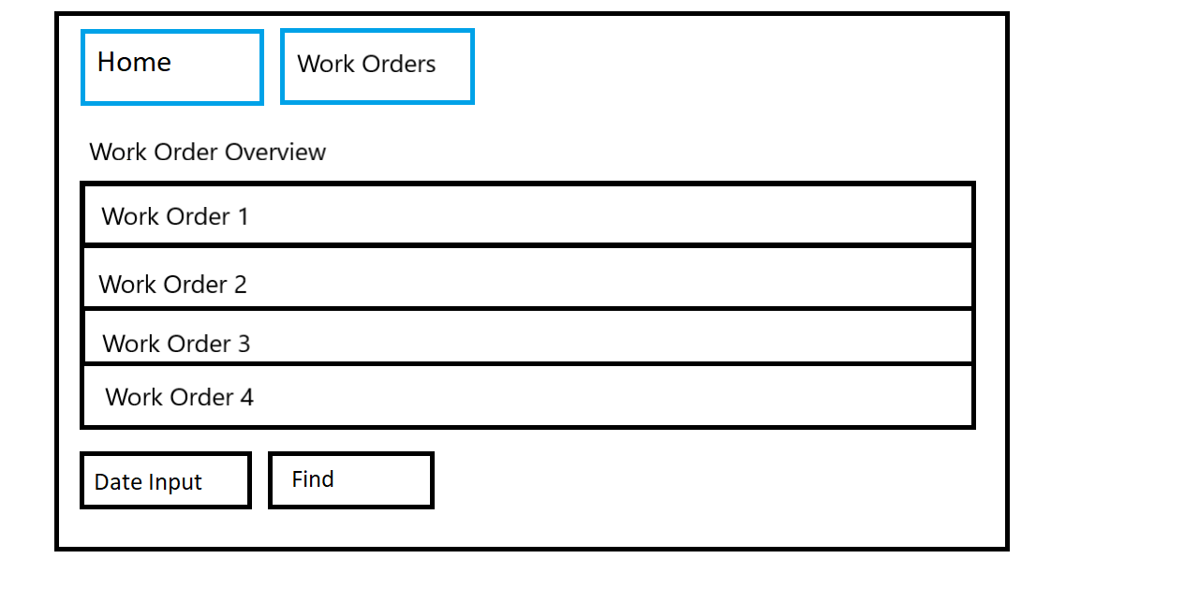

## Acceptance Criteria:

* From the Work Order Overview page I should be able to insert a date I want to search.
* After clicking the find button and thus submitting the form I should be able to see the work orders that fit the date I inserted.

## Technical Criteria:

* When inserting a date that doesn’t match any work orders, I don’t leave the page and my filled in information stays the same.
* The find button doesn’t change any of the work orders in the table itself.