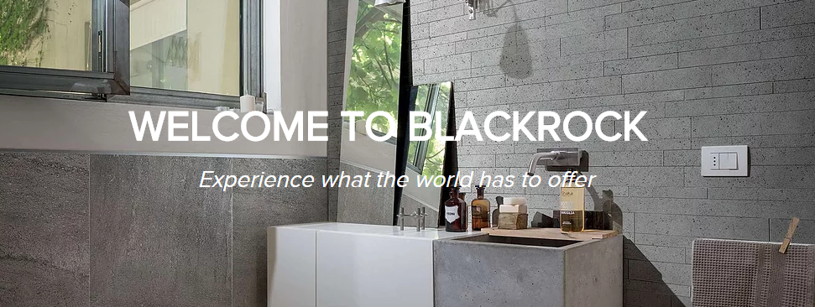

**Tile Selection**

**Project Address; [Customer_Address]**

Tiles that were selected for this job were purchased from Stefano at Blackrock Tiles in Fyshwick.

* 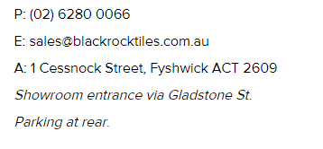[Tile_1]
* [Tile_2]
* [Tile_3]
* [Tile_4]
* [Tile_5]