Mark Sheppard

Bathrooms

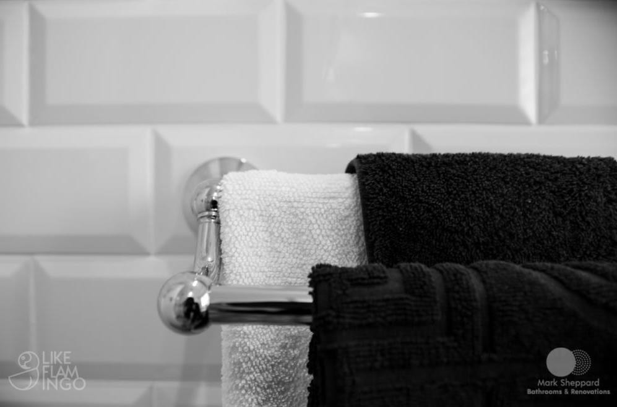

WARRANTY

INFORMATION

[Customer_Name]

[Customer_Address]