Mark Sheppard

Bathrooms

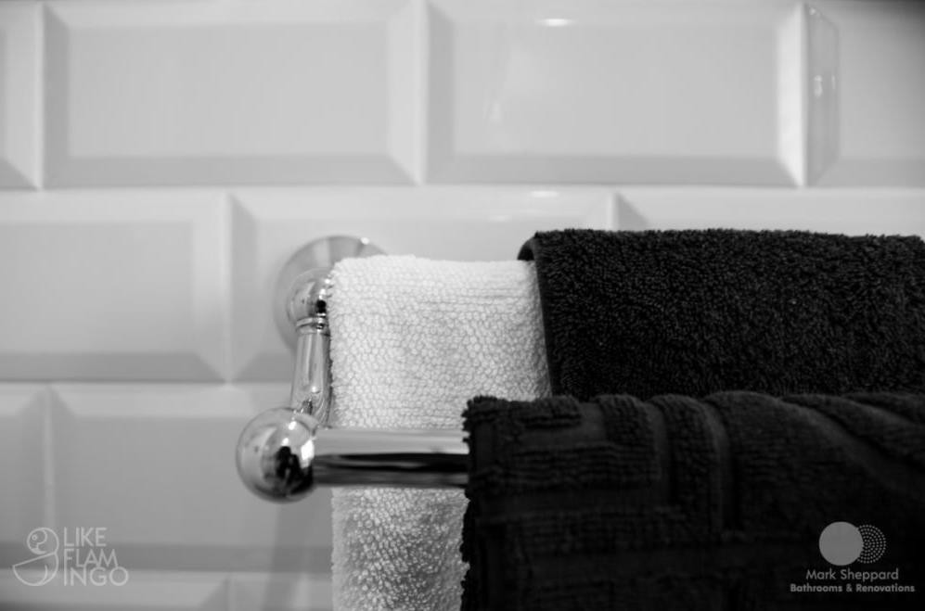

WARRANTY

INFORMATION

Mark Sheppard

8 Regent Street, Queanbeyan East

Mark Sheppard Bathrooms and Renovations

ABN 944 274 070 77

PO Box 3403 Manuka ACT 2603

0405 386 594

info@bathroomsandrenovations.com.au

**Electrical Compliance Certificate**

Project Address; **8 Regent Street, Queanbeyan East**

Pursuant to the provisions of the AS/NZS 3000:2018, Wiring Rules – Electrical Installations Parts 1 and 2 Act 2018, with revisions that comply with AS/NZS 3018 *Domestic Installations* and AS/NZS 3017 *Electrical Installations – Verification Guidelines.*

I, Mark Sheppard of Mark Sheppard Bathrooms and Renovations,

**hereby certify:**

1. That the electrical works completed at **8 Regent Street, Queanbeyan East** carried out by fully qualified and licensed electricians (Details of electrician below)
2. That any electrical works are open to inspection by a government official should a random check be required, as per ACT Building and Development regulations.
3. The electrician certifies that all electrical works have been completed to Australian Standard **3000:2018**
4. That the electrical works have warranty for a period of 7 years from date of completion …./…./………..

**Electrician used for this job:** Peter Norris of Dream Electrical



Full Name: Mark Sheppard

Phone numbers: 0405 386 594

Signature: ………………………………..

Date…………………………

Mark Sheppard Bathrooms and Renovations

ABN 944 274 070 77

PO Box 3403 Manuka ACT 2603

0405 386 594

info@bathroomsandrenovations.com.au

**Plumbing Tradesperson Information**

Project Address; **8 Regent Street, Queanbeyan East**

Pursuant to the provisions of the AS/NZS 3500:2018, Plumbing and drainage regulations Parts 1 – 4 Act 2018,

I, Mark Sheppard of Mark Sheppard Bathrooms and Renovations,

**hereby certify:**

1. That the plumbing works completed at **8 Regent Street, Queanbeyan East** were carried out by fully qualified and licensed plumbers (Details of plumber below)
2. That any plumbing relocations have been inspected by a government official and have been approved, as per ACT Building and Development regulations.
3. The plumber certifies that all plumbing has been completed to Australian Standard **3500.0.2010 – 3500.4.2010**
4. That the plumbing works have warranty for a period of 7 years from date of completion …./…./………..

**Plumber used for this job:** Nathan Moses of AusPlumb+Gas 

Full Name: Mark Sheppard

Phone numbers: 0405 386 594

Signature: ………………………………..

Date…………………………

Mark Sheppard Bathrooms and Renovations

ABN 944 274 070 77

PO Box 3403 Manuka ACT 2603

0405 386 594

info@bathroomsandrenovations.com.au

**Shower Screen Warranty**

Project Address; **8 Regent Street, Queanbeyan East**

I, Mark Sheppard of Mark Sheppard Bathrooms and Renovations,

**Hereby certify:**

* That all shower screens installed for this project have a manufacturers warranty of 12 months.
* 12 months maintenance warranty is also offered by Mark Sheppard Bathrooms and Renovations for any necessary works regarding installation.

from date of completion (…./…./……….)

Full Name: **Mark Sheppard**

Phone numbers: 0405 386 594

Signature: ………………………………..

Date…………………………