Does the loss function need to match the data-generating distribution for regression tasks?

Abstract
Fitting a model, inspecting its residuals and revising it accordingly is a cornerstone of classical statistics, where the choice of distribution family determines the link, the variance function and the inference. Machine learning, by contrast, evaluates models almost exclusively through held-out predictive performance, and the analogous choice — the loss function — is usually made between MSE and MAE on the basis of outlier robustness alone. Whether matching the loss to the data-generating distribution matters is unclear. I simulated Gaussian- and Poisson-distributed data with known effect sizes and fitted one correctly specified GLM and five deep neural networks differing only in their loss function, over 1000 iterations per scenario, comparing predictive accuracy, effect recovery and interval coverage. On Gaussian data no loss function outperformed any other. On right-skewed count data the Poisson and negative binomial losses were consistently but only marginally more accurate than MSE and Gaussian, whereas MAE failed outright, predicting below the support of the response and scoring worse than an intercept-only baseline. All networks underestimated the strongest effect by 13–23% and achieved coverage well below nominal, while the GLM remained unbiased. Matching the loss to the data distribution therefore yields limited gains, but choosing a loss that targets the wrong functional of the conditional distribution can fail badly on skewed count data — a risk absent from current guidance on loss selection.

Introduction
Machine learning now shapes work across science, finance and everyday life, tackling tasks that range from clustering to image analysis. Working with machine learning methods means making choices constantly: which algorithm suits the task, how to prepare the data and which hyperparameters to tune. In ecology, most of these tasks are either classification or regression — distinguishing categories in the first case, predicting continuous values in the second (Pichler & Hartig, 2023). For both, one of the most common approaches is to fit a deep neural network (Goodfellow et al., 2016).
A DNN approximates an unknown function f*(x) from a set of predictors x, generating predictions ŷ that are compared with the known response y. The observed response y is a noisy realization of f*(x); learning f*(x) from labelled pairs (x,y) is what defines this as supervised learning (Goodfellow et al., 2016).
As the name suggests, a DNN's architecture is loosely modelled after the human brain and the behaviour of its neurons. A DNN consists of several layers of artificial neurons; each neuron receives input either directly from the data or from upstream neurons, computes a weighted sum of these inputs and passes the result on through a nonlinear activation function (Goodfellow et al., 2016). The final layer, called the output layer, returns the network's predictions ŷ. Training means iteratively adjusting the weights of every neuron over many training cycles called epochs, so that ŷ moves closer to y with each pass. The quantity minimised is the loss function. It defines a landscape an optimizer performs gradient descent on to find the minimum (Goodfellow et al., 2016).
Regression models in classical statistics are based on an explicit data-generating model, and the most important choice is the distribution family. It does three things at once: It sets the link, constraining the predicted mean – a Poisson GLMs can only predict positive values because of its log-link. It sets the variance-function, tying the datas variance to the mean. And it determines the inference, since standard errors and p-values are derived from the log-likelihood) (McCullagh & Nelder, 1989). The family is therefore critical for structure, weighting, and uncertainty.
A DNNs loss function has only part of this importance. Neural networks are general function approximators –they are not constrained by the data generating model (Goodfellow et al., 2016; LeCun et al., 2015), and they supply no inference at all. Traditionally, hyperparameter tuning is receiving more focus at model training. What a loss function does retain however is the weighting of data points during training: the MSE loss squares the error and is therefore more sensitive to outliers than MAE, which takes absolute values; a Poisson loss encodes the variance assumption Var = μ, while a Gaussian loss does not.
In practice, this weighting receives far less attention than it does in classical statistics. Model development in deep learning focuses overwhelmingly on architecture and hyperparameter tuning, while the loss is left at its default — typically MSE, or MAE where outliers are a concern (Elharrouss et al., 2025; Lathuiliere et al., 2020; Terven et al., 2025). To my knowledge and limited literature research, where loss choice is discussed for regression, the argument is almost always about robustness to outliers rather than about the distribution of the response: the mean–variance relationship and the link function, which determine the family in a GLM, play little role.
This study addresses that gap: does the loss function matching the data-generating distribution give the best predictive accuracy and the best effect recovery? To answer it, I simulate data from two known distributions, Gaussian and Poisson, fit one GLM and five DNNs differing only in their loss function, and compare their predictive accuracy and estimated effects. This study began from a related angle: whether residual diagnostics, the standard tool for model criticism in classical statistics, could be used to guide loss selection for neural networks. Establishing that the loss matching the data-generating distribution is in fact the best one is a precondition for any such rule, and that is the question addressed here.

Materials and Methods

Data Creation
Data were simulated with DHARMa::createData, which generates a response variable (observedResponse) from three predictors (Environment1, Environment2, Environment3) under a specified distribution. I ran two scenarios with different distributions, Gaussian and Poisson, at 1000 iterations each. Effect sizes were set to 2, 0.4 and 0.1 respectively to test a strong, a moderate and a small effect, so that accuracy and inference could be assessed across effect magnitudes. Overdispersion and random-effect variance were set to zero to keep the structure as simple as possible, although varying them alongside intercept and effect sizes would be a natural extension.
The intercept differed between scenarios. For Poisson data I set it to −1; a low mean makes count data strongly right-skewed, where the mismatch between count and continuous losses should be most pronounced. The same intercept proved unusable for Gaussian data, where roughly two thirds of the simulated responses were negative, and the Poisson and negative binomial losses failed to converge (Table 3, see appendix). I therefore raised the Gaussian intercept to 6, the lowest value that reliably produced only positive responses, keeping the mean-to-variance ratio as small as possible while allowing all five losses to be fitted.
Sample size was set to 250 so that, after an 80/20 train–test split and a further 20% validation split within training, each network was fitted on 160 observations. This keeps the sample small, since predictive performance degrades and becomes more variable at low sample sizes (Wisz et al., 2008), while still leaving enough data for the networks to converge.

GLM-fit
As a baseline, I fitted a GLM with the family matching the data-generating distribution. To make the comparison with the DNNs, the GLM was also bootstrapped: 20 resamples of the training data were drawn with replacement, a GLM refitted on each, and predictions averaged across them. Effect estimates were taken as the mean of the 20 bootstrap estimates, standard errors as their standard deviation, and p-values from a z-test. Predictions were generated for both training and test data, from which RMSE, Spearman correlation and R² were calculated.

DNN-fit
Five DNNs were fitted per iteration, differing only in their loss function. MSE, MAE and Gaussian represent commonly used losses with an identity link; Poisson and negative binomial represent losses with a log link, chosen because count data are common regression problems in ecology.
Each network had two hidden layers of 50 nodes, allowing some flexibility while restricting complexity. Networks were trained for up to 200 epochs at a learning rate of 0.003. Rather than tuning the learning rate separately for each combination of loss function and data distribution, I used early stopping with a patience of 20 epochs, so that training halts once the validation loss stops improving. This keeps the optimisation settings identical across losses, at the cost of not optimising any of them individually. Weight decay of 0.01 penalised large weights and so mitigated overfitting; I checked for residual overfitting by comparing accuracy metrics on training and test data (Figure 5, 6, see appendix). For each iteration and model, 20 bootstrap models were trained to extract Standard Error (SE) and p-values.
Two diagnostic variables were recorded alongside the accuracy metrics. Neg_preds counts predictions below zero, which are impossible for count data and indicate a loss function predicting outside the support of the response. Each fit was additionally wrapped in a tryCatch, so that a failed fit was recorded as a missing row rather than terminating the iteration, allowing convergence failures to be reported as a rate per loss function.

Accuracy metrics
Four metrics were calculated per model and iteration, on both training and test predictions.
RMSE measures the deviation between predicted and observed responses on the original scale, so smaller values indicate predictions closer to the observed data:
$RMSE=\sqrt{\frac{1}{n}\sum_{i=1}^{n}{}{(y_{i}-\hat{y_{i}})}^{2}}$ (1)
Because the data were simulated, the noise-free mean μ is known, and RMSE can also be calculated against it rather than against the noisy observations:
${RMSE}_{true}=\sqrt{\frac{1}{n}\sum_{i=1}^{n}{}{({mu}_{i}-\hat{y_{i}})}^{2}}$ (2)
This true RMSE isolates model error from irreducible sampling noise and therefore has a floor of zero. RMSE against the observed response is also reported, since it is the only one of the two computable on real data.
R², the coefficient of determination, compares a model's squared prediction error against that of an intercept-only baseline and so measures whether a model predicts better than the mean: $R^{2}=1-\frac{\sum_{i=1}^{n}{}{(y_{i}-\hat{y_{i}})}^{2}}{\sum_{i=1}^{n}{}{(y_{i}-\overline{y})}^{2}}$ (3)
Because R² is built from squared errors, observations with large values dominate it; for right-skewed count data a small number of high counts determines the metric almost entirely. For the Poisson scenario I therefore used McFadden's pseudo-R², which replaces sums of squares with log-likelihoods and so evaluates predictions under the assumed count distribution rather than on the squared-error scale:
$R_{McF}^{2}=1-\frac{lnL(\hat{M})}{lnL(M_{0})}$ (4)
Since models trained with MSE, MAE or Gaussian losses do not themselves define a count distribution, their predictions were treated as Poisson means for this evaluation. This amounts to scoring every model with the logarithmic score, a strictly proper scoring rule (Gneiting, 2011), normalised against a common baseline. Note that neither metric is bounded below by zero out of sample: negative values indicate predictions worse than the baseline.
Because McFadden's R² is computed from Poisson log-likelihoods via dpois(), which is undefined for a negative rate, predictions were clamped to a lower bound of 1e-8. The clamp is unavoidable rather than a modelling choice: no finite Poisson log-likelihood exists at a non-positive rate, so without it the metric would return NaN for any model producing negative predictions. It is, however, a severe penalty. The Poisson log-density contains a term in log(λ), so a clamped prediction paired with a non-zero count yields a very large negative contribution, and a model whose predictions fall below zero for a substantial share of observations is therefore scored far below the intercept-only baseline. The sign of such an R² is robust, but its magnitude depends on the chosen bound and should not be interpreted quantitatively; the Neg_preds count is reported alongside it as a bound-independent measure of the same behaviour.
Spearman correlation measures predictive performance independently of scale and bias. Because it uses only ranks, it distinguishes a model that has learned the correct pattern but predicts it on the wrong scale from one that has not learned the pattern at all.

Inference metrics
Unlike a GLM, a DNN has no coefficients to extract, so effects were compared via Average Conditional Effects (ACE), obtained from cito's fitted model object (Pichler & Hartig, 2023). For comparability the equivalent quantity was extracted from the GLM as Average Marginal Effects using marginaleffects::avg_slopes. ACE and AME are the same metric under different names, and both are reported on the response scale; I refer to them as ACE from here on.
Standard errors were obtained from the 20 bootstrap networks per model as the standard deviation of their estimates, and p-values from a z-test of estimate over standard error (Pichler & Hartig 2023). Effects were evaluated on the training data, where the true effect is defined.
Estimates were compared against the true average effect implied by the data-generating process. Because this quantity depends on the link, it differs between scenarios: under the identity link it equals the simulated coefficient, whereas under the log link it equals the coefficient multiplied by the mean response, and therefore varies between iterations. Each estimate was compared against the true value for its own iteration.
Across the 1000 iterations I report bias, the mean difference between estimate and truth, and coverage, the proportion of iterations in which the interval estimate ± 1.96 SE contained the true effect. Coverage tests whether a model's self-reported uncertainty is honest: a well-calibrated model should achieve approximately 95%. Monte Carlo standard errors are reported for both, following (Morris et al., 2019); at 1000 iterations the Monte Carlo error on coverage is approximately 0.007, so differences smaller than roughly 0.02 should not be interpreted.

Parallelisation, hardware and reproducibility
Each script ran 1000 iterations, each fitting one GLM and five DNNs with 20 bootstrap replicates. Runtime was therefore substantial, and iterations were distributed across 12 cores using pbmcapply::pbmclapply. Results from each iteration were appended to a data frame and written to disk on completion. Analyses were run on a machine with 24 cores and took approximately 28 hours per scenario.
For reproducibility, the L'Ecuyer-CMRG random number generator was used so that parallel workers receive reproducible streams, with seeds set via set.seed() and, because torch maintains its own generator for weight initialisation, torch_manual_seed() within each worker. All analyses used R 4.5.3 with cito 1.2, DHARMa 0.5.0 and marginaleffects 1.0.0. Other packages I used were pbmcapply 1.5.1, stringr 1.6.0, dplyr 1.2.1, ggplot2 4.0.3, tidyr 1.3.2 and torch 0.17.0

AI-Acknowledgement
I used Anthropics’ Claude Opus 5 for debugging and cleaning code, aiding in literature search and reviewing this text. Study design, interpretation and final text were not delegated to AI.

Results
All trained models converged on Gaussian- and Poisson-distributed data, an earlier Gaussian configuration in which two losses failed entirely is described below. I performed an overfitting analysis to validate the DNNs’ results (see Figure 5 and 6 in appendix).

Poisson-distributed data
Across all three accuracy metrics, differences between loss functions were small, and no DNN outperformed the correctly specified GLM (R² = 0.268, RMSE = 0.832, Spearman = 0.605). Among the DNNs, the two count losses came closest to the GLM on every metric: Poisson and negative binomial achieved R² of 0.257 and 0.256 against 0.213 and 0.225 for MSE and Gaussian and Spearman correlations of 0.596 and 0.595 against 0.585 and 0.586.
MAE was the clear exception. Its McFadden R² was negative (−0.098), indicating predictions worse than the intercept-only baseline, and it also produced the highest RMSE (0.866). Its Spearman correlation, however, was 0.586 — indistinguishable from MSE and Gaussian. MAE therefore ordered observations as well as the other losses while placing them on the wrong scale, a pattern consistent with it predicting negative values for a majority of test observations (median prediction −0.002, Neg_preds = 89.6%). As described in the Methods, predictions at or below zero are clamped before the Poisson log-likelihood is evaluated, which penalizes them heavily).
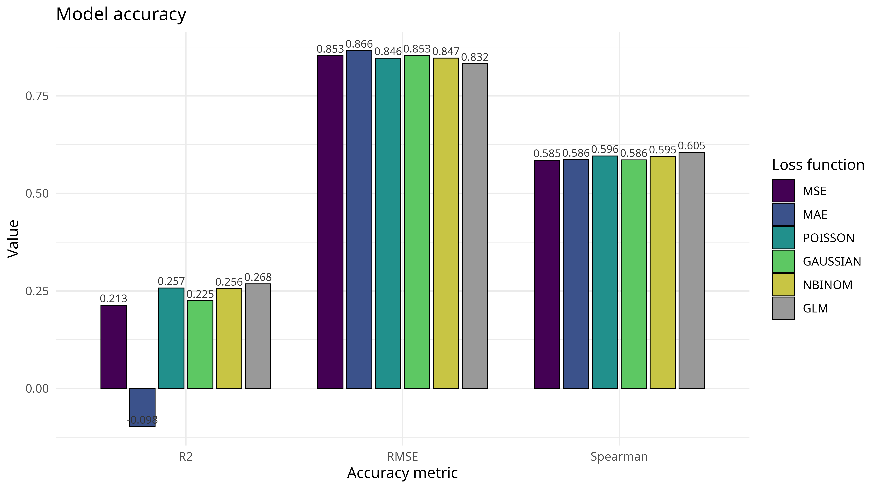Figure 1: Predictive accuracy of five DNN loss functions and the GLM baseline on Poisson-distributed data, averaged over 1000 iterations. Bars show the mean of McFadden's R², RMSE against the observed response, and Spearman correlation, each computed on held-out test data. The GLM (grey) is correctly specified and serves as the reference. Note that McFadden's R² is not bounded below by zero out of sample; negative values indicate predictions worse than an intercept-only baseline.
Effect estimation showed a different pattern from predictive accuracy. The correctly specified GLM recovered the true effects closely across all three predictors (1.373, 0.278 and 0.067 against true values of 1.367, 0.273 and 0.068). All five DNNs, by contrast, underestimated the strongest effect: estimates for Environment1 ranged from 1.055 (MAE) to 1.195 (MSE), a shortfall of 13–23% relative to the true value of 1.367. The same direction held for Environment2 and Environment3, though absolute differences shrank with effect size.
Differences between loss functions were small relative to their uncertainty. Bootstrap standard errors for Environment1 were approximately 0.2 for all DNNs, so the spread between the best and worst loss function fell within roughly one standard error.

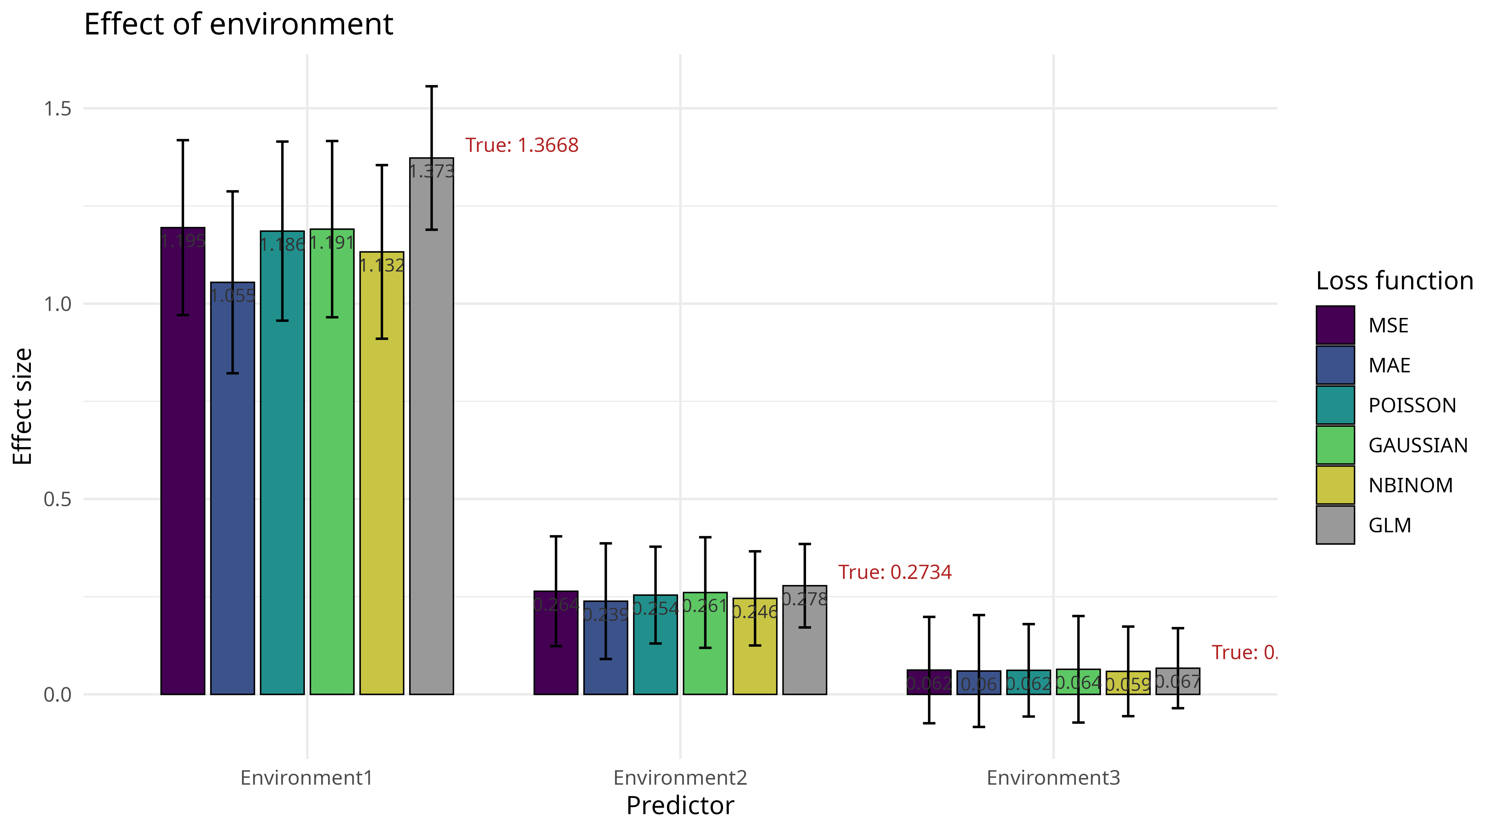Figure 2: Estimated effects of the three predictors for five DNN loss functions and the GLM baseline on Poisson-distributed data, averaged over 1000 iterations. Bars show the mean estimated effect, error bars the mean bootstrap standard error across iterations. Red labels give the true average effect implied by the data-generating process. Effects are average conditional effects on the response scale.
The correctly specified GLM was essentially unbiased for all three predictors and achieved coverage close to the nominal 95% (0.920–0.934). The DNNs behaved differently, and the pattern depended strongly on effect size. For Environment1, the strongest effect, every DNN underestimated the true value and coverage fell well below nominal, from 0.844 for the Gaussian loss down to 0.701 for MAE. For Environment2 and Environment3, bias was negligible, and coverage was slightly above nominal (0.948–0.986).
Coverage tracked bias closely across all DNNs: MAE showed both the largest underestimation (−0.312, 22.8% of the true effect) and the lowest coverage (0.701), followed by the negative binomial loss (−0.234 and 0.765). The remaining three losses were indistinguishable from one another (bias −0.172 to −0.181, coverage 0.822–0.844).

Table 1. Coverage and bias of effect estimates for the three predictors, five DNN loss functions and the GLM baseline on Poisson-distributed data, over 1000 iterations. Coverage is the proportion of iterations in which the estimate ± 1.96 SE contained the true effect; bias is the mean difference between estimate and true effect. Monte Carlo standard errors in parentheses. Nominal coverage is 0.95.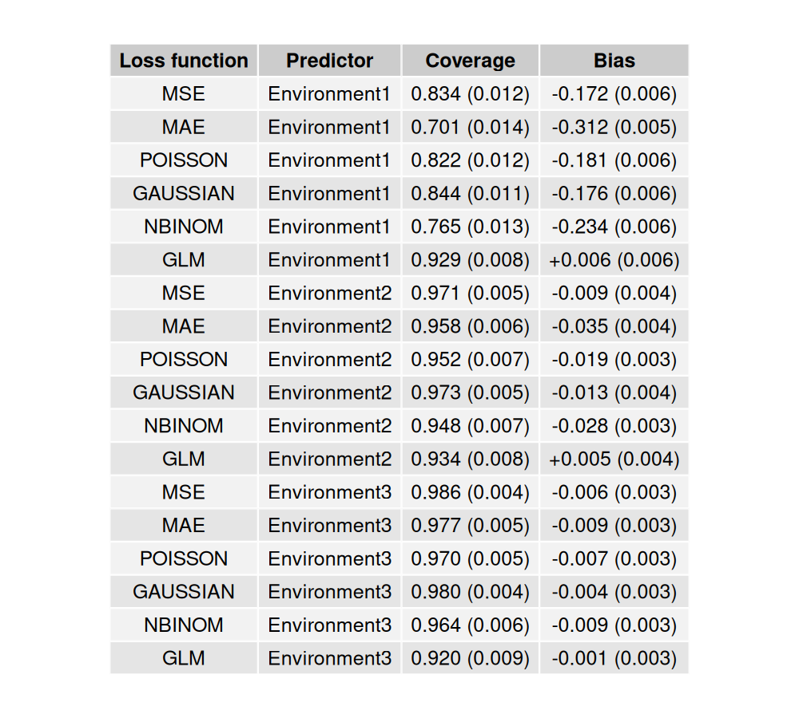

Taken together, matching the loss function to the data-generating distribution produced at most marginal gains in predictive accuracy, while using a loss whose target functional differs from the mean — MAE — degraded both prediction and inference substantially.

Gaussian-distributed data
The first Gaussian runs, at an intercept of −1, produced usable results only for MSE, MAE and Gaussian: the Poisson and negative binomial losses failed to converge in every iteration, as roughly two thirds of simulated responses were negative and lie outside the support of both distributions (see Table 3 in Appendix). The scenario was therefore rerun at an intercept of 6, the lowest value producing reliably positive responses, at which all five losses converged.
Differences between loss functions were again small, and no DNN matched the correctly specified GLM. R² ranged from 0.538 to 0.550 across the DNNs against 0.562 for the GLM, and RMSE from 1.018 to 1.032 against 1.005. Spearman correlations differed even less, spanning 0.741 to 0.749 against 0.753. Unlike the Poisson scenario, the two count losses held no advantage: negative binomial gave the best DNN R² (0.550) and Poisson the third (0.546), but the spread across all five losses was smaller than in any Poisson comparison.
Effect estimation showed the same pattern. For the smaller effects the GLM came closest to the truth (0.397 and 0.104 against 0.4 and 0.1), with the DNNs spanning 0.387–0.396 and 0.100–0.105. For Environment1 the GLM recovered the true effect of 2 almost exactly (1.998), followed by negative binomial (1.988) and Poisson (1.974), while MSE, MAE and Gaussian fell slightly lower (1.942–1.964). The underestimation of the strongest effect was therefore present but far weaker than under Poisson data, where the same losses fell 13–23% short.
Interval coverage showed the opposite pattern to the count scenario. DNN biases were close to zero throughout (−0.058 to +0.005), two orders of magnitude smaller in relative terms than under Poisson data, and coverage exceeded the nominal 95% for every predictor and loss (0.959–0.991). The regularisation-induced underestimation that depressed coverage for the strongest effect under count data was therefore not detectable here, although the intervals were wider than necessary rather than correctly sized. The GLM fell slightly below nominal for all three predictors (0.919–0.937) despite being essentially unbiased, which suggests its bootstrap standard errors are somewhat too narrow.
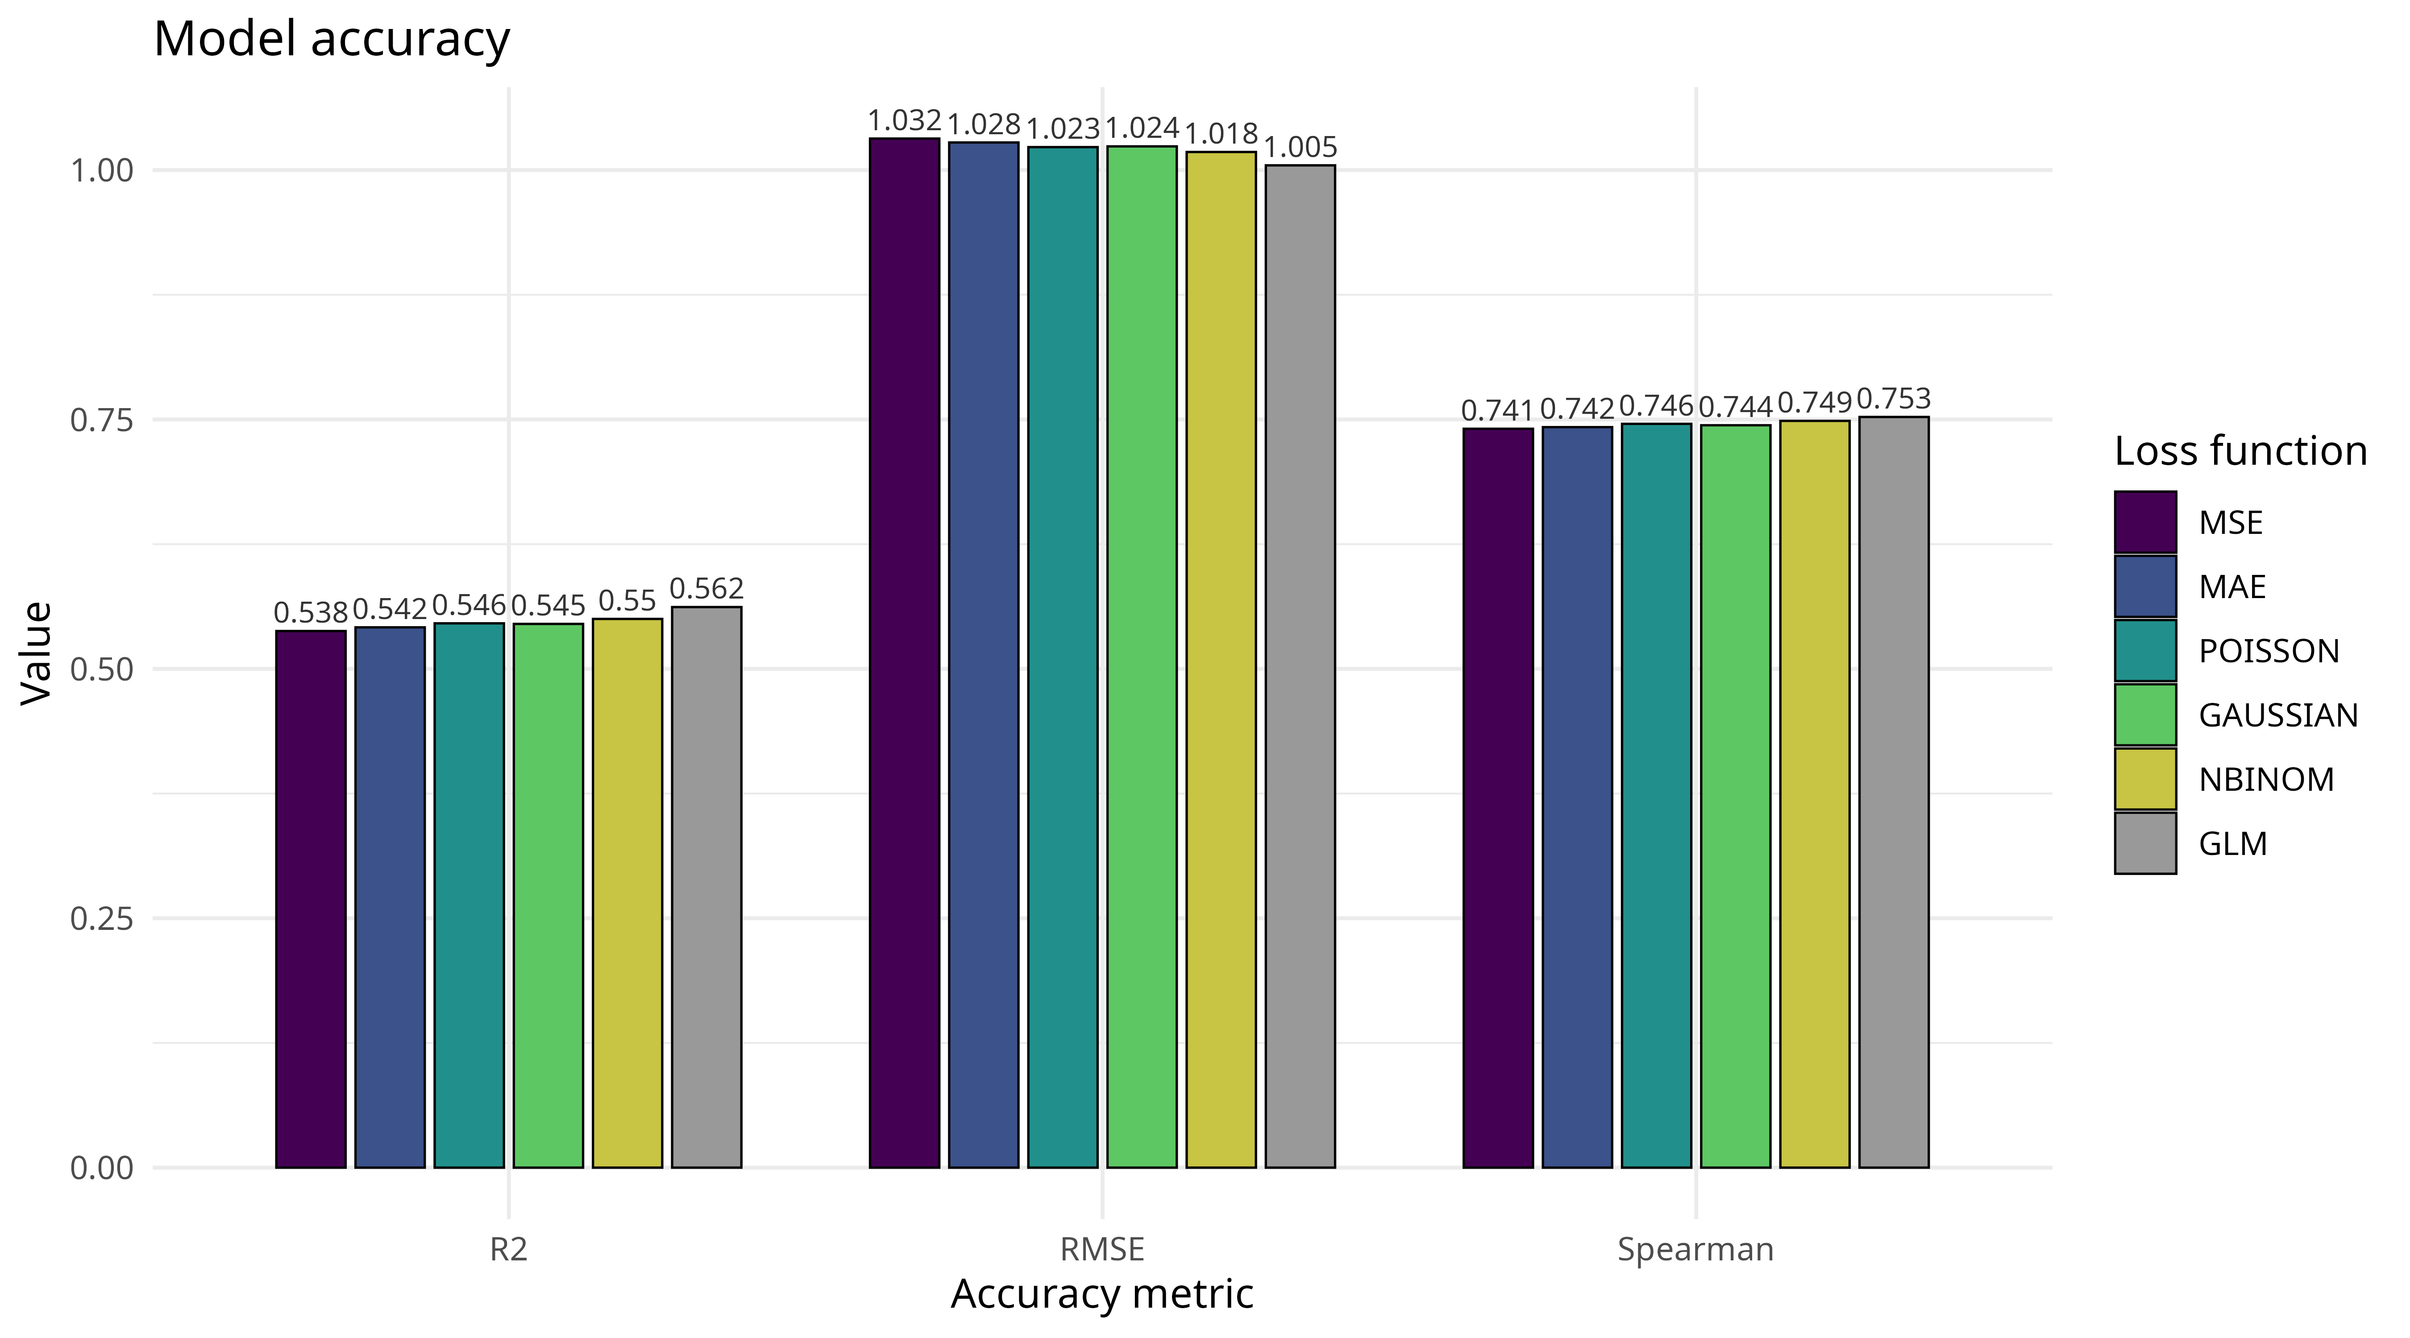Figure 3: Predictive accuracy of five DNN loss functions and the GLM baseline on Gaussian-distributed data, averaged over 1000 iterations. Bars show the mean of the R², RMSE against the observed response, and Spearman correlation, each computed on held-out test data. The GLM (grey) is correctly specified and serves as the reference. Note that the accuracy metrics show no large divergence between models.
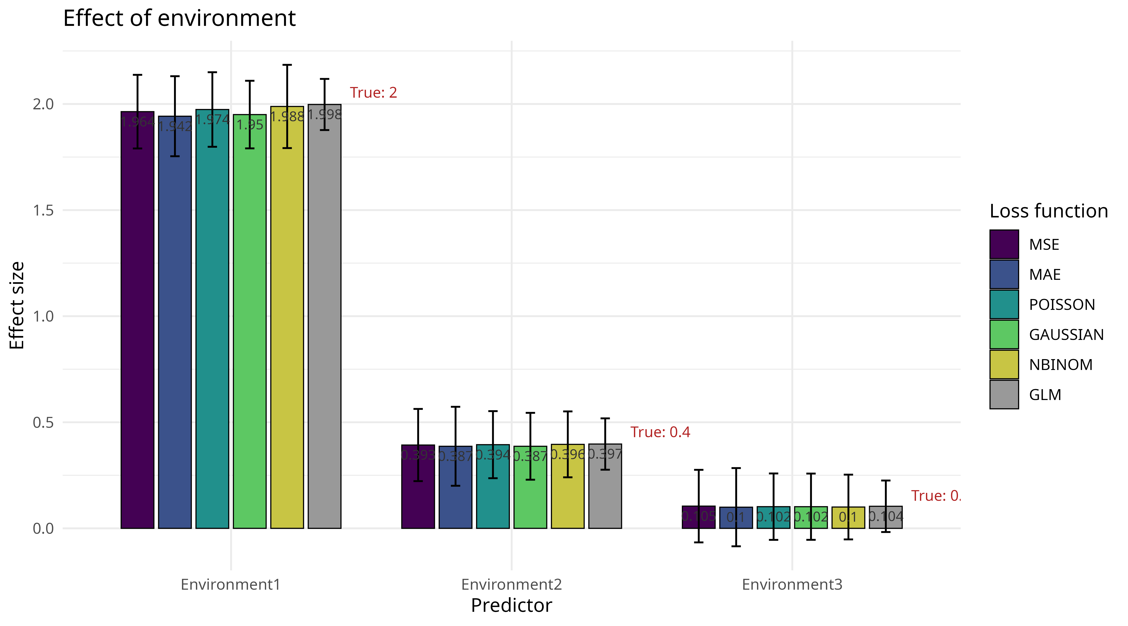
Figure 4: Estimated effects of the three predictors for five DNN loss functions and the GLM baseline on Gaussian-distributed data, averaged over 1000 iterations. Bars show the mean estimated effect, error bars the mean bootstrap standard error across iterations. Red labels give the true average effect implied by the data-generating process. Effects are average conditional effects on the response scale.

Table 2: Coverage and bias of effect estimates for the three predictors, five DNN loss functions and the GLM baseline on Poisson-distributed data, over 1000 iterations. Coverage is the proportion of iterations in which the estimate ± 1.96 SE contained the true effect; bias is the mean difference between estimate and true effect. Monte Carlo standard errors in parentheses. Nominal coverage is 0.95.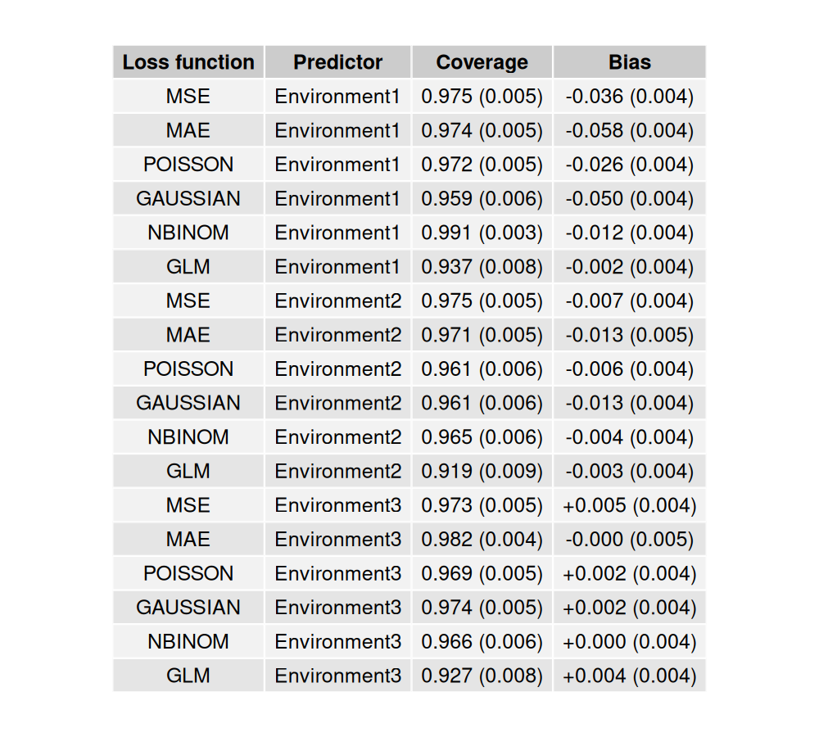

Discussion
The DNN models showed no major differences in performance on Gaussian-distributed data, while on Poisson-distributed data the count losses, Poisson and negative binomial, ranked consistently ahead of Gaussian, MAE and MSE — though the margins were small on every metric. The GLM outperformed every DNN in both scenarios. This is to be expected: specifying the family hands the GLM both the functional form and the correct link, while the DNNs must recover that form from the data. The design also favours the GLM throughout, combining a small sample, small effect sizes, no interactions and no nonlinearity (Jansen et al., 2020; Wisz et al., 2008) — conditions under which a correctly specified parametric model is difficult to beat. That the DNNs came within a few percent of it on most metrics is therefore a reasonable result rather than a poor one.
MAE on Poisson-distributed data was the one clear exception. Its negative McFadden R² indicates predictions worse than an intercept-only baseline, and the mechanism follows from what the loss optimises. Absolute error is minimised by the conditional median rather than the mean (Gneiting, 2011), and at an intercept of −1 the Poisson mean lies below 0.4, so the median count is zero across much of the predictor space. MAE therefore predicted near or below zero for a large share of observations. Because the Poisson log-likelihood is undefined at a non-positive rate, these predictions were clamped before evaluation, which penalises them heavily and produces the negative R². Notably, MAE’s Spearman correlation was indistinguishable from the other losses: the ordering of observations was recovered correctly, only the scale was wrong. Gaussian and MSE also produced occasional negative predictions but far less often (see Table 3 in Appendix), consistent with both targeting the mean, which remains strictly positive. The divergence between mean and median is greatest for strongly skewed distributions, which is precisely what the Poisson scenario was designed to probe.
My results are relevant to filling the identified research gap. Practitioner guidance on loss functions for deep regression commonly recommends MSE or MAE, distinguishing between them mainly by their handling of outliers (Elharrouss et al., 2025; Lathuiliere et al., 2020). Non-academic sources aimed at practitioners follow the same pattern, extending the list to Huber or RMSE but discussing loss choice almost entirely in terms of robustness (Brownlee, n.d.; IBM, n.d.), and count-specific losses such as Poisson or negative binomial appear only as special cases for special tasks. My results suggest this default is defensible for well-behaved, normally distributed data: no loss function outperformed any other on the Gaussian scenario, so nothing is lost by choosing MSE. For Poisson-distributed data with a low intercept, the picture is more differentiated. The count losses were consistently, though only marginally, more accurate than MSE and Gaussian, a difference small enough that it would rarely justify changing a default. MAE, by contrast, failed outright, producing predictions worse than an intercept-only baseline and the largest bias of any loss. The practical implication is therefore not that defaults are wrong, but that they carry a specific risk: a loss targeting the wrong functional of the conditional distribution can fail badly on skewed count data, and nothing in current guidance warns against it.
What remains unresolved is whether the remaining underperformance could be tuned away. Neither architecture nor hyperparameters were tuned in this study, and the learning rate was held constant across both distributions and all five losses, so some of the observed differences may reflect settings that suit one loss better than another. Regularization is a more specific concern. (Pichler & Hartig, 2023)argue that hyperparameters optimized for predictive accuracy need not be optimal for inference, and my results are consistent with that: the DNNs achieved predictive accuracy close to the GLM while showing substantial bias and poor coverage for the strongest effect. Weight decay and early stopping both shrink weights toward zero, which would depress the largest effect most in absolute terms. A preliminary rerun without either confirmed part of this picture, reducing bias for the identity-link losses, but it also widened the bootstrap intervals to the point of uninformative coverage, suggesting a bias–variance trade-off rather than a straightforward improvement. Systematically varying regularization strength would be a natural next step.
The data-generating process offers a further set of levers. Introducing overdispersion or random-effect variance would move the simulated data closer to ecological datasets, and varying these alongside the intercept and effect sizes could identify the conditions under which particular losses fail rather than merely confirming that they can. Repeating the experiment with negative binomial data would be a more extreme version of the count case and should accentuate the underperformance observed for MAE here. A further extension would return to the question that motivated this study: inspecting the simulated quantile residuals of the fitted networks directly, rather than relying on aggregate accuracy metrics, to establish whether a correctly matched loss produces residuals that are demonstrably better behaved and whether that signal could guide loss selection in practice.

References

Brownlee, J. (n.d.). How to Choose Loss Functions When Training Deep Learning Neural Networks. Machine Learning Mastery. Retrieved October 12, 2026, from https://machinelearningmastery.com/how-to-choose-loss-functions-when-training-deep-learning-neural-networks/
Elharrouss, O., Mahmood, Y., Bechqito, Y., Serhani, M. A., Badidi, E., Riffi, J., & Tairi, H. (2025). Loss Functions in Deep Learning: A Comprehensive Review. arXiv. https://doi.org/10.48550/arXiv.2504.04242
Gneiting, T. (2011). Making and Evaluating Point Forecasts. Journal of the American Statistical Association, 106(494), 746–762. https://doi.org/10.1198/jasa.2011.r10138
Goodfellow, I., Bengio, Y., & Courville, A. (2016). Deep Learning. MIT Press. https://www.deeplearningbook.org/
IBM. (n.d.). What is a loss function? Retrieved October 12, 2026, from https://www.ibm.com/think/topics/loss-function
Jansen, J., Woolley, S. N. C., & Dunstan, P. K. (2020). Effects of sample size and network depth on a deep learning approach to species distribution modeling. Ecological Informatics, 60, 101137. https://doi.org/10.1016/j.ecoinf.2020.101137
Lathuiliere, S., Mesejo, P., Alameda-Pineda, X., & Horaud, R. (2020). A Comprehensive Analysis of Deep Regression. IEEE Transactions on Pattern Analysis and Machine Intelligence, 42(9), 2065–2081. https://doi.org/10.1109/TPAMI.2019.2910523
LeCun, Y., Bengio, Y., & Hinton, G. (2015). Deep learning. Nature, 521(7553), 436–444. https://doi.org/10.1038/nature14539
McCullagh, P., & Nelder, J. A. (1989). Generalized Linear Models (2nd ed.). Chapman and Hall/CRC. https://doi.org/10.1201/9780203753736
Morris, T. P., White, I. R., & Crowther, M. J. (2019). Using simulation studies to evaluate statistical methods. Statistics in Medicine, 38(11), 2074–2102. https://doi.org/10.1002/sim.8086
Pichler, M., & Hartig, F. (2023). Machine learning and deep learning—A review for ecologists. Methods in Ecology and Evolution, 14(4), 994–1016. https://doi.org/10.1111/2041-210X.14061
Terven, J., Cordova-Esparza, D.-M., Romero-González, J.-A., Ramírez-Pedraza, A., & Chávez-Urbiola, E. A. (2025). A comprehensive survey of loss functions and metrics in deep learning. Artificial Intelligence Review, 58(7), 195. https://doi.org/10.1007/s10462-025-11198-7
Wisz, M. S., Hijmans, R. J., Li, J., Peterson, A. T., Graham, C. H., & Guisan, A. (2008). Effects of sample size on the performance of species distribution models. Diversity and Distributions, 14(5), 763–773. https://doi.org/10.1111/j.1472-4642.2008.00482.x

Appendix
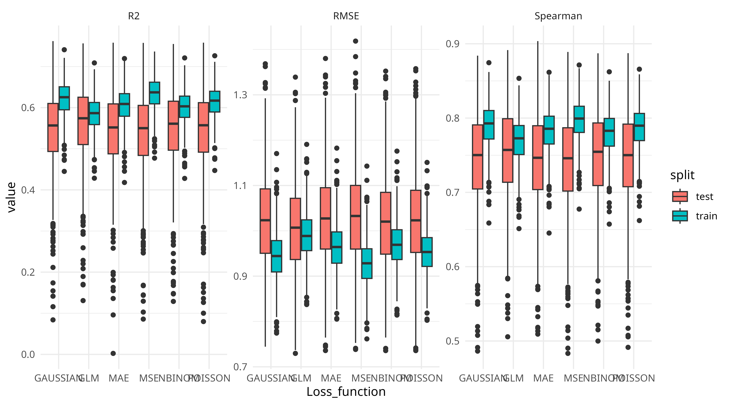Figure 5. Train–test comparison of accuracy metrics on Gaussian-distributed data, over 1000 iterations. Boxplots show the distribution of R², RMSE and Spearman correlation across iterations, calculated separately on training and held-out test data for each model. Substantially better performance on training than on test data would indicate overfitting. All models show a small and comparable train–test gap, with no loss function diverging from the others; the GLM shows the smallest gap, as expected for a four-parameter model.
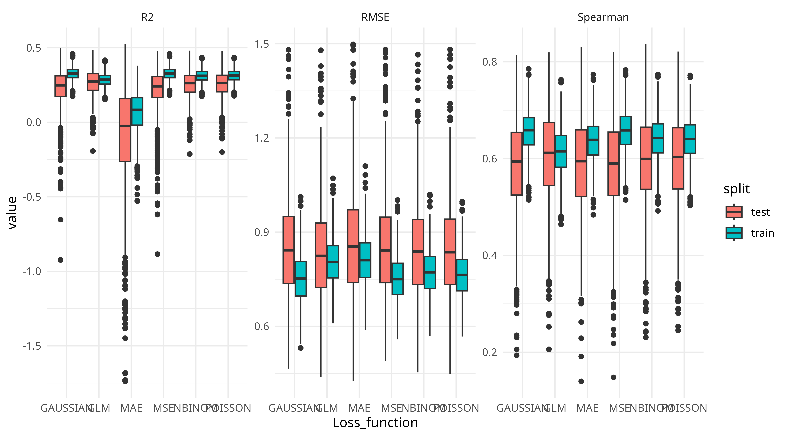Figure 6. Train–test comparison of accuracy metrics on Poisson-distributed data, over 1000 iterations. Boxplots show the distribution of R², RMSE and Spearman correlation across iterations, calculated separately on training and held-out test data for each model. Substantially better performance on training than on test data would indicate overfitting. All models show a small and comparable train–test gap, with only MAE diverging on R2 the others – which is discussed in length in the main text; the GLM shows the smallest gap, as expected for a four-parameter model.

Table 3. Negative predictions by the GLM baseline and five DNN loss functions on Poisson-distributed data, over 1000 iterations with 50 test observations each. Columns give the mean number of negative predictions per iteration, the same figure as a percentage of test observations, the percentage of iterations containing at least one negative prediction, and the largest number observed in any single iteration. Negative values are impossible for count data and indicate predictions outside the support of the response.
