November 2nd 2011

Update of the Reflectivity curve of the MOS included in MTSSim v.>= 2.6.1

by Ruymán Azzollini
(CAB, INTA-CSIC, Spain)

1. Introduction

Tim Grundy and Paul Eccleston (RAL) recently (October 20011) found that the transmission curve of the MOS included in MTSSim (up to v. 2.6.0) might be wrong, and the 11.3 um feature found in that curve may actually be the 8 um feature seen in the FM data (spectra and imaging). After inspection of the INTA documentation it seemed like they were right, and either the file with the curve got corrupted or most probably it was done wrong from the outset. The (original) manufacturer curve indeed showed the characteristic feature at 8 um and not at 11.3 um, as can be seen in Fig. 1.

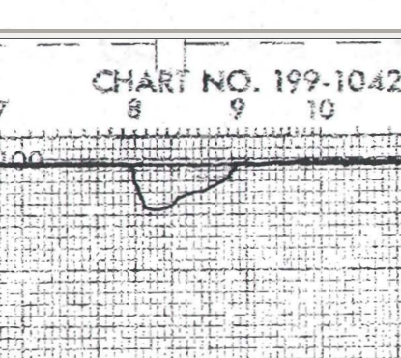Fig. 1: Reflectivity of the MOS mirror coatings as given by the manufacturer. Taken from document MIRI-TS-0004-ATK, page 91 (version of 10th October 2007)

Here is presented the solution implemented to fix this problem.

2. Obtaining a corrected reflectivity curve for the MOS mirrors

The reflectivity curve of the MOS mirrors has been measured using some sample of the coating at RAL, recently. In the words of Paul (in an e-mail sent to Alistair and others on 31st October 2011), “Data is fine at SW (<16 micron) but the FIR beamsplitter measurements are still looking dodgy. May be an possible absorption feature at ~27 microns but looks to be part of oscillations in the data - I need to spend some time with Hugh and understand why we can't get better data at LW end.” The curve they obtained is shown in Fig. 2. Apart from the doubts expressed by Paul, one issue with this curve is that the reflectivity is in many areas larger than 1 (not by a large amount, but enough to cause some trouble understanding it). Besides, the resolution in wavelength of the measurements seems somewhat poorer than that of the curve provided by the manufacturer.

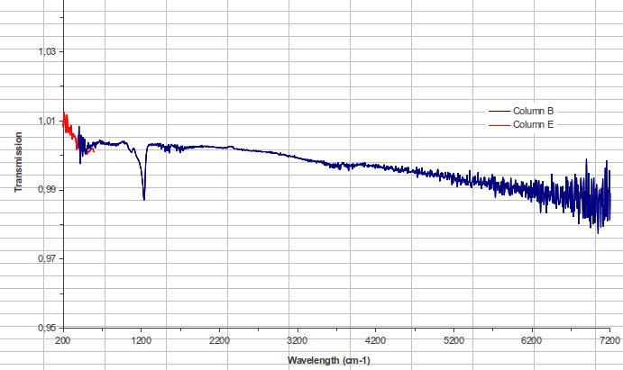Fig. 2: Reflectivity of the coating of the MOS mirrors, as measured at RAL on October 2011.

A compromise solution has been decided in which the curve provided by the manufacturer would be used, but allowing for a shift in wavelength so as to have the absorption feature to fall on the same wavelength as that obtained at RAL recently.

To do so, first we had to “read” the reflectivity curve provided by the manufacturer (document MIRI-TS-00004-ATK), something that was done as follows:

1) The 8 µm feature was read out of the graph (which covers from 2.5 to 16 µm) by means of converting the figure to a .png file and then "tracing" it by hand with an IDL routine. This is rather a rudimentary procedure but it's the best solution found, provided the curve at wavelengnths shorter than 16 µm was not tabulated.

2) from 2 to 8 µm a constant value of 99.5% was assumed, what was apparent from the graph (being precise, there is a minor glitch at around 3 µm introduced after following the graph in more detail).

3) the same as in point 2 was done from 10 to 14 um.

4) from 14 to 28.2 it was possible to use the reflectivity values given in tabulated form in the aforementioned document for an incidence angle of 45deg, which is the same used for the graph in point 1). The value at 30um is just an extrapolation
.

5) These curves were patched together and resampled to a common wavelength sampling.

The resulting curve, around the 8 µm feature, can be seen in Fig. 3. The manufacturer curve is the blue-dashed line, the solid black line is the curve obtained at RAL a few days ago, and the red and green lines are the old MOS curve in MTSSim adjusted to match the new curve, either subtracting some constant from the wavelengths (3 µm) or dividing them by some factor (1.37). All the reflectivity curves have been raised to the 4th power, to simulate the reflectivity of the whole MOS (accounting 4 reflections).
There it can be seen that the RAL curve does not match the shape of the manufacturer shape, and, as said before, it seems that it has somewhat poorer resolution. At first we thought that perhaps this poorer resolution, toghether with the asymmetry of the band, is the reason why the peak absorption of the black and blue lines do not match, as they should. But convolving the blue-dashed line (manufacturer) with some gaussian kernel does not help in matching the peak absorptions of the curves. The difference in the position of the peaks is around 600 Angstroms (0.06 um), the manufacturer being “redwards” of the RAL curve.

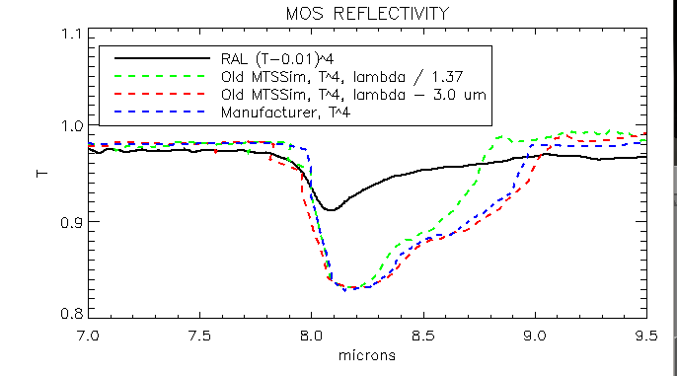Fig. 3: Different versions of the reflectivity curve of the MOS mirrors raised to the 4th power (to account for the 4 reflections in the MOS). Black-continuous: curve measured at RAL using a sample of the coating in October 2011; Green-dashed: curve included in MTSSim v.<=2.6.0, with wavelengths divided by 1.37; red-dashed: curve included in MTSSim v.<=2.6.0 with wavelengths minus 3.0 µm. Blue-dashed: reflectivity curve provided by the manufacturer. MTSSim v. 2.6.1 now includes the blue-dashed curve blue-shifted by 0.06 µm to better match the position of the peak absorption of the black line.
3. New MOS reflectivity curve in MTSSim v. >= 2.6.1

The reflectivity curve, obtained as explained in section 2, is included in MTSSim v.2.6.1 in TRANSMIT/MOScurve_capture_shift_0.00.txt. Then, a second version of it was produced, with the wavelengths shifted 0.06 µm “bluewards”, to allow for a match of the wavelength position of the 8 µm peak absorption with that measured recently at RAL (MOScurve_ capture_shift_blue0.06.txt). This second, slightly blue-shifted version of the curve is the one used by default in MTSSim, but the user may use the non-shifted one by changing the entry “MOStransn” in the internalvalues.pro routine in the src directory of the MTSSim distribution to the name of the other curve. Both files may be found in the TRANSMIT directory within the distribution.

