WK1-PMx — Windows 10 / Kali Linux Connection (VirtualBox)

Reminder — Network Settings
Setting | Value
Network type | VirtualBox NAT Network
Kali Linux IP | 10.0.0.2 / 24
Windows 10 IP | 10.0.0.10 / 24
Gateway | 10.0.0.1
DNS | 8.8.8.8

Step 4: Set the network to NAT Network
- Shut down the Windows 10 VM if it booted into Windows.
- Go to Settings > Network.
- Attached to: NAT Network.
- Name: pick the same NAT Network your Kali VM uses.
- Start the VM again.

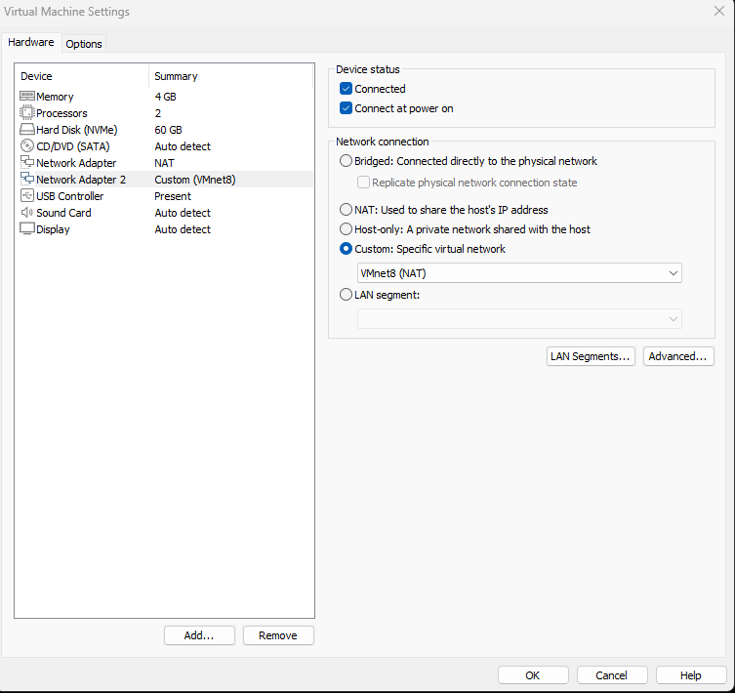

Step 5: Set a static IP inside Windows
- Open Control Panel > Network and Sharing Center > Change adapter settings.
- Right-click the network adapter, then Properties.
- Select Internet Protocol Version 4 (TCP/IPv4), then Properties.
- Use the following IP address:
  - IP address: 10.0.0.10
  - Subnet mask: 255.255.255.0
  - Default gateway: 10.0.0.1
  - Preferred DNS: 8.8.8.8
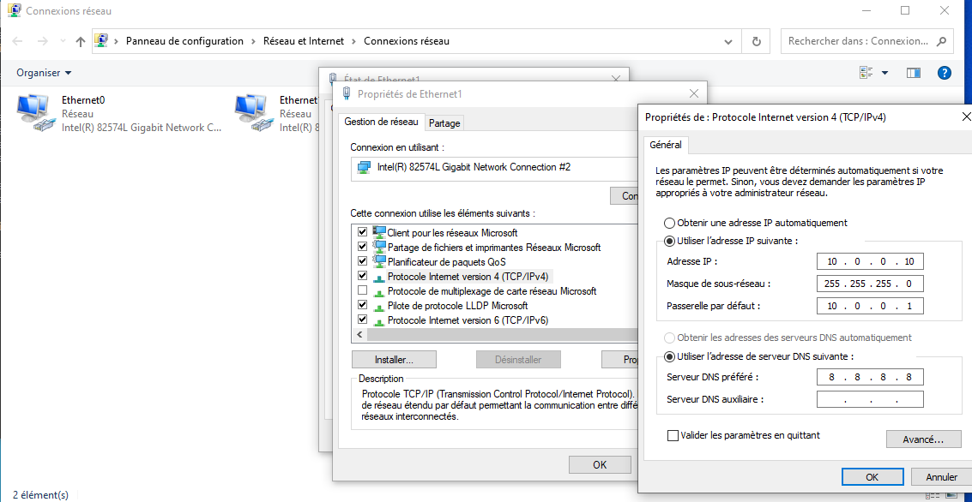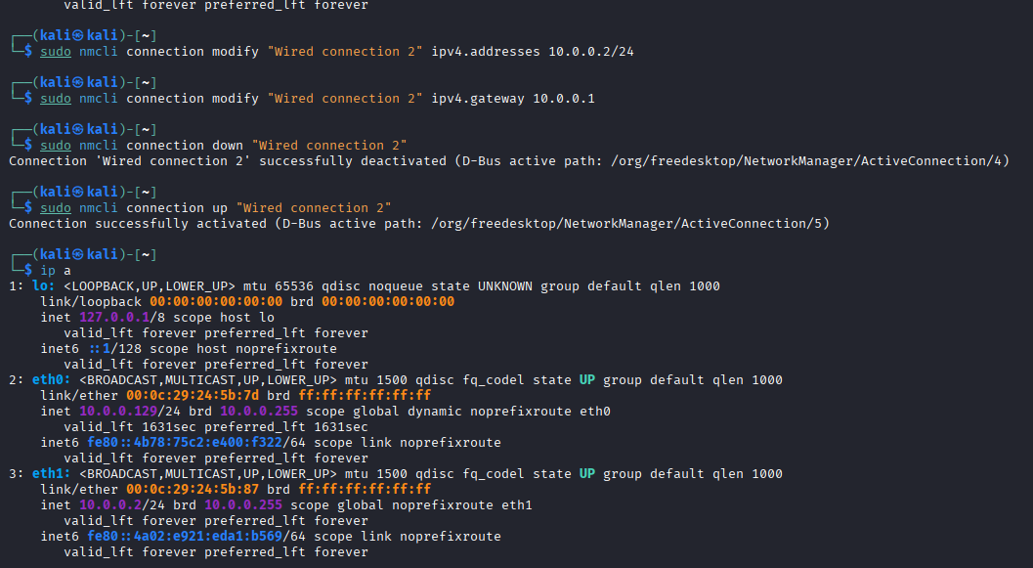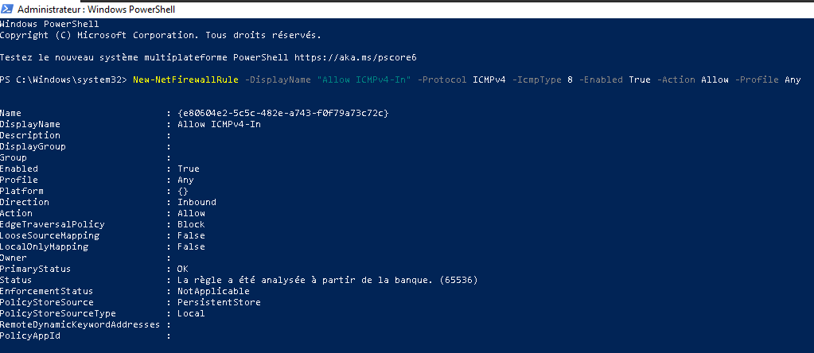

Step 6: Test connectivity
- Open Command Prompt on Windows.
- Run: ping 10.0.0.2 (this should reach your Kali VM).
- Run: ping 8.8.8.8 (this should confirm internet access).
- On Kali, run ping 10.0.0.10 (this should reach Windows).

