**Task description:**

Create endpoint (ASP.NET MVC Web API project) for merging data from three sources. Endpoint should use common criteria between data for merging.

Data from each source is serialized into JSON format.

For accessing to endpoint it is necessary to use authentication process.

**Important:**

It is necessary to use for implementing endpoint:

1. Domain Driven Design (DDD) (without presentation part);
2. Dependency Injection pattern;
3. SOLID principles;
4. Authorization mechanism; (Credentials can be hardcoded);

**Recommended technologies:**

1. For storing data: DBMS MS SQL;
2. For working with data store: Entity Framework (code first);
3. For data mapping: AutoMapper library (<https://www.nuget.org/packages/AutoMapper/>);
4. For authorization: JSON Web Token (JWT);

**Acceptance Criteria:**

Data from all source should be merged correctly.

**Additional info:**

**Database structure**:

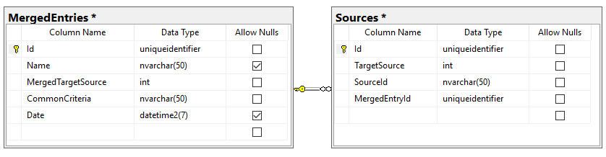

‘**Sources’-**table contains unique data for each entry from each source;

‘**Sources.TargetSource**’-column is value that defines number of source (1, 2 or 3);

‘**Sources.SourceId’**-column is unique value for each entry within target source;

Pair ‘**Sources.TargetSource**’ and ‘**Sources.SourceId’** should be unique;

‘**MergedEntries’**-table contains merged entries from all sources;

‘**MergedEntries .CommonCriteria’**-column is some property that using for merging entries from all sources into merged entries. Other properties can be different in different entries. Data from sources have same priorities and merged properties will have values from last processed source;

‘**MergedEntries.MergedTargetSource’**-column is flag that defines all existed target sources for current entry.

‘**MergedEntries’**-table has one-to-many relation to ‘**Sources’-**table.

**Input values from sources:**

Can be found in ‘/DataSource’ folder.

**Additional (not obligatory) task:**

Implement endpoints for updating and deleting entries from each sources.