**BCA Virtual Account**

Simulator BCA VA = [https://staging.doku.com/VASimulator/BCAAction\_show.doku](https://staging.doku.com/VASimulator/BCAAction_show.doku" \t "_blank)

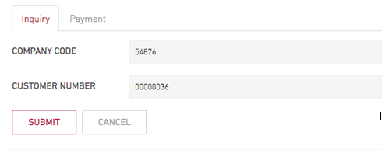

* Input COMPANY CODE with prefix code BCA VA
* Input Customer Number with paymentcode ( without prefix )

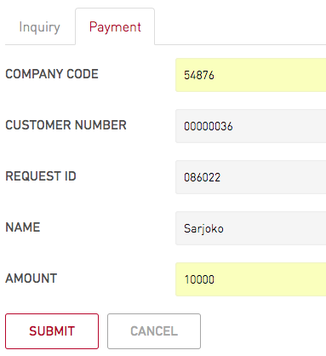

* Input COMPANY CODE with prefix code BCA VA
* Input Customer Number with paymentcode ( without prefix )
* Input REQUESTID from inquiry process
* Input AMOUNT
* Submit

**BRI Virtual Account**

Simulator BRI VA = [https://staging.doku.com/VASimulator/BriAction\_show.doku](https://staging.doku.com/VASimulator/BriAction_show.doku" \t "_blank)

Inquiry Proccess :

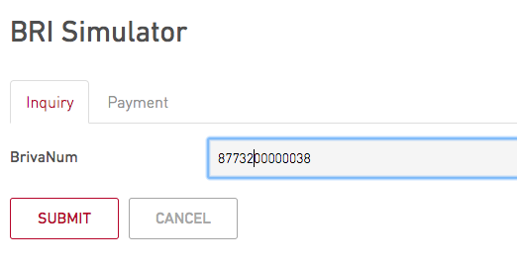

* input full paymentcode
* Submit

Payment Proccess

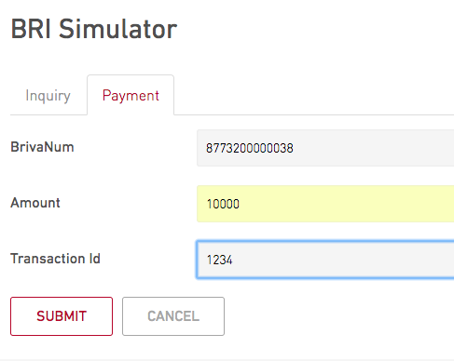

* Input full paymentcode
* Input Amount
* Input transaction id ( random )

Permata Virtual Account

Permata VA = [https://staging.doku.com/VASimulator/PermataAction\_show.doku](https://staging.doku.com/VASimulator/PermataAction_show.doku" \t "_blank)

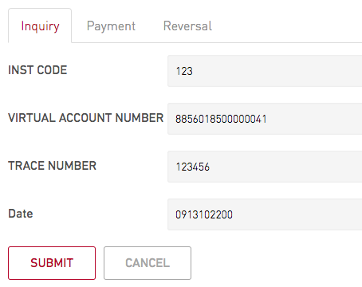

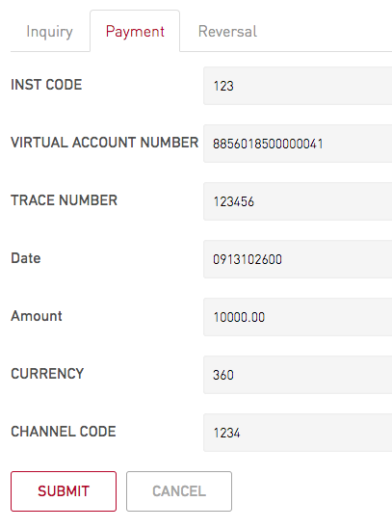Mandiri Virtual Account

Mandiri VA = [https://staging.doku.com/VASimulator/MandiriAction\_show.doku](https://staging.doku.com/VASimulator/MandiriAction_show.doku" \t "_blank)

- Inquiry Process

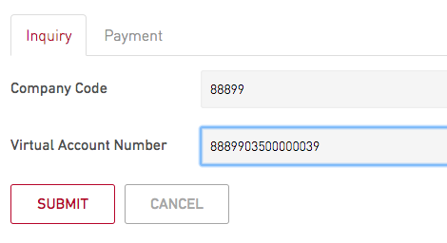

* Input Company Code = 88999
* Input full paymentcode
* Submit

- Payment Process

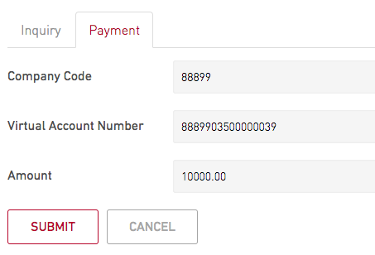

* Input Company Code = 88999
* Input full paymentcode
* Input Amount
* Submit

CIMB NIAGA Virtual Account

Cimb Niaga VA = [https://staging.doku.com/VASimulator/CimbAction\_show.doku](https://staging.doku.com/VASimulator/CimbAction_show.doku" \t "_blank)

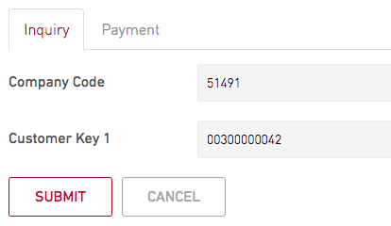

- Input 5 digit of paymentcode of company code ( ex : 51491

- Input the last 11 digits of paymentcode

- Submit

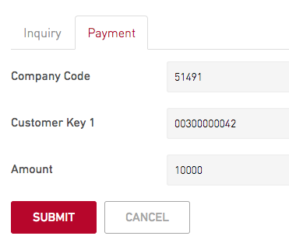

- Input 5 digits of paymentcode (51491 ) in company code

- Input the last 11 digits of paymentcode in customer key 1

- Input amount without delimeter (.00)

- Submit

Danamon Virtual Account

Danamon VA = [https://staging.doku.com/VASimulator/DanamonAction\_show.doku](https://staging.doku.com/VASimulator/DanamonAction_show.doku" \t "_blank)

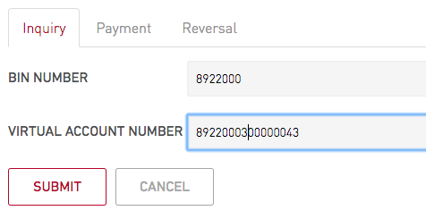

- Input 7 digit first of payment code in bin number

- Input full payment code in virtual account number

- Submit

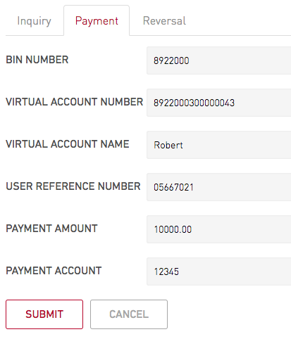

- Input result from inquiry put it again into payment form

How To Indomaret : <https://staging.doku.com/VASimulator/IndomartAction_show.doku>

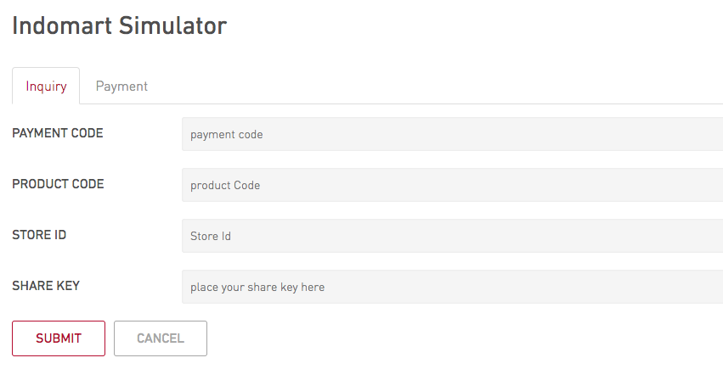

Klik Tab Inquiry

- Put  **full 16** digit **payment code**

- Input **mallid** on **product code**

- input **5 digit prefix** payment code for **store id**

- input **sharekey**

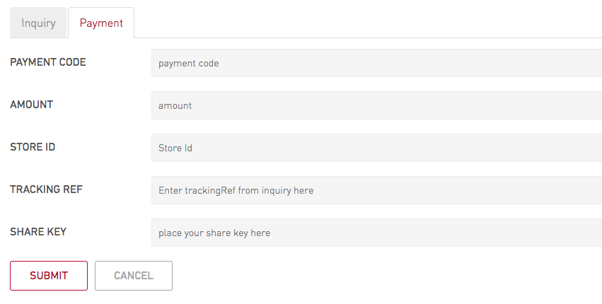

Klik Tab Payment

- Put  full 16 digit **payment code**

- input amount

- input 5 digit prefix for storied

- input tracking ref from inquiry result

- input sharekey

How To Alfamart : <https://staging.doku.com/VASimulator/AlfaAction_show.doku>

**Klik tab Inquiry**

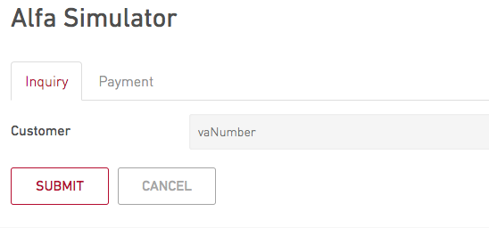

- Put full 16 digit payment code

**Klik Tab Payment**

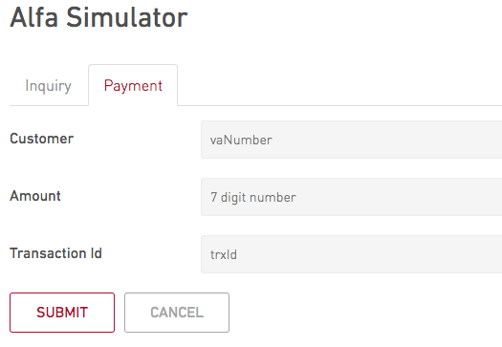

- Put full 16 digit payment code

- Put amount

- Put random number