**Supplementary Table S1 and Fig S1.**

**Table S1**. Sample sizes (N) for seven carcass traits¹ in crossbred pigs (Pietrain × Landrace).

|  |  |  |  |  |  |  |  |
| --- | --- | --- | --- | --- | --- | --- | --- |
|  | BF_PL | MD_PL | MP_PL | BF_AB | MP_AB | CF_AB | CW_AB |
| BF_PL | **6334**2 | 6326 | 6329 | 6334 | 6334 | 4898 | 6334 |
| MD_PL |  | **6332** | 6323 | 6332 | 6332 | 4898 | 6332 |
| MP_PL |  |  | **6330** | 6330 | 6330 | 4894 | 6330 |
| BF_AB |  |  |  | **7255** | 7255 | 5803 | 7255 |
| MP_AB |  |  |  |  | **7255** | 5803 | 7255 |
| CF_AB |  |  |  |  |  | **5803** | 5803 |
| CW_AB |  |  |  |  |  |  | **7255** |

1: BF_PL: Backfat thickness measured using Piglog at the station; MD_PL: Muscle depth measured using Piglog at the station; MP_PL: Meat percentage measured using Piglog at the station; BF_AB: Backfat thickness measured using AutoFOM at the slaughterhouses; MP_AB: Meat percentage measured using AutoFOM at the slaughterhouses; CF_AB: Conformation score measured using AutoFOM at the slaughterhouses; CW_AB: Carcass weight measured using AutoFOM at the slaughterhouses

2: Diagonal entries represent the number of records for each individual trait; off-diagonal entries represent the number of records shared between each pair of traits.

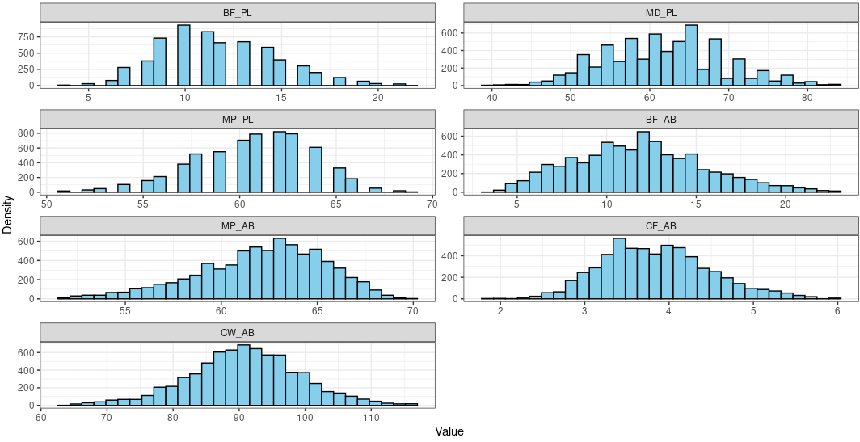

**Fig. S1** Distribution of seven carcass traits¹ in crossbred pigs (Pietrain × Landrace). BF_PL: Backfat thickness measured using Piglog at the station; MD_PL: Muscle depth measured using Piglog at the station; MP_PL: Meat percentage measured using Piglog at the station; BF_AB: Backfat thickness measured using AutoFOM at the slaughterhouses; MP_AB: Meat percentage measured using AutoFOM at the slaughterhouses; CF_AB: Conformation score measured using AutoFOM at the slaughterhouses; CW_AB: Carcass weight measured using AutoFOM at the slaughterhouses