Table S1-1. Sample sizes (N) for seven carcass traits¹ in crossbred pigs (Pietrain × Landrace).
 | BF_PL | MD_PL | MP_PL | BF_AB | MP_AB | CF_AB | CW_AB
BF_PL | 6334² | 6326 | 6329 | 6334 | 6334 | 4898 | 6334
MD_PL |  | 6332 | 6323 | 6332 | 6332 | 4898 | 6332
MP_PL |  |  | 6330 | 6330 | 6330 | 4894 | 6330
BF_AB |  |  |  | 7255 | 7255 | 5803 | 7255
MP_AB |  |  |  |  | 7255 | 5803 | 7255
CF_AB |  |  |  |  |  | 5803 | 5803
CW_AB |  |  |  |  |  |  | 7255
1: BF_PL: Backfat thickness measured using Piglog at the station; MD_PL: Muscle depth measured using Piglog at the station; MP_PL: Meat percentage measured using Piglog at the station; BF_AB: Backfat thickness measured using AutoFOM at the abattoir; MP_AB: Meat percentage measured using AutoFOM at the abattoir; CF_AB: Conformation score measured using AutoFOM at the abattoir; CW_AB: Carcass weight measured using AutoFOM at the abattoir.
²: Diagonal entries represent the number of records for each individual trait; off-diagonal entries represent the number of records shared between each pair of traits.

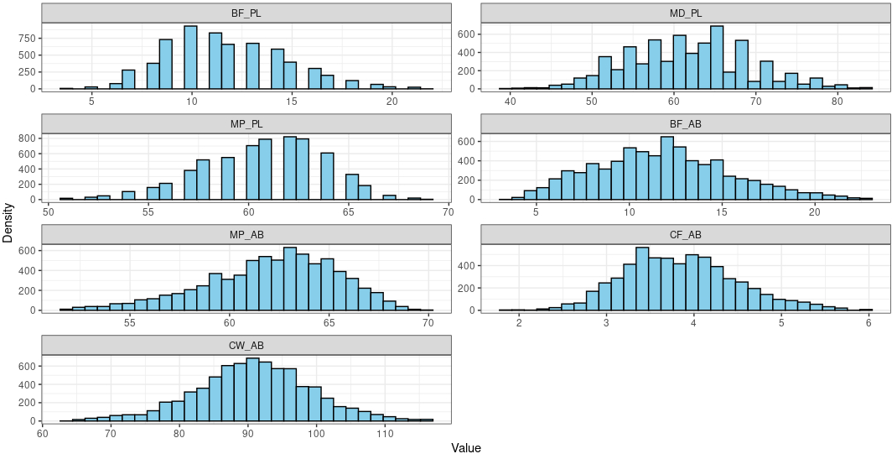
Fig. S1-1 Distribution of seven carcass traits¹ in crossbred pigs (Pietrain × Landrace). BF_PL: Backfat thickness measured using Piglog at the station; MD_PL: Muscle depth measured using Piglog at the station; MP_PL: Meat percentage measured using Piglog at the station; BF_AB: Backfat thickness measured using AutoFOM at the abattoir; MP_AB: Meat percentage measured using AutoFOM at the abattoir; CF_AB: Conformation score measured using AutoFOM at the abattoir; CW_AB: Carcass weight measured using AutoFOM at the abattoir.

